confdb
Retrieves the documents or metadata stored in the confdb. This command receives the name of the database instance or collection as an argument. Administrative privileges are required to execute this command.

Syntax
confdb SUB-COMMAND
SUB-COMMAND
databases
Retrieve a list of all confdb database instances.
cols DB_NAME
List all collection names of the specified confdb database instance.
docs DB_NAME COL_NAME
Retrieve all document objects of the specified confdb collection of the confdb database instance.
logs DB_NAME
Retrieve commit logs of the specified confdb database instance.

Description
confdb is the database storing the (platform) settings of the Logpresso. The logical structure is as follows:
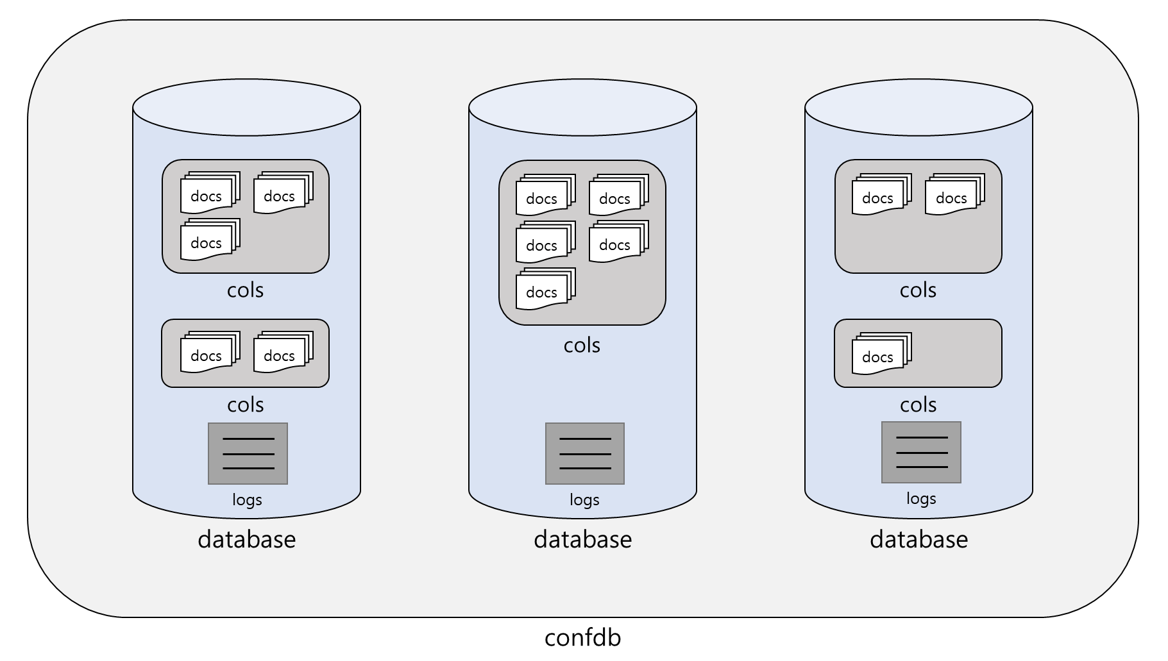
- confdb consists of multiple database instances.
- A database instance consists of more than one collection. A collection is similar to a table in a relational database (RDBMS).
- A collection consists of more than one document. A document is similar to a record in an RDBMS.
- A log is generated once a document is committed to confdb or database revision is updated.
When you provide the unit of the database (databases, cols, docs) as an argument, it extracts the corresponding data.
Retrieve database instances
The following is an example command to get the list of database instances of confdb in Logpresso Sonar.
confdb databases
| # change the output field order
| order name, rev, commits, last_commit, last_msg
| # sort in ascending order by name field
| sort name
Result of the command confdb databases:
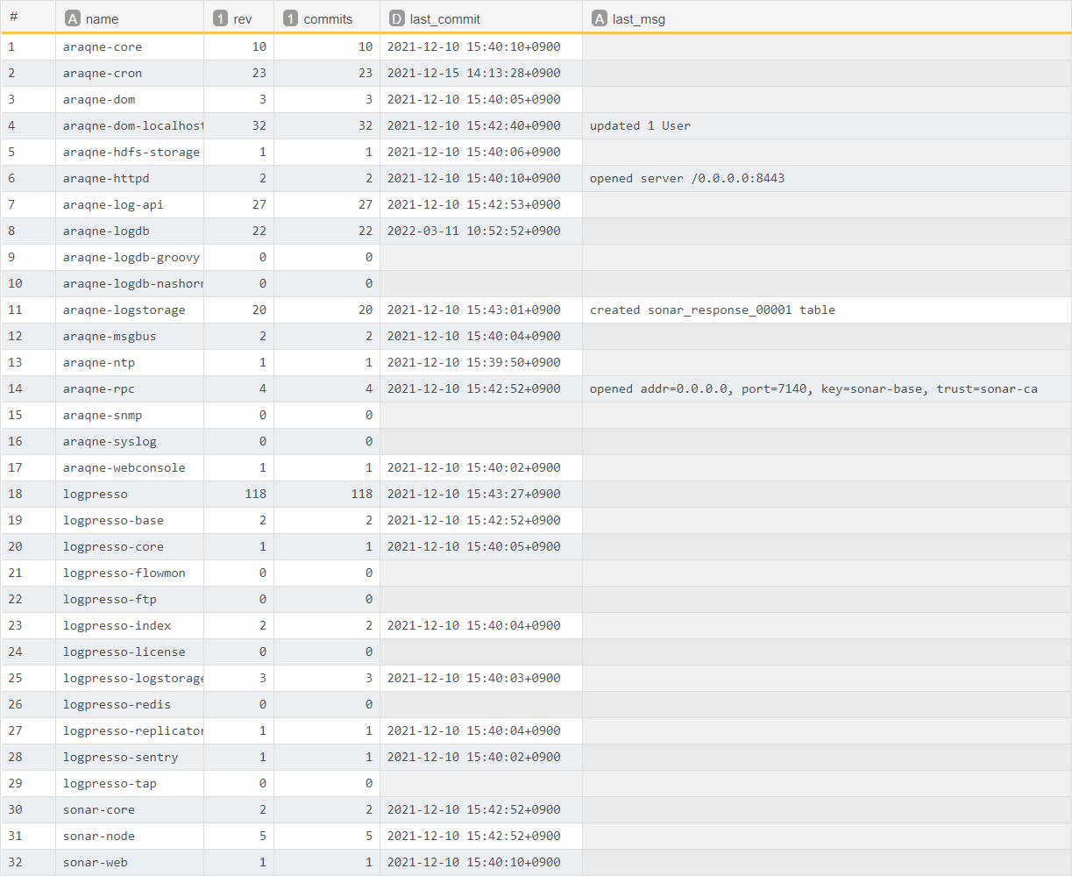
Field | Type | Description
name | String | Name of the database instance
rev | Integer | Revision number of the database instance
commits | Interger | Number of commits to the database
last_commit | Date | Date of the last commit
last_msg | String | Last commit message
List all collection names
The following is an example command to get the list of collections for the database instances araqne-rpc. This collection list has name field only.
confdb cols araqne-rpc
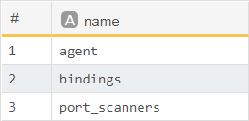
Retrieve documents from collection
The following is an example command to retrieve all documents in the bindings collection in the araqne-rpc database instance.
confdb docs araqne-rpc bindings
A document consists of common attribute fields such as doc_id, doc_prev, and doc_rev, as well as document-specific fields.
For common attribute fields, refer to the below table.
Field | Type | Description
doc_id | Integer | Serial number of document
doc_prev | Integer | Previous revision number of document
doc_rev | Integer | Current revision number of document
Retrieve commit logs
You can view the commit history of the database instance.
confdb logs araqne-rpc
For commit log fields, refer to the below table.
Field | Type | Description
_time | Time | Time of commit
rev_id | Integer | Commit revision ID
committer | String | Name of committer module (araqne-rpc in the above example)
msg | String | Summary of commit
manifest_id | Integer | Manifest ID for changeset

