Logpresso Sonar Installation Guide

Overview

Deployment Topologies
Logpresso Sonar supports cluster configurations where multiple nodes (servers) are grouped together to operate as a single system. Configuring a cluster allows high availability (HA) settings to be applied to each node to enhance stability and usability.

Architecture
Cluster architecture can be categorized as follows based on the tiers that compose the cluster.
- 1-Tier: Control node (single tier)
- 2-Tier: Forwarder (tier 1) - Control (tier 2) / Data (tier 1) - Control (tier 2)
- 3-Tier: Forwarder (tier 1) - Data (tier 2) - Control (tier 3)
Choose the appropriate architecture based on the volume of raw logs collected per day. The recommended architecture by Logpresso is 3-tier.
1-Tier: Control Node
The 1-tier configuration is illustrated as follows. The left shows a single control node configuration, and the right shows a control node pair configuration. A 1-tier cluster can process up to 250GB of data per day (250GB/day).
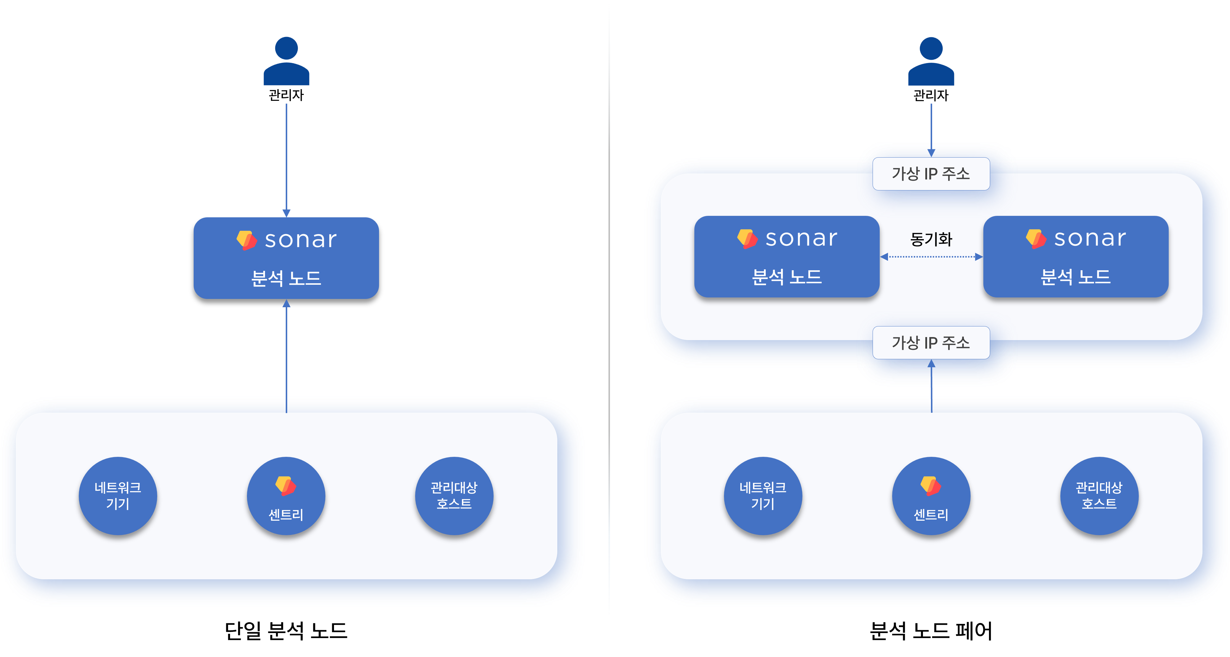
A single control node is the simplest structure that performs the functions of both a data node and a control node simultaneously. If the node fails, data loss may occur.
A control node pair shares a virtual IP address between each node.
- For network load balancing, when data is sent to the IP address of an L4 load balancer/switch placed above, one of the two nodes receives the data.
- When network devices, managed hosts, or sentries send data, the active node of the control node pair receives the data and synchronizes it with the standby node.
- When a user accesses the web console through the virtual IP address, one of the two nodes provides the service.
If the data to be collected increases, you should change to a 3-tier configuration.
2-Tier: Forwarder-Control / Data-Control
The 2-tier configuration is illustrated as follows. The left shows the forwarder-control node configuration, and the right shows the data-control node configuration (legacy).
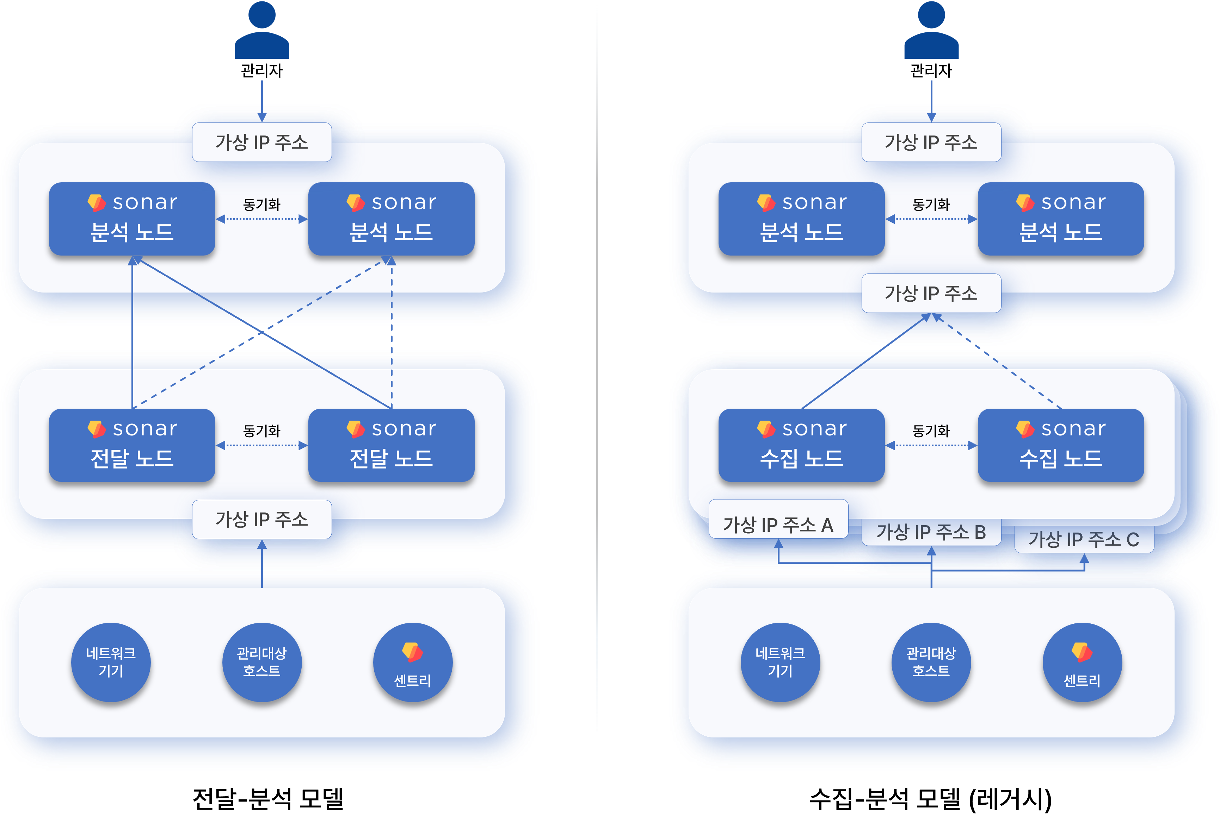
The forwarder-control configuration is the default configuration found in [Logpresso Cloud](https://logpresso.cloud/). The forwarder node was introduced in version 4.0.2404.0, serving as a data gateway and load balancer (related documentation). Forwarder nodes can be operated as a single node, but redundancy is recommended.
The data-control configuration (legacy) is the architecture used before version 4.0.2404.0. Since each data source (network devices, managed hosts, sentries) must communicate with specifically designated data node pairs, the network topology becomes more complex as the number of data node pairs increases, so this configuration is not recommended.
3-Tier: Forwarder-Data-Control
The 3-tier configuration is recommended for large-scale data collection environments.
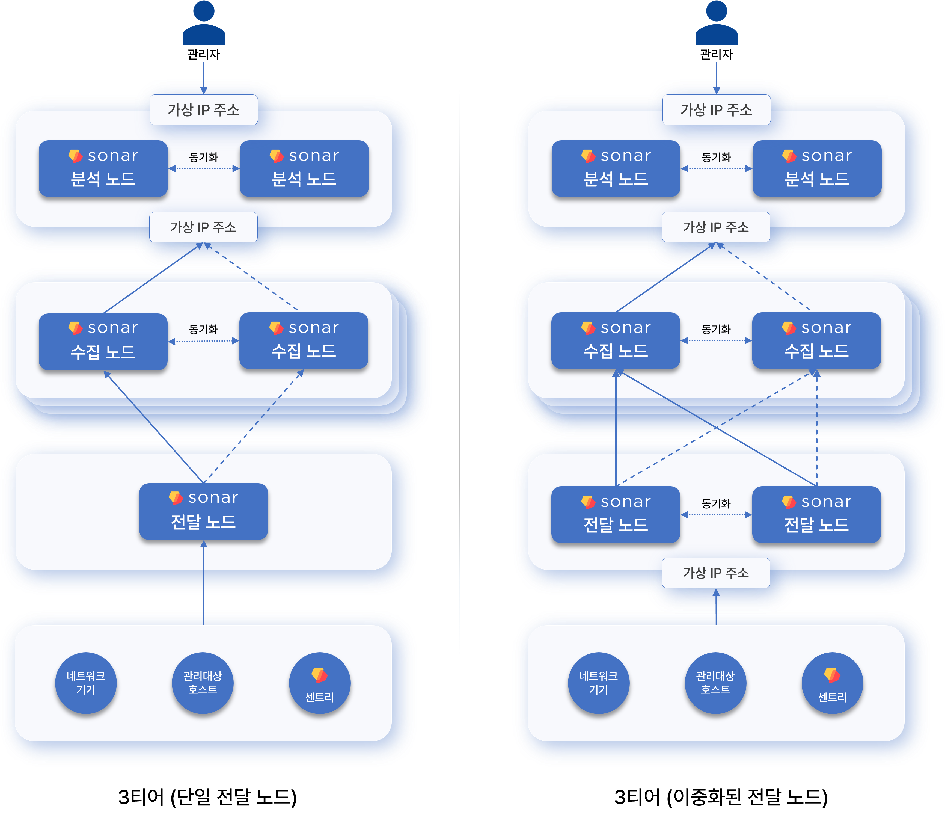
If there are 2 or more data node pairs, forwarder nodes must be configured. Adding forwarder nodes resolves the topology issues of the 2-tier data-control model.

Functions by Node
Nodes (servers) composing the Logpresso cluster are classified into control nodes, data nodes, and forwarder nodes based on their roles. A standalone Logpresso Sonar server can be considered as performing the roles of both a data node and a control node.
Control Node
The control node controls all nodes in the cluster and provides web console services to users. Redundant control nodes (control node pair) share a virtual IP address.
Node Control
Nodes within the cluster communicate using a polling method. When forwarder nodes and data nodes request configuration and policy synchronization from the control node, the control node transmits changed configurations or policies according to each node's request.
User Web Interface
Users can access the web console through the virtual IP or domain address of the control node. Justification requests sent to employees who have been asked to justify policy violations, and review requests sent to approvers who need to review them, are also delivered through this web address.
Data Analysis, Security Threat and Anomaly Detection
Based on data stored on data nodes, the control node performs the following actions according to real-time detection and batch detection scenarios.
- Security threat and anomaly event detection
- Ticket issuance and management
- Justification management
- Automated response to detected threats
The control node establishes and manages execution plans for Logpresso queries, collects results distributed and processed across each node, and processes data. Most queries directly executed by users on the control node or periodically executed in the cluster are processed by the control node reading data stored on data nodes.
Data Node
The data node parses data collected through loggers, normalizes and indexes it, then stores and manages it in tables.
Data Storage and Query Execution
Raw data parsing by parsers and normalization defined in logger models are all performed on data nodes.
All data nodes store raw data and normalized data together in tables with identical names. When a Logpresso query is executed on the control node, data retrieval commands such as table and fulltext are processed in parallel on each data node.
Lifecycle Management
The data node manages collected raw log data according to retention periods and data lifecycle defined in tables.
Forwarder Node
The forwarder node was introduced in version 4.0.2404.0 (related documentation). Redundant forwarder nodes share a virtual IP address.
- When there are 2 or more data node pairs, a 3-tier configuration including forwarder nodes is recommended.
- To operate forwarder node pairs in active-active mode, an L4 switch or network load balancer is required.
Data Gateway
Loggers run on forwarder nodes, and the forwarder node becomes the data transmission/reception gateway of the Logpresso cluster. The virtual IP address or domain address of the forwarder node is used as the gateway address.
Data nodes can serve as the data gateway, but this is not recommended. Since each data source (network devices, managed hosts, sentries) must communicate with specifically designated data node pairs, the network topology becomes more complex as the number of data node pairs increases.
Load Balancing
Data received/collected by the forwarder node is sent to data nodes. The forwarder node performs load balancing to evenly distribute data across multiple data node pairs according to the transmission method defined in the loggers, or sends data to a specific node pair.
When the forwarder node detects a failure during communication with a data node, it temporarily stores data to be sent in memory and local disk. When the failure is recovered, it retransmits the stored data to the data nodes. The forwarder node removes locally remaining data after transmission is complete.
Differences from Sentry
Logpresso Sentry also provides data forwarding functionality, but since Sentry is designed to be installed on managed servers, it is designed to use minimal system resources and provides only minimal collection-related functions. In contrast, forwarder nodes are configured as independent machines and provide app installation functionality.
Especially when sending Syslog from devices located in the user's network to Logpresso Cloud instances, a forwarder node should be installed in the user's network to forward logs in order to prevent plaintext exposure over the internet and minimize UDP packet loss.
The table below summarizes and compares the features of Sentry and forwarder nodes.
Feature | Sentry | Forwarder Node
System Resources | Minimal usage | Full usage
TLS Encrypted Communication | Supported | Supported
Real-time Compressed Transfer | Supported | Supported
Data Collection | Supported | Supported
Data Parsing | Not supported | Not supported
Data Filtering | Supported | Supported
Internal Data Relay | Not supported | Supported
External System Forwarding | Not supported | Supported
Query Execution | Not supported | Supported
App Installation | Not supported | Supported
High Availability | Not supported | Supported
Automatic Load Balancing | Not supported | Supported

Installation Requirements
This document describes the software and hardware requirements for installing Logpresso Sonar.

Software
The following operating systems and software are required to run Logpresso Sonar.
Operating System
The officially supported operating system by Logpresso is Red Hat Enterprise Linux 9.
- RHEL 9-compatible operating systems such as Rocky Linux can also be used.
- The Server with GUI installation type is recommended.
- Depending on the installation type, the following packages may need to be installed additionally: curl, firewalld, lsof, net-tools, traceroute, unzip, vim, wget
JDK
OpenJDK 21 (LTS) provided by default from the operating system repository is recommended. As an alternative, Eclipse Temurin can be brought in and installed. Eclipse Temurin is the name of OpenJDK provided by the Eclipse Foundation.
Database
To install Logpresso Sonar as a single node or to install a control node, MariaDB 11.8 (LTS) is required.
Application
The Logpresso Sonar package is required. It can be downloaded from the Logpresso Store.

Hardware
Control Node & Data Node
The cluster architecture can be configured based on the volume of raw logs collected per day (daily throughput).
- The cluster tier configuration can be determined based on daily throughput.
- In a cluster configuration, the control node is based on 1 unit. The control node can also be made redundant.
- The specifications presented are hardware specifications based on 1 node.
- Available storage is the capacity assuming a 1-year retention period and 85% data compression ratio.
Node | Category | 10GB/day | 50GB/day | 100GB/day | 250GB/day | 500GB/day | 1TB/day
Control Node | CPU | 12 | 12 | 24 | 24 | 24 | 24
 | vCPU | 24 | 24 | 48 | 48 | 48 | 48
 | Memory | 32GB | 64GB | 128GB | 128GB | 128GB | 128GB
 | Disk(OS) | SSD 240GB x 2(RAID 1) | SSD 240GB x 2(RAID 1) | SSD 240GB x 2(RAID 1) | SSD 240GB x 2(RAID 1) | SSD 240GB x 2(RAID 1) | SSD 240GB x 2(RAID 1)
 | Disk(Data) | SATA HDD 4TB x 2(RAID 1) | SATA HDD 12TB x 2(RAID 1) | SATA HDD 24TB x 2(RAID 1) | SATA HDD 24TB x 4(RAID 10) | SATA HDD 4TB x 2(RAID 1) | SATA HDD 4TB x 2(RAID 1)
 | Available Space | 4TB | 12TB | 24TB | 48TB | 4TB | 4TB
 | NIC | 1Gbps x 2 | 1Gbps x 2 | 1Gbps x 2 | 1Gbps x 2 | 10Gbps x 2 | 10Gbps x 2
Data Node | CPU | N/A | N/A | N/A | N/A | 24 | 24
 | vCPU |  |  |  |  | 48 | 48
 | Memory |  |  |  |  | 128GB | 128GB
 | Disk(OS) |  |  |  |  | SSD 240GB x 2(RAID 1) | SSD 240GB x 2(RAID 1)
 | Disk(Data) |  |  |  |  | SATA HDD 24TB x 4(RAID 10) | SATA HDD 24TB x 4(RAID 10)
 | Available Space |  |  |  |  | 48TB | 48TB
 | NIC |  |  |  |  | 10Gbps x 2 | 10Gbps x 2
Cluster |  | Control/Dataintegrated(Redundant: 2 units) | Control/Dataintegrated(Redundant: 2 units) | Control/Dataintegrated(Redundant: 2 units) | Control/Dataintegrated(Redundant: 2 units) | 1 Control node2 Data nodes(Redundant: 6 units) | 1 Control node4 Data nodes(Redundant: 10 units)
- CPU refers to physical cores, and vCPU refers to logical cores.
Forwarder Node
The hardware specifications for the forwarder node are divided based on the daily volume of raw logs collected (daily throughput), with a baseline of 500 sentry connections.
- For daily throughput of 1TB/day or more, scale out forwarder nodes horizontally.
- The specifications presented are hardware specifications based on 1 node.
- Available storage is the capacity assuming up to one week of retention for data node failures and 85% compression.
- A maximum of 500 sentries is assumed.
Network Collection Only Specifications
Category | 1TB/day
CPU | 4
vCPU | 8
Memory | 8GB
Disk (OS) | SSD 240GB x 2 (RAID 1)
Disk (Data) | SATA HDD 4TB x 2 (RAID 1)
Available Space | 4TB
NIC | 10Gbps x 2
Sentry Management and Network Collection Specifications
Category | 1TB/day
CPU | 12
vCPU | 24
Memory | 64GB
Disk (OS) | SSD 240GB x 2 (RAID 1)
Disk (Data) | SATA HDD 4TB x 2 (RAID 1)
Available Space | 4TB
NIC | 10Gbps x 2
AWS EC2 | c5.2xlarge

Network
Prepare IP addresses and L4 switches (or load balancers) considering the operating environment and network configuration.
Node | Single Node Configuration | Redundancy Configuration
Control/Data Integrated | 1 IP address | 3 IP addresses, 1 L4 switch/load balancer
Control Node | 1 IP address | 3 IP addresses, 1 L4 switch/load balancer
Data Node | 1 IP address | (Data-Control 2-tier architecture) 3 IP addresses, 1 L4 switch/load balancer(Forwarder-Data-Control 3-tier architecture) 2 IP addresses
Forwarder Node | 1 IP address | 3 IP addresses, 1 L4 switch/load balancer
- In redundancy configurations, Node A, Node B, and the node pair each require 1 IP address. The node pair IP address is used by the L4 switch/load balancer for load balancing.
- The number of required IP addresses for data nodes varies depending on the architecture.
- In environments where L4 switches cannot be used, VIP failover can be configured using the HA script provided by Logpresso. Request the HA script from the Logpresso technical support team.

Object Storage (Optional)
Logpresso Sonar provides a data lifecycle management feature. It classifies data storage into three tiers—Hot, Warm, and Cold—based on data retention period, and provides data lifecycle management that automatically moves (rolls over) data to lower tiers based on the retention period.
Cold storage supports object storage services such as AWS S3 and Kakao Cloud Object Storage. To use Cold tier storage, prepare object storage in the cloud in advance.
The data lifecycle management feature can be configured separately after installing Logpresso Sonar.

Prerequisites
Prepare the following items before proceeding with the installation.

Deployment Topology Diagram
Refer to Deployment Topologies to create a network topology diagram of the cluster to be configured with Logpresso Sonar and review whether it is appropriate for the operating environment.

Hostnames
Determine unique hostnames in advance for all servers where Logpresso Sonar will be installed.
When there are multiple node pairs composing the cluster, it is recommended to assign hostnames by combining the node pair identifier and node identifier, such as c1a/c1b, d1a/d1b, d2a/d2b, f1a/f1b. For example, for a cluster consisting of 1 control node pair (c1), 2 data node pairs (d1, d2), and 1 forwarder node pair (f1), the following hostnames can be used.
Node Pair | Hostname | Description
c1 | c1a | Node A of control node pair c1
c1 | c1b | Node B of control node pair c1
d1 | d1a | Node A of data node pair d1
d1 | d1b | Node B of data node pair d1
d2 | d2a | Node A of data node pair d2
d2 | d2b | Node B of data node pair d2
f1 | f1a | Node A of forwarder node pair f1
f1 | f1b | Node B of forwarder node pair f1

IP Address Allocation
Allocate IP addresses and subnets to be used for each node and node pair in advance.

L4 Switch/Load Balancer Configuration
For high availability configurations, configure source IP address hash-based load balancing on the L4 switch (or router)/load balancer placed above the control node pair or forwarder node pair for traffic with destination ports 514/udp, 123/udp, and 8514/udp.

Firewall Policy Configuration
It is recommended to isolate the Logpresso Sonar cluster by configuring subnets or controlling network traffic to prevent arbitrary access to the Logpresso Sonar cluster from the internal network.
Inbound
Configure firewall policies to allow incoming traffic to each node.
Control Node
The receiving ports for the control node are as follows.
Source | Port | Purpose
Administrator terminal | 22/tcp | SSH access
Operator terminal | 443/tcp | Web console access (destination: control node representative IP)
Forwarder/Data nodes | 443/tcp | Sonar federation (destination: control node representative IP)
Operator terminal | 8443/tcp | ENT web console access
Employee terminal | 18443/tcp | Justification submission and review (destination: control node representative IP)
127.0.0.1 | 3306/tcp | MariaDB connection (can be replaced with Unix socket)
Peer node | 4444/tcp, 4567-4568/tcp | MariaDB Galera connection
Peer node | 443/tcp | Mutual status check between control node A and B
Forwarder/Data nodes | 7140/tcp | RPC and collected log transmission
All nodes, Sentries | 44300/tcp | Certificate renewal, Sentry installation (destination: control node representative IP)
- If MariaDB is configured to connect via Unix socket, port 3306/tcp does not need to be opened in the firewall. If MariaDB is configured to connect via TCP port, port 3306/tcp must be opened in the firewall.
- Peer node refers to the counterpart node that forms the control node pair together. Node B is the peer of Node A, and Node A is the peer of Node B.
- "Forwarder/Data nodes" refers to either forwarder nodes or data nodes depending on the Logpresso cluster configuration.
Data Node
The receiving ports for the data node are as follows.
Source | Port | Purpose
Administrator terminal | 22/tcp | SSH access
Operator terminal | 8443/tcp | Web management console and API inspection
Control node | 8443/tcp | Sonar federation
Peer node | 8443/tcp | Mutual status check between data node A and B
Forwarder node | 7140/tcp | RPC and collected log transmission
Sentry | 7140/tcp | (When no forwarder node) RPC and collected log transmission
Log collection target | 514/udp | (When no forwarder node) Syslog reception
Log collection target | 8514/udp | (When no forwarder node) Syslog over DTLS reception (port varies)
Log collection target | 162/udp | (When no forwarder node) SNMP TRAP
- Peer node refers to the counterpart that forms the data node pair together. From Node A's perspective, Node B is the peer node, and from Node B's perspective, Node A is the peer node.
Forwarder Node
The receiving ports for the forwarder node are as follows.
Source | Port | Purpose
Administrator terminal | 22/tcp | SSH access
Operator terminal | 8443/tcp | Web management console and API inspection
Control node | 8443/tcp | Sonar federation
Peer node | 8443/tcp | Mutual status check between forwarder node A and B
Sentry | 7140/tcp | RPC and collected log transmission
Log collection target | 514/udp | Syslog reception
Log collection target | 8514/udp | Syslog over DTLS reception (port varies)
Log collection target | 162/udp | SNMP TRAP
- Peer node refers to the counterpart that forms the forwarder node pair together. From Node A's perspective, Node B is the peer node, and from Node B's perspective, Node A is the peer node.
Outbound
Configure firewall policies to allow outgoing traffic from each node.
Source | Destination | Port | Purpose
All nodes | NTP server | 123/udp | NTP time synchronization
Control node | cti.logpresso.com | 443/tcp | Logpresso CTI service
Forwarder node | Log collection target host | 22/tcp | SFTP log collection
Forwarder node | Log collection target host | 161/udp | SNMP
Forwarder node | Log collection target MySQL | 3306/tcp | JDBC log collection
Forwarder node | Log collection target PostgreSQL | 5432/tcp | JDBC log collection
Forwarder node | Log collection target Oracle | 1521/tcp | JDBC log collection
- Additional outbound traffic may be required depending on the log collection method of loggers configured on the forwarder node.

Server Provisioning
Refer to Installation Requirements to provision and install the prepared bare metal or virtual machines at the designated locations.
- If the provisioning environment is an air-gapped network, download OS and database RPM packages in advance and bring them into the air-gapped network.
- It is recommended to install an Uninterruptible Power Supply (UPS) for immediate power redundancy configuration during emergency response.

JDK Download
Download Temurin JDK 21 from Adoptium and bring it into the server. OpenJDK 21 (LTS) provided by default from the operating system can also be used.

Logpresso Sonar Package Download
Download the latest version of the Logpresso Sonar package from the Logpresso Store. All nodes must use the same version.

Control Node

Operating System
This document describes the items required when installing and configuring the operating system.
- Permissions Required for Installation: Describes the permissions required to install Logpresso Sonar.
- Operating System & JDK Installation: Describes the operating system installation, partition configuration, required packages, and JDK installation procedures.
- Operating System Configuration: Configures JDK permissions, SELinux, hostname, NTP, firewall, kernel parameters, and more.
- Creating the Logpresso Directory: Creates the Logpresso installation directory.

Permissions Required for Installation
To install Logpresso Sonar, you need root privileges on the target server or a user account that can execute administrative commands using the sudo command (a user belonging to the wheel group).

Operating System & JDK Installation
The officially supported operating system for Logpresso is Red Hat Enterprise Linux 9.
- RHEL 9-compatible operating systems such as Rocky Linux can also be used.
- The recommended installation type is Server with GUI.
- Separate the operating system partition from the data partition.
- Mount the data partition at /data.
- It is recommended to configure the data partition with LVM so that capacity can be expanded as needed.
Installing Required Packages
Run the following command on a network with internet access to install the required packages.
sudo dnf -y install curl firewalld java-21-openjdk-devel \
lsof net-tools traceroute unzip
Package | Purpose
curl | Used for API testing
firewalld | Host firewall configuration
java-21-openjdk-devel | JDK required to run Logpresso Sonar
lsof | Diagnostic tool for checking open files and ports
net-tools | Network diagnostic tools such as netstat, ifconfig
traceroute | Diagnostic tool for tracing network routes
unzip | Extracts the Logpresso Sonar installation package
- You must install java-21-openjdk-devel instead of java-21-openjdk so that you can use the jmap and jstack commands for debugging in case of failures.
- If installing debugging tools is not permitted in your environment, install the java-21-openjdk-headless package instead.
The following packages are recommended for operational convenience.
sudo dnf -y install vim wget
Package | Purpose
vim | Editing configuration files
wget | Used when running the Sentry installation script on the host where Sentry will be installed
Downloading Packages (For Air-Gapped Environments)
If you need to install in an air-gapped environment, follow the procedure below to prepare the package files to be brought into the air-gapped environment.
Identify the operating system and version used in the air-gapped environment, and prepare a Linux host with the same version on a network with internet access.
Run the following command to download all packages and their dependencies to the specified path.
# Downloading packages does not require sudo privileges.
mkdir $HOME/rpm && cd $HOME/rpm && \
dnf download --resolve curl firewalld java-21-openjdk-devel \
lsof net-tools traceroute unzip vim wget && \
tar czvf rpm.tgz *.rpm
Create a file containing the hash value of the compressed file. The hash value is needed to verify the integrity of the file brought into the air-gapped environment.
sha256sum rpm.tgz > rpm.tgz.sha256
Store the rpm.tgz and rpm.tgz.sha256 files in a safe location (read-only media recommended).
To install the required packages in the air-gapped environment, follow the procedure below.
Create a new directory (e.g., $HOME/rpm) and copy the rpm.tgz and rpm.tgz.sha256 files into it.
Run the following command in the new directory to compare the verified hash value with the hash value recorded in the rpm.tgz.sha256 file.
sha256 sum rpm.tgz
Extract the rpm.tgz file and install the packages.
tar xzvf rpm.tgz && sudo dnf install -y *.rpm

Operating System Configuration
JDK Permission Configuration
Verify the installed JDK version and grant the permissions required to run Logpresso Sonar. This configuration must be performed on all nodes.
Verify the installed JDK version.
java -version
You should see version information similar to the following.
openjdk version "21.0.10" 2026-01-20 LTS
OpenJDK Runtime Environment (Red_Hat-21.0.10.0.7-1) (build 21.0.10+7-LTS)
OpenJDK 64-Bit Server VM (Red_Hat-21.0.10.0.7-1) (build 21.0.10+7-LTS, mixed mode, sharing)
Grant the required permissions to the java executable.
sudo setcap cap_net_bind_service,cap_sys_time,cap_net_raw=+ep $(readlink /etc/alternatives/java)
The permissions granted to the java executable using setcap are as follows.
Option | Description | Remarks
cap_net_bind_service | Permission to use ports below 1024 | Non-root users cannot use ports below 1024
cap_sys_time | Permission to change system time | Required for time synchronization and timestamp adjustment
cap_net_raw | Permission to use raw sockets and packet sockets | Used for direct pcap collection, sendsyslog, and ping apps
+ep | +: Add permissione: Apply permissionp: Retain permission permanently
Verify that the permissions have been applied correctly.
getcap $(readlink /etc/alternatives/java)
You should see output similar to the following.
/usr/lib/jvm/java-21-openjdk-21.0.10.0.7-1.el9.x86_64/bin/java cap_net_bind_service,cap_net_raw,cap_sys_time=ep
SELinux Configuration
SELinux (Security-Enhanced Linux) is a module that enforces kernel-level security policies on Linux. By default, in enforcing mode, any security policy violations are blocked. Since Logpresso Sonar may encounter restricted access to certain directories, SELinux must be changed to permissive.
We plan to improve the documentation after verifying the stability of Logpresso Sonar in SELinux enforcing mode. Currently, the installation is described with SELinux set to Permissive.
Open the /etc/selinux/config file and configure it as follows. The changed configuration takes effect after restarting the system or by running the setenforce 0 command.
# This file controls the state of SELinux on the system.
# SELINUX= can take one of these three values:
# enforcing - SELinux security policy is enforced.
# permissive - SELinux prints warnings instead of enforcing.
# disabled - No SELinux policy is loaded.
SELINUX=permissive
Run the following command to immediately apply SELinux Permissive mode.
sudo setenforce 0
Run the getenforce command to verify that the current SELinux mode is displayed as Permissive.
Changing the Hostname
Change the server hostname using the following command so that Logpresso Sonar nodes can be easily identified.
sudo hostnamectl set-hostname HOSTNAME
- HOSTNAME: The hostname
When there are multiple node pairs, it is recommended to assign hostnames by combining the node pair identifier and node identifier, such as c1a/c1b, d1a/d1b, d2a/d2b, f1a/f1b. For example, for a cluster consisting of 1 control node pair, 2 data node pairs, and 1 forwarder node pair, the following hostnames can be used.
Node Pair | Hostname | Description
c1 | c1a | Node A of control node pair c1
c1 | c1b | Node B of control node pair c1
d1 | d1a | Node A of data node pair d1
d1 | d1b | Node B of data node pair d1
d2 | d2a | Node A of data node pair d2
d2 | d2b | Node B of data node pair d2
f1 | f1a | Node A of forwarder node pair f1
f1 | f1b | Node B of forwarder node pair f1
NTP Configuration
Synchronize all nodes with the same NTP server to ensure that all nodes use accurate time information.
Verify the IP address or FQDN (e.g., time.kriss.re.kr) of the NTP server that provides the network standard time in advance.
Configure the same NTP server or server pool in the /etc/chrony.conf file on all servers so that they synchronize with the same NTP server for the network standard time.
# Use public servers from the pool.ntp.org project.
# Please consider joining the pool (https://www.pool.ntp.org/join.html).
# pool 2.rocky.pool.ntp.org iburst # Comment out the pool line
server time.kriss.re.kr iburst prefer # KRISS (Korea Research Institute of Standards and Science) NTP server
server 192.0.2.1 iburst # NTP server on internal network 192.0.2.0/24 (example)
⚠️ When adding server lines, delete or comment out the pool line. Only one of the two should be used.
Run the following command to restart the chronyd service.
sudo systemctl restart chronyd
Run the following command to check the synchronization status of the currently registered NTP servers. If chronyd is operating correctly, the synchronization status will be displayed.
chronyc sources -v
Run the following command to synchronize the time immediately.
sudo chronyc -a makestep
Host Firewall Configuration
Configure inbound firewall policies to enable the communication required for running Logpresso Sonar. The following is an example of commands to configure firewall policies on the control node server according to the Firewall Policy Configuration described in the prerequisites document.
sudo firewall-cmd --permanent --add-port={22,443,8443,18443,7140,44300,4444,4567,4568}/tcp
sudo firewall-cmd --permanent --add-port={8514}/tcp -add-port={514,8514,162}/udp # Configure when using 1-tier control node topology
sudo firewall-cmd --reload
sudo firewall-cmd --list-all
- If you have configured MariaDB database connections through a Unix socket, remote connections are not possible, so you do not need to open port 3306/tcp in the firewall.
The firewall configuration above has the problem of not restricting source IP addresses. To restrict source IP addresses in the host firewall, you need to execute advanced firewall policy commands using the --add-rich-rule option as shown below. Adjust the IP address ranges to match your actual environment.
# 1. Management network: 192.0.2.0/24
# SSH (22/tcp), Web Console (443/tcp), ENT Web Console (8443/tcp)
sudo firewall-cmd --permanent --add-rich-rule='rule family="ipv4" source address="192.0.2.0/24" port port="22" protocol="tcp" accept'
sudo firewall-cmd --permanent --add-rich-rule='rule family="ipv4" source address="192.0.2.0/24" port port="443" protocol="tcp" accept'
sudo firewall-cmd --permanent --add-rich-rule='rule family="ipv4" source address="192.0.2.0/24" port port="8443" protocol="tcp" accept'
# 2. Corporate network: 198.51.100.0/24
# Explanation writing and review (18443)
sudo firewall-cmd --permanent --add-rich-rule='rule family="ipv4" source address="198.51.100.0/24" port port="18443" protocol="tcp" accept'
# 3. Data node subnet: 203.0.113.128/27 (203.0.113.129 ~ 203.0.113.159)
# Sonar federation (443/tcp), RPC and log transfer (7140/tcp)
# Note: Only allow traffic from the data node group
sudo firewall-cmd --permanent --add-rich-rule='rule family="ipv4" source address="203.0.113.128/27" port port="443" protocol="tcp" accept'
sudo firewall-cmd --permanent --add-rich-rule='rule family="ipv4" source address="203.0.113.128/27" port port="7140" protocol="tcp" accept'
# 4. Forwarder node subnet: 203.0.113.160/27 (203.0.113.161 ~ 203.0.113.190)
# Sonar federation (443/tcp), RPC and log transfer (7140/tcp)
# Note: Only allow traffic from the forwarder node group
sudo firewall-cmd --permanent --add-rich-rule='rule family="ipv4" source address="203.0.113.160/27" port port="443" protocol="tcp" accept'
sudo firewall-cmd --permanent --add-rich-rule='rule family="ipv4" source address="203.0.113.160/27" port port="7140" protocol="tcp" accept'
# 5. Control node DB cluster subnet: 203.0.113.192/27 (203.0.113.193 ~ 203.0.113.222)
# MariaDB Galera ports (4444/tcp, 4567/tcp, 4568/tcp), mutual health check between control node A and B (7140/tcp)
sudo firewall-cmd --permanent --add-rich-rule='rule family="ipv4" source address="203.0.113.192/27" port port="4444" protocol="tcp" accept'
sudo firewall-cmd --permanent --add-rich-rule='rule family="ipv4" source address="203.0.113.192/27" port port="4567" protocol="tcp" accept'
sudo firewall-cmd --permanent --add-rich-rule='rule family="ipv4" source address="203.0.113.192/27" port port="4568" protocol="tcp" accept'
sudo firewall-cmd --permanent --add-rich-rule='rule family="ipv4" source address="203.0.113.192/27" port port="7140" protocol="tcp" accept'
# 6. Sentry (general server subnet): 203.0.113.0/25 (203.0.113.1 ~ 203.0.113.126)
# Sentry certificate renewal and Sentry package installation (44300/tcp)
# Allow access from a wide range of servers where agents are installed
sudo firewall-cmd --permanent --add-rich-rule='rule family="ipv4" source address="203.0.113.0/25" port port="44300" protocol="tcp" accept'
# 7. Service network: 203.0.113.0/25 (203.0.113.1 ~ 203.0.113.126)
# Sentry: RPC and log reception (7140/tcp)
# Configure when using 1-tier control node topology
sudo firewall-cmd --permanent --add-rich-rule='rule family="ipv4" source address="203.0.113.0/25" port port="7140" protocol="tcp" accept'
# 8. Syslog reception (514/udp)
# Configure when using 1-tier control node topology
sudo firewall-cmd --permanent --add-rich-rule='rule family="ipv4" source address="203.0.113.0/25" port port="514" protocol="udp" accept'
# 9. Syslog over DTLS reception (8514/tcp, 8514/udp)
# Configure when using 1-tier control node topology
sudo firewall-cmd --permanent --add-rich-rule='rule family="ipv4" source address="203.0.113.0/25" port port="8514" protocol="tcp" accept'
sudo firewall-cmd --permanent --add-rich-rule='rule family="ipv4" source address="203.0.113.0/25" port port="8514" protocol="udp" accept'
# 10. SNMP TRAP reception (162/udp)
# Configure when using 1-tier control node topology
sudo firewall-cmd --permanent --add-rich-rule='rule family="ipv4" source address="203.0.113.0/25" port port="162" protocol="udp" accept'
# 7. Apply and verify configuration
sudo firewall-cmd --reload
sudo firewall-cmd --list-rich-rules
Socket Buffer and Memory Map Configuration
When receiving Syslog, Syslog over DTLS, or SNMP TRAP data, insufficient kernel socket buffers or memory buffers can cause log packet loss, resulting in log data loss. To prevent this, configure the socket buffer and memory map settings. Perform this task on all nodes.
Create a 50-logpresso.conf file in the /etc/sysctl.d directory and add the following content.
net.core.rmem_default = 52428800
net.core.rmem_max = 52428800
net.ipv4.udp_rmem_min = 8192
net.ipv4.ipfrag_high_thresh = 16777216
vm.max_map_count = 10000000
vm.swappiness = 1
The meaning of each parameter is as follows:
Variable | Description | Default | Value
net.core.rmem_default | Default receive buffer size for sockets | 212992 | 52428800
net.core.rmem_max | Maximum receive buffer size for sockets | 212992 | 52428800
net.ipv4.udp_rmem_min | Minimum receive buffer size for UDP sockets | 4096 | 8192
net.ipv4.ipfrag_high_thresh | Maximum IP packet reassembly buffer size | 4194304 | 16777216
vm.max_map_count | Maximum number of virtual memory area mappings | 65530 | 10000000
vm.swappiness | Minimize swap usage | 60 | 1
Run the following command to apply the changed kernel settings immediately.
sudo sysctl -p
Run the following command to verify the changed settings.
sudo sysctl -a | grep -E "rmem_default|rmem_max|udp_rmem_min|ipfrag_high_thresh|max_map_count"
Resource Limit Configuration
Create a 50-logpresso.conf file in the /etc/security/limits.d directory and add the following content.
logpresso soft nofile 126488
logpresso hard nofile 126488
logpresso soft nproc 126488
logpresso hard nproc 126488
- nofile: Maximum number of files that can be opened simultaneously
- nproc: Maximum number of processes (and threads) that can run simultaneously
Run the following commands to verify the changed settings.
ulimit -n # Check file open limit (nofile)
ulimit -u # Check process limit (nproc)
Granting Diagnostic Tool Permissions
Run the following commands to find the exact paths of the jstack and jmap executables.
readlink /etc/alternatives/jstack
readlink /etc/alternatives/jmap
You should see output similar to the following.
/usr/lib/jvm/java-21-openjdk/bin/jstack
/usr/lib/jvm/java-21-openjdk/bin/jmap
Run sudo visudo /etc/sudoers.d/logpresso and edit the file as follows. This grants the logpresso account permission to run the jstack and jmap executables at the paths confirmed in step 1.
# Adjust the paths according to the output of the readlink command.
%logpresso ALL=(ALL) NOPASSWD: /usr/lib/jvm/java-21-openjdk/bin/jstack
%logpresso ALL=(ALL) NOPASSWD: /usr/lib/jvm/java-21-openjdk/bin/jmap
%logpresso ALL=(ALL) NOPASSWD: /usr/bin/arping
%logpresso ALL=(ALL) NOPASSWD: /usr/bin/netstat
%logpresso ALL=(ALL) NOPASSWD: /usr/sbin/ifconfig
%logpresso ALL=(ALL) NOPASSWD: /usr/sbin/tcpdump
Defaults:logpresso !requiretty
The logpresso account is created during Logpresso Sonar installation. Here, diagnostic tool permissions are granted in advance.
The arping, netstat, ifconfig, and tcpdump commands are used by Logpresso Sonar to check Sentry status or collect pcap files.
Run the following command to verify that the permissions have been applied correctly.
sudo visudo -c

Creating the Logpresso Directory
Run the following command to create the directory where Logpresso will be installed. The Logpresso directory can be changed to suit your operating environment. This document uses /opt/logpresso.
sudo mkdir -p /opt/logpresso

MariaDB
This document describes the process of installing MariaDB on a control node and synchronizing at the database layer. MariaDB is used by Logpresso Sonar to store data and configuration settings, and MariaDB Galera Cluster is required for control nodes A and B to synchronize data with each other.
- Installing MariaDB packages: Install the MariaDB server packages.
- Changing the data directory: Change the MariaDB data directory (optional).
- Node A tasks: Start the MariaDB service, configure security settings, and set up Galera Cluster on node A.
- Node B tasks: Join Galera Cluster and start the service on node B.
- Verifying Galera Cluster operation: Verify that Galera Cluster is operating correctly.
- Creating accounts and databases: Create a database and account for Logpresso Sonar.

Installing MariaDB packages
When internet access is available
Check the repository path for the MariaDB version and Linux distribution you want to install from the MariaDB official mirror server. For example, the repository path for the latest MariaDB 11.8.x for Red Hat Enterprise Linux 9 is http://mirror.mariadb.org/yum/11.8/rhel9-amd64.
Create the /etc/yum.repos.d/MariaDB.repo file based on the path you identified. You need wheel group account privileges to create the file.
[mariadb]
name = MariaDB
baseurl = http://mirror.mariadb.org/yum/11.8/rhel9-amd64
gpgkey=https://yum.mariadb.org/RPM-GPG-KEY-MariaDB
gpgcheck=1
Run the following command in any directory (e.g., $HOME) to install the MariaDB packages.
sudo dnf update && \
sudo dnf install -y MariaDB-server MariaDB-backup
When on an air-gapped network
In an air-gapped environment, you cannot access external repositories. You must download the required packages from an internet-connected environment and then transfer them to the air-gapped network for installation.
Complete steps 1 and 2 from the internet-connected environment instructions.
Run the following command in any directory (e.g., $HOME) to download the packages required for MariaDB installation.
sudo dnf update && \
sudo dnf install -y \
--downloadonly \
--downloaddir=$HOME \
--resolve \
MariaDB-server MariaDB-backup
- --downloadonly: Download only without installing
- --downloaddir: Specify the download path
- --resolve: Download dependency packages as well
Verify that the RPM files are properly prepared, then compress them all. The following is an example list of downloaded RPM files (your actual file list may differ from the example).
MariaDB-backup-11.8.6-1.el9.x86_64.rpm
MariaDB-client-11.8.6-1.el9.x86_64.rpm
MariaDB-common-11.8.6-1.el9.x86_64.rpm
MariaDB-server-11.8.6-1.el9.x86_64.rpm
MariaDB-shared-11.8.6-1.el9.x86_64.rpm
MariaDB-client-compat-11.8.6-1.el9.noarch.rpm
MariaDB-server-compat-11.8.6-1.el9.noarch.rpm
liburing-2.12-1.el9.x86_64.rpm
galera-4-26.4.24-1.el9.x86_64.rpm
socat-1.7.4.1-8.el9_6.1.x86_64.rpm
tar -czvf mariadb11_rpms.tar.gz *.rpm
Upload the compressed file to the working directory on the server where MariaDB will be installed, using a USB drive or an internal transfer network.
Now run the following command on the server where MariaDB will be installed to extract and install the packages.
# Run the command in the directory containing the mariadb11_rpms.tar.gz file
tar -xzvf mariadb11_rpms.tar.gz && sudo dnf localinstall -y *.rpm

Changing the data directory (optional)
The default data directory for MariaDB is /var/lib/mysql. If you want to store data on a separate partition, you must change the data directory before starting the service. This setting must be applied to both node A and node B.
Logpresso Sonar stores tickets, audit logs, event metadata, configurations, and more in MariaDB. Since data continuously accumulates in a production environment, it is recommended to use a separate partition considering disk capacity.
Create the directory for data storage and set permissions.
sudo mkdir -p /data/mysql
sudo chown mysql:mysql /data/mysql
sudo chmod 750 /data/mysql
Open the /etc/my.cnf.d/server.cnf file and add the following to the [mysqld] section.
[mysqld]
datadir=/data/mysql

Node A tasks
Changing character encoding
Change the MariaDB character encoding to utf8. Open the /etc/my.cnf.d/server.cnf file and add the following to the [mysqld] section.
[mysqld]
character-set-server=utf8
skip-character-set-client-handshake
Starting the service
Start the MariaDB service and verify that it is running correctly.
sudo systemctl start mariadb && systemctl status mariadb
If it is running correctly, you will see output similar to the following.
● mariadb.service - MariaDB 11.8.3 database server
Loaded: loaded (/usr/lib/systemd/system/mariadb.service; disabled; preset: disabled)
Drop-In: /etc/systemd/system/mariadb.service.d
└─migrated-from-my.cnf-settings.conf
Active: active (running) since Wed 2025-06-18 14:44:00 KST; 5s ago
Docs: man:mariadbd(8)
https://mariadb.com/kb/en/library/systemd/
Security settings
Run the following command to proceed with the default security configuration. During command execution, you will be prompted with questions about settings to configure. Enter the appropriate answer for each question and press Enter.
sudo mariadb-secure-installation
1. Enter root password
Since no initial root password is set, press Enter at the first prompt.
NOTE: RUNNING ALL PARTS OF THIS SCRIPT IS RECOMMENDED FOR ALL MariaDB
SERVERS IN PRODUCTION USE! PLEASE READ EACH STEP CAREFULLY!
In order to log into MariaDB to secure it, we'll need the current
password for the root user. If you've just installed MariaDB, and
haven't set the root password yet, you should just press enter here.
Enter current password for root (enter for none):
2. Choose whether to use unix_socket authentication
Choose whether to enable unix_socket authentication for the root account. If unix_socket authentication is enabled, all users belonging to the wheel group can log in to the database with root privileges after logging into the system.
- If there are no unnecessary accounts in the wheel group, press Enter.
- If there are other accounts in the wheel group, type n and press Enter. In this case, you must restrict MariaDB access through firewall policies.
Setting the root password or using the unix_socket ensures that nobody
can log into the MariaDB root user without the proper authorisation.
You already have your root account protected, so you can safely answer 'n'.
Switch to unix_socket authentication [Y/n]
3. Choose whether to change root password
When the following prompt appears, decide whether to change the root account password.
... (omitted) ...
Change the root password? [Y/n]
- If you do not plan to set up control node redundancy, press Enter and proceed with the password setup.
- If you plan to configure redundant control nodes, type n and press Enter. The root account password will be changed during the Galera Cluster configuration step.
4. Remove the `anonymous` account
Remove the automatically created anonymous account. Press Enter.
By default, a MariaDB installation has an anonymous user, allowing anyone
to log into MariaDB without having to have a user account created for
them. This is intended only for testing, and to make the installation
go a bit smoother. You should remove them before moving into a
production environment.
Remove anonymous users? [Y/n]
5. Restrict root remote access
Restrict remote access for the root account. Press Enter.
Normally, root should only be allowed to connect from 'localhost'. This
ensures that someone cannot guess at the root password from the network.
Disallow root login remotely? [Y/n]
6. Remove the test database
Remove the automatically created test database. Press Enter.
By default, MariaDB comes with a database named 'test' that anyone can
access. This is also intended only for testing, and should be removed
before moving into a production environment.
Remove test database and access to it? [Y/n]
7. Apply changes
Apply the changes to the system. Press Enter.
Reloading the privilege tables will ensure that all changes made so far
will take effect immediately.
Reload privilege tables now? [Y/n]
Galera Cluster configuration
MariaDB Galera Cluster is required to set up redundancy for Logpresso Sonar control nodes. If you are running both control and data operations on a single node, skip this section.
Account setup
Identify the IP address range for nodes A and B, then use the shell script below to set up the cluster synchronization account.
#!/usr/bin/env bash
set -euo pipefail
# Description
# - This script must be run locally with sudo mysql or root privileges.
# - Disables MariaDB history for the current session.
# - SST_HOST pattern examples: '10.0.0.%', '192.168.1.%'
# - Run this script identically on all Galera nodes.
# Disable MariaDB history
export MYSQL_HISTFILE=/dev/null
# Password input and confirmation function
read_password() {
local prompt_msg=$1
local password_var=$2
local pass1 pass2
while true; do
read -s -p "${prompt_msg}: " pass1
echo
read -s -p "Re-enter ${prompt_msg}: " pass2
echo
if [[ "$pass1" == "$pass2" && -n "$pass1" ]]; then
printf -v "$password_var" "%s" "$pass1"
break
else
echo "Passwords do not match or are empty. Please try again."
fi
done
}
# Input passwords and host pattern
ROOT_PW=""
SST_PW=""
read_password "password to assign to the root account" ROOT_PW
read_password "password to assign to the sst account" SST_PW
# SST_HOST input validation
while true; do
read -p "Enter the host pattern for the database network (e.g., '192.168.1.%'): " SST_HOST
# 0. Remove single quotes (') and double quotes (") from input (to prevent user errors)
SST_HOST="${SST_HOST//[\'\"]/}"
# 1. Check if the value is empty
if [[ -z "$SST_HOST" ]]; then
echo "Error: A host pattern must be entered."
continue
fi
# 2. Validate (check after quotes are removed)
if [[ "$SST_HOST" =~ ^[0-9a-zA-Z\.\%\-_]+$ ]]; then
break
else
echo "Error: Invalid host pattern. (Only IP, %, and domain formats are allowed)"
fi
done
# Escape passwords for SQL injection prevention
# In SQL, single quotes (') must be written as ('') to be recognized as strings
ROOT_PW_SQL="${ROOT_PW//\'/\'\'}"
SST_PW_SQL="${SST_PW//\'/\'\'}"
# 5. Connect to MariaDB and execute configuration
# REPLICA MONITOR is available from MariaDB 10.5+. For older versions, use REPLICATION CLIENT
sudo mysql -u root <<SQL
-- Set local root password
ALTER USER 'root'@'localhost' IDENTIFIED BY '${ROOT_PW_SQL}';
-- Create SST user
CREATE USER IF NOT EXISTS 'sst'@'${SST_HOST}' IDENTIFIED BY '${SST_PW_SQL}';
-- Grant privileges (for MariaDB 10.5 and above)
GRANT RELOAD, PROCESS, LOCK TABLES, BINLOG MONITOR, REPLICA MONITOR ON *.* TO 'sst'@'${SST_HOST}';
FLUSH PRIVILEGES;
SQL
# Clear password information from memory
unset ROOT_PW SST_PW ROOT_PW_SQL SST_PW_SQL
echo "---"
echo "Complete: SST account ('sst'@'${SST_HOST}') setup is finished."
This script is used to create the root account and sst account so that passwords are not recorded and exposed in the SQL history.
Galera Cluster settings
To configure Galera Cluster on the server running node A, follow these steps.
Stop MariaDB and check its status.
sudo systemctl stop mariadb && systemctl status mariadb
Verify the path to the libgalera_smm.so file.
sudo find / -name libgalera_smm.so
The following is an example of the identified file path.
/usr/lib64/galera-4/libgalera_smm.so
Change the permissions of the /etc/my.cnf.d/server.cnf file to 600.
sudo chmod 600 /etc/my.cnf.d/server.cnf
Open the /etc/my.cnf.d/server.cnf file and configure the [galera] section as follows.
[galera]
wsrep_on=ON
wsrep_provider=/usr/lib64/galera-4/libgalera_smm.so
wsrep_node_address=NODE_A_ADDR
wsrep_node_name=c1
wsrep_cluster_address="gcomm://NODE_B_ADDR,NODE_A_ADDR"
wsrep_cluster_name=galera
wsrep_sst_auth=sst:SST_PW
wsrep_sst_method=mariabackup
binlog_format=row
default_storage_engine=InnoDB
innodb_autoinc_lock_mode=2
wsrep_provider_options="pc.bootstrap=YES;pc.weight=2;pc.recovery=TRUE"
- NODE_A_ADDR: IP address of node A. This must be an address within the SST_HOST network range entered during the Galera Cluster account setup.
- NODE_B_ADDR: IP address of node B. This must be an address within the SST_HOST network range entered during the Galera Cluster account setup.
- SST_PW: Enter the SST_PW value that was entered during the Galera Cluster account setup.
The descriptions for each option are as follows.
Option | Description | Notes
wsrep_on | Galera Cluster operation (ON, OFF)
wsrep_provider | Galera library path | Path to the libgalera_smm.so file
wsrep_node_address | Address of the current server
wsrep_node_name | Node identifier | A unique name not duplicated with other nodes. Hostname recommended
wsrep_cluster_address | Addresses of other nodes in the cluster | Enter in order of node B, then node A
wsrep_cluster_name | Cluster name | Enter the same name on both node A and node B
wsrep_sst_auth | Galera Cluster synchronization account
wsrep_sst_method | Data synchronization method when a new node joins | Uses mariabackup
binlog_format | Binary log format | Must be row for Galera
default_storage_engine | MariaDB storage engine | Uses InnoDB
innodb_autoinc_lock_mode | InnoDB autoincrement value management mode | 0: traditional, 1: consecutive, 2: interleaved
wsrep_provider_options | Galera Cluster internal communication and replication settings
Starting Galera Cluster
Run the following command to start MariaDB Galera Cluster and check the wsrep_start_position value.
sudo galera_new_cluster && \
ps -ef | grep mysql
Running this command will produce output similar to the following.
mysql 3785680 1 2 10:46 ? 00:00:00 /usr/sbin/mariadbd --wsrep-new-cluster --wsrep_start_position=c6609d0e-091a-11f0-86bb-3e7cc9ee21e7:1
The galera_new_cluster command must only be run on the first node to start in the cluster. Running the galera_new_cluster command on other nodes will cause the cluster to malfunction.
If the wsrep_start_position value is "00000000-0000-0000-0000-000000000000", stop MariaDB with the systemctl stop mariadb command and then run the galera_new_cluster command again.

Node B tasks
If you are running both control and data operations on a single node, skip this section.
Changing character encoding
Change the MariaDB character encoding to utf8 on the server running node B. Open the /etc/my.cnf.d/server.cnf file and add the following to the [mysqld] section.
[mysqld]
character-set-server=utf8
skip-character-set-client-handshake
Galera Cluster configuration
To configure Galera Cluster on the server running node B, follow these steps. When node B joins the Galera Cluster, it replicates node A's database through SST (State Snapshot Transfer). Therefore, the root account and sst account configured on node A are automatically synchronized, and no separate account setup is required.
Verify the path to the libgalera_smm.so file.
sudo find / -name libgalera_smm.so
The following is an example of the identified file path.
/usr/lib64/galera-4/libgalera_smm.so
Open the /etc/my.cnf.d/server.cnf file and configure the [galera] section as follows.
[galera]
wsrep_on=ON
wsrep_provider=/usr/lib64/galera-4/libgalera_smm.so
wsrep_node_address=NODE_B_ADDR
wsrep_node_name=c2
wsrep_cluster_address="gcomm://NODE_A_ADDR,NODE_B_ADDR"
wsrep_cluster_name=galera
wsrep_sst_auth=sst:SST_PW
wsrep_sst_method=mariabackup
binlog_format=row
default_storage_engine=InnoDB
innodb_autoinc_lock_mode=2
wsrep_provider_options="pc.weight=1;pc.recovery=TRUE"
- Enter the following values to match what was entered in the script during the account setup step.
- NODE_A_ADDR: IP address of node A within the SST_HOST network range
- NODE_B_ADDR: IP address of node B within the SST_HOST network range
- SST_PW: The value entered for SST_PW
Starting the service
Run the following command to start MariaDB and verify that the wsrep_start_position has the same value as node A.
sudo systemctl start mariadb && \
ps -ef | grep mysql
Running this command will produce output similar to the following.
mysql 1141195 1 1 Apr15 ? 22:50:53 /usr/sbin/mariadbd --wsrep_start_position=c6609d0e-091a-11f0-86bb-3e7cc9ee21e7:40512
Node B is joining an already started Galera Cluster, so you must not run the galera_new_cluster command. The galera_new_cluster command must only be run on the first node to start in the cluster. Running the galera_new_cluster command on other nodes will cause the cluster to malfunction.
If the wsrep_start_position value is "00000000-0000-0000-0000-000000000000", run the systemctl restart mariadb command.

Verifying Galera Cluster operation
This task pertains to the redundancy configuration of control nodes. If you are running both control and data operations on a single node, Galera Cluster is not used, so skip this section.
If Galera Cluster is operating correctly, you should be able to log in to MariaDB from node B using the database account configured on node A.
Log in to MariaDB with the database root account on both node A and node B.
mysql -u root -p
Running the command will display a prompt like the one below. Enter the root account password that was configured on node A and press Enter.
Enter password:
Run the following query in the MariaDB shell on both node A and node B to check the Galera Cluster operation status.
show status like 'wsrep_%';
Running this command will produce output similar to the following.
... (omitted) ...
wsrep_local_state_comment : Synced
wsrep_cluster_size : 2
wsrep_connected : ON
wsrep_ready : ON
... (omitted) ...

Creating accounts and databases
To create the database and account required for the Logpresso Sonar installation, follow these steps. Here, we disable the history to prevent the new account password from being recorded in the SQL history, and then launch the MariaDB shell.
Run the following command on one of the control nodes A or B to disable the SQL history and launch the MariaDB shell.
export MYSQL_HISTFILE=/dev/null && mysql -u root -p
Running the command will display a prompt like the one below. Enter the password and press Enter.
Enter password:
Run the following SQL statements to create the sonar database and sonar account. In these SQL statements, you must replace `SONAR_PASSWORD` with a sufficiently strong password.
CREATE DATABASE IF NOT EXISTS `sonar` /*!40100 DEFAULT CHARACTER SET utf8 COLLATE utf8_general_ci */;
CREATE USER IF NOT EXISTS 'sonar'@'localhost' IDENTIFIED BY 'SONAR_PASSWORD';
GRANT
SELECT, EXECUTE, SHOW VIEW, ALTER, ALTER ROUTINE, CREATE, CREATE ROUTINE,
CREATE TEMPORARY TABLES, CREATE VIEW, DELETE, DROP, EVENT, INDEX, INSERT,
REFERENCES, TRIGGER, UPDATE, LOCK TABLES
ON `sonar`.*
TO 'sonar'@'localhost' WITH GRANT OPTION;
EXIT
The database and account names can be changed to suit your operating environment.
Use the following command to restore the MYSQL_HISTFILE environment variable to its original state.
unset MYSQL_HISTFILE
Connect to the MariaDB shell on the other control node and run the following command to verify that the sonar database was automatically created.
SHOW DATABASES;
Running this command will produce output similar to the following.
+--------------------+
| Database |
+--------------------+
| information_schema |
| mysql |
| performance_schema |
| sonar |
+--------------------+
4 rows in set (0.001 sec)

Package Installation
This document describes how to install the Logpresso Sonar package. The control node, data node, and forwarder node all use the same package. Perform all the steps described here on each of the control nodes A and B.
- Extract the package file: Download and extract the Logpresso Sonar package.
- Create the logpresso.conf file: Create the basic configuration file required to run the node.
- Configuration: Configure JVM and node settings to suit the operating environment.
- Start the control node: Register and start the service.

Extract the Package File
First, download and prepare the Logpresso Sonar package, then extract the package on all Logpresso Sonar nodes.
On a PC with internet access, download the latest version package from the Logpresso Store. This document assumes the package version is 4.0.2511.1.
Copy the downloaded package file to the Logpresso directory on the Logpresso Sonar node, then extract it.
# Assumptions
# Logpresso Sonar package file path: $HOME/logpresso-SNR-4.0.2511.1-u3116.zip
# Logpresso directory: /opt/logpresso
sudo unzip logpresso-SNR-4.0.2511.1-u3116.zip -d /opt/logpresso

Create the logpresso.conf File
First, create the logpresso.conf file that stores the basic configuration required to run the node.
sudo /opt/logpresso/logpresso install config
When the logpresso.conf file is created, the following message is displayed.
configuration file is created: /opt/logpresso/etc/logpresso.conf
File Structure and Behavior
The logpresso.conf file contains the JVM settings and server settings required to run Logpresso Sonar.
The characteristics of this file are as follows:
- Each setting uses a key-value format: KEY=VALUE or KEY="VALUE".
- Bash-style comments are supported. Lines starting with "#" are treated as comments.
- Bash-style variable references such as $VAR, ${VAR}, and $(command) are supported.
- The value of JAVA_OPTS is passed as-is to the java command parameters and Logpresso Core (araqne-core) system switches.
- Cumulative append operators are supported in the format JAVA_OPTS+="-Doption=value" (e.g., JAVA_OPTS="$JAVA_OPTS -XX:ActiveProcessorCount=30").
- You can add java command options to the JAVA_OPTS property using the cumulative append operator.
When systemd starts the Logpresso Sonar service, the launcher (logpresso) converts all settings in the logpresso.conf file into java command parameters and passes them.
- Some items are mapped to JVM system properties (-D...).
- Not all items are mapped with -D. Some are used only by the startup script (JVM heap/GC, etc.) or have internal default values applied.
The following is the actual command line referenced while writing this document, reformatted with line breaks for readability (details may vary depending on the Sonar version and system). All parameters in this command line are properties defined in the logpresso.conf file.
/opt/logpresso/jre/bin/java
-Xms1G -Xmx2G \
-XX:MaxDirectMemorySize=2G \
-XX:-OmitStackTraceInFastThrow \
-XX:-UseCompressedOops \
-XX:+UnlockExperimentalVMOptions \
-XX:+UseZGC \
-XX:+ZGenerational \
-XX:MaxGCPauseMillis=200 \
-XX:ParallelGCThreads=6 \
-XX:StringTableSize=10000019 \
-Xlog:gc=trace:file="/opt/logpresso/log/gc.log":time,level:filecount=10,filesize=10240K
-XX:TrimNativeHeapInterval=300000 \
--add-opens java.base/jdk.internal.ref=ALL-UNNAMED \
--add-opens java.base/java.lang=ALL-UNNAMED \
--add-opens java.base/java.net=ALL-UNNAMED \
--add-opens java.base/java.security=ALL-UNNAMED \
--add-opens java.base/java.util.concurrent.atomic=ALL-UNNAMED \
--add-modules jdk.jfr \
--add-exports=java.base/sun.net.www.protocol.http=ALL-UNNAMED \
-Dipojo.proxy=disabled \
-Djava.awt.headless=true \
-Daraqne.dir=/opt/logpresso \
-Daraqne.log.dir=/opt/logpresso/log \
-Daraqne.core.pid_file=/var/run/logpresso/logpresso.pid \
-Daraqne.ssh.server=enabled \
-Daraqne.ssh.address=127.0.0.1 \
-Daraqne.ssh.port=7022 \
-Daraqne.ssh.timeout=600000 \
-Daraqne.dom.block_concurrent_admin=disabled \
-Daraqne.dom.block_concurrent_login=disabled \
-Daraqne.sso.timeout=3600000 \
-Daraqne.log.keepdays=7 \
-Daraqne.core.watchdog=enabled \
-Daraqne.logdb.cepengine=mem \
-DINSTANCE_ID=logpresso \
-jar /opt/logpresso/araqne-core-4.0.5-package.jar

Configuration
Now modify the logpresso.conf file to match your operating environment. Open the /opt/logpresso/etc/logpresso.conf file and adjust the settings for your environment. For settings not covered here, refer to (Appendix) logpresso.conf File Properties.
JVM Configuration Variables
The JVM configuration variables defined in the logpresso.conf file include JAVA_HOME, MIN_HEAP_SIZE, MAX_HEAP_SIZE, and MAX_DIRECT_MEM_SIZE. Refer to the following table to set appropriate values.
Daily Throughput | Physical Cores | vCPU | RAM | APC | HEAP | DIRECT
10GB/day | 12 | 24 | 32GB | 8 | 8GB | 11GB
50GB/day | 12 | 24 | 64GB | 17 | 17GB | 30GB
100GB/day+ | 24 | 48 | 128GB | 34 | 34GB | 68GB
- APC: The value to apply to -XX:ActiveProcessorCount=N
- HEAP: The value to apply for MIN_HEAP_SIZE and MAX_HEAP_SIZE (set both values to the same)
- DIRECT: The value to apply for MAX_DIRECT_MEM_SIZE
The JVM configuration items are as follows.
JAVA_HOME
JDK directory path (e.g., /opt/logpresso/jre, default: none). When Logpresso Sonar starts, the Logpresso launcher (logpresso) looks for the value defined in JAVA_HOME in the logpresso.conf file. If the logpresso.conf file does not exist or no value is assigned to JAVA_HOME, it searches for the java file in the paths specified in the operating system's PATH environment variable and executes it.
-XX:ActiveProcessorCount=N
The number of CPU logical processors for the JVM to use (N is the number of logical processors). This option is a JDK option that is not explicitly defined in the logpresso.conf file. Enter it directly in the logpresso.conf file as follows.
JAVA_OPTS="$JAVA_OPTS -XX:ActiveProcessorCount=30"
JDK 21 recognizes CPU core count and cgroup limits by default. Use this when you need to prevent excessive thread creation. If you specify an individual flag (e.g., -XX:ParallelGCThreads), that value takes precedence.
MIN_HEAP_SIZE
Minimum heap memory size. This value is applied to the -Xms flag parameter. It is recommended to set this to the same value as MAX_HEAP_SIZE.
MAX_HEAP_SIZE
Maximum heap memory size. This value is applied to the -Xmx flag parameter. It is recommended to set this to the same value as MIN_HEAP_SIZE.
-XX:SoftMaxHeapSize
Soft maximum heap size. This option is a JDK option that is not explicitly defined in the logpresso.conf file. Enter it directly in the logpresso.conf file as follows.
JAVA_OPTS="$JAVA_OPTS -XX:SoftMaxHeapSize=4g"
- For 10GB/day, the recommended -XX:SoftMaxHeapSize value is 4g.
- For 50GB/day, the recommended -XX:SoftMaxHeapSize value is 8g.
- For 100GB/day or more, the recommended -XX:SoftMaxHeapSize value is 17g.
MAX_DIRECT_MEM_SIZE
Maximum direct memory size. This value is applied to the -XX:MaxDirectMemorySize flag parameter.
Node Configuration Variables
The key configuration items for the Logpresso Sonar node are as follows.
BASEDIR
Logpresso directory path. The value is automatically assigned when the logpresso.conf file is created, so there is no need to modify it. This setting serves as the default value for other path variables such as LOGDIR.
DATADIR
Collected data directory path (default: $BASEDIR/data). Since the data partition is mounted at /data, change this to /data/logpresso-data.
LOGDIR
Log directory path (default: $BASEDIR/log)
SSH_OPEN
Whether to allow Logpresso shell access (default: disabled). Change to enabled to allow Logpresso shell access.
SSH_ADDR
Logpresso shell access address (default: 127.0.0.1)
SSH_PORT
Logpresso shell access port (default: 7022)
SSH_TIMEOUT
Logpresso shell access timeout (default: 600000 milliseconds = 10 minutes)
LOGKEEPDAY
Retention period for the araqne.log file (default: 7 days). This file is used to record execution of major operations, system errors, and exception conditions. Log records have the following levels: ERROR, WARNING, INFO, DEBUG, TRACE.
LOGDB_PURGE
Whether to allow the purge command in Logpresso queries (default: disabled). Refer to the purge command documentation for details on the command behavior. Change to enabled to enable this feature.
ALLOWED_FILE_SCAN_PATHS
List of directories to allow access when executing query commands (e.g., textfile, csvfile) (default: $DATADIR/araqne-logdb/scan,$LOGDIR, related: 4.0.2511.0 Migration Guide).
For example, if you set ALLOWED_FILE_SCAN_PATHS="/opt/logpresso/data/araqne-logdb/scan,/opt/logpresso/log", query commands that access local files can only access files under the /opt/logpresso/data/araqne-logdb/scan and /opt/logpresso/log directories.

Start the Control Node
After finishing editing the configuration file, register and start the service unit (logpresso.service).
Register and Start the Service
Run the following command to install the Logpresso Sonar server.
sudo /opt/logpresso/logpresso install server && \
sudo systemctl enable --now logpresso
During the Logpresso installation process, the following tasks are performed.
The logpresso user is created, and the owner and group of all files and directories within the Logpresso directory are changed to logpresso.
# logpresso account added to /etc/passwd
logpresso:x:1001:1001::/opt/logpresso:/sbin/nologin
The /etc/ld.so.conf.d/logpresso.conf file is created with the directory path where the libjli.so file is located.
# /etc/ld.so.conf.d/logpresso.conf
# File contents may vary depending on the system.
/opt/logpresso/jdk-21.0.8+9/lib/jli
If the jli directory path was not properly added to the /etc/ld.so.conf.d/logpresso.conf file during this process, the following error may occur when starting the Logpresso Sonar service.
/opt/logpresso/jre/bin/java: error while loading shared libraries: libjli.so: cannot open shared object file: No such file or directory
If this error occurs, run the following command to check the actual directory path of the libjli.so file.
sudo find /opt/logpresso -type f -name libjli.so -exec dirname {} \;
If the contents of the /etc/ld.so.conf.d/logpresso.conf file differ from the actual directory path, update the /etc/ld.so.conf.d/logpresso.conf file to match the actual directory path and run sudo ldconfig.
The logpresso.service service unit file is added to the /usr/lib/systemd/system directory and configured so that systemd can manage the service. The contents of the logpresso.service file are as follows (may vary depending on the version). Modify as needed.
[Unit]
Description=Logpresso daemon
After=multi-user.target network.target mariadb.service
Requires=mariadb.service
Wants=network-online.target
Documentation=https://docs.logpresso.com
[Service]
User=logpresso
Group=logpresso
Type=forking
PIDFile=/opt/logpresso/logpresso.pid
Environment=PKGDIR=/opt/logpresso
ExecStart=/opt/logpresso/logpresso start
ExecStop=/opt/logpresso/logpresso stop
StartLimitBurst=0
TimeoutStopSec=1200
LimitNOFILE=65535
Restart=on-failure
[Install]
WantedBy=multi-user.target
- After, Requires, and Wants are configured because the database service must be running before the Logpresso service starts. If these items are missing from the generated logpresso.service file, add them.
- If the LimitNOFILE line is present, it overrides the /etc/security/limits.d/50-logpresso.conf file setting and applies the value set in the service unit. If this line is present, remove it.
If you modified the service unit file, run the following command to restart the service.
sudo systemctl daemon-reload && sudo systemctl restart logpresso
Check Service Status
Run the following command to verify that the Logpresso service is running normally.
systemctl status logpresso
If the service is running normally, the following output is displayed. Note the value of the Main PID field (1682 in this example).
● logpresso.service - Logpresso daemon
Loaded: loaded (/usr/lib/systemd/system/logpresso.service; enabled; preset: disabled)
Active: active (running) since Wed 2025-10-15 10:56:58 KST; 6 days ago
Docs: https://ko.logpresso.com/documents
Main PID: 1682 (java)
Tasks: 229 (limit: 23116)
Memory: 4.1G
CPU: 4d 40min 56.229s
CGroup: /system.slice/logpresso.service
└─1682 /usr/lib/jvm/java/bin/java ...(omitted)... -jar /opt/logpresso/sonar/araqne-core-4.0.5-package.jar
(remainder omitted)
Run the following command to check the list of ports opened by the java and mariadbd processes.
sudo ss -tuanlp | grep -E '^Netid|java|mariadbd'
If the service is running normally, you can verify the list of ports bound to the java and mariadbd processes in the command output as follows.
Netid State Recv-Q Send-Q Local Address:Port Peer Address:PortProcess
udp UNCONN 0 0 0.0.0.0:162 0.0.0.0:* users:(("java",pid=2783806,fd=421))
udp UNCONN 0 0 0.0.0.0:514 0.0.0.0:* users:(("java",pid=2783806,fd=419))
tcp LISTEN 0 1 0.0.0.0:8787 0.0.0.0:* users:(("java",pid=2783806,fd=6))
tcp LISTEN 0 4096 *:44300 *:* users:(("java",pid=2783806,fd=252))
tcp LISTEN 0 80 *:3306 *:* users:(("mariadbd",pid=843,fd=19))
tcp LISTEN 0 50 [::ffff:127.0.0.1]:7022 *:* users:(("java",pid=2783806,fd=163))
tcp LISTEN 0 512 *:7140 *:* users:(("java",pid=2783806,fd=529))
tcp LISTEN 0 80 [::]:3306 [::]:* users:(("mariadbd",pid=843,fd=23))
tcp LISTEN 0 4096 *:443 *:* users:(("java",pid=2783806,fd=274))
tcp LISTEN 0 4096 *:8443 *:* users:(("java",pid=2783806,fd=241))
tcp LISTEN 0 4096 *:18443 *:* users:(("java",pid=2783806,fd=263))
- Ports used by the mariadbd process are observed only on the control node.
For the control node, check whether port 443 is open in the output. If port 4443 appears instead of 443, the java file does not have permission to use ports below 1024. For details, refer to JDK Installation.

Control Node Configuration
This document describes the tasks to perform after completing package installation on the control node.
- Node A Initial Setup: Configure the basic settings for Node A using the web installer.
- Federation Communication Account Setup: Set up federation accounts used for inter-node communication.
- Node B Initial Setup: Configure the basic settings for Node B to match Node A's configuration.
- Web Console Login: Log in to the web console on both Node A and Node B.
- License Registration: Register licenses on each node.
- Control Node Pair Setup: Configure Node A and Node B as a pair and set a unique identifier for the node pair.
- Network Redundancy: Configure network high availability (HA) using a virtual IP address (VIP).
- Accessing the Web Console via the Representative IP Address: Access the web console using the representative IP address.

Node A Initial Setup
The control node provides a web-based user interface (web console). When an administrator accesses the web console for the first time, the web installer launches to configure initial settings appropriate for the server operating environment.
Run the web installer on Node A.
Accessing the Web Console
Open a web browser and navigate to the IP address or FQDN of control node A (e.g., https://192.0.2.1, https://c1a.example.com, https://c1a).
Since a private SSL certificate is used, the web browser will display a security warning message. If there are no concerns, ignore the security warning and proceed with the connection.
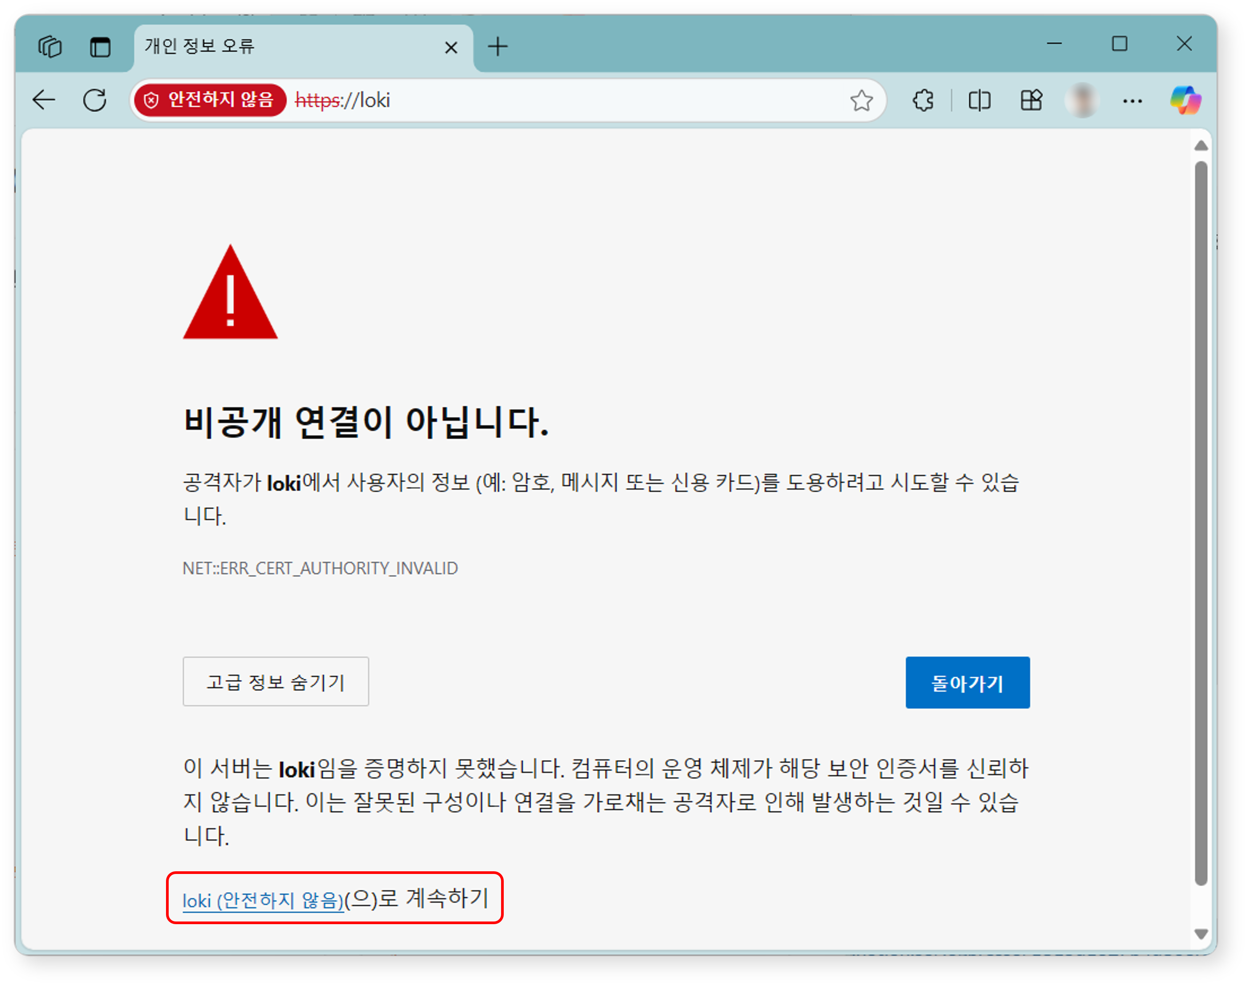
Registering the Cluster Administrator
Register the cluster administrator, who is the top-level administrator of Logpresso Sonar.
When the Register Cluster Administrator screen appears, enter the required information for the cluster administrator registration.
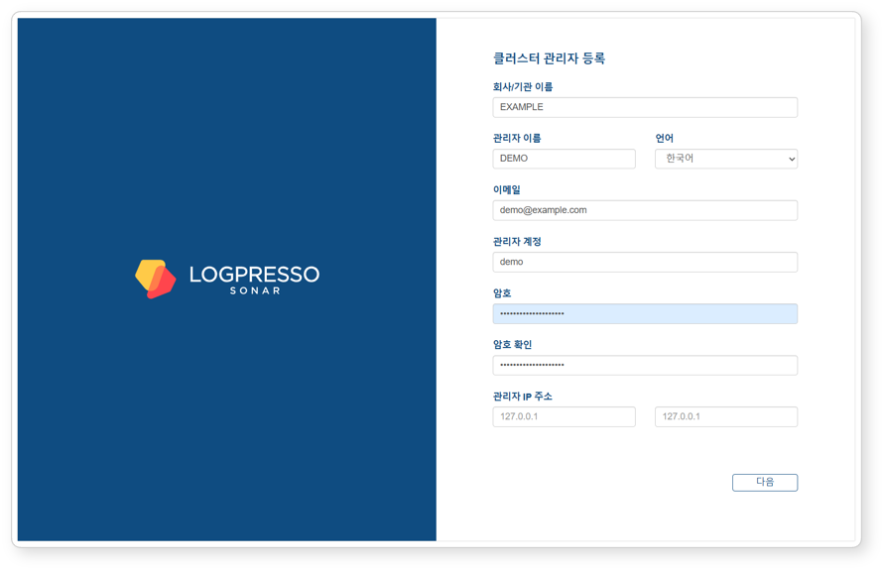
- Company/Organization Name: The name of the company or organization that will operate Logpresso Sonar
- Administrator Name: The name of the cluster administrator. When the cluster administrator logs in, the administrator name is displayed in the upper-right corner of the web console.
- Language: The language for the cluster administrator. Either Korean or English is automatically selected based on the language of the connected web browser.
- Email: The email address of the cluster administrator
- Administrator Account: The login name of the cluster administrator. Do not use well-known login names such as root, system, admin, administrator, logpresso, or sonar.
- Password/Confirm Password: The login password for the cluster administrator
- Administrator IP Address: Used to restrict cluster administrator access to specific IP addresses. You can specify up to 2 IP addresses.
Click the Next button to proceed to the next step.
Certificate and Web Server Address Settings
Replace the certificates and configure the web server address. The web server address is used when employees access the system to write or review justifications for security events.
When the System Settings screen appears, enter the required information for system settings.
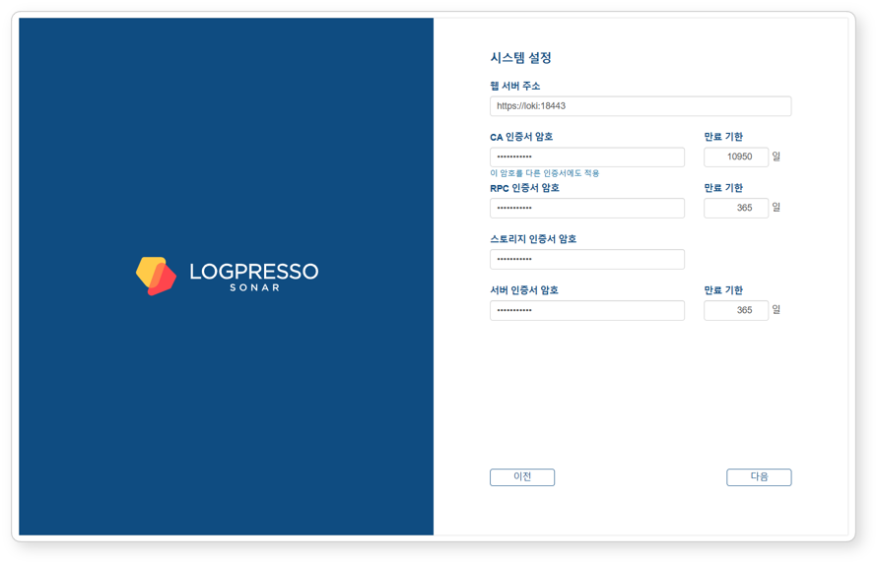
- Web Server Address: The web console address. Use the representative IP address or FQDN of the control node pair as follows:
- # Representative IP address of the control node: 192.0.2.24
# FQDN: sonar.example.com
https://192.0.2.24 or https://sonar.example.com
- CA Certificate Password: CA certificate password (default validity period/maximum: 10,950 days). After entering the password, click Apply this password to other certificates to apply the same password to all other certificates.
- RPC Certificate Password: Certificate password used for communication with sentries (default validity period/maximum: 365 days)
- Storage Certificate Password: Password for the certificate that stores the table encryption key. This certificate has no expiration date.
- Server Certificate Password: Password for the web server certificate used when accessing the Logpresso Sonar web console (default validity period/maximum: 365 days)
Click the Next button to proceed to the next step.
Also keep the following in mind:
- You can change the Web Server Address on the [Justification Template](/en/sonar/4.0/ui/section-push-template) screen in the web console.
- You can view certificate information, reissue certificates, and perform other tasks on the [Certificates](/en/sonar/4.0/ui/section-certificates) screen in the web console.
Calculate the expiration date for all certificates and set up reminders in Google Calendar or similar tools in advance. Reissue certificates before they expire.
After the server certificate is replaced, the web browser will reconnect to the web console. A security warning message may be displayed during the connection; ignore it and proceed.
Object Storage Settings
Configure the object storage to be used as Cold tier storage in the data lifecycle feature. If you do not use object storage or want to configure it later, click the Skip button.
Once object storage is configured, it cannot be changed from the web console. Review all operational environments thoroughly before configuring.
When the Object Storage Settings screen appears, enter the required information for object storage settings.
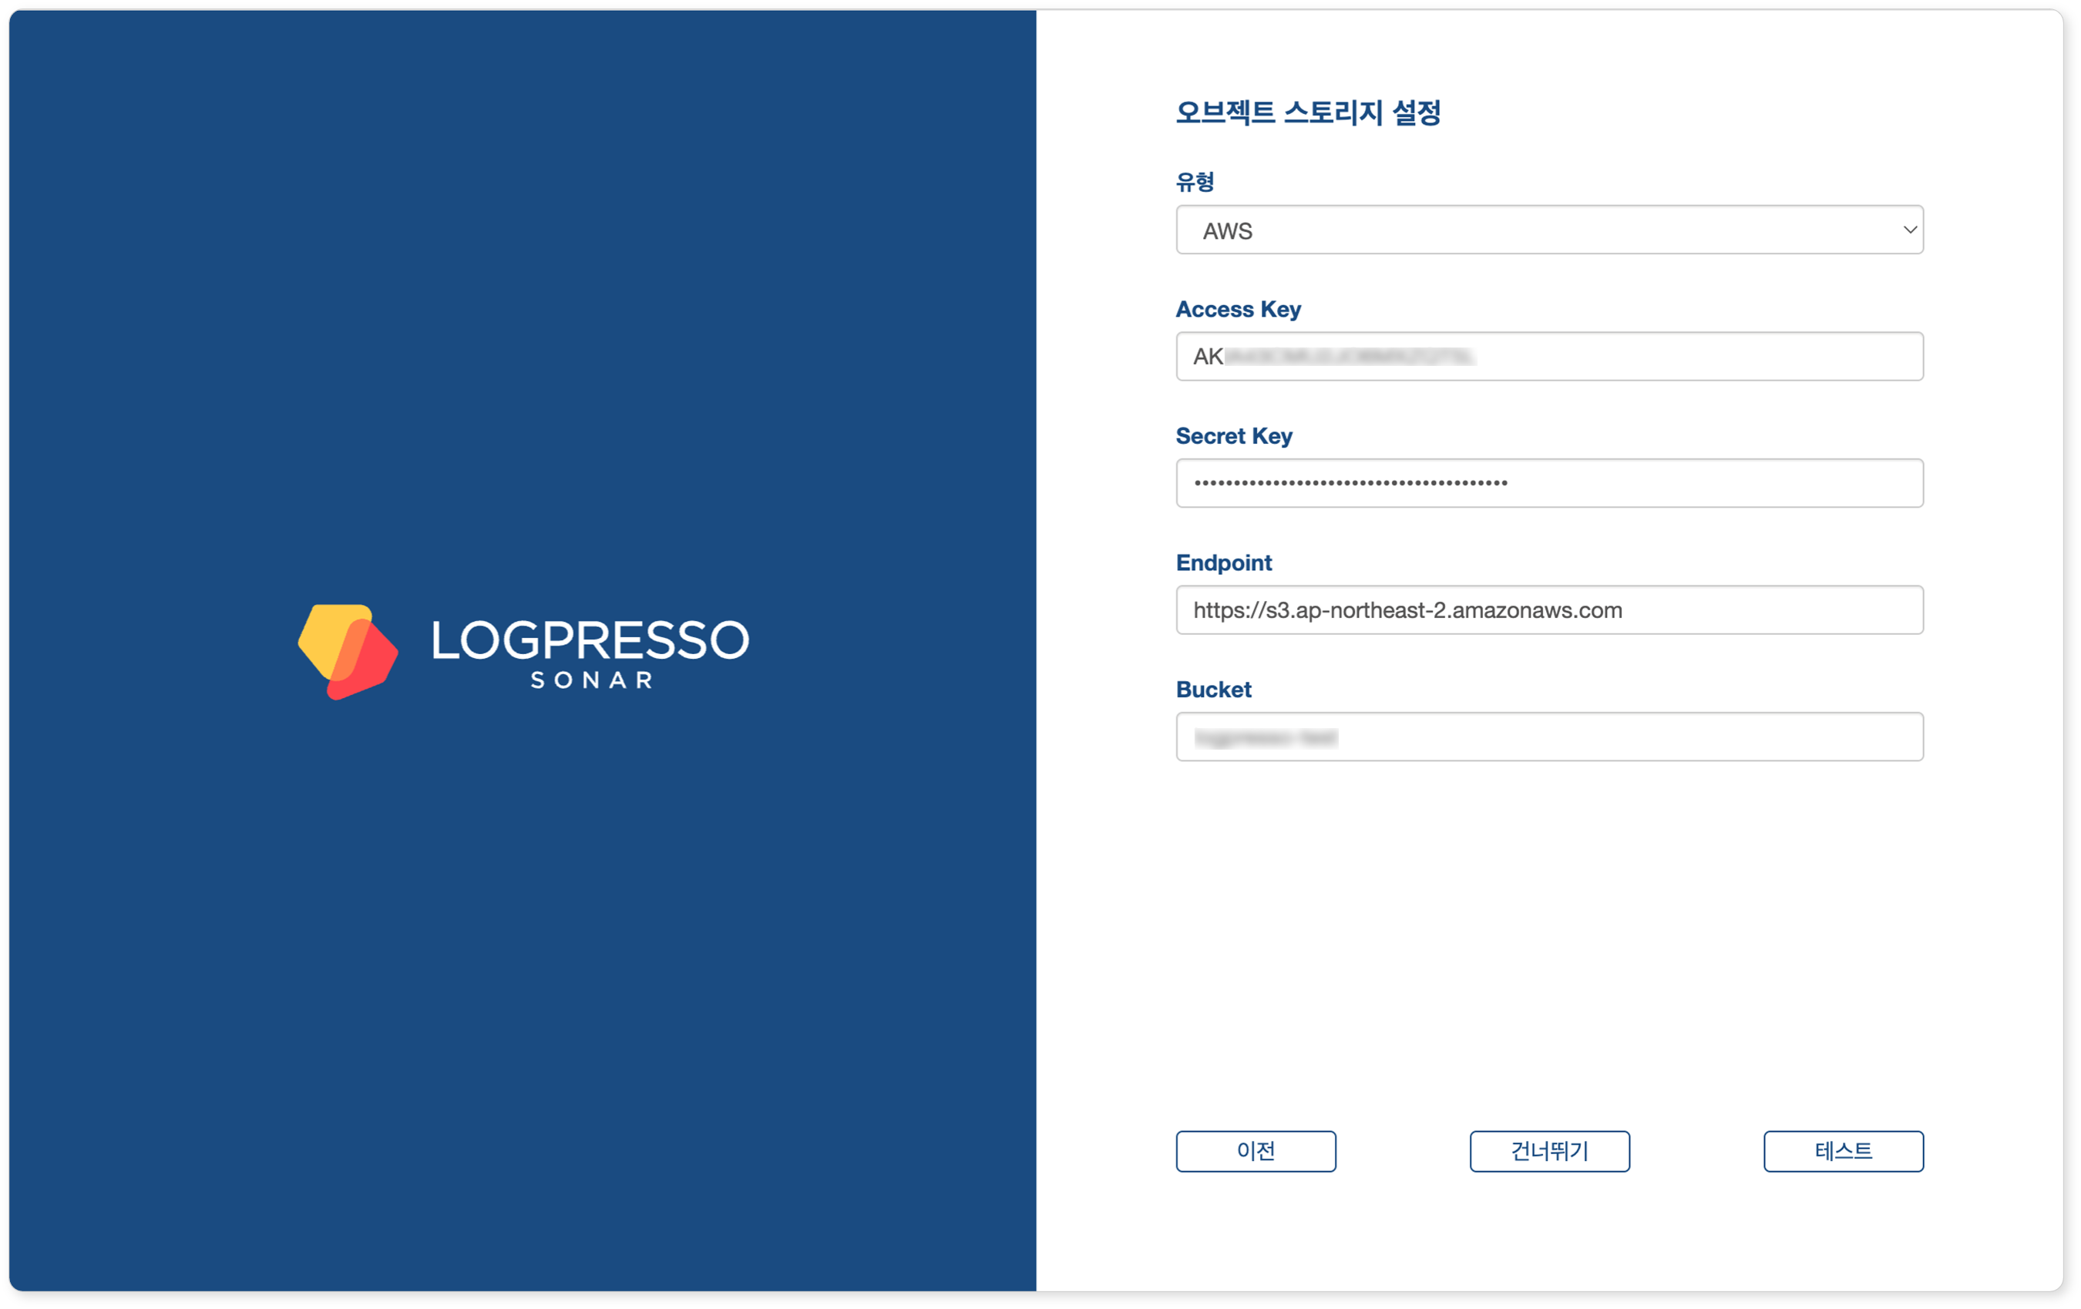
- Type: Storage service provider (select one of AWS, S3 Compatible Storage, or kakaocloud; default: AWS)
- Access Key or Authentication Key: Access key for connecting to the storage service
- Secret Key or Secret access Key: Secret access key for connecting to the storage service
- Endpoint: Storage service connection address
- Bucket: Name of the storage bucket
After entering all properties, click the Test button. You can proceed to the next step only after the test succeeds.
Also keep the following in mind:
- You can manage data according to its lifecycle by configuring the retention period for each storage tier on the Lifecycle tab and configuring rollover on the Storage tab in the Cluster screen of the web console.
Database Settings
Now connect the MariaDB database to Logpresso Sonar.
When the Database Settings screen appears, enter the database settings and click the Next button.
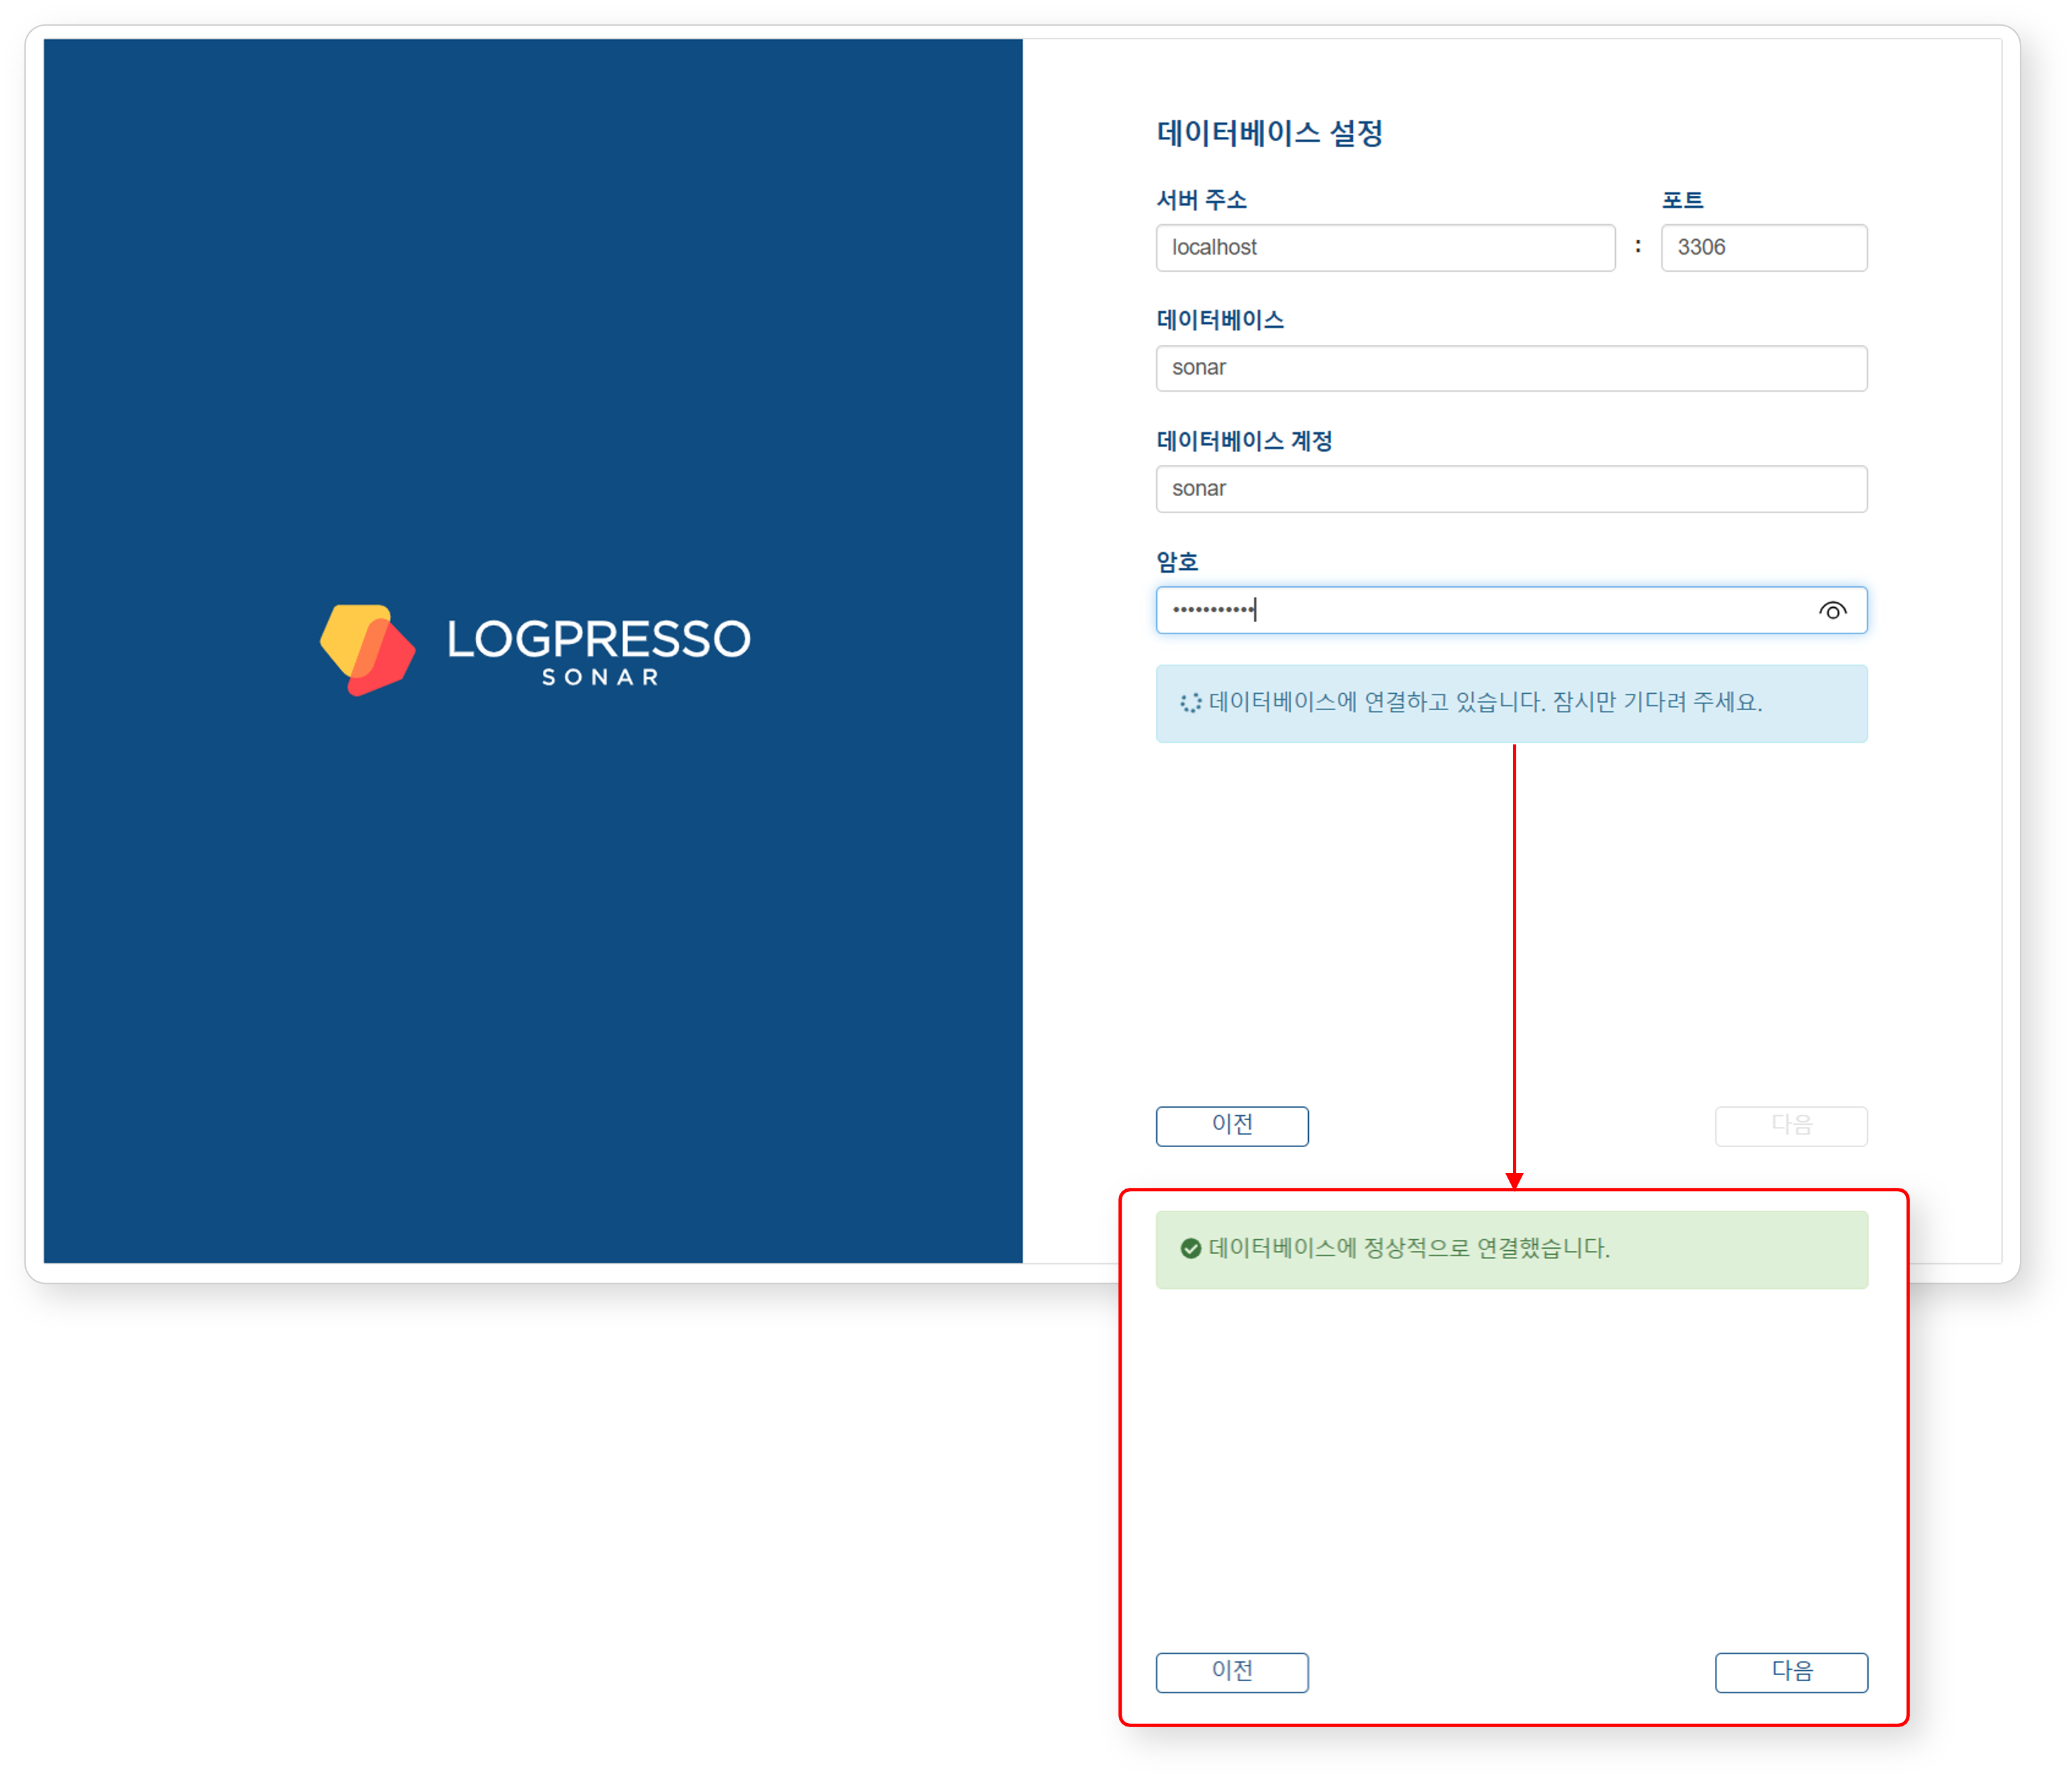
- Server Address: Address of the MariaDB server (default: localhost)
- Port: Port number of the MariaDB server (default: 3306)
- Database: Database name on the MariaDB server (default: sonar)
- Database Account: Dedicated database account for Logpresso Sonar (default: sonar)
- Password: Password for the dedicated Logpresso Sonar database account
Once all settings are entered, the system automatically attempts to connect to the database.
- If the connection succeeds, the message Successfully connected to the database. is displayed and the Next button is enabled.
- If the connection fails, an error message appears. Check the error details, correct the settings, and click the Retry button.
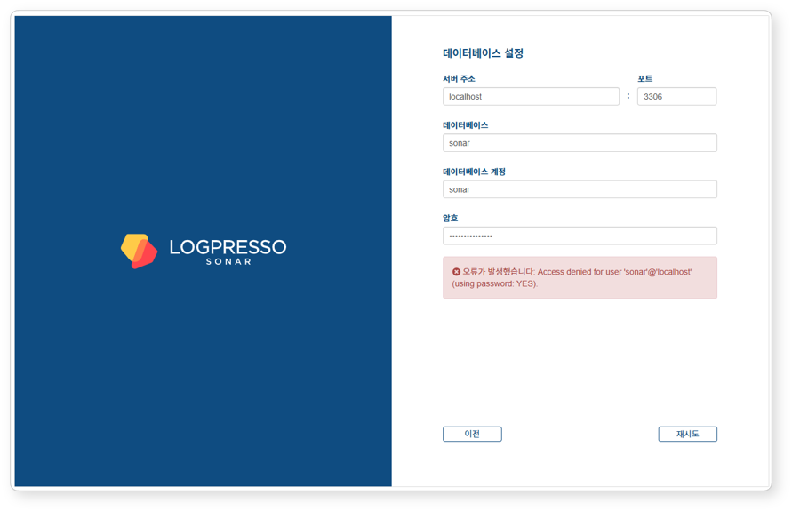
Once the database settings are complete, the configuration required to run Logpresso Sonar is applied automatically. All settings configured in the web installer are synchronized with Node B through the Galera Cluster.
After the settings are applied, the certificates are replaced and the web console reconnects to the login screen. Since self-signed certificates are used, the web browser may display a security warning. Ignore the warning and proceed.
Summary
After completing these steps, the following tasks have been performed on Node A:
- Created the database and tables in MariaDB and injected default data
- Synchronized the database layer with Node B via the Galera Cluster
- Configured the application layer settings
- Created the JDBC profile required for database connection
- Configured the authentication service required for the cluster administrator to access the web console
The basic setup for Node A is complete, but the application layer settings for Node B still need to be configured. This will be done in the next steps.
If you are operating in standalone mode without configuring a cluster, proceed to the License Registration step.

Federation Communication Account Setup
For federation communication between nodes, you must set passwords for the Logpresso shell account and the federation account on both Node A and Node B. This process is performed in the Logpresso shell. The Logpresso shell is the CLI for the Logpresso engine and uses accounts separate from the web console login accounts (e.g., cluster administrator).
Accessing the Logpresso Shell
You must access the Logpresso shell on control node A and B separately and change the default password. It is recommended to register SSH keys as a precaution against password loss.
Changing the Default Password
Run the following command in the terminal to access the Logpresso shell. The port number may differ depending on the SSH_PORT setting in the logpresso.conf file (default: 7022).
ssh -p 7022 root@localhost
When the password prompt appears, enter the default Logpresso shell password.
When the new password prompt appears, enter a new password and press Enter. Since the Logpresso shell account is only used for SSH access to each node, it is acceptable to set a different password for each node.
Please change the default password.
New password: # Enter new password and press Enter
Retype password: # Re-enter new password and press Enter
Password changed successfully.
Logpresso SNR-4.0.2511.1 (build 20250805) on Araqne Core 4.0.5
logpresso> # Logpresso shell prompt
The Logpresso shell rejects reuse of the default password. Never reuse the default password for any account. Logpresso is not responsible for any issues caused by using the default password.
Depending on the operating system, the SSH key exchange and encryption algorithm negotiation may fail when connecting to the Logpresso shell. Add the following content to the ~/.ssh/config file on control node A and B, and connect using the ssh sonar command.
Host sonar
HostName 127.0.0.1
Port 7022
User root
HostKeyAlgorithms +ssh-rsa
PubkeyAcceptedAlgorithms +ssh-rsa
KexAlgorithms +diffie-hellman-group14-sha1
Ciphers +aes256-cbc
PreferredAuthentications publickey # SSH key login
IdentityOnly yes # SSH key login
IdentityFile ~/.ssh/logpresso_rsa # SSH key login
Registering SSH Keys (Optional)
You can access the Logpresso shell using SSH key authentication. Registering SSH keys is recommended as it allows access even if the password is lost.
If you do not have an RSA key, run the following command to generate a key pair.
ssh-keygen -t rsa -b 2048 -f ~/.ssh/logpresso_rsa
The Logpresso shell only supports ssh-rsa keys.
Run the following command in the Logpresso shell to register the SSH public key.
account.addSshKey root
When the prompt appears, enter the SSH public key. The public key can be found in the ~/.ssh/logpresso_rsa.pub file.
SSH public key? ssh-rsa AAAAB3NzaC1yc2EAAAADAQABAAACAQ... # Enter the full public key
root password: # Enter the current password
added
You can also specify the absolute path to the public key file directly: account.addSshKey root /home/logpresso/.ssh/logpresso_rsa.pub
Run the following command to verify the registered SSH key list.
account.sshKeys root
Running the command displays the registered SSH keys as follows:
Authorized SSH keys
---------------------
1: ssh-rsa AAAAB3NzaC1yc2EAAAADAQABAAACAQ...
You can now access the Logpresso shell using the SSH key without a password.
ssh -p 7022 -i ~/.ssh/logpresso_rsa root@localhost
Setting the Federation Account Password
The federation account is used for communication between all nodes in the cluster. All control/data/forwarder nodes must use the same federation account password. The federation account password set in this step is used not only for control node pair registration, but also for data node pairs and forwarder node pairs.
Run the following command in the Logpresso shell on both Node A and Node B to change the federation account password.
dom.resetPassword localhost root
When the new password prompt appears, enter a new password and press Enter.
New Password: # Enter new password and press Enter
- You can only enter the password once. If you enter the password incorrectly, re-run the dom.resetPassword localhost root command.
The federation account root and the Logpresso shell account root belong to different authentication domains even though they share the same name. During the federation password change process, ERROR logs may be temporarily recorded in araqne.log, but this resolves after the change is complete.
Refer to this document to change the password expiration of the federation account to unlimited.
Open a web browser and navigate to https://<Control Node A IP Address>:8443, then log in with the federation account.
Navigate to System > Accounts in the left menu of the web console.
Click root in the federation account list.
Select Unlimited in the Password Expiration field and click the Save button.
Perform the same operation on Node B.

Node B Initial Setup
On Node A, the web installer automatically configures the authentication service and database connection. On Node B, these settings must be configured manually. Since Node A and B share the same MariaDB, completing this setup allows the cluster administrator to log in to the Node B web console with the same account.
sonar Authentication Service Setup
The sonar authentication service is used for web console user authentication. This setup must be completed before the cluster administrator can log in to the Node B web console.
Run the following command in the Logpresso shell on Node B to enable the sonar authentication service.
logdb.useAuthService sonar dom
Run the following command to verify that the sonar authentication service is enabled.
logdb.authServices
In the External Auth Services list, if both dom and sonar have an asterisk (*) and the order is sonar - dom, the configuration is correct.
External Auth Services
------------------------
[*] dom - araqne-dom authentication provider for araqne logdb
[*] sonar - com.logpresso.sonar.dom.impl.SonarAuthServiceImpl@5d7b80f7
order: sonar - dom
Creating the JDBC Profile
A JDBC profile must be created for Logpresso Sonar on Node B to connect to MariaDB.
Run the following command to create the JDBC profile.
logpresso.createConnectProfile jdbc sonar
When the profile creation prompts appear, enter the values as follows:
Connection String (required)? jdbc:mariadb://localhost:3306/sonar # Database connection string
User (optional)? sonar # Database account created by the web installer on Node A (default: sonar)
Password (optional)? # Password for the database account created by the web installer on Node A
Read Only (optional)? false # Must enter false
Granted users (csv)? # Press Enter to skip
Granted groups (csv)? # Press Enter to skip
Run the following command to check the GUID of the created JDBC profile.
logpresso> logpresso.connectProfiles
Connect Profiles
------------------
guid=59f4788b-75df-4297-afbd-579eed9cb086, type=jdbc, name=sonar, description=null, source=ENT
Run the following command with the confirmed GUID to verify that the profile was created correctly.
logpresso> logpresso.connectProfile 59f4788b-75df-4297-afbd-579eed9cb086
Connect Profile
-----------------
Type: jdbc
Name: sonar
Description: null
Configs
* Connection String: jdbc:mariadb://localhost:3306/sonar
* User: sonar
* Password: ********
* Read Only: false
Restarting the Logpresso Service
The Logpresso service must be restarted to apply the profile settings.
Run the following command on Node B to restart the Logpresso service.
sudo systemctl restart logpresso
Run the following command to verify that the service is running properly.
sudo systemctl status logpresso
If the status shows Active: active (running), the service is running normally.
logpresso.service - Logpresso daemon
Loaded: loaded (/usr/lib/systemd/system/logpresso.service; enabled; preset: disabled)
Active: active (running) since Sat 2025-12-13 10:56:58 KST; 6 days ago
Docs: https://ko.logpresso.com/documents
Main PID: 1682 (java)
Tasks: 229 (limit: 23116)
Memory: 4.1G
CPU: 4d 40min 56.229s
CGroup: /system.slice/logpresso.service
└─1682 /opt/logpresso/jre/bin/java ...(omitted)... -jar /opt/logpresso/sonar/araqne-core-4.0.5-package.jar

Web Console Login
Log in to the web console on both Node A and Node B. Log in with the cluster administrator account.
Verify that the login screen is displayed after running the web installer on Node A. If you closed the web browser window, navigate to https://IP_ADDR or https://FQDN (e.g., https://203.0.113.194, https://c1a.example.com).
Access the web console on Node B using the same method.
When you access the web console, a notification blocking message may appear in the lower-right corner of the screen.
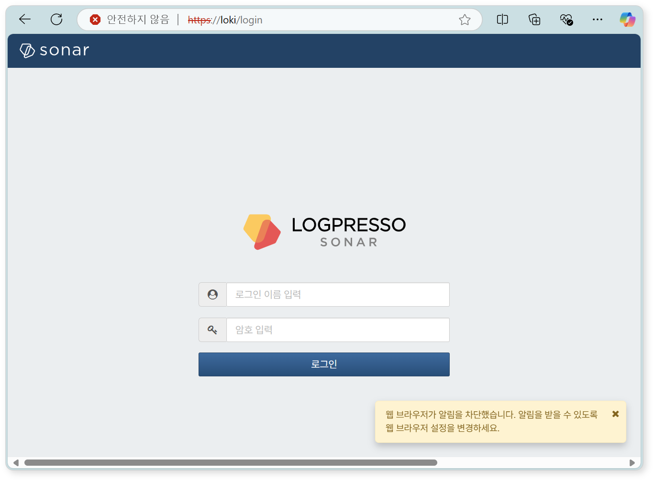
Change the notification settings in the web browser to Allow so that server notifications can be viewed in the web console.
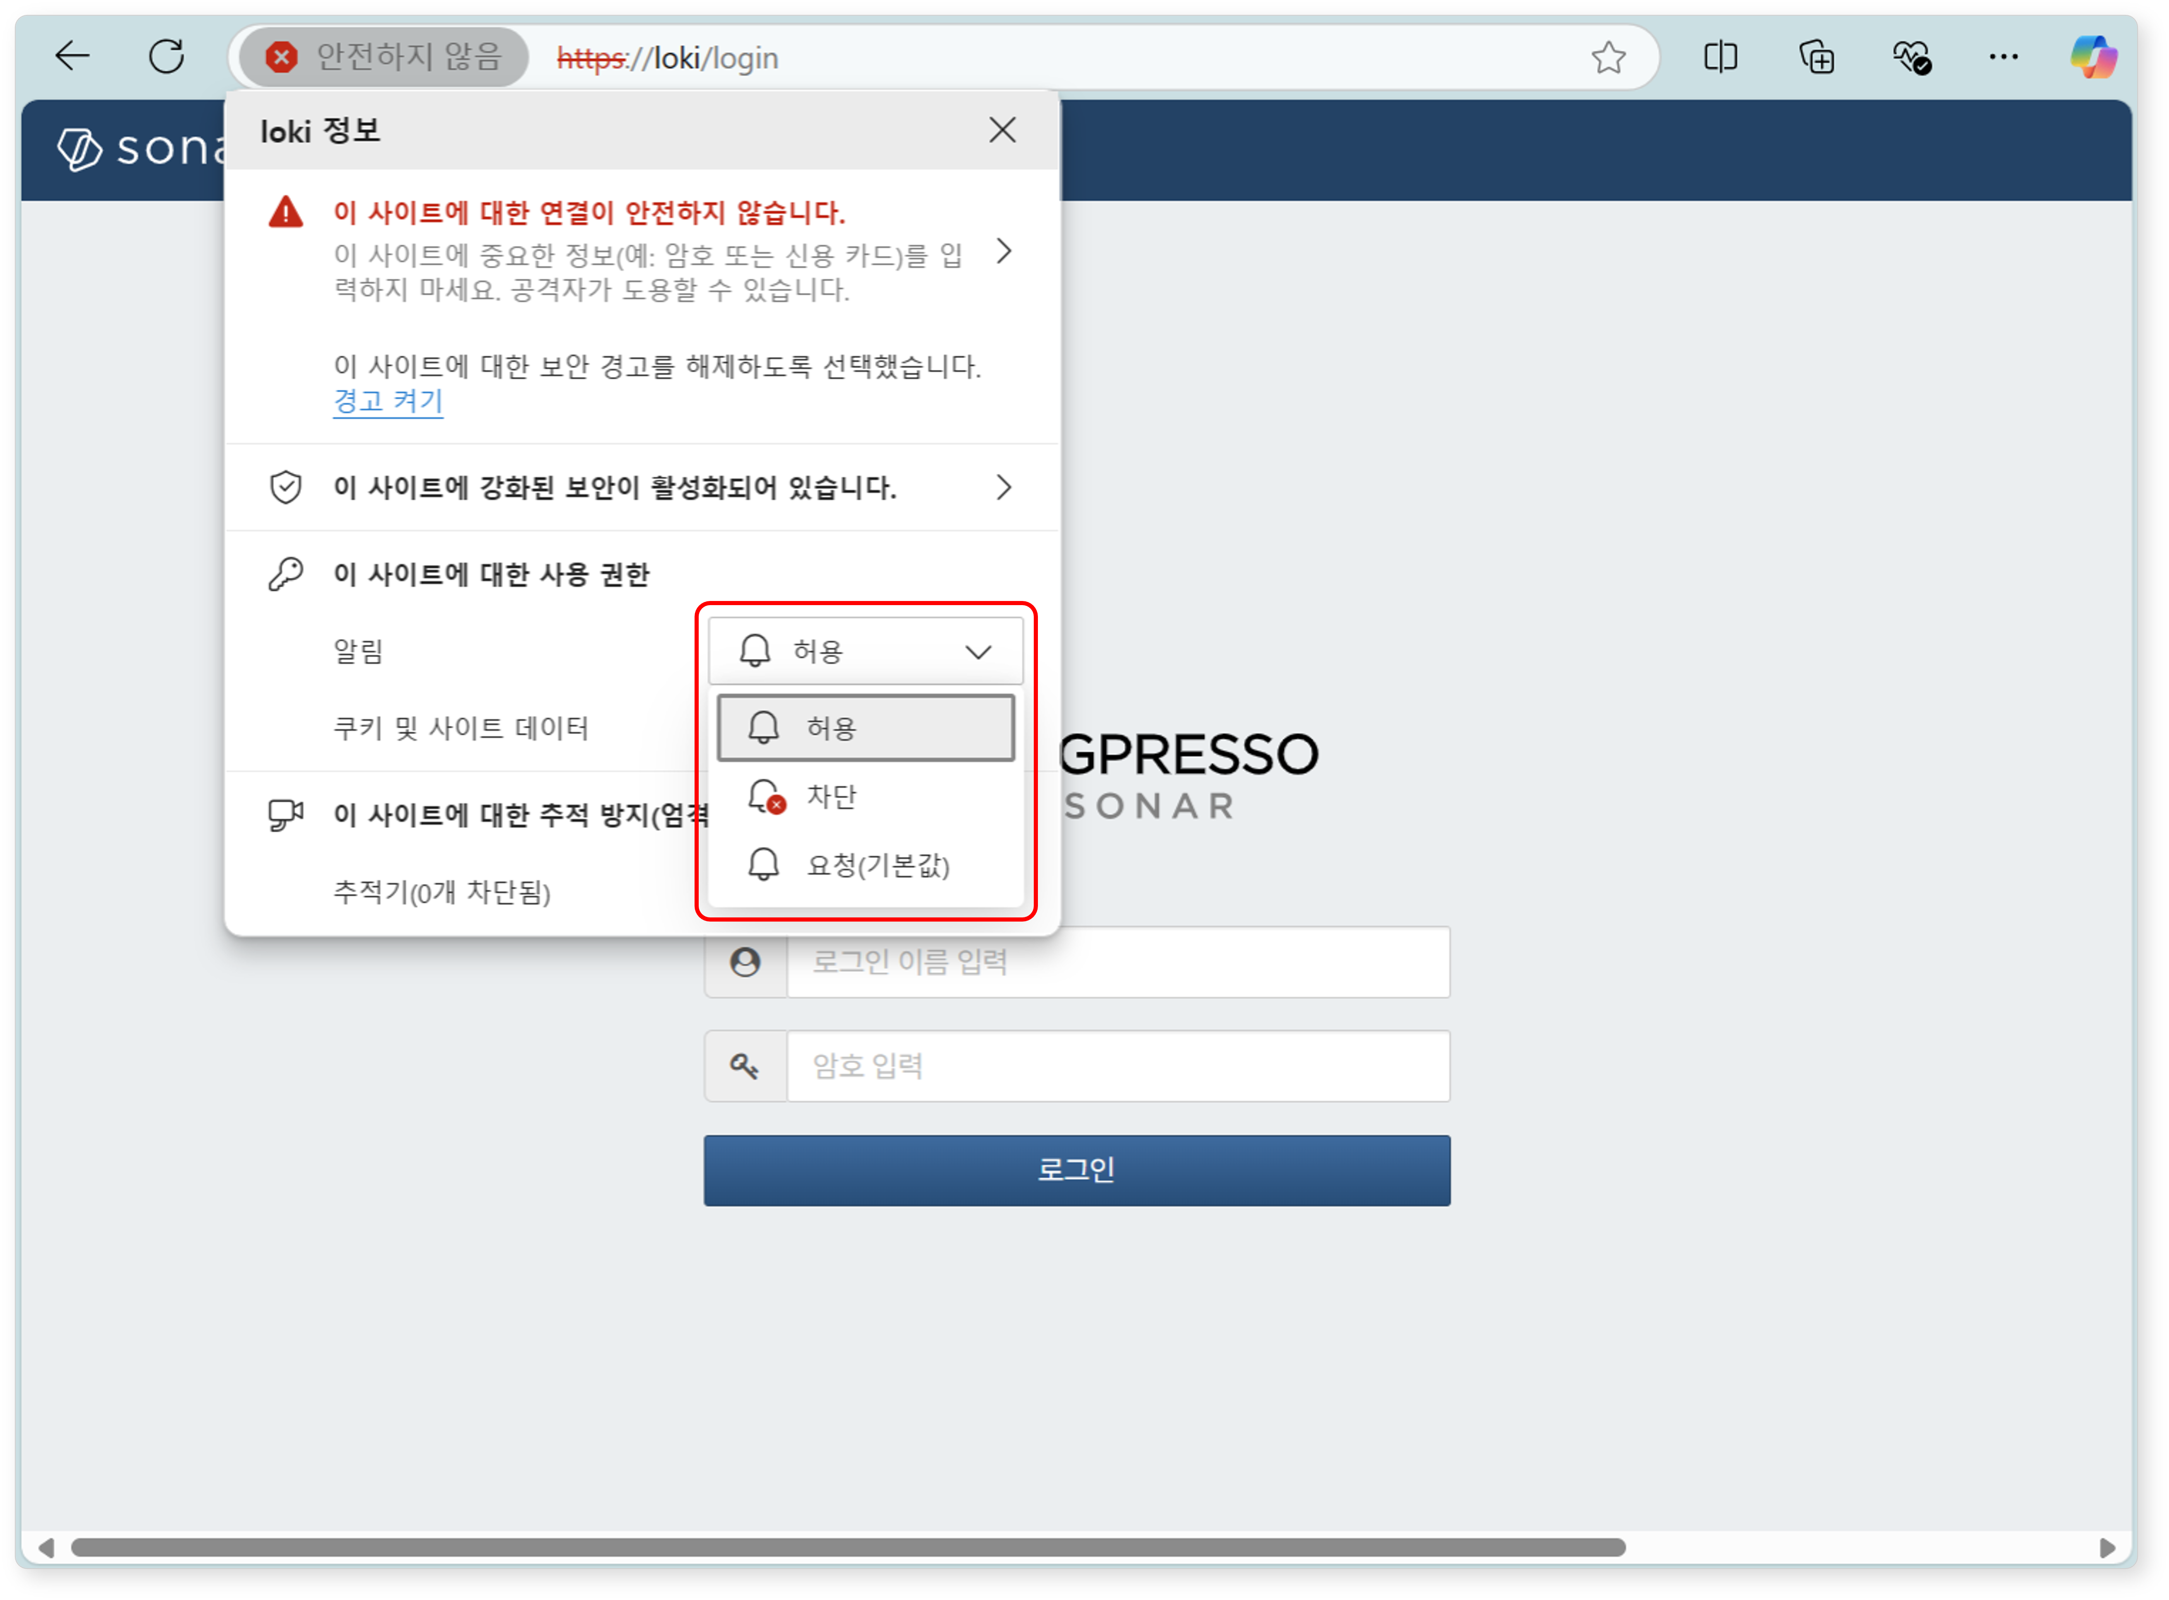
Enter the cluster administrator's login name and password, then click the Login button.
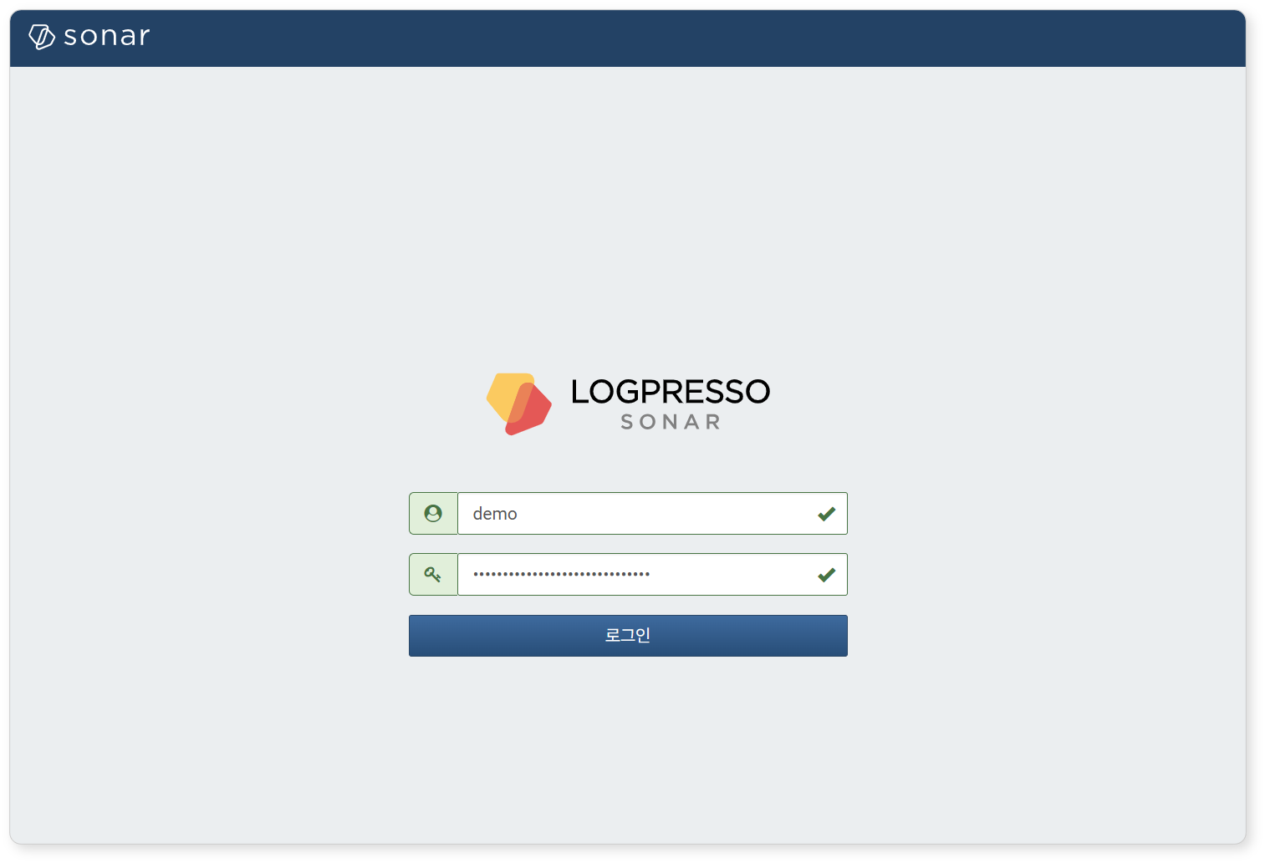
If you fail to log in multiple times, the account will be locked for a certain period. Contact the server administrator if you need to unlock the account or change the password.

License Registration
After logging in, the first thing to do is register the license.
Requesting a License
Check the Hardware Key on the System > License screen of the web console on both Node A and Node B, and record it in a safe place.
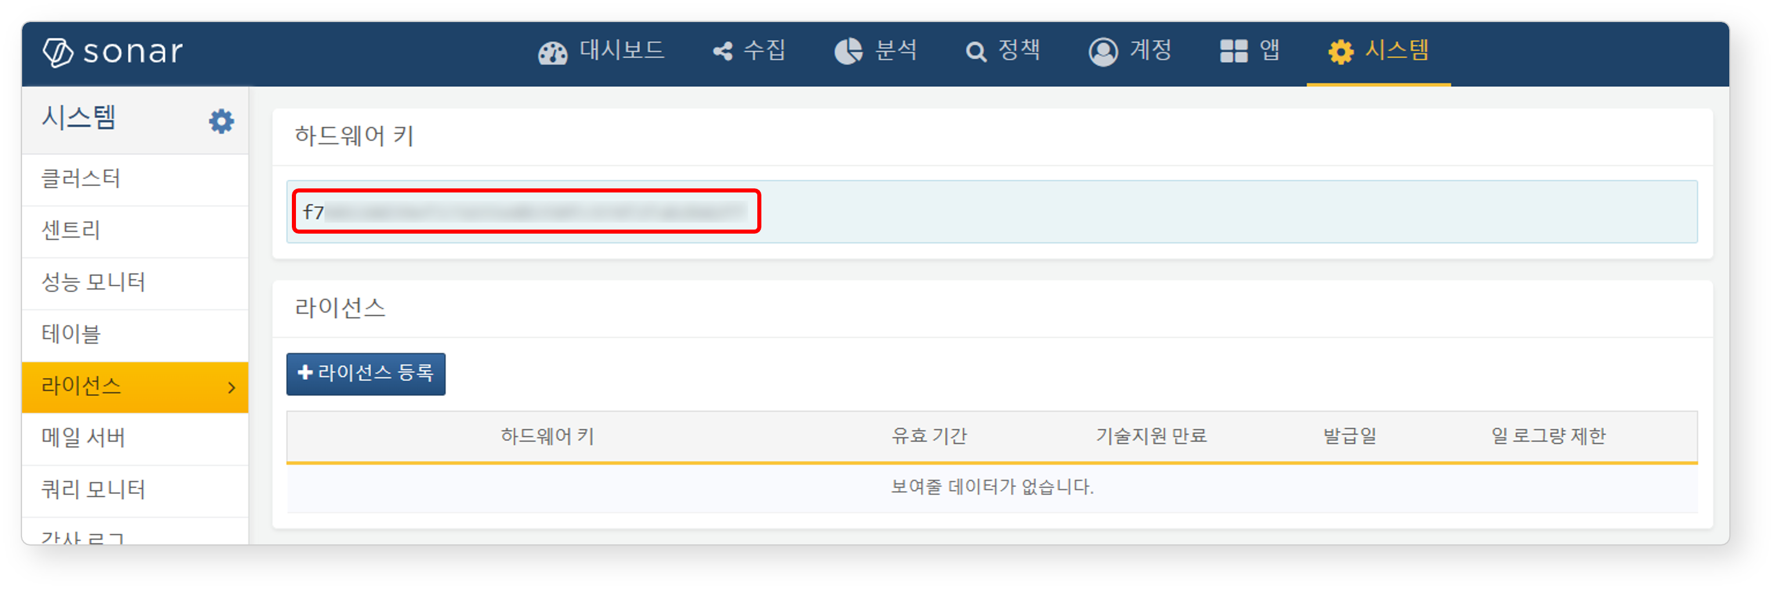
Request license issuance for the hardware keys of Node A and Node B on the Logpresso Support Portal.
Subsequent tasks must be performed after the license has been issued.
Entering the License
Click the Register License button on the System > License screen of the web console on both Node A and Node B.
Paste the issued license information into the input field and click the OK button.
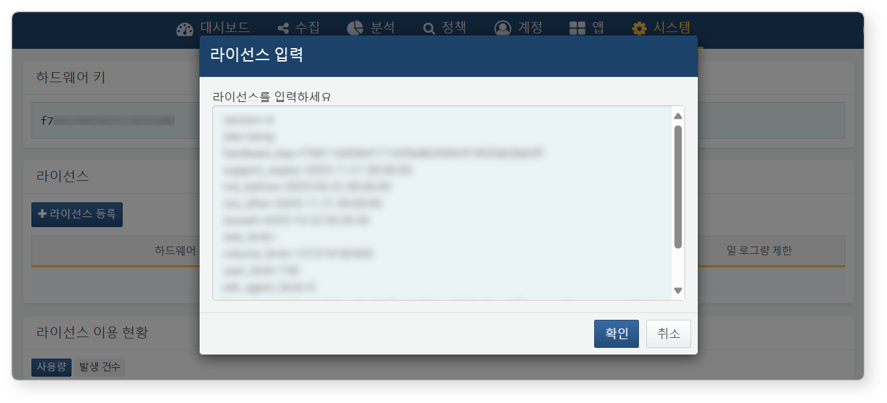
Verify that the license has been registered successfully.
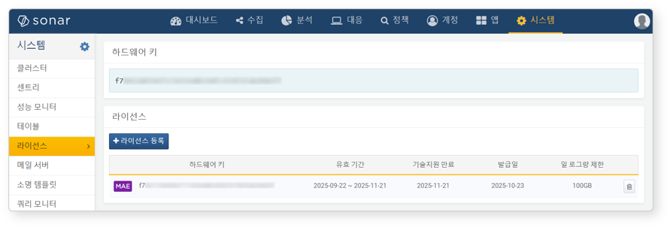

Control Node Pair Setup
Registering the Control Node Pair
Register the node pair on the System > Cluster > Nodes screen of the Node A web console. The instructions here describe the process of deleting the existing node pair and reconfiguring it.
The default node pair name is 'control' and cannot be changed. To change the name, you must delete the default node pair and register a new one.
Navigate to the System > Cluster menu in the Node A web console.
Select the existing control node and click the Delete button.
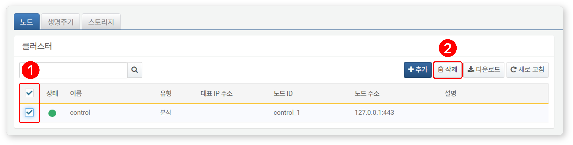
Click the Add button in the upper-right corner of the cluster node list and configure the control node pair. For detailed descriptions of each property, refer to Adding a Node Pair in the user guide.
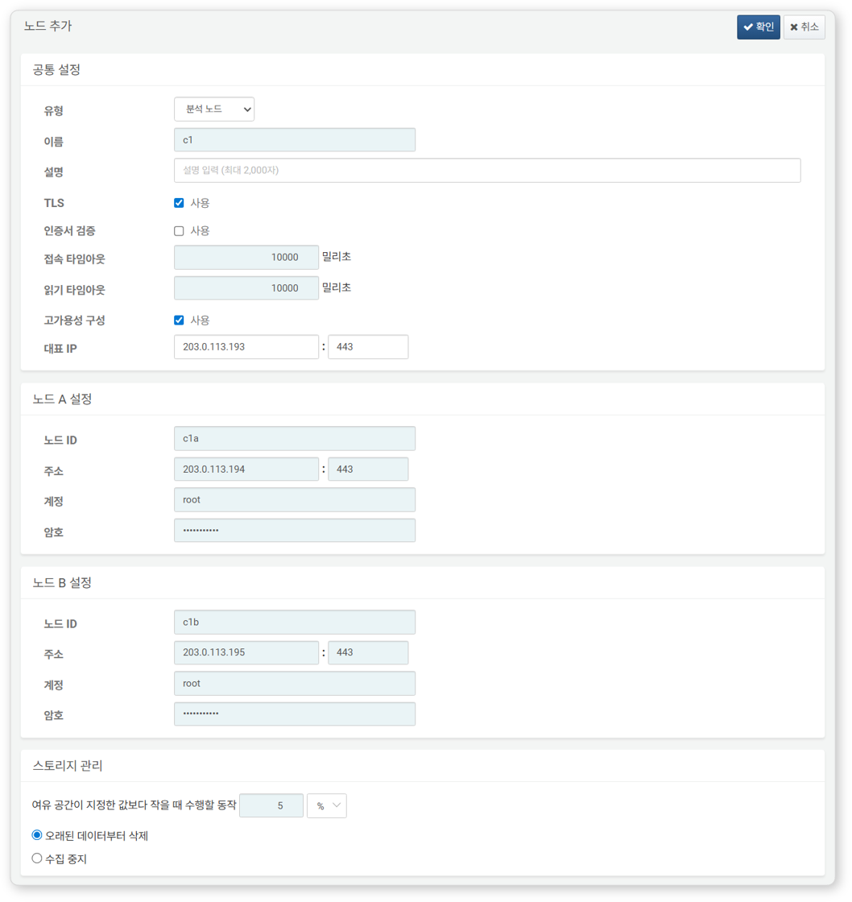
- Type: Select Control Node
- Name: Enter the control node pair identifier (e.g., d1)
- This cannot be changed after clicking the OK button.
- Description: Description of the node pair (optional)
- TLS: Enabled
- Certificate Verification: Disabled
- Connection Timeout: Use default value
- Read Timeout: Use default value
- High Availability Configuration: Enabled
- Representative IP: IP address of the control node pair (e.g., 203.0.113.193)
- This IP address is used as the VIP in the HA script.
- Node A Settings
- Node ID: Enter the Node A identifier (e.g., c1a)
- Address: Actual IP address and communication port of Node A (e.g., 203.0.113.194:443)
- The port number for the control node is 443.
- Account: Enter root
- Password: Enter the Sonar federation account password
- Node B Settings
- Node ID: Node B identifier (e.g., c1b)
- Address: Actual IP address and communication port of Node B (e.g., 203.0.113.195:443)
- Account: Enter root
- Password: Enter the Sonar federation account password
After completing the input, click the OK button. Verify that the control node pair has been added as shown below.
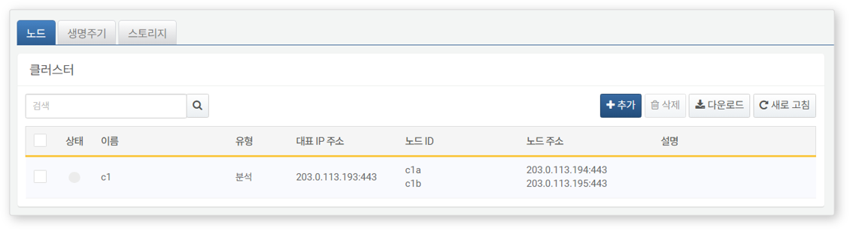
Click the Name of the added control node and check the GUIDs of Node A and Node B. If the Name or Node ID was specified incorrectly, you must delete the node pair and reconfigure it.
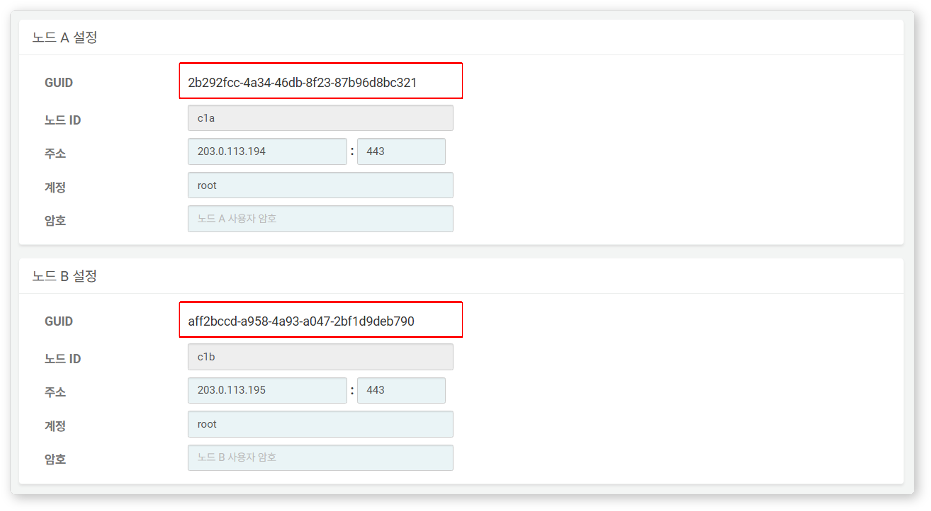
Record the GUIDs of Node A and Node B in a safe place. These values will be used in Node GUID Configuration.
Replicating the Key Encryption Key
Set the Key Encryption Key (KEK) from Node A identically on Node B. The key encryption key does not allow inter-node replication, so the administrator must copy it manually.
Do not change the key encryption key after completing this setup. All nodes in the cluster must use the same key encryption key. If different keys are used, encrypted data cannot be decrypted, making inter-node synchronization impossible.
Run the following command in the Logpresso shell on Node A and record the encryption key string in a safe place.
sonar.cipherKey
Copy the encryption key string from Node A, then run the following command in the Logpresso shell on Node B to configure the same encryption key. KEY_STRING is the encryption key string from Node A.
sonar.setCipherKey KEY_STRING
Node GUID Configuration
Set the changed GUID of Node A and the newly created GUID of Node B from the Control Node Pair Registration step identically in the Logpresso shell.
Run the following command in the Logpresso shell on both Node A and Node B to set the policy synchronization GUID for each node in the Logpresso engine. GUID_STRING is the GUID string of each node.
sonar.setGuid GUID_STRING # Enter the GUID corresponding to each node
You can check the policy synchronization GUID of each node with the following command:
sonar.nodeConfig
Run the following command in the Logpresso shell on both Node A and Node B to set the cluster control GUID in the Logpresso engine.
sonar.setControlGuid GUID_STRING # Enter the GUID corresponding to each node
You can check the cluster control GUID of each node with the following command:
sonar.controlNodeGuid
In each of steps 1 and 2, Node A must be set with Node A's GUID, and Node B must be set with Node B's GUID.
Master Node Connection Settings
Configure the master node connection information for synchronizing policies and settings within the cluster. For the control node, specify itself (127.0.0.1) as the master to load policies from MariaDB.
This setting is separate from the node pair registration information configured earlier in the web console. The node pair information is used when other nodes connect to this node. The master node connection information configured here is used when this node connects to the master and is stored in the Logpresso engine's confdb. Since the control node is its own master, 127.0.0.1 is specified.
Run the following command in the Logpresso shell on both Node A and Node B.
sonar.setMaster
The following describes the prompts displayed after running the command and the values to enter. The account used here is the federation account.
host? 127.0.0.1 # Specify itself as master
port? 443 # Enter 443
account? root # Enter root, the federation account
password? # Enter the federation account password
connect timeout? 10000 # Press Enter to use the default value
read timeout? 10000 # Press Enter to use the default value
secure? true # Enter true (default is false)
skip cert check? true # Enter true (default is false)
Option | Description | Example
host | Control node address | 127.0.0.1
port | Port for communication with the control node | 443
account | Federation account login name | root
password | Federation account password
connect timeout | Server connection wait time | 10000 (ms)
read timeout | Response wait time | 10000 (ms)
secure | Whether to apply TLS communication | true
skip cert check | Whether to skip TLS certificate validation | true
Run the following command to verify that the node settings have been applied.
sonar.nodeConfig
The following is an example of the output when the settings have been configured correctly.
guid: 7bdb297d-1d2a-400b-8efc-ce8d98580a13
host=127.0.0.1, port=443, account=root, connectTimeout=10000, readTimeout=10000, secure=true, skipCertCheck=true
crypto_file_path: /opt/logpresso/data/logpresso-ca/certs/storage.pfx
On the System > Cluster screen of the Node A web console, verify that the Status is displayed in green.
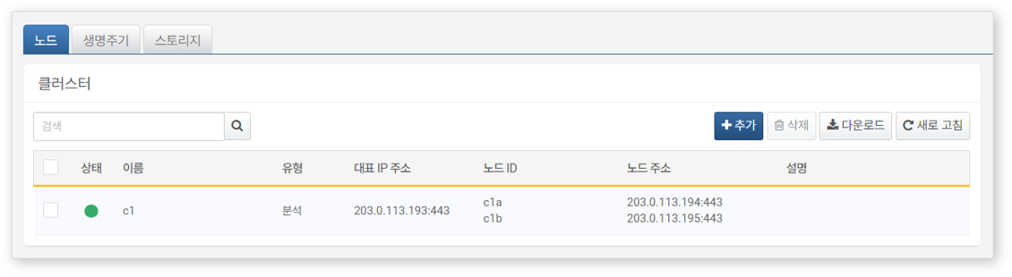
Data Replication Mode Configuration
When a node pair is configured, table data can be replicated between the two nodes. Here, "table" refers to the file-based tables where the Logpresso engine stores data, not database tables.
If identical data exists on both nodes, duplicate results may occur during distributed query execution. To prevent this, each node must be assigned a data replication mode of either ACTIVE or STANDBY.
- Active Node: Stores the original log table data and is included in distributed query searches.
- Standby Node: Receives real-time replication of log table data from the active node. Replicated tables use the same table ID as the originals and are excluded from distributed query searches, preventing duplicate results.
The logpresso.setStandbyNode command designates the peer node as standby, making the current node active.
The logpresso.setActiveNode command designates the peer node as active, making the current node standby.
Node A Configuration (Active)
Run the following command in the Logpresso shell on Node A to check the name of the pair node (Node B).
logpresso.nodeStatuses
The following is an example of the output. In the Federation Nodes section, [c1b] is the name of Node B.
Local
------------------
Node GUID: ffdade37-6d96-4d13-9843-88569d64db6a
Instance GUID: 93e9d502-276f-468a-9311-019e1fed8a79
Federation Nodes
------------------
[c1b] node_guid=92eab23d-83e1-4ba2-91d6-48f5408b12a6, instance_guid=1a2eb7aa-85e2-4d73-a23e-9d8d1421605e, repl_mode=null, pair_guid=null, invalid_guid=false, alive=true, paired=true, failure=false, last connect=2025-06-09 13:51:39, last alive=2025-06-10 11:18:44, created=2025-06-09 13:48:37
The Node GUID and Instance GUID displayed in the logpresso.nodeStatuses command output are identifiers used by the Logpresso engine for log table replication and distributed queries. The Node GUID is used for database identification and is permanently stored in the DB_GUID file. The Instance GUID is the identifier for the currently running process and changes each time the node process starts.
Run the following command to designate Node B as the standby node, which makes Node A the active node. In the command example, c1b is the name of Node B confirmed above.
logpresso.setStandbyNode c1b
Running the logpresso.nodeStatuses command again shows that the Replication Mode in the Local section has been set to ACTIVE.
Local
------------------
Node GUID: ffdade37-6d96-4d13-9843-88569d64db6a
Instance GUID: 93e9d502-276f-468a-9311-019e1fed8a79
Replication Mode: ACTIVE
Pair Node: c1b
Federation Nodes
------------------
[c1b] node_guid=92eab23d-83e1-4ba2-91d6-48f5408b12a6, instance_guid=1a2eb7aa-85e2-4d73-a23e-9d8d1421605e, repl_mode=null, pair_guid=null, invalid_guid=false, alive=true, paired=true, failure=false, last connect=2025-06-09 16:56:24, last alive=2025-03-27 13:35:12, created=2025-06-09 16:56:24
Node B Configuration (Standby)
Run the following command in the Logpresso shell on Node B to designate Node A as active, which makes Node B the standby node. c1a is the name of Node A confirmed from the logpresso.nodeStatuses command output.
logpresso.setActiveNode c1a
Running the logpresso.nodeStatuses command shows that the Replication Mode in the Local section has been set to STANDBY.
Local
------------------
Node GUID: ef5a8e0d-e80d-4b93-80a2-c8fec4b764ad
Instance GUID: c1fb7d52-229b-464b-be06-4f7784001c17
Replication Mode: STANDBY
Pair Node: c1a
Federation Nodes
------------------
[c1a] node_guid=ffdade37-6d96-4d13-9843-88569d64db6a, instance_guid=93e9d502-276f-468a-9311-019e1fed8a79, repl_mode=ACTIVE, pair_guid=ef5a8e0d-e80d-4b93-80a2-c8fec4b764ad, invalid_guid=false, alive=true, paired=true, failure=false, last connect=2025-06-09 16:56:58, last alive=2025-03-27 13:37:34, created=2025-06-09 15:54:59
License Sharing Between Nodes
Configure all nodes in the cluster to be governed by the same license. The license registered on the control node is also applied to data nodes and forwarder nodes. This section describes how to propagate the license registered on the control node to other nodes.
Run the following command in the Logpresso shell on both Node A and Node B to set the license master. Both nodes must be set as license masters.
logpresso.setLicenseMode master
Run the following command to check the license master status.
logpresso.licenseMode
If configured correctly, the output is as follows:
MASTER
Enabling Distributed Queries
Distributed Query is a feature that allows querying table data distributed across multiple nodes with a single query. When a query is executed on the control node, the control node distributes the necessary queries to data node pairs, where the queries are executed. The control node aggregates the results from each data node and returns the final result. Distributed query settings must be enabled on all nodes.
Run the following command in the Logpresso shell on both Node A and Node B to enable distributed queries.
logpresso.enablePlanner
Run the following command to check the distributed query status.
logpresso.plannerStatus
If enabled correctly, the output is as follows:
Running: true
WebSocket Frame Configuration
If distributed query results are large or there is a large amount of data to send to the web browser, transmission may fail with the default WebSocket frame size.
Changing the WebSocket frame size is optional when operating the control node as a combined control/data node, but it is required when configuring a control node pair.
Run the following command in the Logpresso shell on both Node A and Node B to check the current setting.
webconsole.maxFrameSize
The default value is 8MB, and the command output is as follows:
8,388,608 bytes
Run the following command to change the frame size. The value in the example is 84MB.
webconsole.setMaxFrameSize 83886080
Run the webconsole.maxFrameSize command again to verify the changed value.
83,886,080 bytes
Query Cache Configuration
To optimize query performance, table metadata, inverted indexes, and bloom filters are cached in memory. The role of each cache is as follows:
- Table Cache: Caches log data read from disk during queries, allowing the same data to be returned directly from memory without disk I/O on subsequent queries.
- Inverted Index Cache: Caches the list of document IDs containing specific search terms for full-text search.
- Bloom Filter 0/1 Cache: A bloom filter is a probabilistic data structure that quickly determines whether a specific search term exists in a given segment. Bloom filter 0 is used for fast determination, and bloom filter 1 is used for precise determination.
When a search query is executed, caches are consulted in the following order: bloom filter 0, bloom filter 1, inverted index cache, and table cache. If the desired data is not found in the caches, it is retrieved from disk.
Run the following commands in the Logpresso shell on both Node A and Node B to set the cache sizes.
logpresso.tableCacheConfig max_weight CACHE_SIZE # Table cache
logpresso.indexCacheConfig inverted max_weight CACHE_SIZE # Inverted index cache
logpresso.indexCacheConfig bloomfilter0 max_weight CACHE_SIZE # Bloom filter 0 cache
logpresso.indexCacheConfig bloomfilter1 max_weight CACHE_SIZE # Bloom filter 1 cache
Enter the CACHE_SIZE values from the following table based on daily processing volume and memory capacity. The input unit for cache values is bytes.
Daily Volume | RAM | HEAP | DIRECT | max_weight | inverted | bloomfilter0 | bloomfilter1
10GB/day | 32GB | 8GB | 9GB | 643,825,664 | 6,442,450,944 | 1,073,741,824 | 213,909,504
50GB/day | 64GB | 16GB | 26GB | 1,073,741,824 | 19,327,352,832 | 4,294,967,296 | 613,416,960
100GB/day+ | 128GB | 34GB | 68GB | 3,221,225,472 | 46,170,898,432 | 10,737,418,240 | 1,073,741,824
- max_weight: Table cache
- inverted: Inverted index cache
- bloomfilter0: Bloom filter 0 cache
- bloomfilter1: Bloom filter 1 cache
- Do not use commas (,) when entering values. Commas are shown in the table only for readability.
The cache values converted to GB are as follows:
Daily Volume | RAM | HEAP | DIRECT | max_weight | inverted | bloomfilter0 | bloomfilter1
10GB/day | 32GB | 8GB | 9GB | 614MB | 6GB | 1GB | 204MB
50GB/day | 64GB | 16GB | 26GB | 1GB | 18GB | 4GB | 585MB
100GB/day+ | 128GB | 34GB | 68GB | 3GB | 43GB | 10GB | 1GB
Service Restart
The Logpresso service must be restarted to apply the changed settings. The order of operations is as follows:
Stop order: Standby -> Active
Start order: Active -> Standby
By default, Node A is active and Node B is standby. Starting the active node first during system operation allows the original data service to recover quickly, and the standby node can establish a replication connection immediately upon startup. If this order is not followed in an environment where a virtual IP address (VIP) is configured (described later), unnecessary VIP failovers may occur.
To stop the nodes:
Run the following command on the standby node (Node B) to stop the Logpresso service.
sudo systemctl stop logpresso
After Node B has stopped, run the same command on the active node (Node A) to stop the service.
To start the nodes:
Run the following command on Node A to start the Logpresso service.
sudo systemctl start logpresso
After Node A has started successfully, run the same command on Node B to start the Logpresso service.
Log in to the Node A web console and navigate to System > Performance Monitor to verify that each control node's status is displayed in green.
Do not use the sudo systemctl restart logpresso command during operation. Failing to follow the start order for Node A and Node B may cause unnecessary VIP failovers.
If the control node's status is not green, you can check the cause in the /opt/logpresso/log/araqne.log file.

Network Redundancy
The control node pair shares a single virtual IP address (VIP) as a representative address, distributing load at the network level and automatically switching connections during failures. External clients such as data nodes, forwarder nodes, and web browsers access the control node through the VIP, maintaining service continuity regardless of individual node failures.
Network redundancy can be configured in the following two ways:
Load Balancer (Recommended)
Configure a load balancer such as an L4 switch to distribute traffic arriving at the VIP to control node A and control node B. Consider the following when configuring the load balancer:
- Health Check: Configure periodic health checks on port 443 (TCP) of each control node to verify node availability.
- Failover: Configure nodes that fail health checks to be automatically excluded from traffic distribution, and route traffic only to healthy nodes.
HA Script
In environments where a load balancer is not available, you can configure VIP failover using the HA script provided by Logpresso. Request the HA script from the Logpresso technical support team.

Accessing the Web Console via the Representative IP Address
Once the configuration is complete, you can access the web console from a web browser using the representative IP address (e.g., https://203.0.113.193).

Data Node

Operating System
This document describes the items required when installing and configuring the operating system.
- Permissions Required for Installation: Describes the permissions required to install Logpresso Sonar.
- Operating System & JDK Installation: Describes how to install the operating system, configure partitions, install required packages, and install the JDK.
- Operating System Configuration: Configures JDK permissions, SELinux, host name, NTP, firewall, kernel parameters, and more.
- Creating Logpresso Directories: Creates the Logpresso installation directory.

Permissions Required for Installation
To install Logpresso Sonar, you need root privileges on the target server, or a user account that can execute administrative commands using sudo (a user belonging to the wheel group).

Operating System & JDK Installation
The officially supported operating system for Logpresso is Red Hat Enterprise Linux 9.
- RHEL 9-compatible operating systems such as Rocky Linux can also be used.
- The recommended installation type is Server with GUI.
- Separate the operating system partition from the data partition.
- Mount the data partition at /data.
- It is recommended to configure the data partition with LVM so that capacity can be expanded as needed.
Installing Required Packages
Run the following command on a network with internet access to install the required packages.
sudo dnf -y install curl firewalld java-21-openjdk-devel \
lsof net-tools traceroute unzip
Package | Purpose
curl | Used for API testing
firewalld | Host firewall configuration
java-21-openjdk-devel | JDK required for running Logpresso Sonar
lsof | Diagnostic tool for checking open files and ports
net-tools | Network diagnostic tools such as netstat, ifconfig
traceroute | Diagnostic tool for tracing network paths
unzip | Extracting Logpresso Sonar installation packages
- You must install java-21-openjdk-devel instead of java-21-openjdk so that you can use jmap and jstack commands for debugging in case of failures.
- If installing debugging tools is not allowed in your environment, install the java-21-openjdk-headless package.
The following packages are recommended for convenience.
sudo dnf -y install curl vim wget
Package | Purpose
vim | Editing configuration files
wget | Used when running the Sentry installation script on the host where Sentry will be installed
Downloading Packages (For Air-Gapped Environments)
If you need to install in an air-gapped environment, follow these steps to prepare the package files for transfer into the air-gapped environment.
Identify the operating system and version used in the air-gapped environment, and prepare a Linux host with the same version on a network with internet access.
Run the following command to download all required packages and their dependencies to the specified path.
# Downloading packages does not require sudo privileges.
mkdir $HOME/rpm && cd $HOME/rpm && \
dnf download --resolve curl firewalld java-21-openjdk-devel \
lsof net-tools traceroute unzip vim wget && \
tar czvf rpm.tgz *.rpm
Generate a file containing the hash value of the compressed file. The hash value is needed to verify the integrity of the files transferred into the air-gapped environment.
sha256sum rpm.tgz > rpm.tgz.sha256
Store the rpm.tgz and rpm.tgz.sha256 files in a safe location (read-only media is recommended).
To install the required packages in the air-gapped environment, follow these steps.
Create a new directory (e.g., $HOME/rpm) and copy the rpm.tgz and rpm.tgz.sha256 files into it.
Run the following command in the new directory to compare the verified hash value with the hash value recorded in the rpm.tgz.sha256 file.
sha256sum rpm.tgz
Extract the rpm.tgz file and install the packages.
tar xzvf rpm.tgz && sudo dnf install -y *.rpm

Operating System Configuration
JDK Permission Configuration
Verify the installed JDK version and grant the permissions required to run Logpresso Sonar. This configuration must be performed on all nodes.
Check the installed JDK version.
java -version
You should see version information similar to the following.
openjdk version "21.0.10" 2026-01-20 LTS
OpenJDK Runtime Environment (Red_Hat-21.0.10.0.7-1) (build 21.0.10+7-LTS)
OpenJDK 64-Bit Server VM (Red_Hat-21.0.10.0.7-1) (build 21.0.10+7-LTS, mixed mode, sharing)
Grant the required permissions to the java executable.
sudo setcap cap_net_bind_service,cap_sys_time,cap_net_raw=+ep $(readlink /etc/alternatives/java)
The permissions granted to the java executable via setcap are as follows.
Option | Description | Notes
cap_net_bind_service | Permission to use ports below 1024 | Regular user accounts cannot use ports below 1024
cap_sys_time | Permission to change the system time | Required for time synchronization and timestamp adjustment
cap_net_raw | Permission to use raw sockets and packet sockets | Used for direct pcap collection, sendsyslog, and the ping app
+ep | +: Add permissione: Apply permissionp: Retain permission permanently
Verify that the permissions have been applied correctly.
getcap $(readlink /etc/alternatives/java)
You should see a result similar to the following.
/usr/lib/jvm/java-21-openjdk-21.0.10.0.7-1.el9.x86_64/bin/java cap_net_bind_service,cap_net_raw,cap_sys_time=ep
SELinux Configuration
SELinux (Security-Enhanced Linux) is a module that enforces kernel-level security policies on Linux. By default, in enforcing mode, it blocks any actions that violate the security policy. Since SELinux may restrict access to certain directories when running Logpresso Sonar, you must change SELinux to permissive mode.
We plan to improve this documentation after verifying the stability of Logpresso Sonar under SELinux enforcing mode. For now, this guide describes the installation process with SELinux set to Permissive.
Open the /etc/selinux/config file and configure it as follows. The changed settings take effect immediately when you restart the system or run the setenforce 0 command.
# This file controls the state of SELinux on the system.
# SELINUX= can take one of these three values:
# enforcing - SELinux security policy is enforced.
# permissive - SELinux prints warnings instead of enforcing.
# disabled - No SELinux policy is loaded.
SELINUX=permissive
Run the following command to apply Permissive mode immediately.
sudo setenforce 0
Run the getenforce command to verify that the current SELinux mode is displayed as Permissive.
Changing the Host Name
Change the server host name using the following command so that Logpresso Sonar nodes can be easily identified.
sudo hostnamectl set-hostname HOSTNAME
- HOSTNAME: The host name
When there are multiple node pairs, it is recommended to assign host names using node pair identifiers and node identifiers such as c1a/c1b, d1a/d1b, d2a/d2b, f1a/f1b. For example, for a cluster consisting of 1 control node pair, 2 data node pairs, and 1 forwarder node pair, you can use the following host names.
Node Pair | Host Name | Description
c1 | c1a | Node A of control node pair c1
c1 | c1b | Node B of control node pair c1
d1 | d1a | Node A of data node pair d1
d1 | d1b | Node B of data node pair d1
d2 | d2a | Node A of data node pair d2
d2 | d2b | Node B of data node pair d2
f1 | f1a | Node A of forwarder node pair f1
f1 | f1b | Node B of forwarder node pair f1
NTP Configuration
Synchronize all nodes with the same NTP server to ensure accurate time information.
Check the IP address or FQDN (e.g., time.kriss.re.kr) of the NTP server that provides the network standard time in advance.
Configure the same NTP server or server pool in the /etc/chrony.conf file on all servers so that they synchronize with the same network standard time.
# Use public servers from the pool.ntp.org project.
# Please consider joining the pool (https://www.pool.ntp.org/join.html).
# pool 2.rocky.pool.ntp.org iburst # Comment out the pool line
server time.kriss.re.kr iburst prefer # KRISS (Korea Research Institute of Standards and Science) NTP server
server 192.0.2.1 iburst # NTP server in the internal network 192.0.2.0/24 range (example)
Warning: When adding server lines, delete or comment out the pool lines. Only one of the two should be used.
Run the following command to restart the chronyd service.
sudo systemctl restart chronyd
Run the following command to check the synchronization status of the currently registered NTP servers. If chronyd is operating normally, the synchronization status will be displayed.
chronyc sources -v
Run the following command to synchronize the time immediately.
sudo chronyc -a makestep
Host Firewall Configuration
Configure inbound firewall policies to allow the communication required for running Logpresso Sonar. The following is an example of commands to configure firewall policies on the data node server according to the firewall policy configuration described in the prerequisites document.
When receiving data through forwarder nodes
sudo firewall-cmd --permanent --add-port={22,8443,7140}/tcp
sudo firewall-cmd --reload
sudo firewall-cmd --list-all
When data nodes receive data directly without forwarder nodes
sudo firewall-cmd --permanent --add-port={22,8443,7140,8514}/tcp --add-port={514,8514,162}/udp
sudo firewall-cmd --reload
sudo firewall-cmd --list-all
- Syslog over DTLS (8514/tcp, 8514/udp) does not have a standard port, so it may vary depending on the operating environment.
The firewall configuration above does not restrict source IP addresses. To restrict source IP addresses at the host firewall, you must run advanced firewall policy commands using the --add-rich-rule option as shown below. Adjust the IP address ranges to match your actual environment.
# 1. Management network: 192.0.2.0/24
# SSH (22/tcp), ENT web console (8443/tcp)
sudo firewall-cmd --permanent --add-rich-rule='rule family="ipv4" source address="192.0.2.0/24" port port="22" protocol="tcp" accept'
sudo firewall-cmd --permanent --add-rich-rule='rule family="ipv4" source address="192.0.2.0/24" port port="8443" protocol="tcp" accept'
# 2. Control nodes: 203.0.113.240/29
# Control nodes: Sonar Federation (8443/tcp)
# Note: Uses the same port 8443 as operators, but access from the control node range is also separately allowed
sudo firewall-cmd --permanent --add-rich-rule='rule family="ipv4" source address="203.0.113.240/29" port port="8443" protocol="tcp" accept'
# 3. Data node range: 203.0.113.128/27 (203.0.113.129 ~ 203.0.113.159)
# Health check between peer nodes (7140/tcp)
# Note: Only allow traffic from the data node group
sudo firewall-cmd --permanent --add-rich-rule='rule family="ipv4" source address="203.0.113.128/27" port port="7140" protocol="tcp" accept'
# 4. Forwarder node range: 203.0.113.160/27 (203.0.113.161 ~ 203.0.113.190)
# Forwarder nodes: RPC and log transmission (7140/tcp)
# Note: Configure when logs are transmitted to data nodes through forwarder nodes
# Note: Only allow traffic from the forwarder node group
sudo firewall-cmd --permanent --add-rich-rule='rule family="ipv4" source address="203.0.113.160/27" port port="7140" protocol="tcp" accept'
# 5. Service network: 203.0.113.0/25 (203.0.113.1 ~ 203.0.113.126)
# Sentry: RPC and log reception (7140/tcp)
# Configure when Sentry connects directly to data nodes without forwarder nodes
sudo firewall-cmd --permanent --add-rich-rule='rule family="ipv4" source address="203.0.113.0/25" port port="7140" protocol="tcp" accept'
# Syslog reception (514/udp)
# Configure when receiving Syslog data directly without forwarder nodes
sudo firewall-cmd --permanent --add-rich-rule='rule family="ipv4" source address="203.0.113.0/25" port port="514" protocol="udp" accept'
# Syslog over DTLS reception (8514/tcp, 8514/udp)
# Configure when receiving Syslog over DTLS data directly without forwarder nodes
sudo firewall-cmd --permanent --add-rich-rule='rule family="ipv4" source address="203.0.113.0/25" port port="8514" protocol="tcp" accept'
sudo firewall-cmd --permanent --add-rich-rule='rule family="ipv4" source address="203.0.113.0/25" port port="8514" protocol="udp" accept'
# SNMP TRAP reception (162/udp)
# Configure when receiving SNMP TRAP data directly without forwarder nodes
sudo firewall-cmd --permanent --add-rich-rule='rule family="ipv4" source address="203.0.113.0/25" port port="162" protocol="udp" accept'
# 6. Apply and verify settings
sudo firewall-cmd --reload
sudo firewall-cmd --list-rich-rules
Socket Buffer and Memory Map Configuration
When receiving Syslog, Syslog over DTLS, or SNMP TRAP, insufficient kernel socket buffers or memory buffers can cause log packet loss. To prevent this, modify the socket buffer and memory map settings. Perform this task on all nodes.
Create a 50-logpresso.conf file in the /etc/sysctl.d directory and add the following content.
net.core.rmem_default = 52428800
net.core.rmem_max = 52428800
net.ipv4.udp_rmem_min = 8192
net.ipv4.ipfrag_high_thresh = 16777216
vm.max_map_count = 10000000
vm.swappiness = 1
The meaning of each item is as follows:
Variable | Description | Default | Setting
net.core.rmem_default | Default receive buffer size for sockets | 212992 | 52428800
net.core.rmem_max | Maximum receive buffer size for sockets | 212992 | 52428800
net.ipv4.udp_rmem_min | Minimum receive buffer size for UDP sockets | 4096 | 8192
net.ipv4.ipfrag_high_thresh | Maximum IP packet reassembly buffer size | 4194304 | 16777216
vm.max_map_count | Maximum number of virtual memory area mappings | 65530 | 10000000
vm.swappiness | Minimize swap usage | 60 | 1
Run the following command to apply the changed kernel settings immediately.
sudo sysctl -p
Run the following command to verify the changed settings.
sudo sysctl -a | grep -E "rmem_default|rmem_max|udp_rmem_min|ipfrag_high_thresh|max_map_count"
Resource Limit Configuration
Create a 50-logpresso.conf file in the /etc/security/limits.d directory and add the following content.
logpresso soft nofile 126488
logpresso hard nofile 126488
logpresso soft nproc 126488
logpresso hard nproc 126488
- nofile: Maximum number of files that can be open simultaneously
- nproc: Maximum number of processes (and threads) that can run simultaneously
Run the following commands to verify the changed settings.
ulimit -n # Check file open limit (nofile)
ulimit -u # Check process limit (nproc)
Granting Diagnostic Tool Permissions
Run the following commands to find the exact paths of the jstack and jmap executables.
readlink /etc/alternatives/jstack
readlink /etc/alternatives/jmap
You should see results similar to the following.
/usr/lib/jvm/java-21-openjdk/bin/jstack
/usr/lib/jvm/java-21-openjdk/bin/jmap
Run sudo visudo /etc/sudoers.d/logpresso and edit as follows. This grants the logpresso account permission to execute the jstack and jmap executables at the paths confirmed in step 1.
# Adjust the paths according to the output of the readlink command.
%logpresso ALL=(ALL) NOPASSWD: /usr/lib/jvm/java-21-openjdk/bin/jstack
%logpresso ALL=(ALL) NOPASSWD: /usr/lib/jvm/java-21-openjdk/bin/jmap
%logpresso ALL=(ALL) NOPASSWD: /usr/bin/arping
%logpresso ALL=(ALL) NOPASSWD: /usr/bin/netstat
%logpresso ALL=(ALL) NOPASSWD: /usr/sbin/ifconfig
%logpresso ALL=(ALL) NOPASSWD: /usr/sbin/tcpdump
Defaults:logpresso !requiretty
The logpresso account is created during Logpresso Sonar installation. Here, we describe granting diagnostic tool permissions in advance.
The arping, netstat, ifconfig, and tcpdump commands are used by Logpresso Sonar to check Sentry status or collect pcap files.
Run the following command to verify that the permissions have been applied correctly.
sudo visudo -c

Creating Logpresso Directories
Run the following command to create the directory where Logpresso will be installed. The Logpresso directory can be changed to suit your operating environment. This document uses /opt/logpresso.
sudo mkdir -p /opt/logpresso

Package Installation
This document describes how to install the Logpresso Sonar package. The control node, data node, and forwarder node all use the same package. Perform all of the steps described here on each of the data nodes A and B.
- Extracting the package file: Download and extract the Logpresso Sonar package.
- Creating the logpresso.conf file: Create the base configuration file required to run the node.
- Configuration: Configure JVM and node settings to suit your operating environment.
- Starting the data node: Register and start the service.

Extracting the Package File
First, download and prepare the Logpresso Sonar package, then extract it on all Logpresso Sonar nodes.
On a PC with internet access, download the latest version package from Logpresso Store. This document assumes version 4.0.2511.1.
Copy the downloaded package file to the Logpresso directory on the data node and extract it.
# Assumptions
# Logpresso Sonar package file path: $HOME/logpresso-SNR-4.0.2511.1-u3116.zip
# Logpresso directory: /opt/logpresso
sudo unzip logpresso-SNR-4.0.2511.1-u3116.zip -d /opt/logpresso

Creating the logpresso.conf File
First, create the logpresso.conf file that stores the base settings required to run the node.
sudo /opt/logpresso/logpresso install config
When the logpresso.conf file is created, the following message is displayed.
configuration file is created: /opt/logpresso/etc/logpresso.conf
File Structure and Behavior
The logpresso.conf file stores the JVM settings and server settings required to run Logpresso Sonar.
The characteristics of this file are as follows:
- Each setting uses a key-value format of KEY=VALUE or KEY="VALUE".
- Bash-style comments are supported. Lines starting with "#" are treated as comments.
- Bash-style variable references such as $VAR, ${VAR}, and $(command) are supported.
- The value of JAVA_OPTS is passed as-is to the java command parameters and Logpresso Core (araqne-core) system switches.
- Cumulative append operators in the format JAVA_OPTS+="-Doption=value" are supported (e.g., JAVA_OPTS="$JAVA_OPTS -XX:ActiveProcessorCount=30").
- Options for the java command can be added to the JAVA_OPTS property using the cumulative append operator.
When systemd starts the Logpresso Sonar service, the launcher (logpresso) converts all settings recorded in the logpresso.conf file into java command parameters and passes them.
- Some items are mapped to JVM system properties (-D...).
- Not all items are mapped to -D. Some are used only by the execution script (JVM heap/GC, etc.) or have internal defaults applied.
The following is the actual command line referenced while writing this document, reformatted with line breaks for readability (details may vary depending on the Sonar version and system). All parameters in this command line are properties defined in the logpresso.conf file.
/opt/logpresso/jre/bin/java
-Xms1G -Xmx2G \
-XX:MaxDirectMemorySize=2G \
-XX:-OmitStackTraceInFastThrow \
-XX:-UseCompressedOops \
-XX:+UnlockExperimentalVMOptions \
-XX:+UseZGC \
-XX:+ZGenerational \
-XX:MaxGCPauseMillis=200 \
-XX:ParallelGCThreads=6 \
-XX:StringTableSize=10000019 \
-Xlog:gc=trace:file="/opt/logpresso/log/gc.log":time,level:filecount=10,filesize=10240K
-XX:TrimNativeHeapInterval=300000 \
--add-opens java.base/jdk.internal.ref=ALL-UNNAMED \
--add-opens java.base/java.lang=ALL-UNNAMED \
--add-opens java.base/java.net=ALL-UNNAMED \
--add-opens java.base/java.security=ALL-UNNAMED \
--add-opens java.base/java.util.concurrent.atomic=ALL-UNNAMED \
--add-modules jdk.jfr \
--add-exports=java.base/sun.net.www.protocol.http=ALL-UNNAMED \
-Dipojo.proxy=disabled \
-Djava.awt.headless=true \
-Daraqne.dir=/opt/logpresso \
-Daraqne.log.dir=/opt/logpresso/log \
-Daraqne.core.pid_file=/var/run/logpresso/logpresso.pid \
-Daraqne.ssh.server=enabled \
-Daraqne.ssh.address=127.0.0.1 \
-Daraqne.ssh.port=7022 \
-Daraqne.ssh.timeout=600000 \
-Daraqne.dom.block_concurrent_admin=disabled \
-Daraqne.dom.block_concurrent_login=disabled \
-Daraqne.sso.timeout=3600000 \
-Daraqne.log.keepdays=7 \
-Daraqne.core.watchdog=enabled \
-Daraqne.logdb.cepengine=mem \
-DINSTANCE_ID=logpresso \
-jar /opt/logpresso/araqne-core-4.0.5-package.jar

Configuration
Now modify the logpresso.conf file to suit the environment where Logpresso Sonar will be operated. Open the /opt/logpresso/etc/logpresso.conf file and adjust the settings for your operating environment. For settings other than those described here, refer to (Appendix) logpresso.conf File Properties.
JVM Setting Variables
The JVM setting variables defined in the logpresso.conf file are JAVA_HOME, MIN_HEAP_SIZE, MAX_HEAP_SIZE, and MAX_DIRECT_MEM_SIZE. Refer to the following table to set appropriate values.
Daily Throughput | Physical Cores | vCPU | RAM | APC | HEAP | DIRECT
500GB/day | 24 | 48 | 128GB | 26 | 26GB | 76GB
- Data nodes are operated in a redundant configuration in environments with daily throughput of 500GB/day or more. For daily throughput of 250GB/day or less, an integrated control/data node configuration is used, so set values based on the control node JVM setting variables.
- Additional data nodes should be added for every 500GB/day of throughput exceeded.
- APC: The value to apply to -XX:ActiveProcessorCount=N
- HEAP: The value to apply to MIN_HEAP_SIZE and MAX_HEAP_SIZE (set both values to the same)
- DIRECT: The value to apply to MAX_DIRECT_MEM_SIZE
The JVM setting items are as follows:
JAVA_HOME
JDK directory path (e.g., /opt/logpresso/jre, default: none). When Logpresso Sonar starts, the Logpresso launcher (logpresso) looks for the value defined in JAVA_HOME in the logpresso.conf file. If the logpresso.conf file does not exist or no value is assigned to JAVA_HOME, it searches for the java file in the paths specified in the operating system's PATH environment variable.
-XX:ActiveProcessorCount=N
The number of CPU logical processors for the JVM to use (N is the number of logical processors). This option is a JDK option that is not explicitly defined in the logpresso.conf file. Enter it directly in the logpresso.conf file as follows:
JAVA_OPTS="$JAVA_OPTS -XX:ActiveProcessorCount=30"
JDK 21 recognizes the CPU core count and cgroup limits by default. Use this when you need to prevent excessive thread creation. If you specify individual flags (e.g., -XX:ParallelGCThreads), those values take precedence.
MIN_HEAP_SIZE
Minimum heap memory size. This value is applied to the -Xms flag parameter. It is recommended to set this to the same value as MAX_HEAP_SIZE.
MAX_HEAP_SIZE
Maximum heap memory size. This value is applied to the -Xmx flag parameter. It is recommended to set this to the same value as MIN_HEAP_SIZE.
-XX:SoftMaxHeapSize
Soft maximum heap size. This option is a JDK option that is not explicitly defined in the logpresso.conf file. Enter it directly in the logpresso.conf file as follows:
JAVA_OPTS="$JAVA_OPTS -XX:SoftMaxHeapSize=13g"
- For 500GB/day, the recommended -XX:SoftMaxHeapSize value is 13g.
MAX_DIRECT_MEM_SIZE
Maximum direct memory size. This value is applied to the -XX:MaxDirectMemorySize flag parameter.
Node Setting Variables
The key settings for Logpresso Sonar nodes are as follows:
BASEDIR
Logpresso directory path. The value is automatically assigned when the logpresso.conf file is created, so there is no need to modify it. This setting serves as the default value for other path variables such as LOGDIR.
DATADIR
Collected data directory path (default: $BASEDIR/data). Since the data partition is mounted at /data, change this to /data/logpresso-data.
LOGDIR
Log directory path (default: $BASEDIR/log)
SSH_OPEN
Whether to allow Logpresso shell access (default: disabled). Change to enabled to allow access to the Logpresso shell.
SSH_ADDR
Logpresso shell access address (default: 127.0.0.1)
SSH_PORT
Logpresso shell access port (default: 7022)
SSH_TIMEOUT
Logpresso shell access timeout (default: 600000 milliseconds = 10 minutes)
LOGKEEPDAY
Retention period for the araqne.log file (default: 7 days). This file is used to record major operation execution, system errors, and exceptions. Log records have the levels ERROR, WARNING, INFO, DEBUG, and TRACE.
LOGDB_PURGE
Whether to allow the purge command in Logpresso queries (default: disabled). Refer to the purge command documentation for details on how the command works. Change to enabled to activate this feature.
ALLOWED_FILE_SCAN_PATHS
List of directories to allow access when executing query commands (e.g., textfile, csvfile) (default: $DATADIR/araqne-logdb/scan,$LOGDIR, related: 4.0.2511.0 Migration Guide).
For example, if you set ALLOWED_FILE_SCAN_PATHS="/opt/logpresso/data/araqne-logdb/scan,/opt/logpresso/log", query commands that access local files will only be able to access files under the /opt/logpresso/data/araqne-logdb/scan and /opt/logpresso/log directories.

Starting the Data Node
After finishing editing the configuration file, register and start the service unit (logpresso.service).
Service Registration and Startup
To install the Logpresso Sonar server, run the following command.
sudo /opt/logpresso/logpresso install server && \
sudo systemctl enable --now logpresso
During the Logpresso installation process, the following tasks are performed:
A logpresso user is created, and the owner and group of all files and directories within the Logpresso directory are changed to logpresso.
# logpresso account added to /etc/passwd
logpresso:x:1001:1001::/opt/logpresso:/sbin/nologin
The /etc/ld.so.conf.d/logpresso.conf file is created and the directory path where the libjli.so file is located is stored in it.
# /etc/ld.so.conf.d/logpresso.conf
# File contents may vary depending on the system.
/opt/logpresso/jdk-21.0.8+9/lib/jli
If the jli directory path is not properly added to the /etc/ld.so.conf.d/logpresso.conf file during this process, the following error may occur when starting the Logpresso Sonar service.
/opt/logpresso/jre/bin/java: error while loading shared libraries: libjli.so: cannot open shared object file: No such file or directory
If this error occurs, run the following command to check the actual directory path of the libjli.so file.
sudo find /opt/logpresso -type f -name libjli.so -exec dirname {} \;
If the contents of the /etc/ld.so.conf.d/logpresso.conf file differ from the actual directory path, update the /etc/ld.so.conf.d/logpresso.conf file to match the actual directory path and run sudo ldconfig.
A logpresso.service service unit file is added to the /usr/lib/systemd/system directory, and systemd is configured to manage the service. The contents of the logpresso.service file are as follows (may vary depending on the version). Modify as needed.
[Unit]
Description=Logpresso daemon
After=multi-user.target network.target
Wants=network-online.target
Documentation=https://docs.logpresso.com
[Service]
User=logpresso
Group=logpresso
Type=forking
PIDFile=/opt/logpresso/logpresso.pid
Environment=PKGDIR=/opt/logpresso
ExecStart=/opt/logpresso/logpresso start
ExecStop=/opt/logpresso/logpresso stop
StartLimitBurst=0
TimeoutStopSec=1200
LimitNOFILE=65535
Restart=on-failure
[Install]
WantedBy=multi-user.target
- Wants is an additionally configured item. If this item is missing from the generated logpresso.service file, add it.
- If the LimitNOFILE line is present, it overrides the /etc/security/limits.d/50-logpresso.conf file setting and the value set in the service unit is applied. If this line is present, remove it.
If you modified the service unit file, run the following command to restart the service.
sudo systemctl daemon-reload && sudo systemctl restart logpresso
Checking the Service Status
Run the following command to verify that the Logpresso service is running normally.
systemctl status logpresso
If it is running normally, the following output is displayed. Note the value in the Main PID field (1682 in this example).
● logpresso.service - Logpresso daemon
Loaded: loaded (/usr/lib/systemd/system/logpresso.service; enabled; preset: disabled)
Active: active (running) since Wed 2025-10-15 10:56:58 KST; 6 days ago
Docs: https://ko.logpresso.com/documents
Main PID: 1682 (java)
Tasks: 229 (limit: 23116)
Memory: 4.1G
CPU: 4d 40min 56.229s
CGroup: /system.slice/logpresso.service
└─1682 /usr/lib/jvm/java/bin/java ...(omitted)... -jar /opt/logpresso/sonar/araqne-core-4.0.5-package.jar
(remainder omitted)
Run the following command to check the list of ports opened by the java process.
sudo ss -tuanlp | grep -E '^Netid|java'
When the service is running normally, you can see the list of ports bound to the java process in the command output as follows.
Netid State Recv-Q Send-Q Local Address:Port Peer Address:Port Process
tcp LISTEN 0 512 *:7140 *:* users:(("java",pid=2981,fd=407))
tcp LISTEN 0 50 [::ffff:127.0.0.1]:7022 *:* users:(("java",pid=2981,fd=144))
tcp LISTEN 0 4096 *:443 *:* users:(("java",pid=2981,fd=257))
tcp LISTEN 0 4096 *:44300 *:* users:(("java",pid=2981,fd=219))
tcp LISTEN 0 4096 *:8443 *:* users:(("java",pid=2981,fd=200))
tcp LISTEN 0 4096 *:18443 *:* users:(("java",pid=2981,fd=238))

Data Node Configuration
This document describes the tasks to perform after completing the package installation on data nodes. These tasks can be performed after completing the Control Node Configuration.
- Federation Communication Account Setup: Set the federation account password on the data nodes.
- Data Node Pair Setup: Register and configure data node pairs from the web console.

Federation Communication Account Setup
Connecting to the Logpresso Shell
You must connect to the Logpresso shell on data nodes A and B separately and change the initial password. It is recommended to register an SSH key in case of password loss.
Changing the Default Password
Run the following command in the terminal to connect to the Logpresso shell. The port number may differ depending on the SSH_PORT setting in the logpresso.conf file (default: 7022).
ssh -p 7022 root@localhost
When the password prompt appears, enter the initial Logpresso shell password.
When the new password prompt appears, enter a new password and press Enter. Since the Logpresso shell account is only used for SSH access to each node, it is acceptable to set a different password for each node.
Please change the default password.
New password: # Enter new password, then press Enter
Retype password: # Re-enter new password, then press Enter
Password changed successfully.
Logpresso SNR-4.0.2511.1 (build 20250805) on Araqne Core 4.0.5
logpresso> # Logpresso shell prompt
The Logpresso shell rejects reuse of the default password. Never reuse the default password for any account. Logpresso is not responsible for any issues that arise from using the default password.
Depending on the operating system, the connection may fail during SSH key exchange and encryption algorithm negotiation when connecting to the Logpresso shell. Add the following content to the ~/.ssh/config file on data nodes A and B, and connect using the ssh sonar command.
Host sonar
HostName 127.0.0.1
Port 7022
User root
HostKeyAlgorithms +ssh-rsa
PubkeyAcceptedAlgorithms +ssh-rsa
KexAlgorithms +diffie-hellman-group14-sha1
Ciphers +aes256-cbc
PreferredAuthentications publickey # SSH key login
IdentityOnly yes # SSH key login
IdentityFile ~/.ssh/logpresso_rsa # SSH key login
SSH Key Registration (Optional)
You can connect to the Logpresso shell using SSH key authentication. Registering an SSH key is recommended as it allows access even if you lose your password.
If you do not have an RSA key, run the following command to generate a key pair.
ssh-keygen -t rsa -b 2048 -f ~/.ssh/logpresso_rsa
The Logpresso shell only supports ssh-rsa keys.
Run the following command in the Logpresso shell to register the SSH public key.
account.addSshKey root
When the prompt appears, enter the SSH public key. The public key is located in the ~/.ssh/logpresso_rsa.pub file.
SSH public key? ssh-rsa AAAAB3NzaC1yc2EAAAADAQABAAACAQ... # Enter the full public key
root password: # Enter the current password
added
You can also specify the absolute path to the public key file directly: account.addSshKey root /home/logpresso/.ssh/logpresso_rsa.pub
Run the following command to verify the registered SSH key list.
account.sshKeys root
Running the command displays the registered SSH keys as follows.
Authorized SSH keys
---------------------
1: ssh-rsa AAAAB3NzaC1yc2EAAAADAQABAAACAQ...
You can now connect to the Logpresso shell using the SSH key without a password.
ssh -p 7022 -i ~/.ssh/logpresso_rsa root@localhost
Setting the Federation Account Password
The federation account is used for communication between all nodes in the cluster. It uses the same federation account password that was already configured on the control node pair.
Run the following command in the Logpresso shell on data nodes A and B to change the federation account password.
dom.resetPassword localhost root
When the new password prompt appears, enter the same federation account password that was set on the control node pair and press Enter.
New Password: # Enter the password, then press Enter
- You can only enter the password once. If you enter the wrong password, re-run the dom.resetPassword localhost root command.
The federation account root and the Logpresso shell account root share the same name but belong to different authentication domains. During the federation password change process, ERROR logs may temporarily appear in araqne.log, but they will be resolved after the change is complete.
Refer to this document to change the password expiration of the federation account to unlimited.
Open a web browser and navigate to https://<data node A IP address>:8443, then log in with the federation account.
Navigate to System > Accounts from the left menu of the web console.
Click root in the federation account list.
Select Unlimited in the Password Expiration field and click the Save button.
Perform the same operation on node B.

Data Node Pair Setup
Registering the Data Node Pair
Register the data node pair from the web console System > Cluster > Nodes screen.
Click the Add button at the top right of the cluster node list and configure the data node pair. For descriptions of each property, refer to Add Node Pair in the user guide.
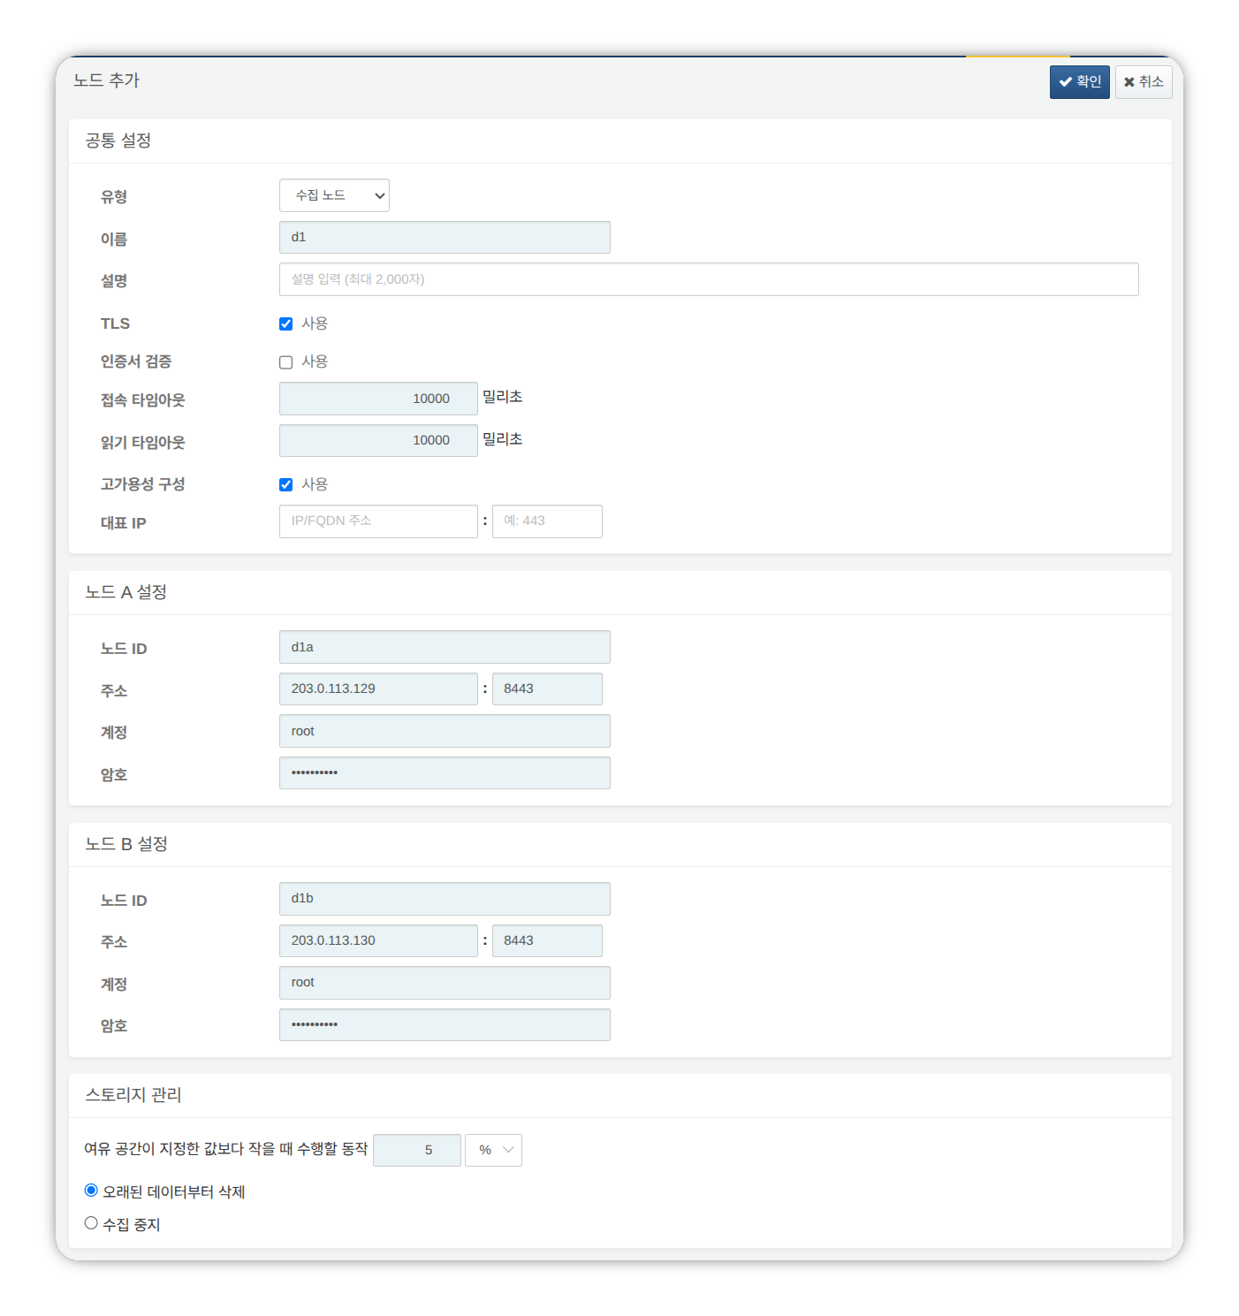
- Type: Select Data Node
- Name: Enter a data node pair identifier (e.g., d1)
- This cannot be changed after clicking the OK button.
- Description: Description of the node pair (optional).
- TLS: Selected
- Certificate Verification: Not selected
- Connection Timeout: Use default value
- Read Timeout: Use default value
- High Availability Configuration: Selected
- Representative IP: Not selected
- Node A Settings
- Node ID: Enter the node A identifier (e.g., d1a)
- Address: Node A actual IP address and communication port (e.g., 200.0.113.129:8443)
- The data node port number is 8443.
- Account: Enter root
- Password: Enter the federation account password
- Node B Settings
- Node ID: Enter the node B identifier (e.g., d1b)
- Address: Node B actual IP address and communication port (e.g., 200.0.113.130:8443)
- Account: Enter root
- Password: Enter the federation account password
After completing the input, click the OK button. Verify that the data node pair has been added as shown below.
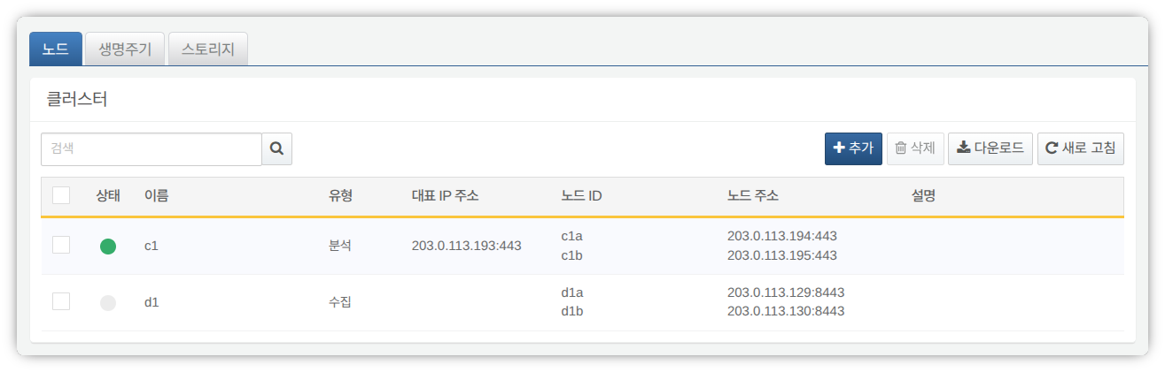
You can click the Name of the added data node to view and modify its properties. If the Name or Node ID was configured incorrectly, you must delete the node pair and reconfigure it.
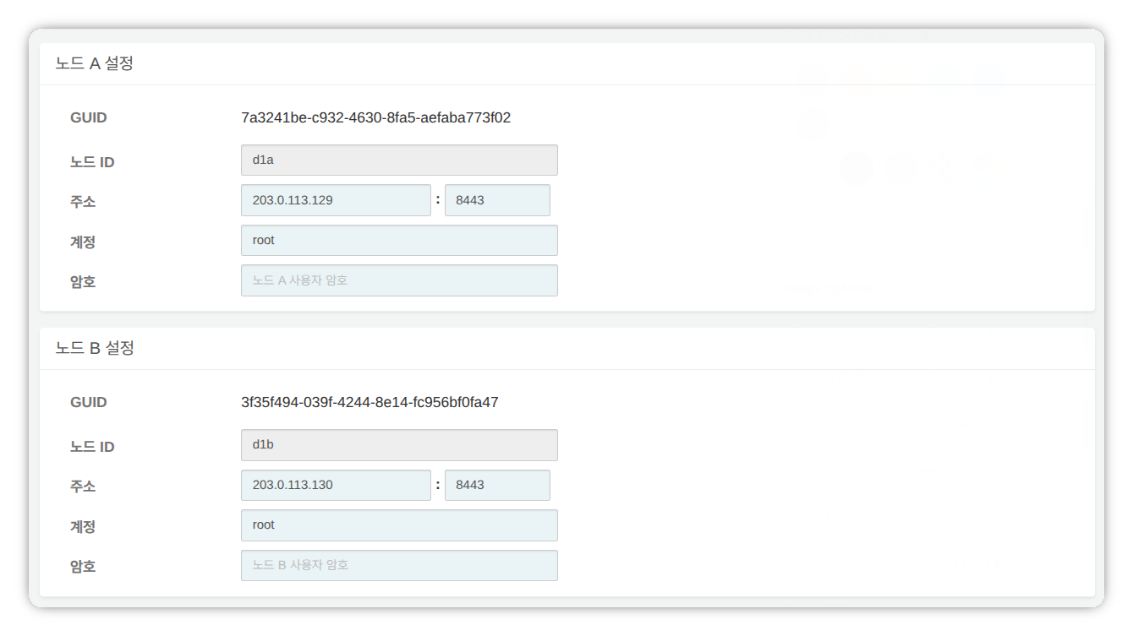
Record the GUIDs of node A and node B in a safe place. These values are used in Node GUID Configuration.
Replicating the Key Encryption Key
Replicate the control node's Key Encryption Key (KEK) identically to data nodes A and B.
Do not change the Key Encryption Key after completing this configuration. All nodes in the cluster must use the same Key Encryption Key. If different keys are used, encrypted data cannot be decrypted, preventing synchronization between nodes.
Run the following command in the Logpresso shell on control node A or B and record the encryption key string in a safe place.
sonar.cipherKey
Run the following command in the Logpresso shell on data nodes A and B respectively to configure the same encryption key. KEY_STRING is the encryption key string from the control node.
sonar.setCipherKey KEY_STRING
Node GUID Configuration
Set the GUIDs of data nodes A and B confirmed in the Registering the Data Node Pair step identically in each node's Logpresso shell.
Run the following command in the Logpresso shell on data nodes A and B to set each node's policy synchronization GUID in the Logpresso engine. GUID_STRING is the GUID string for each node.
sonar.setGuid GUID_STRING # Enter the GUID corresponding to each node
You can verify each node's policy synchronization GUID with the following command.
sonar.nodeConfig
Master Node Connection Configuration
Data nodes are controlled by control nodes. Since communication is initiated by the data node connecting to the control node, you must configure the information for connecting to the policy master node.
Run the following command in the Logpresso shell on nodes A and B.
sonar.setMaster
The following describes the prompts displayed after running the command and the values to enter. The account used here is the federation account.
host? 203.0.113.193 # Representative IP address of the control node pair
port? 443 # Enter 443
account? root # Enter root, the federation account
password? # Enter the federation account password
connect timeout? 10000 # Press Enter to use the default value
read timeout? 10000 # Press Enter to use the default value
secure? true # Enter true (default is false)
skip cert check? true # Enter true (default is false)
Option | Description | Example
host | Representative IP address of the control node pair | 203.0.113.193
port | Federation communication port of the control node | 443
account | Federation account | root
password | Federation account password
connect timeout | Server connection wait time | 10000 (ms)
read timeout | Response wait time | 10000 (ms)
secure | Whether to enable TLS communication | true
skip cert check | Whether to skip TLS certificate validation | true
Run the following command to verify that the node configuration has been applied.
sonar.nodeConfig
The following is an example of the output when the configuration is set correctly.
guid: 7a3241be-c932-4630-8fa5-aefaba773f02
host=203.0.113.193, port=443, account=root, connectTimeout=10000, readTimeout=10000, secure=true, skipCertCheck=true
crypto_file_path: null
Data Replication Mode Configuration
When a node pair is configured, table data can be replicated between the two nodes. Here, "table" refers not to a database table, but to a file-based table where the Logpresso engine stores data.
If identical data exists on both nodes, duplicate searches may occur during distributed query execution. To prevent this, each node must be assigned one of two data replication modes: ACTIVE or STANDBY.
- Active node: Stores the original log table data and is included in distributed query searches.
- Standby node: Receives real-time replication of the active node's log table data. Replicated tables use the same table ID as the original, and are excluded from distributed query searches, preventing duplicate results.
The logpresso.setStandbyNode command designates the peer node as standby, making the local node active.
The logpresso.setActiveNode command designates the peer node as active, making the local node standby.
Node A Configuration (Active)
Run the following command in the Logpresso shell on node A to identify the peer node (node B) name.
logpresso.nodeStatuses
The following is an example output. In the Federation Nodes section, [d1b] is the name of node B.
Local
------------------
Node GUID: b6b014f9-88c2-48c1-96c8-e23d8bdb65bc
Instance GUID: af43a33f-7985-41cb-9c7b-31224e47c35a
Federation Nodes
------------------
[d1b] node_guid=44494d5a-40c7-4e02-93bb-71adb50f3aec, instance_guid=3189e170-dae7-465a-a713-21e3da40cbb7, repl_mode=null, pair_guid=null, invalid_guid=false, alive=true, paired=true, failure=false, last connect=2025-06-09 13:39:20, last alive=2025-06-10 14:08:08, created=2025-06-09 13:39:20
The Node GUID and Instance GUID displayed in the logpresso.nodeStatuses command output are identifiers used by the Logpresso engine for log table replication and distributed queries. The Node GUID is used for database identification and is permanently stored in the DB_GUID file. The Instance GUID is a process identifier for the currently running instance and changes each time the node process starts.
Run the following command to designate node B as the standby node, which makes node A the active node. In the command example, d1b is the name of node B confirmed above.
logpresso.setStandbyNode d1b
Running the logpresso.nodeStatuses command again shows that Replication Mode is set to ACTIVE in the Local section.
------------------
Node GUID: b6b014f9-88c2-48c1-96c8-e23d8bdb65bc
Instance GUID: af43a33f-7985-41cb-9c7b-31224e47c35a
Replication Mode: ACTIVE
Pair Node: d1b
Federation Nodes
------------------
[d1b] node_guid=44494d5a-40c7-4e02-93bb-71adb50f3aec, instance_guid=3189e170-dae7-465a-a713-21e3da40cbb7, repl_mode=null, pair_guid=null, invalid_guid=false, alive=true, paired=true, failure=false, last connect=2025-06-09 13:49:36, last alive=2025-06-10 14:08:08, created=2025-06-09 13:49:36
Node B Configuration (Standby)
Run the following command in the Logpresso shell on node B to designate node A as active, which makes node B the standby node. c1a is the name of node A confirmed from the logpresso.nodeStatuses command output.
logpresso.setActiveNode d1a
Running the logpresso.nodeStatuses command shows that Replication Mode is set to STANDBY in the Local section.
Local
------------------
Node GUID: 44494d5a-40c7-4e02-93bb-71adb50f3aec
Instance GUID: 3189e170-dae7-465a-a713-21e3da40cbb7
Replication Mode: STANDBY
Pair Node: d1a
Federation Nodes
------------------
[d1a] node_guid=6b6b014f9-88c2-48c1-96c8-e23d8bdb65bc, instance_guid=af43a33f-7985-41cb-9c7b-31224e47c35a, repl_mode=ACTIVE, pair_guid=44494d5a-40c7-4e02-93bb-71adb50f3aec, invalid_guid=false, alive=true, paired=true, failure=false, last connect=2025-03-26 17:03:11, last alive=2025-03-27 13:40:55, created=2025-03-26 17:03:11
System Log Forwarding Configuration
Configure the collection of performance data such as CPU and memory from data nodes. The collected data can be viewed on the web console System > Performance Monitor screen.
Run the sentry.setGuid command in the Logpresso shell on data nodes A and B respectively to set the sentry GUID. Here, GUID refers to the node ID. For example, if the node ID of data node A is d1a, configure it as follows.
sentry.setGuid d1a
Run the following command on data nodes A and B to configure the control node to which logs will be forwarded.
# sentry.addBase BASE_NAME IP_ADDR PORT SENTRY_CERT CA_CERT SWAP_SIZE
sentry.addBase c1 203.0.113.193 7140 logpresso-sentry logpresso-ca 1073741824
- BASE_NAME: Name of the control node pair (e.g., c1)
- IP_ADDR: Representative IP address of the control node pair (e.g., 203.0.113.193)
- PORT: Sentry port (e.g., 7140)
- SENTRY_CERT: Sentry certificate (e.g., logpresso-sentry)
- CA_CERT: Logpresso CA certificate (e.g., logpresso-ca)
- SWAP_SIZE: Swap size (e.g., 1073741824 (=1GB), unit: bytes)
Run the following command to verify the connection.
sentry.connections
The following is an example of the output when the configuration is set correctly.
Connections
--------------------
[c1] id=2035698886, peer=(1b3fcc3f-61ce-41ae-9c45-d0096b8b7fff, /203.0.113.193:7140), trusted level=Low, ssl=true, props={phase=post_hello, type=command}
Inter-Node License Sharing Configuration
Configure all nodes in the cluster to use the same license. The license registered on the control node is also applied to data nodes and forwarder nodes. This section describes how to apply the control node license to data nodes.
Run the following command in the Logpresso shell on nodes A and B to enable license sharing.
logpresso.setLicenseMode slave
Run the following command to check the license master status.
logpresso.licenseMode
If configured correctly, the following output is displayed.
SLAVE
(Control nodes A, B) Refer to this document to register the data nodes as license slaves.
Open a web browser and navigate to https://<control node A IP address>:8443.
Log in with the federation account and navigate to Settings > License Management.
Click Add New Node in the All Nodes List.
Enter the license slave node information and click Create.
- Name: Name to identify the data node (e.g., d1a, d1b)
- Host Address: IP address of the data node
- Port: Federation communication port of the data node. Enter 8443.
- User: Federation account ID (root)
- Password: Password of the federation account
- Encrypted Communication: Select Enabled.
- Server Certificate Verification: Uncheck if Enabled is checked.
- Connection Timeout: Use the default value.
- Read Timeout: Use the default value.
Perform the same operation on control node B.
Enabling Distributed Queries
Distributed Query is a feature that allows querying table data distributed across multiple nodes with a single query. To prevent duplicate searches and obtain correct query results when executing distributed queries, distributed queries must be enabled on all nodes.
Run the following command in the Logpresso shell on nodes A and B respectively to enable distributed queries.
logpresso.enablePlanner
Run the following command to check the distributed query status.
logpresso.plannerStatus
If enabled correctly, the following output is displayed.
Running: true
Web Server Configuration
After package installation, there are open web service ports. Close unnecessary ports and only open the ports required for data node operation.
Run the following command in the Logpresso shell to check the open web service ports.
httpd.bindings
The following is an example of the output.
/0.0.0.0:8443 (ssl: key logpresso-web, trust null), opened, default context: webconsole, idle timeout: 0seconds, log file prefix: null, access log: false, error log: false
/0.0.0.0:18443 (ssl: key logpresso-web, trust null), opened, default context: sonar-explanation, idle timeout: 0seconds, log file prefix: null, access log: false, error log: false
/0.0.0.0:443 (ssl: key logpresso-web, trust null), opened, default context: sonar, idle timeout: 0seconds, log file prefix: null, access log: false, error log: false
/0.0.0.0:44300 (ssl: key logpresso-web, trust null), opened, default context: deploy, idle timeout: 0seconds, log file prefix: null, access log: false, error log: false
Run the following commands to close all open web ports and reopen only the port used for federation communication, applying the certificate changes.
httpd.close 8443
httpd.close 18443
httpd.close 443
httpd.close 44300
httpd.openSsl 8443 webconsole logpresso-web
The httpd mentioned in the commands does not refer to the Apache web server, but to the Logpresso Sonar web service.
WebSocket Frame Configuration (Optional)
Since federation communication uses WebSockets, the default WebSocket frame size may cause transmission failures when distributed query results are large or there is a lot of data to transfer. To handle large volumes of data smoothly, the frame size must be increased.
Run the following command in the Logpresso shell on nodes A and B to check the current setting.
webconsole.maxFrameSize
The default value is 8MB, and the command output is as follows.
8,388,608 bytes
Run the following command to change the frame size. The value set in this example is 84MB.
webconsole.setMaxFrameSize 83886080
Run the webconsole.maxFrameSize command again to verify the changed value.
83,886,080 bytes
Query Cache Configuration
To optimize query performance, table metadata, inverted indexes, and bloom filters are cached in memory. The role of each cache is as follows.
- Table cache: Caches log data read from disk during queries, returning the same data directly from memory without disk I/O on subsequent requests.
- Inverted index cache: Caches the list of document IDs containing a specific search term for full-text search.
- Bloom filter 0/1 cache: A bloom filter is a probabilistic data structure that quickly determines whether a specific search term exists in a given segment. Bloom filter 0 is used for fast determination, and bloom filter 1 is used for precise determination.
When a search query is executed, the caches are queried in the following order: bloom filter 0, bloom filter 1, inverted index cache, and table cache. If the desired data is not found in the cache, it is retrieved from disk.
Run the following commands in the Logpresso shell on nodes A and B to set the cache sizes.
logpresso.tableCacheConfig max_weight CACHE_SIZE # Table cache
logpresso.indexCacheConfig inverted max_weight CACHE_SIZE # Inverted index cache
logpresso.indexCacheConfig bloomfilter0 max_weight CACHE_SIZE # Bloom filter 0 cache
logpresso.indexCacheConfig bloomfilter1 max_weight CACHE_SIZE # Bloom filter 1 cache
Enter the values from the following table for CACHE_SIZE, considering the daily processing volume and memory capacity. The input unit for cache size is bytes.
Daily Volume | RAM | HEAP | DIRECT | max_weight | inverted | bloomfilter0 | bloomfilter1
500GB/day | 128GB | 26GB | 76GB | 4,294,967,296 | 53,687,091,200 | 12,884,901,888 | 1,073,741,824
- max_weight: Table cache
- inverted: Inverted index cache
- bloomfilter0: Bloom filter 0 cache
- bloomfilter1: Bloom filter 1 cache
- Do not enter commas (,). Commas are shown only for readability to separate digit groups.
The cache sizes converted to GB are shown in the following table.
Daily Volume | RAM | HEAP | DIRECT | max_weight | inverted | bloomfilter0 | bloomfilter1
500GB/day | 128GB | 26GB | 76GB | 4GB | 50GB | 12GB | 1GB
Restarting the Service
The Logpresso service must be restarted to apply the changed settings. The order of operations is as follows.
Stop order: Standby then Active
Start order: Active then Standby
By default, node A is active and node B is standby. Starting the active node first during system operation allows for quick recovery of the original data service, and the standby node can immediately establish a replication connection upon startup.
To stop the nodes,
Run the following command on the standby node (node B) to stop the Logpresso service.
sudo systemctl stop logpresso
After node B has stopped, run the same command on active node A to stop the service.
To start the nodes,
Run the following command on node A to start the Logpresso service.
sudo systemctl start logpresso
After node A starts successfully, run the same command on node B to start the Logpresso service.
After logging into the web console on node A, verify that the status of each data node is displayed in green on the System > Performance Monitor screen.
If the data node status is not green, you can check the cause in the /opt/logpresso/log/araqne.log file.

Connecting Stream Queries with the Control Node
Configure a pipeline so that event data generated by real-time detection rules on data nodes is forwarded to the control node for final event processing (alert). The role of each component is as follows.
- sonar_event_logger (data node): A stream collector that collects the output of the sonar_event stream query on the data node
- sonar_event_data (control node): A stream query that reads data from the data node's sonar_event_logger
- sonar_event (control node): A stream query that receives sonar_event_data as input, executes the alert command, and processes and stores events
The final data flow is configured as follows: (data nodes A, B) sonar_event_logger -> (control nodes A, B) sonar_event_data -> (control nodes A, B) sonar_event
Creating the sonar_event_logger Collector
(Data nodes A, B) Run the following command in the Logpresso shell to create the sonar_event_logger collector.
# logapi.createLogger LOGGER_FACTORY_NAME NAMESPACE LOGGER_NAME
logapi.createLogger stream local sonar_event_logger
- LOGGER_FACTORY_NAME: Collector factory name. Enter stream.
- NAMESPACE: Collector namespace. Enter local.
- LOGGER_NAME: Name of the collector to create. Enter sonar_event_logger.
The following describes the prompts displayed after running the command and the values to enter.
Stream query name (required)? sonar_event # Enter sonar_event
transformer (optional, enter to skip)? # Press Enter to skip
- Stream query name: Name of the data stream query that will receive the collected logs. Enter sonar_event.
- transformer: Press Enter without entering anything.
After entering all values at the prompts, the created collector information is displayed as follows.
logger created: name=local\sonar_event_logger, factory=local\stream, status=stopped (passive), log count=0, log volume=0, last start=null, last run=null, last log=null
(Data nodes A, B) Run the logapi.loggers command to verify that the sonar_event_logger collector has been created. The following is an example output, where the sonar_event_logger collector shows disabled for the enabled field and stopped for the status field.
Loggers
----------------------
+------------------------------+--------------------+----------+---------+------------+----------+------------+-----------+---------------------------+-------------+-------+
| name | factory | enabled | status | intvl.(ms) | schedule | time range | log count | last log | stop reason | error |
+------------------------------+--------------------+----------+---------+------------+----------+------------+-----------+---------------------------+-------------+-------+
| local\sonar_system_alert | system-alert | enabled | running | 0 | null | null | 17 | 2025-07-09 15:09:59 +0900 | | |
| local\sonar_event_logger | stream | disabled | stopped | 0 | null | null | 0 | null | | |
+------------------------------+--------------------+----------+---------+------------+----------+------------+-----------+---------------------------+-------------+-------+
(Control node A) Run the logapi.loggers command in the Logpresso shell to query the list of currently created collectors. The collectors created on the data nodes are displayed under each data node's namespace (d1a, d1b).
Loggers
----------------------
+--------------------------------+--------------------+----------+---------+------------+----------+------------+-----------+---------------------------+-------------+-------+
| name | factory | enabled | status | intvl.(ms) | schedule | time range | log count | last log | stop reason | error |
+--------------------------------+--------------------+----------+---------+------------+----------+------------+-----------+---------------------------+-------------+-------+
| d1a\sonar_event_logger | stream | disabled | stopped | 0 | null | null | 0 | null | | |
| d1a\sonar_system_alert | system-alert | enabled | running | 0 | null | null | 17 | 2025-07-09 15:09:59 +0900 | | |
| d1b\sonar_event_logger | stream | disabled | stopped | 0 | null | null | 0 | null | | |
| d1b\sonar_system_alert | system-alert | enabled | running | 0 | null | null | 23 | 2025-07-09 15:09:59 +0900 | | |
| local\sonar_system_alert | system-alert | enabled | running | 0 | null | null | 72 | 2025-07-09 16:17:10 +0900 | | |
+--------------------------------+--------------------+----------+---------+------------+----------+------------+-----------+---------------------------+-------------+-------+
(Control node A) Run the following command to register the data node collectors as managed targets. Collectors registered as managed targets are automatically started on system restart, and state synchronization is performed in HA environments.
# logpresso.createLogger NAMESPACE\LOGGER_NAME
logpresso.createLogger d1a\sonar_event_logger
logpresso.createLogger d1b\sonar_event_logger
- NAMESPACE\LOGGER_NAME: Full name of the collector. Enter the collector name confirmed in step 3.
(Control node A) Run the following command to enable the collectors.
# logapi.startLogger NAMESPACE\LOGGER_NAME
logapi.startLogger d1a\sonar_event_logger
logapi.startLogger d1b\sonar_event_logger
- NAMESPACE\LOGGER_NAME: Full name of the collector. Enter the collector name confirmed in step 3.
(Control node A) Run the logapi.loggers command and verify that the sonar_event_logger collectors show enabled for the enabled field and running for the status field in the output.
Loggers
----------------------
+--------------------------------+--------------------+---------+---------+------------+----------+------------+-----------+---------------------------+-------------+-------+
| name | factory | enabled | status | intvl.(ms) | schedule | time range | log count | last log | stop reason | error |
+--------------------------------+--------------------+---------+---------+------------+----------+------------+-----------+---------------------------+-------------+-------+
| d1a\sonar_event_logger | stream | enabled | running | 0 | null | null | 0 | null | | |
| d1a\sonar_system_alert | system-alert | enabled | running | 0 | null | null | 17 | 2025-07-09 15:09:59 +0900 | | |
| d1b\sonar_event_logger | stream | enabled | running | 0 | null | null | 0 | null | | |
| d1b\sonar_system_alert | system-alert | enabled | running | 0 | null | null | 23 | 2025-07-09 15:09:59 +0900 | | |
| local\sonar_system_alert | system-alert | enabled | running | 0 | null | null | 72 | 2025-07-09 16:17:10 +0900 | | |
+--------------------------------+--------------------+---------+---------+------------+----------+------------+-----------+---------------------------+-------------+-------+
Creating the sonar_event_data Stream Query
Perform the following process to forward data collected by the data node collectors to the sonar_event stream query on the control node.
(Control node A) Run the following command in the Logpresso shell to create a stream query.
# logpresso.createStreamQuery NAME SOURCE_TYPE
logpresso.createStreamQuery sonar_event_data logger
- NAME: Name of the stream query. Enter sonar_event_data.
- SOURCE_TYPE: Data source type. Enter logger.
The following describes the prompts displayed after running the command and the values to enter.
interval? 60 # Enter 60 (seconds)
query? bypass # Enter bypass
loggers? d1a\sonar_event_logger, d1b\sonar_event_logger # Enter the full name list of collectors on data nodes A and B
owner? root # Enter the owner account name
async [y/N]? N # Enter N
- interval: Execution interval of the stream query. Enter 60.
- query: Query string of the stream query. Enter bypass.
- loggers: Full name of the collectors to connect. Enter d1a\sonar_event_logger.
- owner: Owner account name. Enter root.
- async: Whether to run in asynchronous mode. Enter N.
Run the logpresso.streamQueries command and verify that the sonar_event_data stream query appears in the stream query list. The following is an example output, where the sonar_event_data stream query shows true for the enabled field and true for the running field.
Stream Queries
----------------
+-----------------------------------------+-------------+--------------+---------------------+---------+---------+-------+-------+
| name | input count | output count | last refresh | running | enabled | async | error |
+-----------------------------------------+-------------+--------------+---------------------+---------+---------+-------+-------+
| sonar_event | 0 | 0 | 2025-07-09 15:14:54 | true | true | false | null |
| sonar_event_data | 0 | 0 | 2025-07-09 15:21:35 | true | true | false | null |
| ..... |
+-----------------------------------------+-------------+--------------+---------------------+---------+---------+-------+-------+
Connecting the sonar_event Stream Query
Now connect the data source stream query created above to the sonar_event stream query on control node A.
Run the following command on the Logpresso web console Analysis > Query screen to generate a stream query list with sonar_event_data added.
system-streams
| search name == "sonar_event"
| eval streams = format("sonar_event_data,%s", strjoin(",", input_streams))
| fields streams
Copy the value in the streams field to a safe place. You will need to enter this value at the streams prompt in the next step.
Run the following command to connect the sonar_event stream query with the sonar_event_data stream query.
# logpresso.updateStreamQuery NAME SOURCE_TYPE
logpresso.updateStreamQuery sonar_event STREAM # Enter STREAM in uppercase
- NAME: Name of the stream query. Enter sonar_event.
- SOURCE_TYPE: Data source type. Enter STREAM.
The following describes the prompts displayed after running the command and the values to enter.
interval? 0 # Enter 0
query? alert # Enter alert
streams? sonar_rule_00001,sonar_rule_00003,sonar_rule_00005, ..., sonar_rule_00051,sonar_event_data # Value copied from the streams field
async [y/N]? N # Enter N
owner? root # Enter the owner account name
The logpresso.updateStreamQuery command overwrites all existing data, so use it with caution. When entering values at the stream prompt, you must accurately enter the stream list queried from the input_streams field and sonar_event_data, separated by commas (,).
Control Node Pair Synchronization
The sonar_event_logger collector and the sonar_event_data and sonar_event stream queries configured above were manually created in the Logpresso shell and do not support automatic redundancy through synchronization.
You must stop cluster synchronization, perform the same configuration steps on control node B as were performed on control node A, and then restart the cluster.
(Control node A) Stop the logpresso service from the terminal.
sudo systemctl stop logpresso
(Control node B) Run the following command in the Logpresso shell to unregister the remaining collectors on control node B from managed targets and delete the collector instances.
# logapi.removeLogger NAMESPACE\LOGGER_NAME
logapi.removeLogger d1a\sonar_event_logger
logapi.removeLogger d1b\sonar_event_logger
- NAMESPACE\LOGGER_NAME: Full name of the collector
(Data nodes A, B) Create the collectors on data nodes A and B.
# Create sonar_event_logger collector
logapi.createLogger stream local sonar_event_logger
(Control node B) Perform the same operations on control node B as were performed on control node A.
# Create sonar_event_logger collectors
logpresso.createLogger d1a\sonar_event_logger
logpresso.createLogger d1b\sonar_event_logger
# Enable sonar_event_logger collectors
logapi.startLogger d1a\sonar_event_logger
logapi.startLogger d1b\sonar_event_logger
# Create sonar_event_data stream query
logpresso.createStreamQuery sonar_event_data logger
# Check the input_streams field value from the stream query list on control node B
system streams
| search name == "sonar_event_data"
| order source_type, name, running, enabled, async, interval, query_string, owner, input_streams
# Connect sonar_event stream query
logpresso.updateStreamQuery sonar_event STREAM
(Control node B) Run the following command in the terminal to stop the logpresso service.
sudo systemctl stop logpresso
(Control node A, then control node B) Run the following command in the terminal to start the logpresso service. Once control node A starts first, its configuration will be synchronized to control node B.
sudo systemctl start logpresso

Forwarder Node

Operating System
This document describes the items required when installing and configuring the operating system.
- Permissions Required for Installation: Describes the permissions required to install Logpresso Sonar.
- Operating System & JDK Installation: Describes the operating system installation, partition configuration, required packages, and JDK installation methods.
- Operating System Configuration: Configures JDK permissions, SELinux, hostname, NTP, firewall, kernel parameters, and more.
- Creating Logpresso Directories: Creates the Logpresso installation directory.

Permissions Required for Installation
To install Logpresso Sonar, you need root privileges on the target server, or a user account that can execute administrative commands using sudo (a user belonging to the wheel group).

Operating System & JDK Installation
The officially supported operating system for Logpresso is Red Hat Enterprise Linux 9.
- RHEL 9-compatible operating systems such as Rocky Linux can also be used.
- The Server with GUI installation type is recommended.
- Separate the operating system partition from the data partition.
- Mount the data partition at /data.
- It is recommended to configure the data partition with LVM so that capacity can be expanded as needed.
Installing Required Packages
Run the following command on a network with internet access to install the required packages.
sudo dnf -y install curl firewalld java-21-openjdk-devel \
lsof net-tools traceroute unzip
Package | Purpose
curl | Used for API testing
firewalld | Host firewall configuration
java-21-openjdk-devel | JDK required to run Logpresso Sonar
lsof | Diagnostic tool for checking open files and ports
net-tools | Network diagnostic tools such as netstat and ifconfig
traceroute | Diagnostic tool for tracing network paths
unzip | Extracting the Logpresso Sonar installation package
- Install the java-21-openjdk-devel package instead of java-21-openjdk so that you can debug issues using jmap and jstack commands when failures occur.
- If installing debugging tools is not permitted in your environment, install the java-21-openjdk-headless package instead.
The following packages are recommended for operational convenience.
sudo dnf -y install vim wget
Package | Purpose
vim | Editing configuration files
wget | Used when running the Sentry installation script on the host where Sentry is to be installed
Downloading Packages (for Air-Gapped Environments)
If you need to install in an air-gapped environment, follow these steps to prepare the package files to bring into the air-gapped environment.
Check the operating system and version to be used in the air-gapped environment, and prepare a Linux host with the same version on a network with internet access.
Run the following command to download all required packages and their dependencies to the specified path.
# Downloading packages does not require sudo privileges.
mkdir $HOME/rpm && cd $HOME/rpm && \
dnf download --resolve curl firewalld java-21-openjdk-devel \
lsof net-tools traceroute unzip vim wget && \
tar czvf rpm.tgz *.rpm
Generate a file containing the hash value of the compressed file. The hash value is needed to verify the integrity of the file brought into the air-gapped environment.
sha256sum rpm.tgz > rpm.tgz.sha256
Store the rpm.tgz and rpm.tgz.sha256 files in a safe location (read-only media recommended).
To install the required packages in the air-gapped environment, follow these steps.
Create a new directory (e.g., $HOME/rpm) and copy the rpm.tgz and rpm.tgz.sha256 files to the new directory.
Run the following command in the new directory to compare the verified hash value with the hash value recorded in the rpm.tgz.sha256 file.
sha256sum rpm.tgz
Extract the rpm.tgz file and install the packages.
tar xzvf rpm.tgz && sudo dnf install -y *.rpm

Operating System Configuration
JDK Permission Configuration
Check the installed JDK version and grant the permissions required to run Logpresso Sonar. This configuration must be performed on all nodes.
Check the installed JDK version.
java -version
You should see version information similar to the following.
openjdk version "21.0.10" 2026-01-20 LTS
OpenJDK Runtime Environment (Red_Hat-21.0.10.0.7-1) (build 21.0.10+7-LTS)
OpenJDK 64-Bit Server VM (Red_Hat-21.0.10.0.7-1) (build 21.0.10+7-LTS, mixed mode, sharing)
Grant the required permissions to the java executable.
sudo setcap cap_net_bind_service,cap_sys_time,cap_net_raw=+ep $(readlink /etc/alternatives/java)
The permissions granted to the java executable using setcap are as follows.
Option | Description | Notes
cap_net_bind_service | Permission to use ports below 1024 | Non-root users cannot use ports below 1024
cap_sys_time | Permission to change system time | Required for time synchronization and timestamp adjustment
cap_net_raw | Permission to use raw sockets and packet sockets | Used for direct pcap collection, sendsyslog, and ping apps
+ep | +: Add permissione: Apply permissionp: Retain permanently
Verify that the permissions have been applied correctly.
getcap $(readlink /etc/alternatives/java)
You should see output similar to the following.
/usr/lib/jvm/java-21-openjdk-21.0.10.0.7-1.el9.x86_64/bin/java cap_net_bind_service,cap_net_raw,cap_sys_time=ep
SELinux Configuration
SELinux (Security-Enhanced Linux) is a module that enforces kernel-level security policies on Linux. By default, in enforcing mode, any security policy violation is blocked. Since Logpresso Sonar may be restricted from accessing certain directories, SELinux must be changed to permissive.
We plan to improve this document after verifying the stability of Logpresso Sonar in SELinux enforcing mode. Currently, the instructions describe installation with SELinux set to Permissive.
Open the /etc/selinux/config file and configure it as follows. The changed settings take effect after restarting the system or running the setenforce 0 command.
# This file controls the state of SELinux on the system.
# SELINUX= can take one of these three values:
# enforcing - SELinux security policy is enforced.
# permissive - SELinux prints warnings instead of enforcing.
# disabled - No SELinux policy is loaded.
SELINUX=permissive
Run the following command to apply Permissive mode immediately.
sudo setenforce 0
Run the getenforce command to verify that the current SELinux mode displays Permissive.
Changing the Hostname
Change the server hostname using the following command to make it easier to identify Logpresso Sonar nodes.
sudo hostnamectl set-hostname HOSTNAME
- HOSTNAME: The hostname
When there are multiple node pairs, it is recommended to assign hostnames using node pair identifiers and node identifiers such as c1a/c1b, d1a/d1b, d2a/d2b, f1a/f1b. For example, in a cluster consisting of 1 control node pair, 2 data node pairs, and 1 forwarder node pair, the following hostnames can be used.
Node Pair | Hostname | Description
c1 | c1a | Node A of control node pair c1
c1 | c1b | Node B of control node pair c1
d1 | d1a | Node A of data node pair d1
d1 | d1b | Node B of data node pair d1
d2 | d2a | Node A of data node pair d2
d2 | d2b | Node B of data node pair d2
f1 | f1a | Node A of forwarder node pair f1
f1 | f1b | Node B of forwarder node pair f1
NTP Configuration
Synchronize all nodes with the same NTP server to ensure accurate time information.
Check the IP address or FQDN (e.g., time.kriss.re.kr) of the NTP server that provides network standard time in advance.
Configure the same NTP server or server pool in the /etc/chrony.conf file on all servers to synchronize with the same network standard time.
# Use public servers from the pool.ntp.org project.
# Please consider joining the pool (https://www.pool.ntp.org/join.html).
# pool 2.rocky.pool.ntp.org iburst # Comment out the pool line
server time.kriss.re.kr iburst prefer # KRISS (Korea Research Institute of Standards and Science) NTP server
server 192.0.2.1 iburst # NTP server in internal network 192.0.2.0/24 (example)
⚠️ When adding server lines, delete or comment out the pool line. Only one of the two should be used.
Run the following command to restart the chronyd service.
sudo systemctl restart chronyd
Run the following command to check the synchronization status of the currently registered NTP servers. If chronyd is running correctly, the synchronization status will be displayed.
chronyc sources -v
Run the following command to synchronize the time immediately.
sudo chronyc -a makestep
Host Firewall Configuration
Configure the inbound firewall policy to allow the communication required for Logpresso Sonar operation. The following is an example of commands to configure the firewall policy on the forwarder node server, based on the firewall policy configuration described in the prerequisites document.
sudo firewall-cmd --permanent --add-port={22,8443,7140,8514,44300}/tcp --add-port={514,8514,162}/udp
sudo firewall-cmd --reload
sudo firewall-cmd --list-all
- Syslog over DTLS (8514/tcp, 8514/udp) does not have a standard port, so it may differ depending on the operating environment.
The firewall configuration above has the issue of not restricting source IP addresses. To restrict source IP addresses in the host firewall, you need to run advanced firewall policy commands using the --add-rich-rule option as shown below. Adjust the IP address ranges to match your actual environment.
# 1. Management network: 192.0.2.0/24
# Administrators: SSH access (22), web management console and API inspection (8443)
sudo firewall-cmd --permanent --add-rich-rule='rule family="ipv4" source address="192.0.2.0/24" port port="22" protocol="tcp" accept'
sudo firewall-cmd --permanent --add-rich-rule='rule family="ipv4" source address="192.0.2.0/24" port port="8443" protocol="tcp" accept'
# 2. Control nodes: 203.0.113.240/29
# Control nodes: Sonar federation (8443)
sudo firewall-cmd --permanent --add-rich-rule='rule family="ipv4" source address="203.0.113.240/29" port port="8443" protocol="tcp" accept'
# 3. Forwarder node range: 203.0.113.160/27 (203.0.113.161 ~ 203.0.113.190)
# Health check between peer nodes (7140)
# Note: Only allow traffic from the forwarder node group
sudo firewall-cmd --permanent --add-rich-rule='rule family="ipv4" source address="203.0.113.160/27" port port="7140" protocol="tcp" accept'
# 4. Service network: 203.0.113.0/25 (203.0.113.1 ~ 203.0.113.126)
# Targets: Sentry agents and general log-generating devices (switches, servers, etc.)
# Sentry: RPC and log reception (7140/tcp)
sudo firewall-cmd --permanent --add-rich-rule='rule family="ipv4" source address="203.0.113.0/25" port port="7140" protocol="tcp" accept'
# Log collection targets: Syslog (514/udp)
sudo firewall-cmd --permanent --add-rich-rule='rule family="ipv4" source address="203.0.113.0/25" port port="514" protocol="udp" accept'
# Log collection targets: Syslog over DTLS (8514/udp)
sudo firewall-cmd --permanent --add-rich-rule='rule family="ipv4" source address="203.0.113.0/25" port port="8514" protocol="tcp" accept'
sudo firewall-cmd --permanent --add-rich-rule='rule family="ipv4" source address="203.0.113.0/25" port port="8514" protocol="udp" accept'
# Log collection targets: SNMP TRAP (162/udp)
sudo firewall-cmd --permanent --add-rich-rule='rule family="ipv4" source address="203.0.113.0/25" port port="162" protocol="udp" accept'
# 5. Sentry range: 203.0.113.0/25 (203.0.113.1 ~ 203.0.113.126)
# Certificate renewal, Sentry installation (44300/tcp)
sudo firewall-cmd --permanent --add-rich-rule='rule family="ipv4" source address="203.0.113.0/25" port port="44300" protocol="tcp" accept'
# 6. Apply and verify settings
sudo firewall-cmd --reload
sudo firewall-cmd --list-rich-rules
Socket Buffer and Memory Map Configuration
When receiving Syslog, Syslog over DTLS, or SNMP TRAP, insufficient kernel socket buffers or memory buffers can cause log packet loss and result in log data loss. To prevent this, configure the socket buffer and memory map settings. Perform this task on all nodes.
Create a 50-logpresso.conf file in the /etc/sysctl.d directory and add the following content.
net.core.rmem_default = 52428800
net.core.rmem_max = 52428800
net.ipv4.udp_rmem_min = 8192
net.ipv4.ipfrag_high_thresh = 16777216
vm.max_map_count = 10000000
vm.swappiness = 1
The meaning of each item is as follows:
Variable | Description | Default | Setting
net.core.rmem_default | Default receive buffer size for sockets | 212992 | 52428800
net.core.rmem_max | Maximum receive buffer size for sockets | 212992 | 52428800
net.ipv4.udp_rmem_min | Minimum receive buffer size for UDP sockets | 4096 | 8192
net.ipv4.ipfrag_high_thresh | Maximum IP packet reassembly buffer size | 4194304 | 16777216
vm.max_map_count | Maximum number of virtual memory area mappings | 65530 | 10000000
vm.swappiness | Minimize swap usage | 60 | 1
Run the following command to apply the changed kernel settings immediately.
sudo sysctl -p
Run the following command to verify the changed settings.
sudo sysctl -a | grep -E "rmem_default|rmem_max|udp_rmem_min|ipfrag_high_thresh|max_map_count"
Resource Limit Configuration
Create a 50-logpresso.conf file in the /etc/security/limits.d directory and add the following content.
logpresso soft nofile 126488
logpresso hard nofile 126488
logpresso soft nproc 126488
logpresso hard nproc 126488
- nofile: Maximum number of files that can be opened simultaneously
- nproc: Maximum number of processes (and threads) that can be run simultaneously
Run the following commands to verify the changed settings.
ulimit -n # Check file open limit (nofile)
ulimit -u # Check process limit (nproc)
Granting Diagnostic Tool Permissions
Run the following commands to find the exact paths of the jstack and jmap executables.
readlink /etc/alternatives/jstack
readlink /etc/alternatives/jmap
You should see output similar to the following.
/usr/lib/jvm/java-21-openjdk/bin/jstack
/usr/lib/jvm/java-21-openjdk/bin/jmap
Run the sudo visudo /etc/sudoers.d/logpresso command and edit it as follows. Grant permissions to run the jstack and jmap executables found in step 1 under the logpresso account.
# Adjust the paths according to the output of the readlink command.
%logpresso ALL=(ALL) NOPASSWD: /usr/lib/jvm/java-21-openjdk/bin/jstack
%logpresso ALL=(ALL) NOPASSWD: /usr/lib/jvm/java-21-openjdk/bin/jmap
%logpresso ALL=(ALL) NOPASSWD: /usr/bin/arping
%logpresso ALL=(ALL) NOPASSWD: /usr/bin/netstat
%logpresso ALL=(ALL) NOPASSWD: /usr/sbin/ifconfig
%logpresso ALL=(ALL) NOPASSWD: /usr/sbin/tcpdump
Defaults:logpresso !requiretty
The logpresso account is created during the Logpresso Sonar installation. Here, the diagnostic tool permissions are granted in advance.
The arping, netstat, ifconfig, and tcpdump commands are used by Logpresso Sonar to check Sentry status or collect pcap files.
Run the following command to verify that the permissions have been applied correctly.
sudo visudo -c

Creating Logpresso Directories
Run the following command to create the directory where Logpresso will be installed. The Logpresso directory can be changed to suit your operating environment. This document uses /opt/logpresso.
sudo mkdir -p /opt/logpresso

Package Installation
This document describes how to install the Logpresso Sonar package. The control node, data node, and forwarder node all use the same package. Perform all the steps described here on each of the forwarder nodes A and B.
- Extract the package file: Download and extract the Logpresso Sonar package.
- Create the logpresso.conf file: Create the base configuration file required to run the node.
- Configuration: Configure JVM and node settings to match your operating environment.
- Start the forwarder node: Register and start the service.

Extract the Package File
First, download the Logpresso Sonar package and extract it on all Logpresso Sonar nodes.
On a PC with internet access, download the latest version package from the Logpresso Store. This document assumes version 4.0.2511.1 of the package.
Copy the downloaded package file to the Logpresso directory on the forwarder node, then extract it.
# Assumptions
# Logpresso Sonar package file path: $HOME/logpresso-SNR-4.0.2511.1-u3116.zip
# Logpresso directory: /opt/logpresso
sudo unzip logpresso-SNR-4.0.2511.1-u3116.zip -d /opt/logpresso

Create the logpresso.conf File
First, create the logpresso.conf file, which stores the base configuration required to run the node.
sudo /opt/logpresso/logpresso install config
When the logpresso.conf file is created, the following message is displayed.
configuration file is created: /opt/logpresso/etc/logpresso.conf
File Structure and Behavior
The logpresso.conf file contains the JVM settings and server settings required to run Logpresso Sonar.
The characteristics of this file are as follows:
- Each setting uses a key-value format of KEY=VALUE or KEY="VALUE".
- Bash-style comments are supported. Lines starting with "#" are treated as comments.
- Bash-style variable references such as $VAR, ${VAR}, and $(command) are supported.
- The value of JAVA_OPTS is passed as-is to the java command parameters and as system switches for the Logpresso core (araqne-core).
- Cumulative append operators such as JAVA_OPTS+="-Doption=value" are supported (e.g., JAVA_OPTS="$JAVA_OPTS -XX:ActiveProcessorCount=30").
- You can add java command options to the JAVA_OPTS property using the cumulative append operator.
When systemd starts the Logpresso Sonar service, the launcher (logpresso) converts all settings recorded in the logpresso.conf file into java command parameters and passes them.
- Some items are mapped to JVM system properties (-D...).
- Not all items are mapped to -D. Some items are used only in the execution script (JVM heap/GC, etc.) or have internal default values applied.
The following is the actual command line referenced while writing this document, reformatted with line breaks for readability (details may vary depending on the Sonar version and system). All parameters in this command line are properties defined in the logpresso.conf file.
/opt/logpresso/jre/bin/java
-Xms1G -Xmx2G \
-XX:MaxDirectMemorySize=2G \
-XX:-OmitStackTraceInFastThrow \
-XX:-UseCompressedOops \
-XX:+UnlockExperimentalVMOptions \
-XX:+UseZGC \
-XX:+ZGenerational \
-XX:MaxGCPauseMillis=200 \
-XX:ParallelGCThreads=6 \
-XX:StringTableSize=10000019 \
-Xlog:gc=trace:file="/opt/logpresso/log/gc.log":time,level:filecount=10,filesize=10240K
-XX:TrimNativeHeapInterval=300000 \
--add-opens java.base/jdk.internal.ref=ALL-UNNAMED \
--add-opens java.base/java.lang=ALL-UNNAMED \
--add-opens java.base/java.net=ALL-UNNAMED \
--add-opens java.base/java.security=ALL-UNNAMED \
--add-opens java.base/java.util.concurrent.atomic=ALL-UNNAMED \
--add-modules jdk.jfr \
--add-exports=java.base/sun.net.www.protocol.http=ALL-UNNAMED \
-Dipojo.proxy=disabled \
-Djava.awt.headless=true \
-Daraqne.dir=/opt/logpresso \
-Daraqne.log.dir=/opt/logpresso/log \
-Daraqne.core.pid_file=/var/run/logpresso/logpresso.pid \
-Daraqne.ssh.server=enabled \
-Daraqne.ssh.address=127.0.0.1 \
-Daraqne.ssh.port=7022 \
-Daraqne.ssh.timeout=600000 \
-Daraqne.dom.block_concurrent_admin=disabled \
-Daraqne.dom.block_concurrent_login=disabled \
-Daraqne.sso.timeout=3600000 \
-Daraqne.log.keepdays=7 \
-Daraqne.core.watchdog=enabled \
-Daraqne.logdb.cepengine=mem \
-DINSTANCE_ID=logpresso \
-jar /opt/logpresso/araqne-core-4.0.5-package.jar

Configuration
Now modify the logpresso.conf file to match your operating environment. Open the /opt/logpresso/etc/logpresso.conf file and adjust the settings for your environment. For settings not described here, refer to (Appendix) logpresso.conf File Properties.
JVM Configuration Variables
The JVM configuration variables defined in the logpresso.conf file are JAVA_HOME, MIN_HEAP_SIZE, MAX_HEAP_SIZE, and MAX_DIRECT_MEM_SIZE. Refer to the following tables to set appropriate values.
Network collection only
Daily throughput | Physical cores | vCPU | RAM | APC | HEAP | DIRECT
1TB/day | 4 | 8 | 8GB | 3 | 3GB | 2GB
Sentry management and network collection
Daily throughput | Physical cores | vCPU | RAM | APC | HEAP | DIRECT
1TB/day | 12 | 24 | 64GB | 24 | 31GB | 20GB
- Forwarder nodes are deployed in environments with a daily throughput of 1TB/day or more. If high availability is important, consider a redundant configuration.
- Add additional forwarder nodes for each additional 1TB/day of throughput beyond the initial 1TB/day.
- APC: The value to apply to -XX:ActiveProcessorCount
- HEAP: The value to apply to MIN_HEAP_SIZE and MAX_HEAP_SIZE (set both to the same value)
- DIRECT: The value to apply to MAX_DIRECT_MEM_SIZE
The JVM configuration items are as follows.
JAVA_HOME
JDK directory path (e.g., /opt/logpresso/jre, default: none). When Logpresso Sonar starts, the Logpresso launcher (logpresso) looks for the value defined in JAVA_HOME in the logpresso.conf file. If the logpresso.conf file does not exist or no value is assigned to JAVA_HOME, it searches for the java binary in the paths specified in the operating system's PATH environment variable.
-XX:ActiveProcessorCount=N
The number of CPU logical processors for the JVM to use (N is the number of logical processors). This option is a JDK option that is not explicitly defined in the logpresso.conf file. Add it directly to the logpresso.conf file as follows.
JAVA_OPTS="$JAVA_OPTS -XX:ActiveProcessorCount=30"
JDK 21 recognizes CPU core counts and cgroup limits by default. Use this when you need to prevent excessive thread creation. If individual flags (e.g., -XX:ParallelGCThreads) are specified, those values take precedence.
MIN_HEAP_SIZE
Minimum heap memory size. This value is applied to the -Xms flag parameter. It is recommended to set this to the same value as MAX_HEAP_SIZE.
MAX_HEAP_SIZE
Maximum heap memory size. This value is applied to the -Xmx flag parameter. It is recommended to set this to the same value as MIN_HEAP_SIZE.
-XX:SoftMaxHeapSize
Soft maximum heap size. This option is a JDK option that is not explicitly defined in the logpresso.conf file. Add it directly to the logpresso.conf file as follows.
JAVA_OPTS="$JAVA_OPTS -XX:SoftMaxHeapSize=1g"
- For network collection only, the recommended -XX:SoftMaxHeapSize value is 1g.
- For sentry management and network collection, the recommended -XX:SoftMaxHeapSize value is 15g.
MAX_DIRECT_MEM_SIZE
Maximum direct memory size. This value is applied to the -XX:MaxDirectMemorySize flag parameter.
Node Configuration Variables
The key configuration items for the forwarder node are as follows.
BASEDIR
Logpresso directory path. This value is automatically assigned when the logpresso.conf file is created, so there is no need to modify it. This setting serves as the default value for other path variables such as LOGDIR.
DATADIR
Collected data directory path (default: $BASEDIR/data). Since the data partition is mounted at /data, change this to /data/logpresso-data.
LOGDIR
Log directory path (default: $BASEDIR/log)
SSH_OPEN
Whether to allow Logpresso shell access (default: disabled). Change to enabled to allow Logpresso shell access.
SSH_ADDR
Logpresso shell access address (default: 127.0.0.1)
SSH_PORT
Logpresso shell access port (default: 7022)
SSH_TIMEOUT
Logpresso shell access timeout (default: 600000 milliseconds = 10 minutes)
LOGKEEPDAY
Retention period for the araqne.log file (default: 7 days). This file is used to record execution of major operations, system errors, and exceptions. Log records have levels of ERROR, WARNING, INFO, DEBUG, and TRACE.
LOGDB_PURGE
Whether to allow the purge command in Logpresso queries (default: disabled). For the behavior of this command, refer to the purge command documentation. Change to enabled to activate this feature.
ALLOWED_FILE_SCAN_PATHS
List of directories to allow access when executing query commands (e.g., textfile, csvfile) (default: $DATADIR/araqne-logdb/scan,$LOGDIR, related content: 4.0.2511.0 Migration Guide).
For example, if you set ALLOWED_FILE_SCAN_PATHS="/opt/logpresso/data/araqne-logdb/scan,/opt/logpresso/log", query commands that access local files can only access files under the /opt/logpresso/data/araqne-logdb/scan and /opt/logpresso/log directories.
-Dsonar.node.ignore_pattern_group=true
Disable pattern group synchronization. This option is a system switch that is not explicitly defined in the logpresso.conf file. Add it directly to the logpresso.conf file as follows.
JAVA_OPTS="$JAVA_OPTS -Dsonar.node.ignore_pattern_group=true"
sonar.node.ignore_pattern_group This system switch is only configured on forwarder nodes.

Start the Forwarder Node
After finishing the configuration file edits, register and start the service unit (logpresso.service).
Register and Start the Service
Run the following command to install the Logpresso Sonar server.
sudo /opt/logpresso/logpresso install server && \
sudo systemctl enable --now logpresso
During the Logpresso installation, the following tasks are performed.
The logpresso user is created, and the owner and group of all files and directories within the Logpresso directory are changed to logpresso.
# logpresso account added to /etc/passwd
logpresso:x:1001:1001::/opt/logpresso:/sbin/nologin
The /etc/ld.so.conf.d/logpresso.conf file is created and the directory path where the libjli.so file is located is stored in it.
# /etc/ld.so.conf.d/logpresso.conf
# File contents may vary depending on the system.
/opt/logpresso/jdk-21.0.8+9/lib/jli
If the jli directory path is not properly added to the /etc/ld.so.conf.d/logpresso.conf file during this process, the following error may occur when starting the Logpresso Sonar service.
/opt/logpresso/jre/bin/java: error while loading shared libraries: libjli.so: cannot open shared object file: No such file or directory
If this error occurs, run the following command to verify the actual directory path of the libjli.so file.
sudo find /opt/logpresso -type f -name libjli.so -exec dirname {} \;
If the contents of the /etc/ld.so.conf.d/logpresso.conf file differ from the actual directory path, update the /etc/ld.so.conf.d/logpresso.conf file to match the actual directory path and run sudo ldconfig.
A logpresso.service service unit file is added to the /usr/lib/systemd/system directory and configured so that systemd can manage the service. The contents of the logpresso.service file are as follows (may vary by version). Modify as needed.
[Unit]
Description=Logpresso daemon
After=multi-user.target network.target
Wants=network-online.target
Documentation=https://docs.logpresso.com
[Service]
User=logpresso
Group=logpresso
Type=forking
PIDFile=/opt/logpresso/logpresso.pid
Environment=PKGDIR=/opt/logpresso
ExecStart=/opt/logpresso/logpresso start
ExecStop=/opt/logpresso/logpresso stop
StartLimitBurst=0
TimeoutStopSec=1200
LimitNOFILE=65535
Restart=on-failure
[Install]
WantedBy=multi-user.target
- Wants is an additionally configured item. If this item is not present in the generated logpresso.service file, add it.
- If the LimitNOFILE line is present, it overrides the /etc/security/limits.d/50-logpresso.conf file settings and applies the value set in the service unit. If this line is present, remove it.
If you modified the service unit file, run the following command to restart the service.
sudo systemctl daemon-reload && sudo systemctl restart logpresso
Check the Service Status
Run the following command to verify that the Logpresso service is running normally.
systemctl status logpresso
If running normally, output similar to the following is displayed. Note the value of the Main PID field (1682 in this example).
● logpresso.service - Logpresso daemon
Loaded: loaded (/usr/lib/systemd/system/logpresso.service; enabled; preset: disabled)
Active: active (running) since Wed 2025-10-15 10:56:58 KST; 6 days ago
Docs: https://ko.logpresso.com/documents
Main PID: 1682 (java)
Tasks: 229 (limit: 23116)
Memory: 4.1G
CPU: 4d 40min 56.229s
CGroup: /system.slice/logpresso.service
└─1682 /usr/lib/jvm/java/bin/java ...(omitted)... -jar /opt/logpresso/sonar/araqne-core-4.0.5-package.jar
(remainder omitted)
Run the following command to check the list of ports opened by the java process.
sudo ss -tuanlp | grep -E '^Netid|java'
When the service is running normally, the command output shows the list of ports bound to the java and mariadbd processes as follows.
Netid State Recv-Q Send-Q Local Address:Port Peer Address:Port Process
udp UNCONN 0 0 0.0.0.0:162 0.0.0.0:* users:(("java",pid=2981,fd=338))
udp UNCONN 0 0 0.0.0.0:514 0.0.0.0:* users:(("java",pid=2981,fd=336))
udp UNCONN 0 0 0.0.0.0:8514 0.0.0.0:* users:(("java",pid=2981,fd=339))
tcp LISTEN 0 512 *:7140 *:* users:(("java",pid=2981,fd=407))
tcp LISTEN 0 50 [::ffff:127.0.0.1]:7022 *:* users:(("java",pid=2981,fd=144))
tcp LISTEN 0 4096 *:44300 *:* users:(("java",pid=2981,fd=219))
tcp LISTEN 0 4096 *:8443 *:* users:(("java",pid=2981,fd=200))
Check whether any ports at or below 1024 are open in the output. If you do not have permission to use ports at or below 1024, refer to JDK Installation.

Forwarder Node Configuration
This document describes the tasks to perform after completing package installation on forwarder nodes. These tasks can be performed after completing the Data Node Configuration.
- Federation Communication Account Setup: Configure the federation account password for forwarder nodes.
- Forwarder Node Pair Setup: Register forwarder node pairs and perform related settings in the web console.
- Network Redundancy: Configure network high availability (HA) using a virtual IP address (VIP).

Federation Communication Account Setup
Accessing the Logpresso Shell
You must access the Logpresso shell on forwarder nodes A and B separately and change the initial password. It is recommended to register an SSH key in case you forget your password.
Changing the Default Password
Run the following command in the terminal to access the Logpresso shell. The port number may vary depending on the SSH_PORT setting in the logpresso.conf file (default: 7022).
ssh -p 7022 root@localhost
When the password prompt appears, enter the initial Logpresso shell password.
When the new password prompt appears, enter a new password and press Enter. Since the Logpresso shell account is only used for SSH access to each node, it is acceptable to set a different password for each node.
Please change the default password.
New password: # Enter the new password and press Enter
Retype password: # Re-enter the new password and press Enter
Password changed successfully.
Logpresso SNR-4.0.2511.1 (build 20250805) on Araqne Core 4.0.5
logpresso> # Logpresso shell prompt
The Logpresso shell rejects reuse of the default password. Never reuse the default password for any account. Logpresso is not responsible for any issues that arise from using the default password.
Depending on the operating system, you may be unable to connect to the Logpresso shell due to SSH key exchange and encryption algorithm negotiation failures. Add the following content to the ~/.ssh/config file on forwarder nodes A and B, and connect using the ssh sonar command.
Host sonar
HostName 127.0.0.1
Port 7022
User root
HostKeyAlgorithms +ssh-rsa
PubkeyAcceptedAlgorithms +ssh-rsa
KexAlgorithms +diffie-hellman-group14-sha1
Ciphers +aes256-cbc
PreferredAuthentications publickey # SSH key login
IdentityOnly yes # SSH key login
IdentityFile ~/.ssh/logpresso_rsa # SSH key login
SSH Key Registration (Optional)
You can access the Logpresso shell using SSH key authentication. SSH key registration is recommended as it allows access even if you forget your password.
If you do not have an RSA key, run the following command to generate a key pair.
ssh-keygen -t rsa -b 2048 -f ~/.ssh/logpresso_rsa
The Logpresso shell only supports ssh-rsa keys.
Run the following command in the Logpresso shell to register your SSH public key.
account.addSshKey root
When prompted, enter your SSH public key. The public key is located in the ~/.ssh/logpresso_rsa.pub file.
SSH public key? ssh-rsa AAAAB3NzaC1yc2EAAAADAQABAAACAQ... # Enter the full public key
root password: # Enter the current password
added
You can also specify the absolute path to the public key file directly: account.addSshKey root /home/logpresso/.ssh/logpresso_rsa.pub
Run the following command to verify the registered SSH key list.
account.sshKeys root
After running the command, you can see the registered SSH keys as follows.
Authorized SSH keys
---------------------
1: ssh-rsa AAAAB3NzaC1yc2EAAAADAQABAAACAQ...
You can now access the Logpresso shell using the SSH key without a password.
ssh -p 7022 -i ~/.ssh/logpresso_rsa root@localhost
Setting the Federation Account Password
The federation account is used for communication between all nodes that make up the cluster. It uses the same federation account password that was already set on the control node pair.
Run the following command in the Logpresso shell on forwarder nodes A and B to change the federation account password.
dom.resetPassword localhost root
When the new password prompt appears, enter the same federation account password that was set on the control node pair and press Enter.
New Password: # Enter the password and press Enter
- The password can only be entered once. If you enter the wrong password, re-run the dom.resetPassword localhost root command.
The federation account root and the Logpresso shell account root share the same name but belong to different authentication domains. During the federation password change process, ERROR logs may temporarily appear in araqne.log, but they will be resolved after the change is complete.
Refer to this document to change the password expiration of the federation account to unlimited.
Open a web browser and navigate to https://<Forwarder Node A IP Address>:8443, then log in with the federation account.
In the web console left menu, go to System > Accounts.
Click root in the federation account list.
In the Password Expiration field, select Unlimited and click the Save button.
Perform the same steps on Node B.

Forwarder Node Pair Setup
Registering the Forwarder Node Pair
Register the forwarder node pair in the web console under System > Cluster > Nodes.
Click the Add button at the top right of the cluster node list and configure the forwarder node pair. For descriptions of each property, refer to Add Node Pair in the user guide.
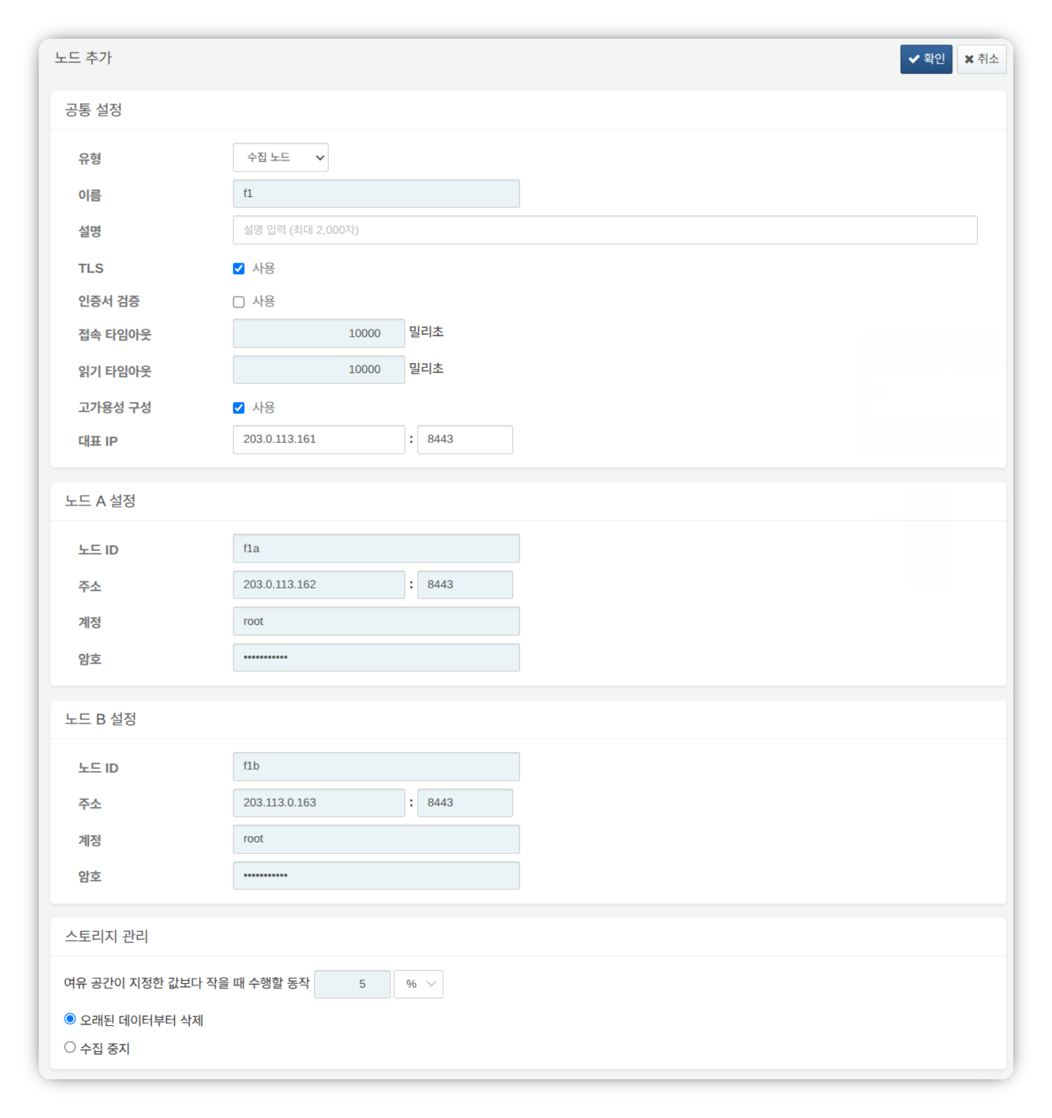
- Type: Select Forwarder Node
- Name: Enter a forwarder node pair identifier (e.g., f1)
- This cannot be changed after clicking the OK button.
- Description: Description of the node pair (optional)
- TLS: Select
- Certificate Verification: Deselect
- Connection Timeout: Use default value
- Read Timeout: Use default value
- High Availability Configuration: Select
- Representative IP: IP address of the forwarder node pair (e.g., 203.0.113.161)
- This IP address is used as the VIP in the HA Script.
- Node A Settings
- Node ID: Enter a Node A identifier (e.g., f1a)
- Address: Actual IP address and communication port of Node A (e.g., 203.0.113.162:8443)
- The port number for forwarder nodes is 8443.
- Account: Enter root
- Password: Enter the Sonar federation account password
- Node B Settings
- Node ID: Enter a Node B identifier (e.g., f1b)
- Address: Actual IP address and communication port of Node B (e.g., 203.0.113.163:8443)
- The port number for forwarder nodes is 8443.
- Account: Enter root
- Password: Enter the Sonar federation account password
After completing the input, click the OK button. Verify that the forwarder node pair has been added as shown below.
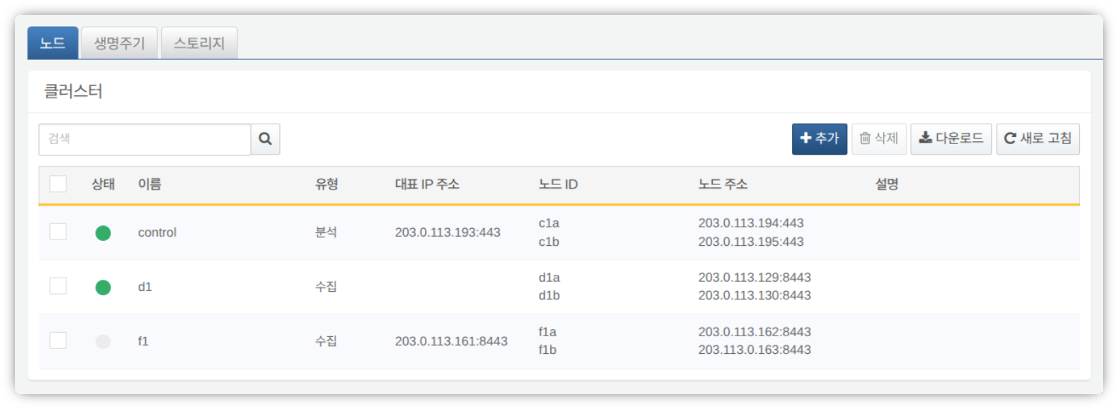
You can click the Name of the added forwarder node to view and modify its properties. If the Name or Node ID was entered incorrectly, you must delete the node pair and reconfigure it.
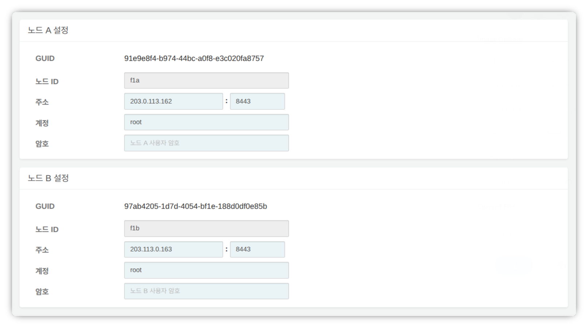
Record the GUIDs of Node A and Node B in a safe place. These values are used in Node GUID Configuration.
Key Encryption Key Replication
Replicate the key encryption key (KEK) from the control node identically to forwarder nodes A and B.
Do not change the key encryption key after completing this configuration. All nodes in the cluster must use the same key encryption key. If different keys are used, encrypted data cannot be decrypted and node synchronization will fail.
Run the following command in the Logpresso shell on control node A or B and record the encryption key string in a safe place.
sonar.cipherKey
Run the following command in the Logpresso shell on forwarder nodes A and B respectively to configure the same encryption key. KEY_STRING is the encryption key string from the control node.
sonar.setCipherKey KEY_STRING
Node GUID Configuration
Set the GUIDs of forwarder nodes A and B, which were obtained during the Registering the Forwarder Node Pair step, in the Logpresso shell of each node.
Run the following command in the Logpresso shell on forwarder nodes A and B to set the policy synchronization GUID for each node in the Logpresso engine.
sonar.setGuid GUID_STRING # Enter the GUID for each respective node
You can verify the policy synchronization GUID for each node with the following command.
sonar.nodeConfig
Master Node Connection Setup
Forwarder nodes are controlled by the control node. Communication is initiated by the forwarder node connecting to the control node, so you must configure the connection information for the policy master node.
Run the following command in the Logpresso shell on Node A and Node B.
sonar.setMaster
The following describes the prompts and values to enter after running the command. The account used here is the federation account.
host? 203.0.113.193 # Representative IP address of the control node pair
port? 443 # Enter 443
account? root # Enter root, the federation account
password? # Enter the federation account password
connect timeout? 10000 # Press Enter to use the default value
read timeout? 10000 # Press Enter to use the default value
secure? true # Enter true (default is false)
skip cert check? true # Enter true (default is false)
Option | Description | Example
host | Representative IP address of the control node pair | 203.0.113.193
port | Federation communication port of the control node | 443
account | Federation account | root
password | Federation account password
connect timeout | Server connection wait time | 10000 (ms)
read timeout | Response wait time | 10000 (ms)
secure | Whether to apply TLS communication | true
skip cert check | Whether to skip TLS certificate validation | true
Run the following command to verify that the node settings have been applied.
sonar.nodeConfig
The following is an example of the output when the settings have been configured correctly.
guid: 7a3241be-c932-4630-8fa5-aefaba773f02
host=203.0.113.193, port=443, account=root, connectTimeout=10000, readTimeout=10000, secure=true, skipCertCheck=true
crypto_file_path: null
Data Replication Mode Configuration
When a node pair is configured, table data can be replicated between the two nodes. Here, "table" does not refer to a database table, but to a file-based table where the Logpresso engine stores data.
If identical data exists on both nodes, duplicate searches may occur when executing distributed queries. To prevent this, each node must be set to either ACTIVE or STANDBY data replication mode.
- Active node: Stores the original log table data and is included as a search target in distributed queries.
- Standby node: Receives real-time replication of log table data from the active node. Replicated tables use the same table IDs as the originals and are excluded from searches in distributed queries, preventing duplicate search results.
The logpresso.setStandbyNode command designates the peer node as standby, making the local node active.
The logpresso.setActiveNode command designates the peer node as active, making the local node standby.
Node A Configuration (Active)
Run the following command in the Logpresso shell on Node A to check the name of the pair node (Node B).
logpresso.nodeStatuses
The following is an example of the output. In the Federation Nodes section, [f1b] is the name of Node B.
Local
------------------
Node GUID: b6b014f9-88c2-48c1-96c8-e23d8bdb65bc
Instance GUID: af43a33f-7985-41cb-9c7b-31224e47c35a
Federation Nodes
------------------
[f1b] node_guid=44494d5a-40c7-4e02-93bb-71adb50f3aec, instance_guid=3189e170-dae7-465a-a713-21e3da40cbb7, repl_mode=null, pair_guid=null, invalid_guid=false, alive=true, paired=true, failure=false, last connect=2025-06-09 13:39:20, last alive=2025-06-10 14:08:08, created=2025-06-09 13:39:20
The Node GUID and Instance GUID shown in the logpresso.nodeStatuses command output are identifiers used by the Logpresso engine for log table replication and distributed queries. The Node GUID is used for database identification and is permanently stored in the DB_GUID file. The Instance GUID is the identifier for the currently running process and changes each time the node process starts.
Run the following command to designate Node B as the standby node, which makes Node A the active node. In the example, f1b is the name of Node B as identified above.
logpresso.setStandbyNode f1b
Run the logpresso.nodeStatuses command again to confirm that Replication Mode has been set to ACTIVE in the Local section.
------------------
Node GUID: b6b014f9-88c2-48c1-96c8-e23d8bdb65bc
Instance GUID: af43a33f-7985-41cb-9c7b-31224e47c35a
Replication Mode: ACTIVE
Pair Node: f1b
Federation Nodes
------------------
[f1b] node_guid=44494d5a-40c7-4e02-93bb-71adb50f3aec, instance_guid=3189e170-dae7-465a-a713-21e3da40cbb7, repl_mode=null, pair_guid=null, invalid_guid=false, alive=true, paired=true, failure=false, last connect=2025-06-09 13:49:36, last alive=2025-06-10 14:08:08, created=2025-06-09 13:49:36
Node B Configuration (Standby)
Run the following command in the Logpresso shell on Node B to designate Node A as active, which makes Node B the standby node. f1a is the name of Node A as identified from the logpresso.nodeStatuses command output.
logpresso.setActiveNode f1a
Run the logpresso.nodeStatuses command to confirm that Replication Mode has been set to STANDBY in the Local section.
Local
------------------
Node GUID: 44494d5a-40c7-4e02-93bb-71adb50f3aec
Instance GUID: 3189e170-dae7-465a-a713-21e3da40cbb7
Replication Mode: STANDBY
Pair Node: f1a
Federation Nodes
------------------
[f1a] node_guid=6b6b014f9-88c2-48c1-96c8-e23d8bdb65bc, instance_guid=af43a33f-7985-41cb-9c7b-31224e47c35a, repl_mode=ACTIVE, pair_guid=44494d5a-40c7-4e02-93bb-71adb50f3aec, invalid_guid=false, alive=true, paired=true, failure=false, last connect=2025-03-26 17:03:11, last alive=2025-03-27 13:40:55, created=2025-03-26 17:03:11
Collected Log Forwarding Setup
To forward data collected by the forwarder node to the base node, you must configure RPC connections. RPC connections are encrypted with TLS, and if a connection is temporarily lost, data is buffered to disk and retransmitted after the connection is restored.
The target node for data forwarding varies depending on the cluster architecture. The target node is called the base node.
- 3-tier architecture: Forward data to data nodes
- 2-tier architecture: Forward data to control nodes
Run the forwarder.setGuid command in the Logpresso shell on forwarder nodes A and B respectively, entering the Node ID of forwarder node A/B that was specified during the Registering the Forwarder Node Pair step. In the example, this corresponds to f1a.
# forwarder.setGuid NODE_ID
forwarder.setGuid f1a
- NODE_ID: The ID of the forwarder node (e.g., f1a, f1b)
Add the properties required for base node connections.
# forwarder.addBase BASE_NAME IP_ADDR PORT SENTRY_CERT CA_CERT SWAP_SIZE
# Active base node
forwarder.addBase d1a 203.0.113.129 7140 logpresso-sentry logpresso-ca 1073741824
# Standby base node
forwarder.addBase d1b 203.0.113.130 7140 logpresso-sentry logpresso-ca 1073741824
- BASE_NAME: Node ID of the base node (e.g., d1a, d1b)
- For a 2-tier architecture (e.g., Logpresso Cloud): the name of the control node
- For a 3-tier architecture: the name of the data node
- IP_ADDR: IP address of the base node (e.g., 203.0.113.129, 203.0.113.130)
- Enter the actual IP address of the base node.
- PORT: RPC communication port (e.g., 7140)
- SENTRY_CERT: RPC communication certificate (e.g., logpresso-sentry)
- CA_CERT: Logpresso CA certificate (e.g., logpresso-ca)
- SWAP_SIZE: Swap size (e.g., 1073741824 (=1GB), unit: bytes).
- Set this considering the size of the /data partition. The swap is a disk swap space that temporarily stores data in case of data node connection failures.
- Set a sufficient size to retain data for the target retention period.
- When the buffer capacity is exceeded, the oldest data is deleted first.
If the base node is configured as a single server, do not add base node B.
Designate the base node pair as a high availability configuration unit. The following command designates d1a and d1b as the member nodes of the d1 base node pair.
# forwarder.addBasepair BASE_PAIR_NAME ACTIVE_NODE STANDBY_NODE
forwarder.addBasepair d1 d1a d1b
- BASE_PAIR_NAME: Name of the base node pair (e.g., d1)
- ACTIVE_NODE: Active node ID (e.g., d1a)
- STANDBY_NODE: Standby node ID (e.g., d1b)
If the base node is a single node, enter the same node ID for both the active and standby nodes.
Run the following command to verify the connections.
forwarder.connections
The following is an example of the output when the settings have been configured correctly.
Connections
--------------------
[d1a] id=1847293650, peer=(a3c7e2f1-8b4d-4a92-9f6e-2d1c8b5a7e3f, /203.0.113.129:7140), trusted level=Low, ssl=true, props={phase=post_hello, type=command}
[d1b] id=1847293651, peer=(b4d8f3g2-9c5e-5b03-0g7f-3e2d9c6b8f4g, /203.0.113.130:7140), trusted level=Low, ssl=true, props={phase=post_hello, type=command}
System Log Forwarding Setup
Configure the forwarder node to collect performance information such as CPU and memory. The collected data can be viewed in the web console under System > Performance Monitor.
Run the sentry.setGuid command in the Logpresso shell on forwarder nodes A and B respectively to set the sentry GUID. Here, the GUID refers to the Node ID. For example, if the Node ID of forwarder node A is f1a, configure it as follows.
# sentry.setGuid SENTRY_NAME
sentry.setGuid f1a
- SENTRY_NAME: Node ID of the sentry (e.g., f1a, f1b)
Run the following command on forwarder nodes A and B to set the control node to which logs will be forwarded.
# sentry.addBase BASE_NAME IP_ADDR PORT SENTRY_CERT CA_CERT SWAP_SIZE
sentry.addBase c1 203.0.113.193 7140 logpresso-sentry logpresso-ca 1073741824
- BASE_NAME: Name of the control node pair (e.g., c1)
- IP_ADDR: Representative IP address of the control node pair (e.g., 203.0.113.193). Unlike RPC connection setup, you must always enter the representative IP address of the control node.
- PORT: Sentry port (e.g., 7140)
- SENTRY_CERT: Sentry certificate (e.g., logpresso-sentry)
- CA_CERT: Logpresso CA certificate (e.g., logpresso-ca)
- SWAP_SIZE: Swap size (e.g., 1073741824 (=1GB), unit: bytes)
Run the following command to verify the connection.
sentry.connections
The following is an example of the output when the settings have been configured correctly.
Connections
--------------------
[c1] id=2035698886, peer=(1b3fcc3f-61ce-41ae-9c45-d0096b8b7fff, /203.0.113.193:7140), trusted level=Low, ssl=true, props={phase=post_hello, type=command}
License Sharing Between Nodes
Configure all nodes in the cluster to be governed by the same license. The license registered on the control node is applied to data nodes and forwarder nodes as well. This section describes how to apply the control node's license to forwarder nodes.
Run the following command in the Logpresso shell on Node A and Node B to enable license sharing.
logpresso.setLicenseMode slave
Run the following command to check the license master status.
logpresso.licenseMode
When configured correctly, the following output is displayed.
SLAVE
(Control Nodes A and B) Refer to this document to register the forwarder nodes as license slaves.
Open a web browser and navigate to https://<Control Node A IP Address>:8443.
Log in with the federation account and go to Settings > License Management.
Click Add New Node in the All Node List.
Enter the license slave node information and click Create.
- Name: Name to identify the forwarder node (e.g., f1a, f1b)
- Host Address: IP address of the forwarder node
- Port: Federation communication port of the forwarder node. Enter 8443.
- User: Federation account ID (root)
- Password: Password of the federation account
- Encrypted Communication: Select Enable.
- Server Certificate Verification: Deselect if it is checked.
- Connection Timeout: Use the default value.
- Read Timeout: Use the default value.
Perform the same steps on control node B.
Enabling Distributed Queries
Distributed Query is a feature that consolidates and queries table data distributed across multiple nodes with a single query. To prevent duplicate searches and obtain correct query results when executing distributed queries, distributed queries must be enabled on all nodes.
Run the following command in the Logpresso shell on Node A and Node B respectively to enable distributed queries.
logpresso.enablePlanner
Run the following command to check the distributed query status.
logpresso.plannerStatus
When enabled correctly, the following output is displayed.
Running: true
Since forwarder nodes forward collected data to data nodes and do not retain data in local tables, query cache configuration is not required, unlike data nodes.
Web Server Configuration
After package installation, some web service ports are open. Close unnecessary ports and open only the ports required for forwarder node operation.
Run the following command in the Logpresso shell to check the open web service ports.
httpd.bindings
The following is an example of the output.
/0.0.0.0:8443 (ssl: key logpresso-web, trust null), opened, default context: webconsole, idle timeout: 0seconds, log file prefix: null, access log: false, error log: false
/0.0.0.0:18443 (ssl: key logpresso-web, trust null), opened, default context: sonar-explanation, idle timeout: 0seconds, log file prefix: null, access log: false, error log: false
/0.0.0.0:443 (ssl: key logpresso-web, trust null), opened, default context: sonar, idle timeout: 0seconds, log file prefix: null, access log: false, error log: false
/0.0.0.0:44300 (ssl: key logpresso-web, trust null), opened, default context: deploy, idle timeout: 0seconds, log file prefix: null, access log: false, error log: false
Run the following commands to close all open web ports and reopen only the port used for federation communication with the updated certificate.
httpd.close 8443
httpd.close 18443
httpd.close 443
httpd.close 44300
httpd.openSsl 8443 webconsole logpresso-web
The httpd mentioned in the commands does not refer to the Apache web server but to the web service of Logpresso Sonar.
WebSocket Frame Configuration (Optional)
Since federation communication uses WebSockets, the default WebSocket frame size may cause transmission failures when distributed query results are large or there is a lot of data to transmit. To handle large volumes of data smoothly, you need to increase the frame size.
Run the following command in the Logpresso shell on Node A and Node B to check the current setting.
webconsole.maxFrameSize
The default value is 8MB, and the command output is as follows.
8,388,608 bytes
Run the following command to change the frame size. The value set in this example is 84MB.
webconsole.setMaxFrameSize 83886080
Run the webconsole.maxFrameSize command again to verify the changed value.
83,886,080 bytes
Service Restart
You must restart the Logpresso service to apply the changed settings. The order of operations is as follows.
Stop order: Standby then Active
Start order: Active then Standby
By default, Node A is active and Node B is standby. Starting the active node first during system operation allows the original data service to be restored quickly, and the standby node can establish the replication connection immediately upon startup.
To stop the nodes:
Run the following command on the standby node (Node B) to stop the Logpresso service.
sudo systemctl stop logpresso
After Node B has stopped, run the same command on active Node A to stop the service.
To start the nodes:
Run the following command on Node A to start the Logpresso service.
sudo systemctl start logpresso
After Node A has started successfully, run the same command on Node B to start the Logpresso service.
Log in to the web console on Node A and verify that the status of each forwarder node is displayed in green on the System > Performance Monitor screen.
If the forwarder node status is not green, you can check the cause in the /opt/logpresso/log/araqne.log file.

Network Redundancy
The forwarder node pair shares a single virtual IP address (VIP, Virtual IP Address) as the representative address between the two nodes, distributing load at the network level and automatically switching connections in the event of a failure. External clients such as data nodes, control nodes, and web browsers access the forwarder node through the VIP, maintaining service continuity regardless of individual node failures.
Network redundancy can be configured in the following two ways.
Load Balancer (Recommended)
Configure a load balancer such as an L4 switch to distribute traffic arriving at the VIP to forwarder nodes A and B. When configuring the load balancer, note the following.
- Health Check: Configure periodic health checks on the listening port (e.g., 7140/tcp) of each forwarder node to verify node availability.
- Failover: Configure the load balancer to automatically exclude nodes that fail health checks from traffic distribution and forward traffic only to healthy nodes.
HA Script
In environments where a load balancer is not available, you can configure VIP failover using the HA script provided by Logpresso. Contact the Logpresso technical support team to obtain the HA script.

Appendix

Troubleshooting

Connection Issues
Data/Forwarder Node Status Displayed as Gray in the Web Console
First, check whether the control node can connect to the web server of the data/forwarder node. Log in to the Logpresso shell on the control node and enter the data/forwarder node IP address and web server port as shown below to verify connectivity.
# tcpscan <data/forwarder node IP> 8443
tcpscan 203.0.113.161 8443
Diagnosing Firewall Policy Issues
Depending on the command execution result, there may be a firewall policy issue or a federation communication port issue as described below.
timeout
If timeout is displayed after a certain period of time when running the tcpscan command as shown below, check all firewall policies along the communication path from the control node to the data/forwarder node and verify the local firewall policy on the node using the firewall-cmd --list-all command.
trying to connect /203.0.113.161:8443
timeout
not opened: Connection refused
If the not opened: Connection refused message is displayed, the federation communication port is not open. Run the httpd.bindings command in the Logpresso shell on the data/forwarder node to recheck the port configuration. Under normal conditions, the output looks like this:
# httpd.bindings command output
/0.0.0.0:8443 (ssl: key logpresso-web, trust null), opened, default context: webconsole, idle timeout: 0seconds, log file prefix: null, access log: false, error log: false
Run the httpd.openSsl command as follows to open the federation communication port:
# httpd.openSsl <port> <context> <key alias>
httpd.openSsl 8443 webconsole logpresso-web
Diagnosing Web Server Certificate Issues
If the tcpscan <data/forwarder node IP> 8443 command shows opened but the data/forwarder node connection status still appears gray in the web console, the SSL certificate or policy synchronization password may be incorrectly configured. To distinguish the cause, try accessing port 8443 of the node from a web browser on your workstation. If ERR_SSL_PROTOCOL_ERROR is displayed as shown below, it is a certificate issue.
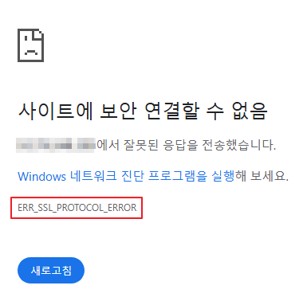
If it is a web server certificate issue on the data/forwarder node, re-run the master node connection setup using the sonar.setMaster command (this process downloads and installs the certificate while communicating with the master node). The following describes the values to enter when running the sonar.setMaster command.
host? 203.0.113.193 # Representative IP address of the control node pair
port? 8443 # Enter 8443
account? root # Enter root, the control node federation account
password? # Enter the control node federation account password
connect timeout? 10000 # Press Enter to use the default value
read timeout? 10000 # Press Enter to use the default value
secure? true # Enter true (default is false)
skip cert check? true # Enter true (default is false)
Diagnosing Policy Synchronization Password Issues
If the ENT web console screen displays normally when you access port 8443 of the data/forwarder node via a web browser, enter the federation account name and password on this screen to check whether you can log in successfully. If login is not possible, run the dom.resetPassword localhost root command in the Logpresso shell on the data/forwarder node to reset the password, then re-enter the reset password in the Password fields under Node A Settings and Node B Settings on the web console System > Cluster > Nodes page.
Data/Forwarder Node Fails to Connect to Control Node via RPC
Diagnosing RPC Connection Status
Run the following commands in the Logpresso shell on the data/forwarder node to check whether the connection to the control node RPC port is established successfully.
forwarder.connections # For forwarder nodes
sentry.connections # For data nodes. Can also be run on forwarder nodes
The command output should display content similar to the following.
Connections
--------------------
[c1a] id=1317075310, peer=(39c2dd55-5bb5-4497-a327-ee6f8cae9ad9, /203.0.113.194:7140), trusted level=Low, ssl=true, props={phase=post_hello, ping_failure=0, type=command}
If no RPC connection related to the control node IP address is displayed as shown above, it may be a firewall policy issue or a certificate issue used for TLS mutual authentication.
Diagnosing Firewall Policy Issues
First, enter the control node IP address and RPC port in the Logpresso shell on the data/forwarder node as shown below to verify connectivity.
# tcpscan <control node IP> 7140
tcpscan 203.0.113.193 7140
If timeout is displayed after a certain period of time as shown below, check all firewall policies along the communication path from the data/forwarder node to the control node.
trying to connect /203.0.113.193:7140
timeout
Diagnosing SSL Certificate Issues
You can check the daemon logs by running the logger.tail command in the Logpresso shell on the data/forwarder node, or by viewing the /opt/logpresso/log/araqne.log file.
Certificate Password Error
If the keystore password was incorrect error occurs as shown below, the certificate password is incorrect.
[2025-01-30 09:24:10.812] WARN (KeyStoreManagerImpl) - getKeyStore() error:
java.io.IOException: keystore password was incorrect
at java.base/sun.security.pkcs12.PKCS12KeyStore.engineLoad(PKCS12KeyStore.java:2116)
at java.base/sun.security.util.KeyStoreDelegator.engineLoad(KeyStoreDelegator.java:222)
at java.base/java.security.KeyStore.load(KeyStore.java:1479)
at org.araqne.keystore.KeyStoreManagerImpl.getKeyStore(KeyStoreManagerImpl.java:298)
at org.araqne.keystore.KeyStoreManagerImpl.getKeyManagerFactory(KeyStoreManagerImpl.java:414)
at org.araqne.rpc.RpcKeyStoreManagerImpl.__M_getKeyManagerFactory(RpcKeyStoreManagerImpl.java:62)
at org.araqne.rpc.RpcKeyStoreManagerImpl.getKeyManagerFactory(RpcKeyStoreManagerImpl.java)
at org.logpresso.sentry.impl.ConnectionWatchdogImpl.__M_connect(ConnectionWatchdogImpl.java:216)
at org.logpresso.sentry.impl.ConnectionWatchdogImpl.connect(ConnectionWatchdogImpl.java)
at org.logpresso.sentry.impl.ConnectionWatchdogImpl.__M_checkConnections(ConnectionWatchdogImpl.java:171)
at org.logpresso.sentry.impl.ConnectionWatchdogImpl.checkConnections(ConnectionWatchdogImpl.java)
at org.logpresso.sentry.impl.ConnectionWatchdogImpl.__M_checkNow(ConnectionWatchdogImpl.java:149)
at org.logpresso.sentry.impl.ConnectionWatchdogImpl.checkNow(ConnectionWatchdogImpl.java)
at org.logpresso.sentry.impl.ConnectionWatchdogImpl.__M_run(ConnectionWatchdogImpl.java:123)
at org.logpresso.sentry.impl.ConnectionWatchdogImpl.run(ConnectionWatchdogImpl.java)
at java.base/java.lang.Thread.run(Thread.java:829)
Caused by: java.security.UnrecoverableKeyException: failed to decrypt safe contents entry: javax.crypto.BadPaddingException: Given final block not properly padded. Such issues can arise if a bad key is used during decryption.
... 16 more
Untrusted Certificate Error
If the No trusted certificate found error occurs as shown below, the automatically generated certificate from the initial daemon startup is being used instead of the certificate issued by the control node.
[2025-01-30 09:28:14.623] ERROR (ConnectionWatchdogImpl) - logpresso-sentry: failed to connect, closing connection (No trusted certificate found)
[2025-01-30 09:28:14.624] ERROR (RpcHandler) - araqne rpc: ssl handshake exception from x.x.x.x:7140, channel 2ca2e90a (No trusted certificate found)
For both errors, re-run the master node connection setup using the sonar.setMaster command (this process downloads and installs the certificate while communicating with the master node). The following describes the values to enter when running the sonar.setMaster command.
host? 203.0.113.193 # Representative IP address of the control node pair
port? 8443 # Enter 8443
account? root # Enter root, the control node federation account
password? # Enter the control node federation account password
connect timeout? 10000 # Press Enter to use the default value
read timeout? 10000 # Press Enter to use the default value
secure? true # Enter true (default is false)
skip cert check? true # Enter true (default is false)

Syslog Reception Diagnostics
If Syslog is not collected properly through the forwarder node even after configuring a collector in the web console, diagnose the issue as follows. In the examples below, it is assumed that packets are being sent from IP address 172.20.100.100.
Forwarder Node Trace
Connect to the forwarder node via SSH and run the following command to enter the Logpresso shell.
ssh -p7022 root@localhost
Run the syslog.servers command to view the Syslog server configuration list.
Syslog Servers
----------------
[logpresso] 0.0.0.0:514 (udp), charset=UTF-8 (override: 0), capacity=20000, rx_buf_size=0, receiver_cpu_id=-1, queue_count=1, buffer_file_path=./, buffer_file_size=10737418240, start from=2024-12-11 13:22:13, received=7
You can view Syslog reception statistics per client IP address using the syslog.stats logpresso command.
Syslog Statistics
-------------------
x.x.x.x => 1 (first seen 2025-01-20 10:58:44, last seen 2025-01-20 10:58:44)
You can trace Syslog packets received in real time using the syslog.trace logpresso command. Press Ctrl+C to stop tracing.
Syslog Packet Verification
You can verify whether packets are reaching the Logpresso forwarder node by using the tcpdump command in the terminal as follows.
# tcpdump -i <interface> host <forwarder node IP address> port <forwarder node syslog port> -A
tcpdump -i any host 172.20.100.100 port 514 -A
Verifying Port Availability
If it has been confirmed that Syslog packets are reaching the forwarder node, run the netstat -na | grep :514 command to check whether the port is open.
# netstat -na | grep :514
udp 0 0 0.0.0.0:514 0.0.0.0:*
If the port is not open as shown above, the JVM privilege assignment step may have been skipped during installation, causing the port to fail to open, or the port configuration may have been changed. Run the following command to check whether cap_net_bind_service is displayed.
# getcap <java executable path>
getcap /opt/logpresso/jdk/bin/java
If the privilege has not been assigned, use the setcap command to grant the required privileges to the java executable.
# setcap cap_net_bind_service,cap_sys_time,cap_net_raw=+ep <java executable path>
setcap cap_net_bind_service,cap_sys_time,cap_net_raw=+ep /opt/logpresso/jdk/bin/java
Verifying Host Firewall Policies
If there are no blocked segments in the connection path from the Syslog client to the forwarder node but Syslog packets are not arriving at the forwarder node at all, run the firewall-cmd --list-ports command to recheck the host firewall policies.
# firewall-cmd --list-ports
Verifying rp_filter Settings
If the firewall policies and port availability are all normal but you cannot verify reception using the syslog.trace command in the Logpresso shell, it may be a Linux kernel Reverse Path Filtering configuration issue.
The Linux kernel Reverse Path Filtering feature verifies the source of packets to block spoofed packets. The default value is 1, which drops packets arriving from invalid routes.
If the forwarder node has multiple network interface cards and packets can be received from the source through multiple network interface cards, change the rp_filter setting.
Checking the Current Settings
Run the cat /proc/sys/net/ipv4/conf/<interface>/rp_filter command to check the rp_filter setting value.
# cat /proc/sys/net/ipv4/conf/eth2/rp_filter # output
1
- 0 (disabled): Does not perform Reverse Path Filtering
- 1 (default, strict): Checks the route for the interface based on the source IP address of the packet, and drops the packet if it does not match
- 2 (loose): Allows the packet if a valid route exists for a packet with the same source IP address through any interface
If the value is 1, add the following setting to the end of the /etc/sysctl.conf file.
net.ipv4.conf.eth2.rp_filter = 2
Run the following command with administrator privileges to apply the kernel configuration change.
sysctl -p

MariaDB
Galera Cluster Cannot Be Restarted
If the cluster does not start after all Galera Cluster servers have been stopped and the database does not start even with the systemctl start mariadb command, restart MariaDB by following these steps.
(Control node A) Edit the /var/lib/mysql/grastate.dat file with administrator privileges.
# GALERA saved state
Version: 2.1
Uuid: 5022f7e5-281a-11e8-98c9-9baa762d13e6
Seqno: -1
Safe_to_bootstrap: 1
- Change the Safe_to_bootstrap value from 1 to 0.
(Control node A) Restart the Galera Cluster server.
sudo galera_new_cluster
(Control node B) Run the following command to start MariaDB and verify that wsrep_start_position has the same value as control node A.
sudo systemctl start mariadb && \
ps -ef | grep mysql
Running this command should produce output similar to the following.
mysql 1141195 1 1 Apr15 ? 22:50:53 /usr/sbin/mariadbd --wsrep_start_position=c6609d0e-091a-11f0-86bb-3e7cc9ee21e7:40512
Node B is joining an already started Galera Cluster, so you must not run the galera_new_cluster command. The galera_new_cluster command should only be run on the first node to start in the cluster.
If the wsrep_start_position value is "00000000-0000-0000-0000-000000000000", run the systemctl restart mariadb command.

OOM and Memory Leak Diagnostics
Generating a Heap Dump
If an OutOfMemoryError (OOM) occurs on a node causing the logpresso process to stop, or if a memory leak is suspected, you can generate a heap dump to diagnose the cause.
The heap dump file size can be similar to the JVM heap size. Make sure there is sufficient free disk space at the save path.
Add the following lines to the end of the /opt/logpresso/etc/logpresso.conf file.
JAVA_OPTS="$JAVA_OPTS -XX:+HeapDumpOnOutOfMemoryError"
JAVA_OPTS="$JAVA_OPTS -XX:HeapDumpPath=/data/heapdump.hprof"
Restart the logpresso process.
sudo systemctl restart logpresso
If an OOM occurs afterward, a heap dump file will be automatically created at the specified path. Verify the file with the following command.
ls -lh /data/heapdump.hprof

Collecting Data for Failure Analysis
Run the jcmd command to find the PID of the java process running araqne-core. The following is an example of the command output.
3370022 /logpresso/araqne-core-4.0.5-package.jar
2428126 jdk.jcmd/sun.tools.jcmd.JCmd
Generate diagnostics artifacts based on the PID identified above.
# Run jcmd based on the PID identified above.
# The file save path can be changed.
# Ensure all artifact files are saved to a directory with sufficient free space.
# Generate jmap
jcmd 3370022 GC.class_histogram > /data/histogram_yyMMdd.txt
# Generate JFR -> (The file will be created after 60 seconds.)
jcmd 3370022 JFR.start duration=60s settings=profile filename=/data/jfr_yyMMdd.jfr
# Generate jstack
jcmd 3370022 Thread.print > /data/jstack_yyMMdd.txt
# Generate HeapDump
# The file size can be as large as the Java heap memory size. Run this in a directory with sufficient free space.
jcmd 3370022 GC.heap_dump -all=true /data/heapdump_yyyyMMdd.hprof
Export the generated diagnostics artifacts.
If you are using an OpenJDK distributed as a ZIP file, the java file path may be registered in the PATH environment variable. Run the 'ps -ef | grep java' command first to check the java file path used to run Logpresso Sonar.
If the path is not registered in PATH, navigate to the directory containing the java file and prepend './' to each command to run the diagnostics artifact generation commands.

logpresso.conf File Properties

Overview
This document describes the options defined in logpresso.conf.

Environment Variables and Launcher Options
The options below control the runtime environment such as JVM memory/GC, ulimit, and paths. They are not mapped to -D system properties (some are used as JVM flags -X, -XX or affect script behavior).
Option | Description | Allowed Values | Default
ETCDIR | Configuration file directory path | Path | $BASEDIR/etc
LOGDIR | Log directory path | Path | $BASEDIR/log
HOSTNAME | Hostname (compatibility) | String | $(hostname)
ARAQNE_CORE_VERSION | Core version (display/compat) | String | Undefined
OPEN_FILE_LIMIT | Process open file limit | Integer | 50,240
OPEN_PROC_LIMIT | Process count limit | Integer | 50,240
JAVA_HOME | JDK path | Path | Undefined
MIN_HEAP_SIZE | JVM initial heap size | e.g., 2G | 2G
MAX_HEAP_SIZE | JVM maximum heap size | e.g., 4G | 4G
MAX_PERMGEN_SIZE | PermGen (legacy JDK) | e.g., 300M | 300M
MAX_DIRECT_MEM_SIZE | Direct memory | e.g., 4G | 4G
GC_LOG_FILECOUNT | Number of GC log files | Integer | 10
GC_LOG_FILESIZE | Max size per GC log file | Size (e.g., 10240K) | 10240K
TRIM_NATIVE_HEAP_INTERVAL | Native heap trim interval | Milliseconds | 300,000
PIDFILE | PID file path | Path | /var/run/logpresso/logpresso.pid
Note: TRIM_NATIVE_HEAP_INTERVAL is applied as -XX:TrimNativeHeapInterval on JDK 21 and above. MIN_HEAP_SIZE/MAX_HEAP_SIZE are applied as -Xms/-Xmx respectively.

System Options
The options below are passed by the launcher as system properties (the mapped -D key is shown in parentheses).
Option | Description | Allowed Values | Default
BASEDIR (-Daraqne.dir) | Base installation path | Path | /opt/logpresso
CERTDIR (-Daraqne.cert.dir) | Certificate/key directory | Path | Undefined
CACHEDIR (-Daraqne.cache.dir) | Cache directory (components) | Path | $BASEDIR/cache (recommended)
DATADIR (-Daraqne.data.dir) | Data directory | Path | $BASEDIR/data
DIAGDIR (-Daraqne.diag.dir) | Abnormal termination/memory dump storage | Path | $BASEDIR/diag
DOWNDIR (-Daraqne.download.dir) | Bundle download temporary directory | Path | $BASEDIR/download
SFTPDIR (-Daraqne.home.dir) | SFTP home directory | Path | $BASEDIR/home
PLGNDIR (-Daraqne.plugin.dir) | Plugin directory | Path | $BASEDIR/plugin
LOGDIR (-Daraqne.log.dir) | Log directory | Path | $BASEDIR/log
INDEXDIR (-Daraqne.index.dir) | Index directory | Path | $DATADIR/logpresso-index/online
LOG_API_STATE_DIR (-Daraqne.logapi.state.dir) | Log API state directory | Path | $DATADIR/araqne-log-api/state
PACKMANDIR (-Daraqne.packman.dir) | Package directory | Path | $BASEDIR/pkg
PIDFILE (-Daraqne.core.pid_file) | PID file path | Path | /var/run/logpresso/logpresso.pid
HTTP_404 (-Daraqne.http.404) | 404 page path | Path | Predefined page
HTTP_500 (-Daraqne.http.500) | 500 page path | Path | Predefined page
HTTPD_AES256 (-Daraqne.httpd.aes256) | Use strong TLS cipher suites | disabled/enabled | disabled
HTTPD_CORS (-Daraqne.httpd.cors) | Enable CORS | disabled/enabled | disabled
HTTPD_LOG_PATH (-Daraqne.httpd.log_path) | HTTP POST logging path | Path | $LOGDIR/httpd
HTTPD_LOG_RETENTION (-Daraqne.httpd.log_days) | HTTP log retention days | Integer (days) | 7
HTTPD_WORKER_POOL (-Daraqne.httpd.max_worker) | Web worker thread count | 4 to CPU core count | Auto
HTTPD_XSS_PROTECT (-Daraqne.httpd.xss_protection) | XSS protection header | disabled/enabled | enabled
HTTPS_PROTOCOL (-Daraqne.https.protocols) | TLS protocol list | TLSv1.1/1.2/1.3,... | Undefined (null)
SSH_OPEN (-Daraqne.ssh.server) | Enable SSH service | disabled/enabled | disabled
SSH_ADDR (-Daraqne.ssh.address) | SSH bind address | IPv4 | 127.0.0.1
SSH_PORT (-Daraqne.ssh.port) | SSH port | 1--65535 | 7022
SSH_TMOUT (-Daraqne.ssh.timeout) | SSH session timeout (ms) | Integer | 600,000
TEL_OPEN (-Daraqne.telnet.server) | Telnet service | disabled/enabled | disabled
TEL_ADDR (-Daraqne.telnet.address) | Telnet bind address | IPv4 | 127.0.0.1
TEL_PORT (-Daraqne.telnet.port) | Telnet port | 1--65535 | 7004
ADM_IP (-Daraqne.dom.admin_trust_hosts) | Admin access allowed IPs | IPv4 (max 2, comma-separated) | Undefined (unlimited)
BLOCK_CC_ADM (-Daraqne.dom.block_concurrent_admin) | Block concurrent admin login | disabled/enabled | disabled
BLOCK_CC_LOGIN (-Daraqne.dom.block_concurrent_login) | Block concurrent login | disabled/enabled | disabled
SSO_TMOUT (-Daraqne.sso.timeout) | SSO token timeout (ms) | Integer | 3,600,000
LOGKEEPDAY (-Daraqne.log.keepdays) | Log retention days | Integer (days) | 7
TAIL_LIMIT (-Daraqne.log.last_size) | logger.tail result limit | Integer (<=0 treated as 0) | 1,000
LOGSTORAGE_REPAIR (-Daraqne.logstorage.repair) | Log storage integrity repair | disabled/enabled | enabled
MSGBUS_DELAY (-Daraqne.msgbus.delay) | Response delay simulation (ms) | Integer | 0
RPC_CLIENT_IOWORKER (-Daraqne.rpc.client.ioworker) | RPC client IO workers | Integer | 2
RPC_CLIENT_OIO (-Daraqne.rpc.client.oio) | RPC OIO mode (blocking I/O) | disabled/enabled | disabled
RPC_WORKER (-Daraqne.rpc.max_worker) | RPC worker thread limit | 4--8 | Auto
REPAIR_FORCECHECK (-Dlogpresso.repair.forcecheck) | Force integrity check on next boot | false/true | false
LOG_EMPTY_LINE (-Daraqne.logapi.collect_empty_line) | Allow empty line collection | disabled/enabled | disabled
LOG_EVICT_MS (-Daraqne.logapi.evict_interval) | Collection buffer eviction interval (ms) | Integer | 3,600,000
LOG_WATCHER_MODE (-Daraqne.logapi.watcher) | File watch mode | naive/null | null
LOG_NIO_POLL_MS (-Daraqne.nio.poll_interval) | NIO polling interval (ms) | Integer | 0
LOG_NIO_POLL_TMOUT (-Daraqne.nio.poll_timeout) | NIO polling timeout (ms) | Integer | 100
HP_FTP_FIX (-Dlogpresso.ftp.rotation.useWuFtpFix) | WuFtpd compatibility fix | false/true | false
JDBC_FETCH (-Dlogpresso.jdbc.fetch_size) | DB fetch size | Integer | 10,000 (collection) / 5,000 (query)
SNMP_MAX_REPEAT (-Dlogpresso.snmp.bulk_max_repeat) | SNMP bulk max-repeat | Integer | 20
SSH_BULK_REQ (-Dlogpresso.ssh.bulk_req) | SFTP bulk request count | Integer | 16
ALLOWED_FILE_SCAN_PATHS (-Daraqne.logdb.allowed_file_scan_paths) | Allowed local file access paths | Paths (comma-separated) | $DATADIR/araqne-logdb/scan,$LOGDIR
LOGDB_ARRAY_CAP (-Daraqne.logdb.array_capacity) | array() input limit | Integer | 100
CEPENGINE (-Daraqne.logdb.cepengine) | CEP storage | mem/offheap | mem
JDK_REGEX_STEP_LIMIT (-Daraqne.logdb.regex.jdk_regex_step_limit) | JDK regex step limit | -1 or integer >= 0 | 300,000,000
COUNTER_SLOT (-Daraqne.logdb.counter_slot) | Slotted counter slot count | Integer | Auto (CPU/config)
DISCARD_NULL_COL (-Daraqne.logdb.discard_null_column) | Discard null columns | false/true | false
DISCARD_NULL_GRP (-Daraqne.logdb.discard_null_group) | Discard null groups | false/true | false
EXEC_QUERY (-Daraqne.logdb.exec_query) | Allow exec/execpip | disabled/enabled | disabled
LEGACY_STR_MATCH (-Daraqne.logdb.legacy_string_match) | Legacy IP string matching | disabled/enabled | disabled
COLUMNS_LIMIT (-Daraqne.logdb.max_columns) | CSV column count limit | Integer | 10,000
LOGDB_PURGE (-Daraqne.logdb.purge) | Allow purge command | disabled/enabled | disabled
QUERY_POOL_SIZE (-Daraqne.logdb.query_pool_size) | Parallel table query core count | Integer | CPU count
SORT_HEAP_SIZE (-Daraqne.logdb.sort_offheap) | Sort offheap size | Size (MB/G) | 100MB
SORT_PARTITIONS (-Daraqne.logdb.sort_partitions) | Sort partition count | Integer | 32
TABLE_OPTIMIZER (-Daraqne.logdb.table_scan_optimizer) | Scan optimizer | disabled/enabled | enabled
UTF8BOM (-Daraqne.logdb.utf8bom) | Add BOM to outputcsv | false/true | false
VALUES_CAP (-Daraqne.logdb.values_capacity) | values() input limit | Integer | 100
WGET_SIZE_LIMIT (-Daraqne.logdb.wget_max_size) | wget max response size | Bytes | 10,485,760
CUREVFIT_LIMIT (-Dlogpresso.curvefit.limit) | curvefit input limit | Integer | 10,000
INSTANT_CACHING (-Dlogpresso.index.instant_caching) | Instant caching | disabled/enabled | enabled
OLD_FULLTEXT (-Dlogpresso.index.old_fulltext_func) | Keep legacy fulltext function | disabled/enabled | disabled
INVERTED_CACHE_SIZE (-Dlogpresso.inverted_cache_size) | Inverted cache size | Bytes | 104,857,600
KMEANS_LIMIT (-Dlogpresso.kmeans.limit) | kmeans input limit | Integer | 10,000
CACHE_RECORD_STATS (-Dlogpresso.log_cache_record_stats) | Table cache statistics | false/true | false
CACHE_SIZE (-Dlogpresso.log_cache_size) | Table cache size | Bytes | 104,857,600
QUERY_RESULT_POOL_SIZE (-Dlogpresso.logstorage.query_result_pool_size) | Temporary result creation threads | 4 to CPU cores | Auto
FCST_SERIAL (-Dlogpresso.ml.forecast.serial) | forecast serial execution | f/t | f
LOF_OPTIMIZER (-Dlogpresso.ml.lof.optimize) | Use LOF optimization | f/t | t
DETECT_DEADLOCK (-Dlogpresso.query.deadlock_detect) | Deadlock detection | disabled/enabled | enabled
REPAIR_CHECKDAYS (-Dlogpresso.repair.checkdays) | Integrity check window (days) | Integer / -1 | 2
STL_LIMIT (-Dlogpresso.stl.limit) | stl input limit | Integer | 1,000
ASYNC_POOL_SIZE (-Dlogpresso.stream.async_pool_size) | Async stream pool size | 1 < Integer <= 100 | CPU count
STREAMJOIN_BUFFER_SIZE (-Dlogpresso.streamjoin.max_buffer_size) | Stream join buffer | Size (M/G) | 1000M
SENTRY_LINK_SPEED (-Dlogpresso.sentry.default_link_speed) | Sentry link speed | 10m/100m/1g/10g | 0
SENTRY_FLOWCTRL (-Dlogpresso.sentry.disableFlowControl) | Flow control | false/true | false
SENTRY_HOSTNAME (-Dlogpresso.sentry.hostname) | Sentry hostname | String | $(hostname)
SENTRY_AWS_PROFILE (-Dlogpresso.sentry.logger_provisioning_profile) | Sentry provisioning profile | String (UUID, etc.) | null
ROOT_ID (-Daraqne.dom.master_account) | Root account ID rename | String | root
HASHJOINTHRESHOLD (-Daraqne.hashjointhreshold) | Hash join threshold | Integer | 10,000,000
VERIFY_SIGN (-Dlogpresso.packman.verify_sign) | Allow unsigned packages | disabled/enabled | enabled
AWT_HEADLESS (-Djava.awt.headless) | Headless mode | false/true | true
Notes:
- SSH_OPEN/TEL_OPEN only pass the related properties when the value is not disabled.
- Some entries are commented out in the template and take effect only when uncommented.

