Forwarder Node Configuration
This document describes the tasks to perform after completing package installation on forwarder nodes. These tasks can be performed after completing the Data Node Configuration.
- Federation Communication Account Setup: Configure the federation account password for forwarder nodes.
- Forwarder Node Pair Setup: Register forwarder node pairs and perform related settings in the web console.
- Network Redundancy: Configure network high availability (HA) using a virtual IP address (VIP).

Federation Communication Account Setup
Accessing the Logpresso Shell
You must access the Logpresso shell on forwarder nodes A and B separately and change the initial password. It is recommended to register an SSH key in case you forget your password.
Changing the Default Password
Run the following command in the terminal to access the Logpresso shell. The port number may vary depending on the SSH_PORT setting in the logpresso.conf file (default: 7022).
ssh -p 7022 root@localhost
When the password prompt appears, enter the initial Logpresso shell password.
When the new password prompt appears, enter a new password and press Enter. Since the Logpresso shell account is only used for SSH access to each node, it is acceptable to set a different password for each node.
Please change the default password.
New password: # Enter the new password and press Enter
Retype password: # Re-enter the new password and press Enter
Password changed successfully.
Logpresso SNR-4.0.2511.1 (build 20250805) on Araqne Core 4.0.5
logpresso> # Logpresso shell prompt
The Logpresso shell rejects reuse of the default password. Never reuse the default password for any account. Logpresso is not responsible for any issues that arise from using the default password.
Depending on the operating system, you may be unable to connect to the Logpresso shell due to SSH key exchange and encryption algorithm negotiation failures. Add the following content to the ~/.ssh/config file on forwarder nodes A and B, and connect using the ssh sonar command.
Host sonar
HostName 127.0.0.1
Port 7022
User root
HostKeyAlgorithms +ssh-rsa
PubkeyAcceptedAlgorithms +ssh-rsa
KexAlgorithms +diffie-hellman-group14-sha1
Ciphers +aes256-cbc
PreferredAuthentications publickey # SSH key login
IdentityOnly yes # SSH key login
IdentityFile ~/.ssh/logpresso_rsa # SSH key login
SSH Key Registration (Optional)
You can access the Logpresso shell using SSH key authentication. SSH key registration is recommended as it allows access even if you forget your password.
If you do not have an RSA key, run the following command to generate a key pair.
ssh-keygen -t rsa -b 2048 -f ~/.ssh/logpresso_rsa
The Logpresso shell only supports ssh-rsa keys.
Run the following command in the Logpresso shell to register your SSH public key.
account.addSshKey root
When prompted, enter your SSH public key. The public key is located in the ~/.ssh/logpresso_rsa.pub file.
SSH public key? ssh-rsa AAAAB3NzaC1yc2EAAAADAQABAAACAQ... # Enter the full public key
root password: # Enter the current password
added
You can also specify the absolute path to the public key file directly: account.addSshKey root /home/logpresso/.ssh/logpresso_rsa.pub
Run the following command to verify the registered SSH key list.
account.sshKeys root
After running the command, you can see the registered SSH keys as follows.
Authorized SSH keys
---------------------
1: ssh-rsa AAAAB3NzaC1yc2EAAAADAQABAAACAQ...
You can now access the Logpresso shell using the SSH key without a password.
ssh -p 7022 -i ~/.ssh/logpresso_rsa root@localhost
Setting the Federation Account Password
The federation account is used for communication between all nodes that make up the cluster. It uses the same federation account password that was already set on the control node pair.
Run the following command in the Logpresso shell on forwarder nodes A and B to change the federation account password.
dom.resetPassword localhost root
When the new password prompt appears, enter the same federation account password that was set on the control node pair and press Enter.
New Password: # Enter the password and press Enter
- The password can only be entered once. If you enter the wrong password, re-run the dom.resetPassword localhost root command.
The federation account root and the Logpresso shell account root share the same name but belong to different authentication domains. During the federation password change process, ERROR logs may temporarily appear in araqne.log, but they will be resolved after the change is complete.
Refer to this document to change the password expiration of the federation account to unlimited.
Open a web browser and navigate to https://<Forwarder Node A IP Address>:8443, then log in with the federation account.
In the web console left menu, go to System > Accounts.
Click root in the federation account list.
In the Password Expiration field, select Unlimited and click the Save button.
Perform the same steps on Node B.

Forwarder Node Pair Setup
Registering the Forwarder Node Pair
Register the forwarder node pair in the web console under System > Cluster > Nodes.
Click the Add button at the top right of the cluster node list and configure the forwarder node pair. For descriptions of each property, refer to Add Node Pair in the user guide.
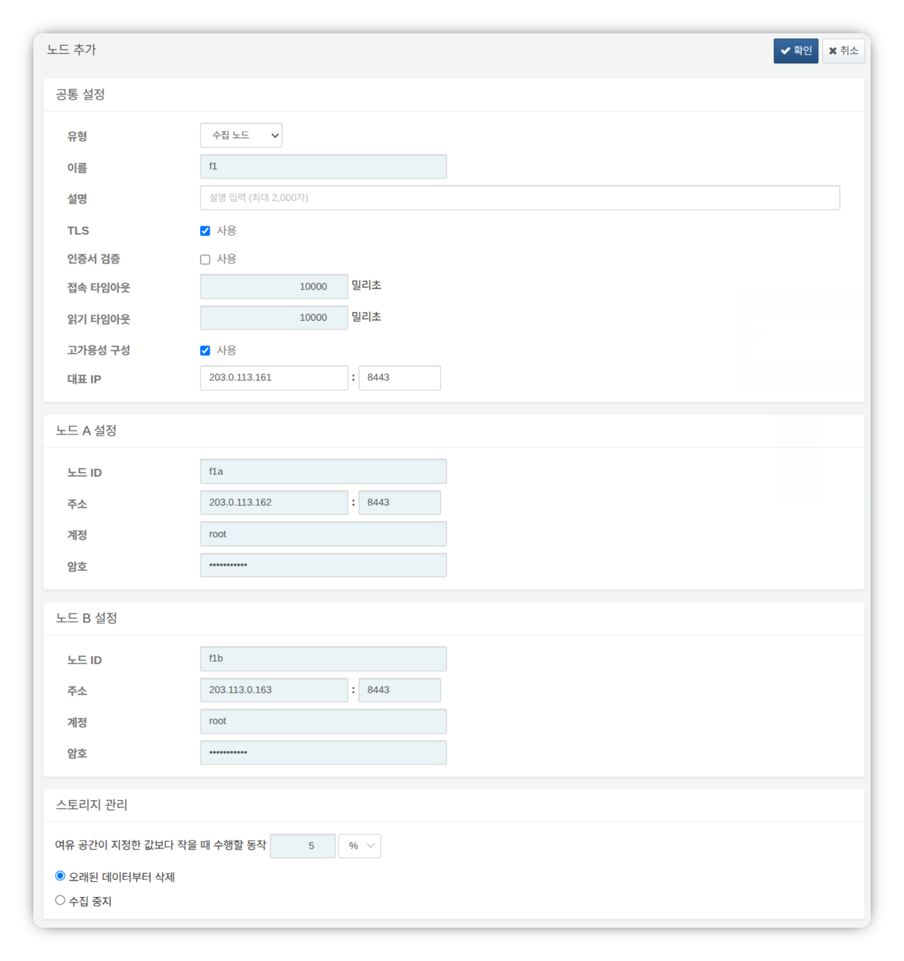
- Type: Select Forwarder Node
- Name: Enter a forwarder node pair identifier (e.g., f1)
- This cannot be changed after clicking the OK button.
- Description: Description of the node pair (optional)
- TLS: Select
- Certificate Verification: Deselect
- Connection Timeout: Use default value
- Read Timeout: Use default value
- High Availability Configuration: Select
- Representative IP: IP address of the forwarder node pair (e.g., 203.0.113.161)
- This IP address is used as the VIP in the HA Script.
- Node A Settings
- Node ID: Enter a Node A identifier (e.g., f1a)
- Address: Actual IP address and communication port of Node A (e.g., 203.0.113.162:8443)
- The port number for forwarder nodes is 8443.
- Account: Enter root
- Password: Enter the Sonar federation account password
- Node B Settings
- Node ID: Enter a Node B identifier (e.g., f1b)
- Address: Actual IP address and communication port of Node B (e.g., 203.0.113.163:8443)
- The port number for forwarder nodes is 8443.
- Account: Enter root
- Password: Enter the Sonar federation account password
After completing the input, click the OK button. Verify that the forwarder node pair has been added as shown below.
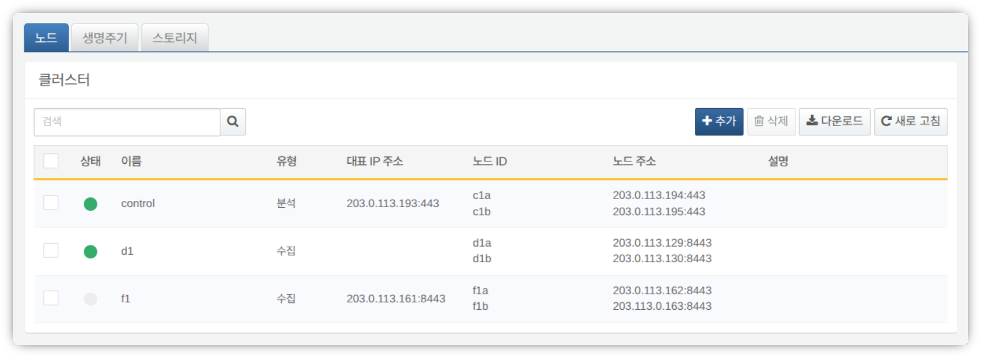
You can click the Name of the added forwarder node to view and modify its properties. If the Name or Node ID was entered incorrectly, you must delete the node pair and reconfigure it.
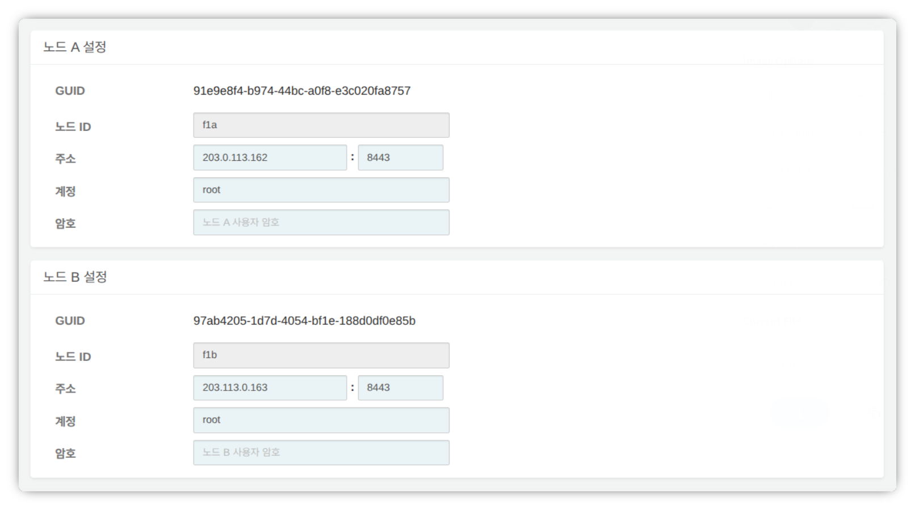
Record the GUIDs of Node A and Node B in a safe place. These values are used in Node GUID Configuration.
Key Encryption Key Replication
Replicate the key encryption key (KEK) from the control node identically to forwarder nodes A and B.
Do not change the key encryption key after completing this configuration. All nodes in the cluster must use the same key encryption key. If different keys are used, encrypted data cannot be decrypted and node synchronization will fail.
Run the following command in the Logpresso shell on control node A or B and record the encryption key string in a safe place.
sonar.cipherKey
Run the following command in the Logpresso shell on forwarder nodes A and B respectively to configure the same encryption key. KEY_STRING is the encryption key string from the control node.
sonar.setCipherKey KEY_STRING
Node GUID Configuration
Set the GUIDs of forwarder nodes A and B, which were obtained during the Registering the Forwarder Node Pair step, in the Logpresso shell of each node.
Run the following command in the Logpresso shell on forwarder nodes A and B to set the policy synchronization GUID for each node in the Logpresso engine.
sonar.setGuid GUID_STRING # Enter the GUID for each respective node
You can verify the policy synchronization GUID for each node with the following command.
sonar.nodeConfig
Master Node Connection Setup
Forwarder nodes are controlled by the control node. Communication is initiated by the forwarder node connecting to the control node, so you must configure the connection information for the policy master node.
Run the following command in the Logpresso shell on Node A and Node B.
sonar.setMaster
The following describes the prompts and values to enter after running the command. The account used here is the federation account.
host? 203.0.113.193 # Representative IP address of the control node pair
port? 443 # Enter 443
account? root # Enter root, the federation account
password? # Enter the federation account password
connect timeout? 10000 # Press Enter to use the default value
read timeout? 10000 # Press Enter to use the default value
secure? true # Enter true (default is false)
skip cert check? true # Enter true (default is false)
Option | Description | Example
host | Representative IP address of the control node pair | 203.0.113.193
port | Federation communication port of the control node | 443
account | Federation account | root
password | Federation account password
connect timeout | Server connection wait time | 10000 (ms)
read timeout | Response wait time | 10000 (ms)
secure | Whether to apply TLS communication | true
skip cert check | Whether to skip TLS certificate validation | true
Run the following command to verify that the node settings have been applied.
sonar.nodeConfig
The following is an example of the output when the settings have been configured correctly.
guid: 7a3241be-c932-4630-8fa5-aefaba773f02
host=203.0.113.193, port=443, account=root, connectTimeout=10000, readTimeout=10000, secure=true, skipCertCheck=true
crypto_file_path: null
Data Replication Mode Configuration
When a node pair is configured, table data can be replicated between the two nodes. Here, "table" does not refer to a database table, but to a file-based table where the Logpresso engine stores data.
If identical data exists on both nodes, duplicate searches may occur when executing distributed queries. To prevent this, each node must be set to either ACTIVE or STANDBY data replication mode.
- Active node: Stores the original log table data and is included as a search target in distributed queries.
- Standby node: Receives real-time replication of log table data from the active node. Replicated tables use the same table IDs as the originals and are excluded from searches in distributed queries, preventing duplicate search results.
The logpresso.setStandbyNode command designates the peer node as standby, making the local node active.
The logpresso.setActiveNode command designates the peer node as active, making the local node standby.
Node A Configuration (Active)
Run the following command in the Logpresso shell on Node A to check the name of the pair node (Node B).
logpresso.nodeStatuses
The following is an example of the output. In the Federation Nodes section, [f1b] is the name of Node B.
Local
------------------
Node GUID: b6b014f9-88c2-48c1-96c8-e23d8bdb65bc
Instance GUID: af43a33f-7985-41cb-9c7b-31224e47c35a
Federation Nodes
------------------
[f1b] node_guid=44494d5a-40c7-4e02-93bb-71adb50f3aec, instance_guid=3189e170-dae7-465a-a713-21e3da40cbb7, repl_mode=null, pair_guid=null, invalid_guid=false, alive=true, paired=true, failure=false, last connect=2025-06-09 13:39:20, last alive=2025-06-10 14:08:08, created=2025-06-09 13:39:20
The Node GUID and Instance GUID shown in the logpresso.nodeStatuses command output are identifiers used by the Logpresso engine for log table replication and distributed queries. The Node GUID is used for database identification and is permanently stored in the DB_GUID file. The Instance GUID is the identifier for the currently running process and changes each time the node process starts.
Run the following command to designate Node B as the standby node, which makes Node A the active node. In the example, f1b is the name of Node B as identified above.
logpresso.setStandbyNode f1b
Run the logpresso.nodeStatuses command again to confirm that Replication Mode has been set to ACTIVE in the Local section.
------------------
Node GUID: b6b014f9-88c2-48c1-96c8-e23d8bdb65bc
Instance GUID: af43a33f-7985-41cb-9c7b-31224e47c35a
Replication Mode: ACTIVE
Pair Node: f1b
Federation Nodes
------------------
[f1b] node_guid=44494d5a-40c7-4e02-93bb-71adb50f3aec, instance_guid=3189e170-dae7-465a-a713-21e3da40cbb7, repl_mode=null, pair_guid=null, invalid_guid=false, alive=true, paired=true, failure=false, last connect=2025-06-09 13:49:36, last alive=2025-06-10 14:08:08, created=2025-06-09 13:49:36
Node B Configuration (Standby)
Run the following command in the Logpresso shell on Node B to designate Node A as active, which makes Node B the standby node. f1a is the name of Node A as identified from the logpresso.nodeStatuses command output.
logpresso.setActiveNode f1a
Run the logpresso.nodeStatuses command to confirm that Replication Mode has been set to STANDBY in the Local section.
Local
------------------
Node GUID: 44494d5a-40c7-4e02-93bb-71adb50f3aec
Instance GUID: 3189e170-dae7-465a-a713-21e3da40cbb7
Replication Mode: STANDBY
Pair Node: f1a
Federation Nodes
------------------
[f1a] node_guid=6b6b014f9-88c2-48c1-96c8-e23d8bdb65bc, instance_guid=af43a33f-7985-41cb-9c7b-31224e47c35a, repl_mode=ACTIVE, pair_guid=44494d5a-40c7-4e02-93bb-71adb50f3aec, invalid_guid=false, alive=true, paired=true, failure=false, last connect=2025-03-26 17:03:11, last alive=2025-03-27 13:40:55, created=2025-03-26 17:03:11
Collected Log Forwarding Setup
To forward data collected by the forwarder node to the base node, you must configure RPC connections. RPC connections are encrypted with TLS, and if a connection is temporarily lost, data is buffered to disk and retransmitted after the connection is restored.
The target node for data forwarding varies depending on the cluster architecture. The target node is called the base node.
- 3-tier architecture: Forward data to data nodes
- 2-tier architecture: Forward data to control nodes
Run the forwarder.setGuid command in the Logpresso shell on forwarder nodes A and B respectively, entering the Node ID of forwarder node A/B that was specified during the Registering the Forwarder Node Pair step. In the example, this corresponds to f1a.
# forwarder.setGuid NODE_ID
forwarder.setGuid f1a
- NODE_ID: The ID of the forwarder node (e.g., f1a, f1b)
Add the properties required for base node connections.
# forwarder.addBase BASE_NAME IP_ADDR PORT SENTRY_CERT CA_CERT SWAP_SIZE
# Active base node
forwarder.addBase d1a 203.0.113.129 7140 logpresso-sentry logpresso-ca 1073741824
# Standby base node
forwarder.addBase d1b 203.0.113.130 7140 logpresso-sentry logpresso-ca 1073741824
- BASE_NAME: Node ID of the base node (e.g., d1a, d1b)
- For a 2-tier architecture (e.g., Logpresso Cloud): the name of the control node
- For a 3-tier architecture: the name of the data node
- IP_ADDR: IP address of the base node (e.g., 203.0.113.129, 203.0.113.130)
- Enter the actual IP address of the base node.
- PORT: RPC communication port (e.g., 7140)
- SENTRY_CERT: RPC communication certificate (e.g., logpresso-sentry)
- CA_CERT: Logpresso CA certificate (e.g., logpresso-ca)
- SWAP_SIZE: Swap size (e.g., 1073741824 (=1GB), unit: bytes).
- Set this considering the size of the /data partition. The swap is a disk swap space that temporarily stores data in case of data node connection failures.
- Set a sufficient size to retain data for the target retention period.
- When the buffer capacity is exceeded, the oldest data is deleted first.
If the base node is configured as a single server, do not add base node B.
Designate the base node pair as a high availability configuration unit. The following command designates d1a and d1b as the member nodes of the d1 base node pair.
# forwarder.addBasepair BASE_PAIR_NAME ACTIVE_NODE STANDBY_NODE
forwarder.addBasepair d1 d1a d1b
- BASE_PAIR_NAME: Name of the base node pair (e.g., d1)
- ACTIVE_NODE: Active node ID (e.g., d1a)
- STANDBY_NODE: Standby node ID (e.g., d1b)
If the base node is a single node, enter the same node ID for both the active and standby nodes.
Run the following command to verify the connections.
forwarder.connections
The following is an example of the output when the settings have been configured correctly.
Connections
--------------------
[d1a] id=1847293650, peer=(a3c7e2f1-8b4d-4a92-9f6e-2d1c8b5a7e3f, /203.0.113.129:7140), trusted level=Low, ssl=true, props={phase=post_hello, type=command}
[d1b] id=1847293651, peer=(b4d8f3g2-9c5e-5b03-0g7f-3e2d9c6b8f4g, /203.0.113.130:7140), trusted level=Low, ssl=true, props={phase=post_hello, type=command}
System Log Forwarding Setup
Configure the forwarder node to collect performance information such as CPU and memory. The collected data can be viewed in the web console under System > Performance Monitor.
Run the sentry.setGuid command in the Logpresso shell on forwarder nodes A and B respectively to set the sentry GUID. Here, the GUID refers to the Node ID. For example, if the Node ID of forwarder node A is f1a, configure it as follows.
# sentry.setGuid SENTRY_NAME
sentry.setGuid f1a
- SENTRY_NAME: Node ID of the sentry (e.g., f1a, f1b)
Run the following command on forwarder nodes A and B to set the control node to which logs will be forwarded.
# sentry.addBase BASE_NAME IP_ADDR PORT SENTRY_CERT CA_CERT SWAP_SIZE
sentry.addBase c1 203.0.113.193 7140 logpresso-sentry logpresso-ca 1073741824
- BASE_NAME: Name of the control node pair (e.g., c1)
- IP_ADDR: Representative IP address of the control node pair (e.g., 203.0.113.193). Unlike RPC connection setup, you must always enter the representative IP address of the control node.
- PORT: Sentry port (e.g., 7140)
- SENTRY_CERT: Sentry certificate (e.g., logpresso-sentry)
- CA_CERT: Logpresso CA certificate (e.g., logpresso-ca)
- SWAP_SIZE: Swap size (e.g., 1073741824 (=1GB), unit: bytes)
Run the following command to verify the connection.
sentry.connections
The following is an example of the output when the settings have been configured correctly.
Connections
--------------------
[c1] id=2035698886, peer=(1b3fcc3f-61ce-41ae-9c45-d0096b8b7fff, /203.0.113.193:7140), trusted level=Low, ssl=true, props={phase=post_hello, type=command}
License Sharing Between Nodes
Configure all nodes in the cluster to be governed by the same license. The license registered on the control node is applied to data nodes and forwarder nodes as well. This section describes how to apply the control node's license to forwarder nodes.
Run the following command in the Logpresso shell on Node A and Node B to enable license sharing.
logpresso.setLicenseMode slave
Run the following command to check the license master status.
logpresso.licenseMode
When configured correctly, the following output is displayed.
SLAVE
(Control Nodes A and B) Refer to this document to register the forwarder nodes as license slaves.
Open a web browser and navigate to https://<Control Node A IP Address>:8443.
Log in with the federation account and go to Settings > License Management.
Click Add New Node in the All Node List.
Enter the license slave node information and click Create.
- Name: Name to identify the forwarder node (e.g., f1a, f1b)
- Host Address: IP address of the forwarder node
- Port: Federation communication port of the forwarder node. Enter 8443.
- User: Federation account ID (root)
- Password: Password of the federation account
- Encrypted Communication: Select Enable.
- Server Certificate Verification: Deselect if it is checked.
- Connection Timeout: Use the default value.
- Read Timeout: Use the default value.
Perform the same steps on control node B.
Enabling Distributed Queries
Distributed Query is a feature that consolidates and queries table data distributed across multiple nodes with a single query. To prevent duplicate searches and obtain correct query results when executing distributed queries, distributed queries must be enabled on all nodes.
Run the following command in the Logpresso shell on Node A and Node B respectively to enable distributed queries.
logpresso.enablePlanner
Run the following command to check the distributed query status.
logpresso.plannerStatus
When enabled correctly, the following output is displayed.
Running: true
Since forwarder nodes forward collected data to data nodes and do not retain data in local tables, query cache configuration is not required, unlike data nodes.
Web Server Configuration
After package installation, some web service ports are open. Close unnecessary ports and open only the ports required for forwarder node operation.
Run the following command in the Logpresso shell to check the open web service ports.
httpd.bindings
The following is an example of the output.
/0.0.0.0:8443 (ssl: key logpresso-web, trust null), opened, default context: webconsole, idle timeout: 0seconds, log file prefix: null, access log: false, error log: false
/0.0.0.0:18443 (ssl: key logpresso-web, trust null), opened, default context: sonar-explanation, idle timeout: 0seconds, log file prefix: null, access log: false, error log: false
/0.0.0.0:443 (ssl: key logpresso-web, trust null), opened, default context: sonar, idle timeout: 0seconds, log file prefix: null, access log: false, error log: false
/0.0.0.0:44300 (ssl: key logpresso-web, trust null), opened, default context: deploy, idle timeout: 0seconds, log file prefix: null, access log: false, error log: false
Run the following commands to close all open web ports and reopen only the port used for federation communication with the updated certificate.
httpd.close 8443
httpd.close 18443
httpd.close 443
httpd.close 44300
httpd.openSsl 8443 webconsole logpresso-web
The httpd mentioned in the commands does not refer to the Apache web server but to the web service of Logpresso Sonar.
WebSocket Frame Configuration (Optional)
Since federation communication uses WebSockets, the default WebSocket frame size may cause transmission failures when distributed query results are large or there is a lot of data to transmit. To handle large volumes of data smoothly, you need to increase the frame size.
Run the following command in the Logpresso shell on Node A and Node B to check the current setting.
webconsole.maxFrameSize
The default value is 8MB, and the command output is as follows.
8,388,608 bytes
Run the following command to change the frame size. The value set in this example is 84MB.
webconsole.setMaxFrameSize 83886080
Run the webconsole.maxFrameSize command again to verify the changed value.
83,886,080 bytes
Service Restart
You must restart the Logpresso service to apply the changed settings. The order of operations is as follows.
Stop order: Standby then Active
Start order: Active then Standby
By default, Node A is active and Node B is standby. Starting the active node first during system operation allows the original data service to be restored quickly, and the standby node can establish the replication connection immediately upon startup.
To stop the nodes:
Run the following command on the standby node (Node B) to stop the Logpresso service.
sudo systemctl stop logpresso
After Node B has stopped, run the same command on active Node A to stop the service.
To start the nodes:
Run the following command on Node A to start the Logpresso service.
sudo systemctl start logpresso
After Node A has started successfully, run the same command on Node B to start the Logpresso service.
Log in to the web console on Node A and verify that the status of each forwarder node is displayed in green on the System > Performance Monitor screen.
If the forwarder node status is not green, you can check the cause in the /opt/logpresso/log/araqne.log file.

Network Redundancy
The forwarder node pair shares a single virtual IP address (VIP, Virtual IP Address) as the representative address between the two nodes, distributing load at the network level and automatically switching connections in the event of a failure. External clients such as data nodes, control nodes, and web browsers access the forwarder node through the VIP, maintaining service continuity regardless of individual node failures.
Network redundancy can be configured in the following two ways.
Load Balancer (Recommended)
Configure a load balancer such as an L4 switch to distribute traffic arriving at the VIP to forwarder nodes A and B. When configuring the load balancer, note the following.
- Health Check: Configure periodic health checks on the listening port (e.g., 7140/tcp) of each forwarder node to verify node availability.
- Failover: Configure the load balancer to automatically exclude nodes that fail health checks from traffic distribution and forward traffic only to healthy nodes.
HA Script
In environments where a load balancer is not available, you can configure VIP failover using the HA script provided by Logpresso. Contact the Logpresso technical support team to obtain the HA script.

