Deployment Topologies
Logpresso Sonar supports cluster configurations where multiple nodes (servers) are grouped together to operate as a single system. Configuring a cluster allows high availability (HA) settings to be applied to each node to enhance stability and usability.

Architecture
Cluster architecture can be categorized as follows based on the tiers that compose the cluster.
- 1-Tier: Control node (single tier)
- 2-Tier: Forwarder (tier 1) - Control (tier 2) / Data (tier 1) - Control (tier 2)
- 3-Tier: Forwarder (tier 1) - Data (tier 2) - Control (tier 3)
Choose the appropriate architecture based on the volume of raw logs collected per day. The recommended architecture by Logpresso is 3-tier.
1-Tier: Control Node
The 1-tier configuration is illustrated as follows. The left shows a single control node configuration, and the right shows a control node pair configuration. A 1-tier cluster can process up to 250GB of data per day (250GB/day).
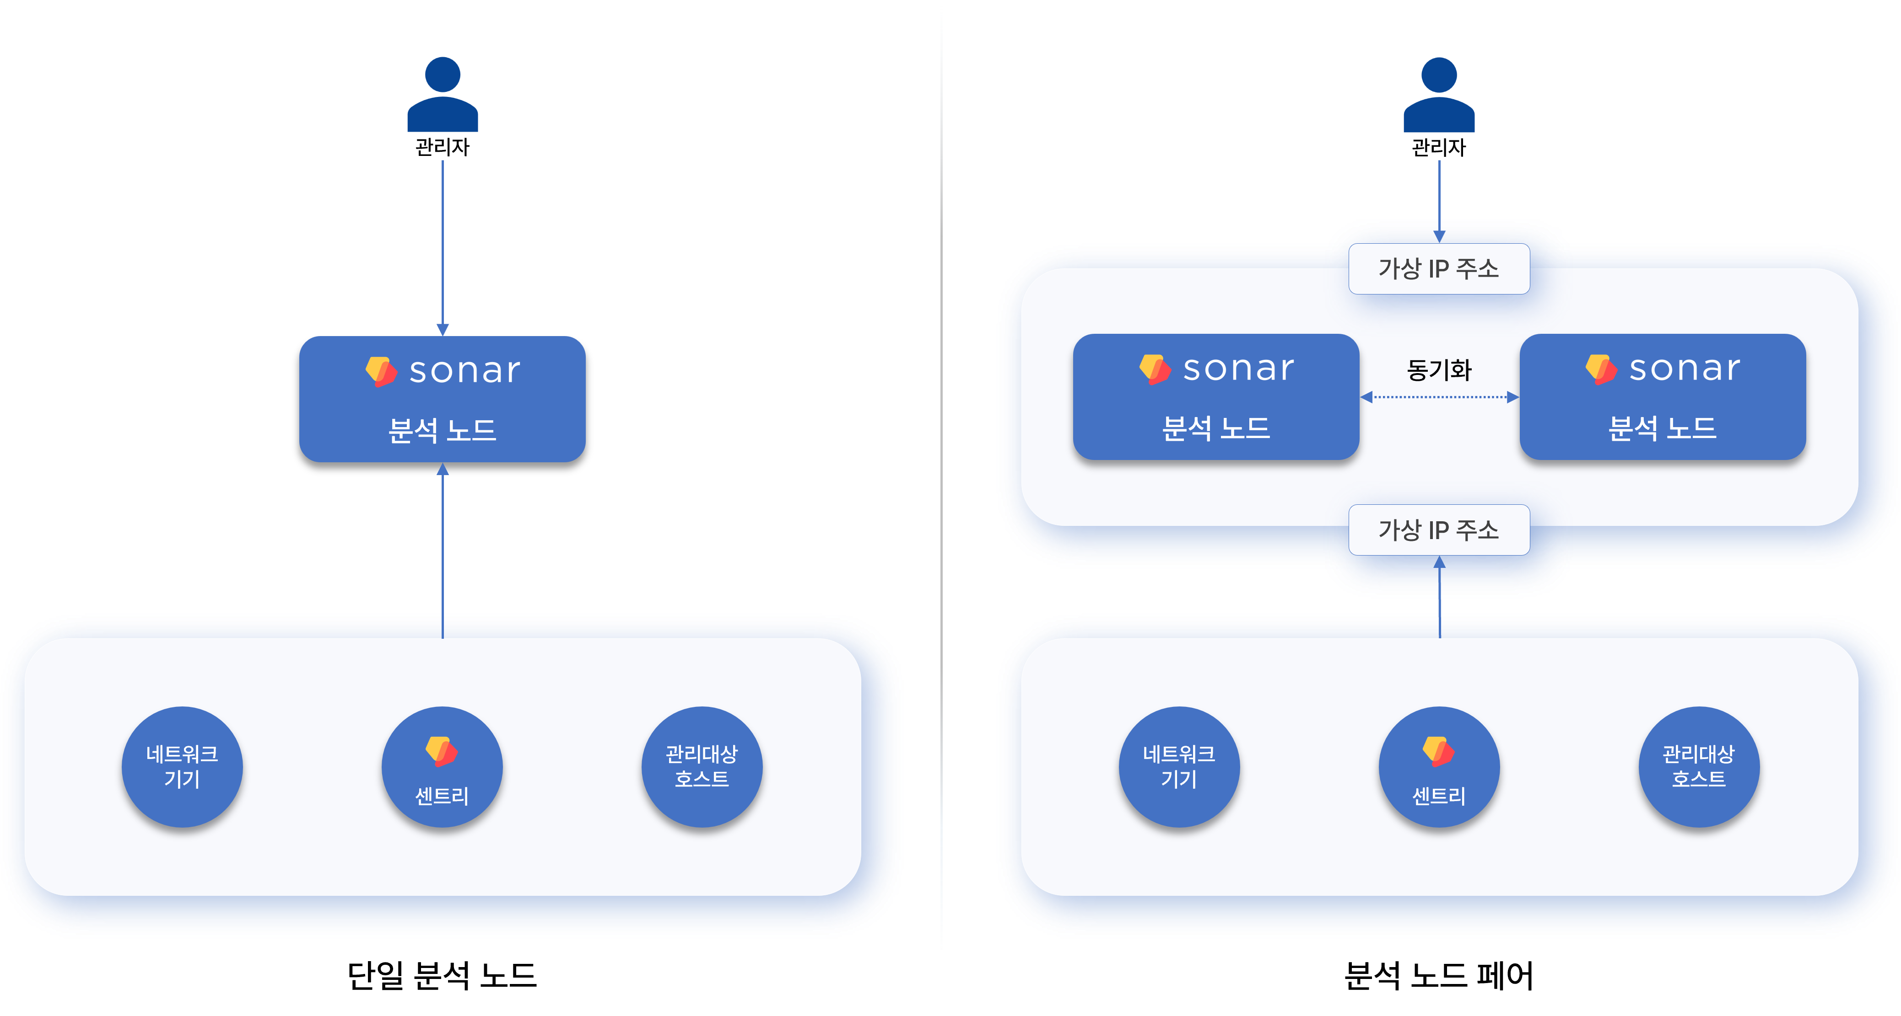
A single control node is the simplest structure that performs the functions of both a data node and a control node simultaneously. If the node fails, data loss may occur.
A control node pair shares a virtual IP address between each node.
- For network load balancing, when data is sent to the IP address of an L4 load balancer/switch placed above, one of the two nodes receives the data.
- When network devices, managed hosts, or sentries send data, the active node of the control node pair receives the data and synchronizes it with the standby node.
- When a user accesses the web console through the virtual IP address, one of the two nodes provides the service.
If the data to be collected increases, you should change to a 3-tier configuration.
2-Tier: Forwarder-Control / Data-Control
The 2-tier configuration is illustrated as follows. The left shows the forwarder-control node configuration, and the right shows the data-control node configuration (legacy).
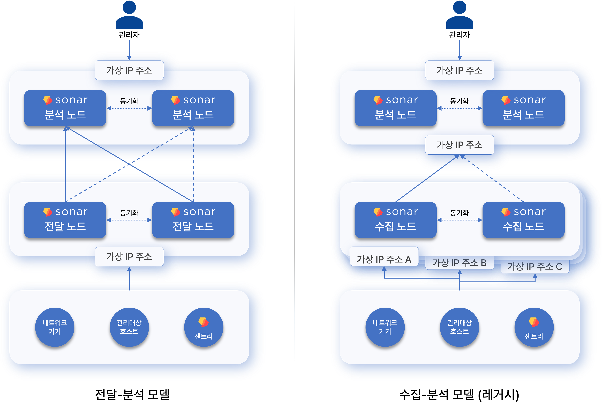
The forwarder-control configuration is the default configuration found in [Logpresso Cloud](https://logpresso.cloud/). The forwarder node was introduced in version 4.0.2404.0, serving as a data gateway and load balancer (related documentation). Forwarder nodes can be operated as a single node, but redundancy is recommended.
The data-control configuration (legacy) is the architecture used before version 4.0.2404.0. Since each data source (network devices, managed hosts, sentries) must communicate with specifically designated data node pairs, the network topology becomes more complex as the number of data node pairs increases, so this configuration is not recommended.
3-Tier: Forwarder-Data-Control
The 3-tier configuration is recommended for large-scale data collection environments.
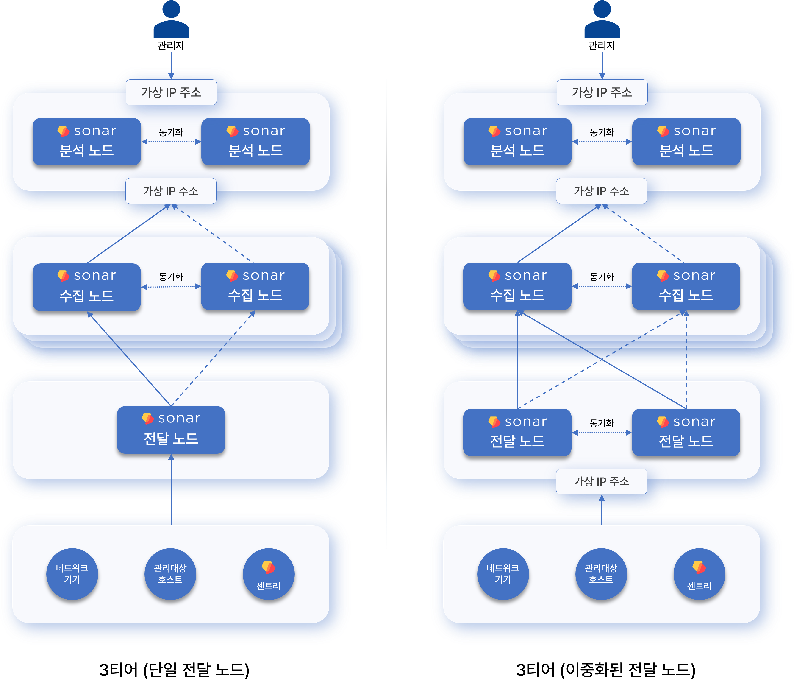
If there are 2 or more data node pairs, forwarder nodes must be configured. Adding forwarder nodes resolves the topology issues of the 2-tier data-control model.

Functions by Node
Nodes (servers) composing the Logpresso cluster are classified into control nodes, data nodes, and forwarder nodes based on their roles. A standalone Logpresso Sonar server can be considered as performing the roles of both a data node and a control node.
Control Node
The control node controls all nodes in the cluster and provides web console services to users. Redundant control nodes (control node pair) share a virtual IP address.
Node Control
Nodes within the cluster communicate using a polling method. When forwarder nodes and data nodes request configuration and policy synchronization from the control node, the control node transmits changed configurations or policies according to each node's request.
User Web Interface
Users can access the web console through the virtual IP or domain address of the control node. Justification requests sent to employees who have been asked to justify policy violations, and review requests sent to approvers who need to review them, are also delivered through this web address.
Data Analysis, Security Threat and Anomaly Detection
Based on data stored on data nodes, the control node performs the following actions according to real-time detection and batch detection scenarios.
- Security threat and anomaly event detection
- Ticket issuance and management
- Justification management
- Automated response to detected threats
The control node establishes and manages execution plans for Logpresso queries, collects results distributed and processed across each node, and processes data. Most queries directly executed by users on the control node or periodically executed in the cluster are processed by the control node reading data stored on data nodes.
Data Node
The data node parses data collected through loggers, normalizes and indexes it, then stores and manages it in tables.
Data Storage and Query Execution
Raw data parsing by parsers and normalization defined in logger models are all performed on data nodes.
All data nodes store raw data and normalized data together in tables with identical names. When a Logpresso query is executed on the control node, data retrieval commands such as table and fulltext are processed in parallel on each data node.
Lifecycle Management
The data node manages collected raw log data according to retention periods and data lifecycle defined in tables.
Forwarder Node
The forwarder node was introduced in version 4.0.2404.0 (related documentation). Redundant forwarder nodes share a virtual IP address.
- When there are 2 or more data node pairs, a 3-tier configuration including forwarder nodes is recommended.
- To operate forwarder node pairs in active-active mode, an L4 switch or network load balancer is required.
Data Gateway
Loggers run on forwarder nodes, and the forwarder node becomes the data transmission/reception gateway of the Logpresso cluster. The virtual IP address or domain address of the forwarder node is used as the gateway address.
Data nodes can serve as the data gateway, but this is not recommended. Since each data source (network devices, managed hosts, sentries) must communicate with specifically designated data node pairs, the network topology becomes more complex as the number of data node pairs increases.
Load Balancing
Data received/collected by the forwarder node is sent to data nodes. The forwarder node performs load balancing to evenly distribute data across multiple data node pairs according to the transmission method defined in the loggers, or sends data to a specific node pair.
When the forwarder node detects a failure during communication with a data node, it temporarily stores data to be sent in memory and local disk. When the failure is recovered, it retransmits the stored data to the data nodes. The forwarder node removes locally remaining data after transmission is complete.
Differences from Sentry
Logpresso Sentry also provides data forwarding functionality, but since Sentry is designed to be installed on managed servers, it is designed to use minimal system resources and provides only minimal collection-related functions. In contrast, forwarder nodes are configured as independent machines and provide app installation functionality.
Especially when sending Syslog from devices located in the user's network to Logpresso Cloud instances, a forwarder node should be installed in the user's network to forward logs in order to prevent plaintext exposure over the internet and minimize UDP packet loss.
The table below summarizes and compares the features of Sentry and forwarder nodes.
Feature | Sentry | Forwarder Node
System Resources | Minimal usage | Full usage
TLS Encrypted Communication | Supported | Supported
Real-time Compressed Transfer | Supported | Supported
Data Collection | Supported | Supported
Data Parsing | Not supported | Not supported
Data Filtering | Supported | Supported
Internal Data Relay | Not supported | Supported
External System Forwarding | Not supported | Supported
Query Execution | Not supported | Supported
App Installation | Not supported | Supported
High Availability | Not supported | Supported
Automatic Load Balancing | Not supported | Supported

