Dimension Field Configuration

To proceed with the pivot operation, it is essential to specify the fields to be used as dimension fields for aggregation. Generally, fields that are used as key values or classification criteria are utilized as dimensions. In the example below, the fields Source IP, Source Port, Destination IP, and Destination Port are set as row items, while Protocol and Response fields are set as column items. Pivot mode cannot be entered until the value fields are configured.

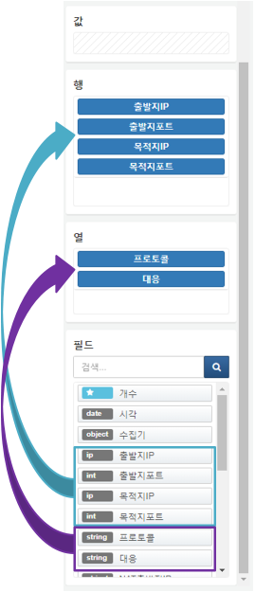

Clicking on the fields set in the rows/columns will display a context menu. From here, you can sort the values of the selected field or remove the field from the dimension configuration.

