Value Field Configuration

Once the dimension fields are set, you can now configure the value fields. Value fields typically utilize numerical data that can be aggregated using aggregation functions. Drag and drop the fields to be analyzed from the field list into the value area. If you want the count of values corresponding to the dimension field values rather than an aggregation operation on a specific field, select Count from the field list and drag and drop it into the value area. The example below shows a screen that aggregates the count, latest timestamp, and the sum of transmitted and received bytes for the source IP-destination IP pair.

When you set the value fields, you enter pivot mode, where aggregation operations are performed on the row/column fields.

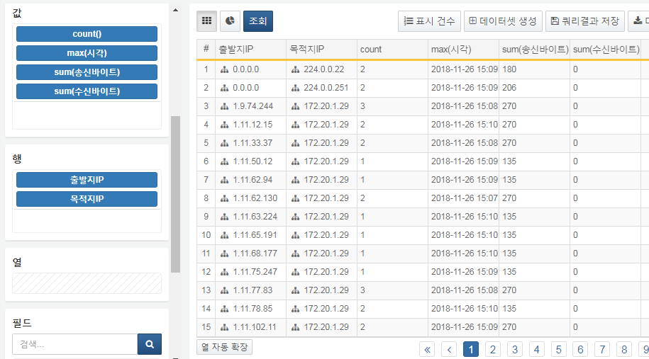

When you click on a field in the value area, you can edit the aggregation settings for that field. A list of available aggregation functions and descriptions of each function will be displayed. After selecting the desired aggregation function, click the Edit button to reflect it on the pivot screen. Clicking the delete button will remove the field from the value area. Clicking the ascending/descending sort buttons will display the sorted results for the corresponding aggregated values.

The currently available aggregation functions include Count, Sum, Max, Min, Average, Variance, Standard Deviation, First Value, Last Value, Unique Values, Unique Count, and Estimated Unique Count.

For the Count field aggregation, only delete, ascending sort, and descending sort functionalities are provided.

There may be unsupported aggregation functions depending on the field type. For example, applying the average aggregation function to a string type field will result in a null value.

