#### Data Aggregation

Users can easily analyze data by dragging the field list of the retrieved data with the mouse. This functionality is similar to the pivot table feature in MS Excel.

To analyze key fields, drag and drop them into the row items, and for fields to be analyzed in relation, drag and drop them into the column fields. Records will be generated for each row field value, and each record will display the aggregated values calculated for each column field. The concept of pivot operation can be understood through the simple example below.

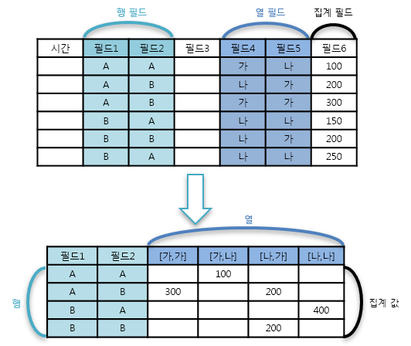

As shown in the example image, records are generated based on the combinations of field values set in the rows. For each record, columns are created for each combination of field values set in the columns, and each column value is filled with the aggregated value of the designated field. Since not all field combinations may contain data, there may be empty spaces.

The process of conducting pivot analysis in Logpresso Sonar is as follows. Drag and drop the fields to be analyzed from the field list on the bottom left into the value, row, and column items. In the example below, session data is used, with the source IP and destination IP fields in the row items, the protocol and response fields in the column items, and the count in the value items.

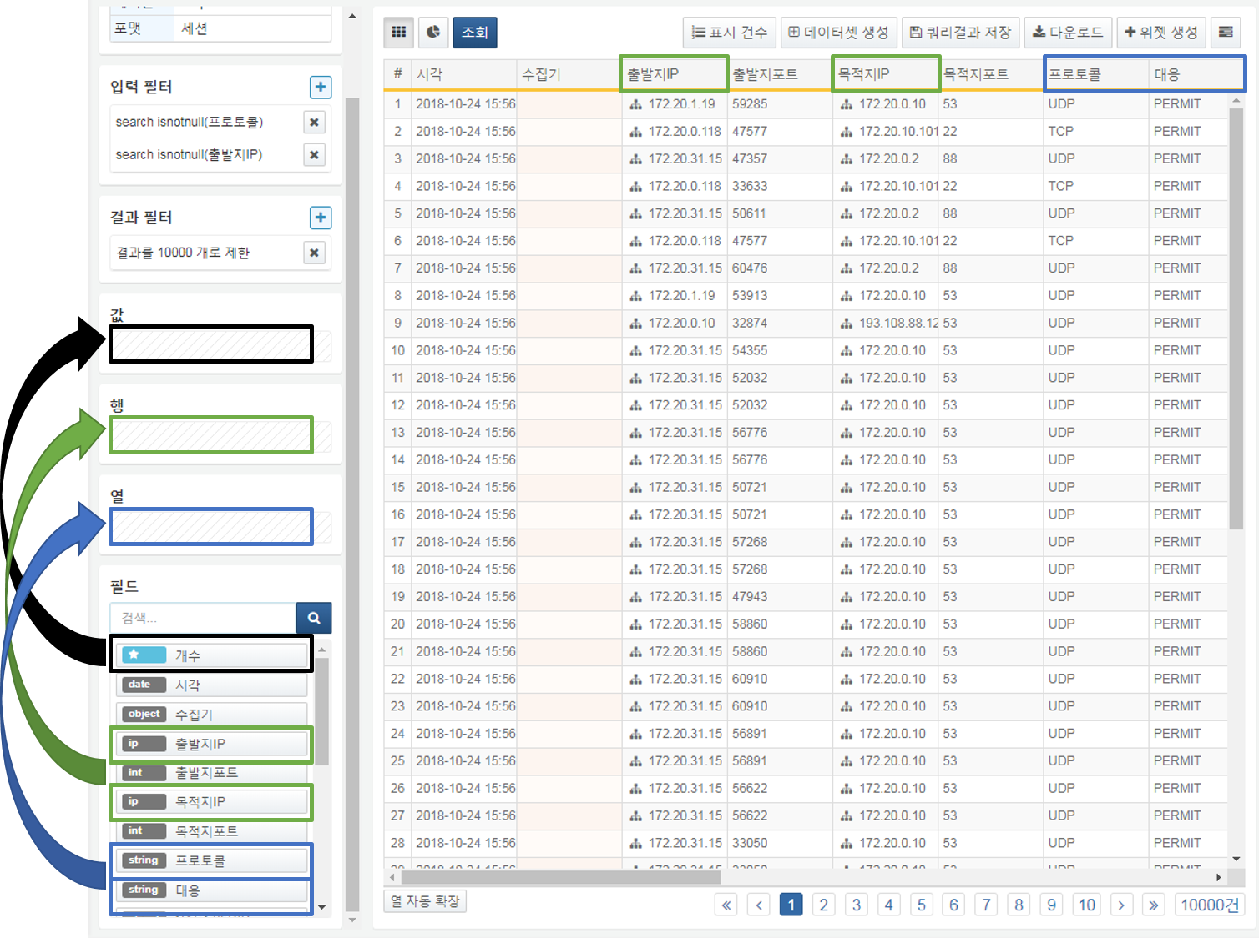

Once the pivot settings are applied as shown above, the following screen will be displayed. You can see how many times events occurred for each combination of protocol, response for each source IP-destination IP combination.

