### Manage Apps

#### Install Apps

Users with administrator privileges can upload an app file (with .app extension) and install the app on the Logpresso server. You can download the apps you want to install from the [Logpresso Store](https://logpresso.store) (membership required).

Go to **Apps** and click **Install** in the top right corner of the page.

When the **App Installation Wizard** window appears, upload an app file by browsing or drag and drop. Once the app file is uploaded, the app installation will proceed automatically.

* Click **Browse** to select the app file to upload or drag and drop the file to **App Installation Wizard** window.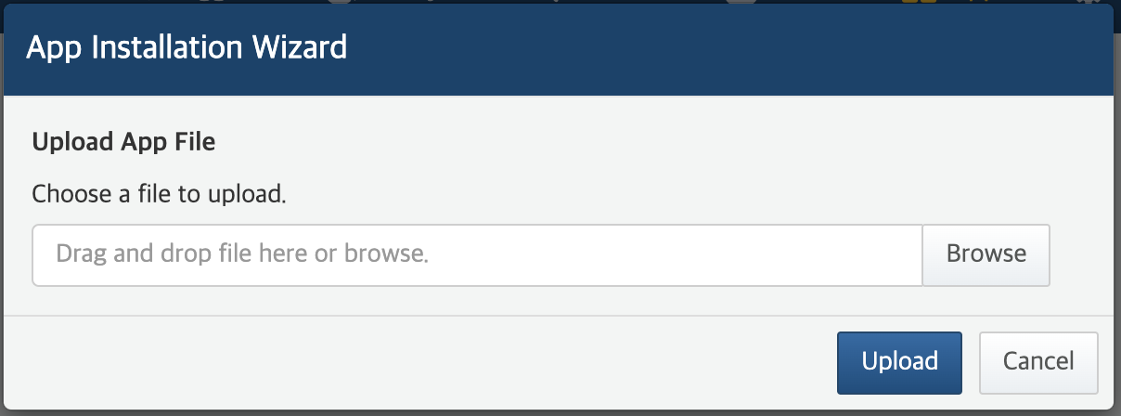
* Click **Upload** to upload the app file.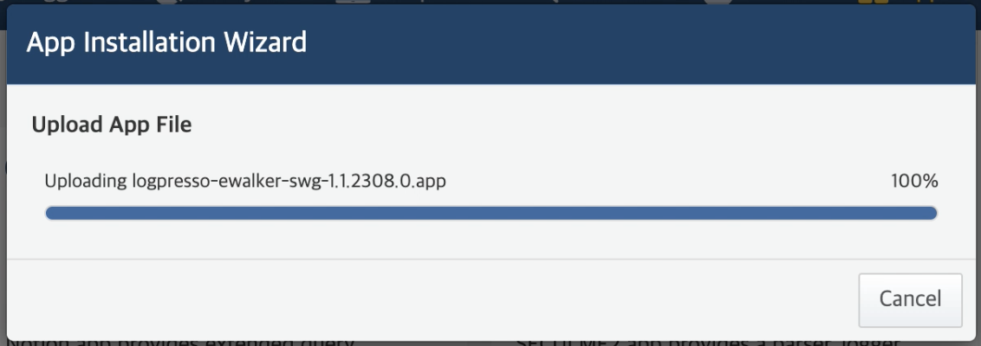
* If the app file is not valid, the upload will be aborted.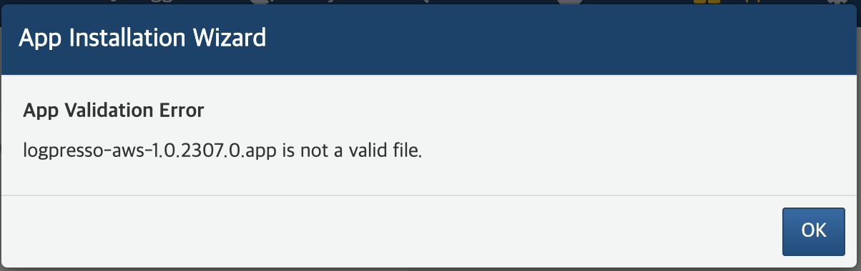
* If the app is already installed with the same version, the following message appears.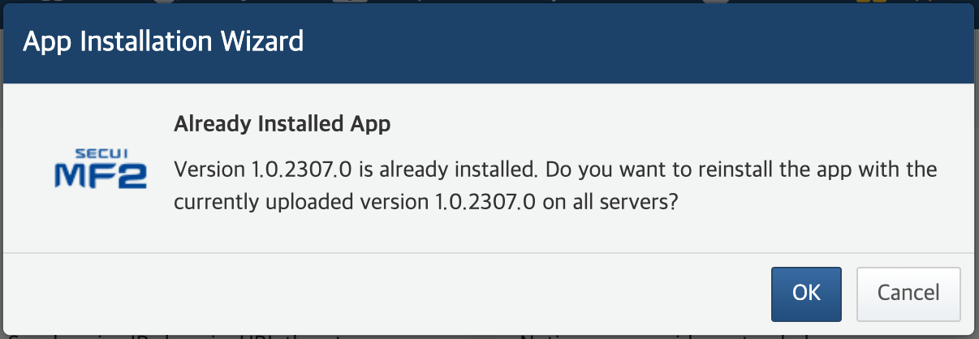
* If the app is already installed but with a different version, the following message appears. If you want to re-install the app with the version you just uploaded, click **Reinstall**. To cancel the installation, click **Cancel**.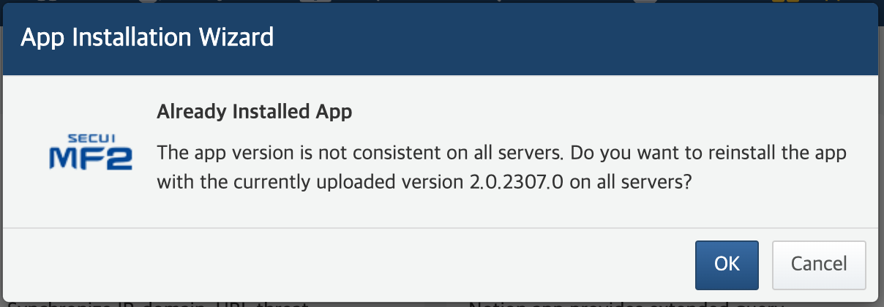
* Once the file is uploaded, the installation will proceed automatically.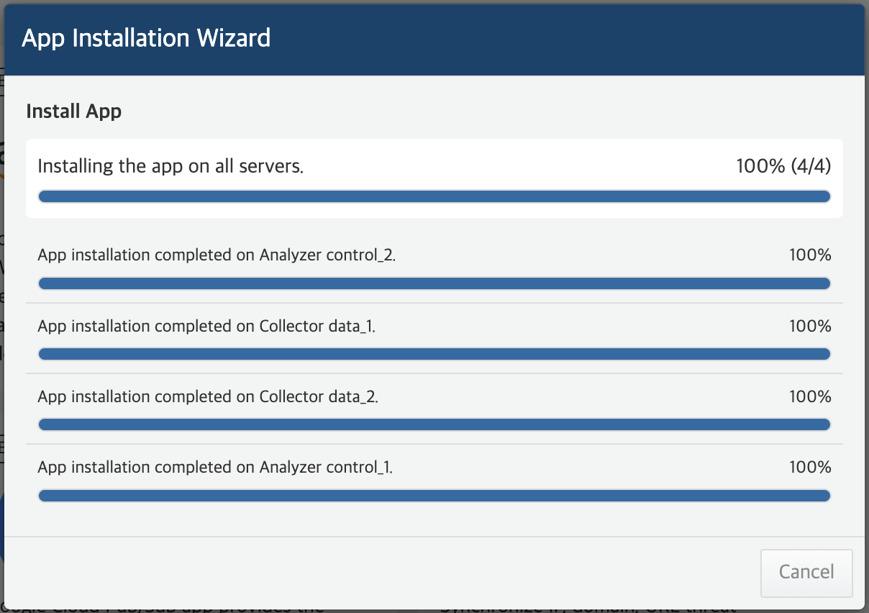
* If there are multiple Logpresso servers (nodes), the app will be installed in the following order: Forwarder, data node, control node.
* The installation progress per server is not relevant to the app installation order.
* The **App Installation Wizard** exits after the app is successfully installed on all Logpresso servers.

Once the app is installed, the app is automatically enabled and the app card appears on the **Apps** page. The app installation date is displayed next to the app version information.

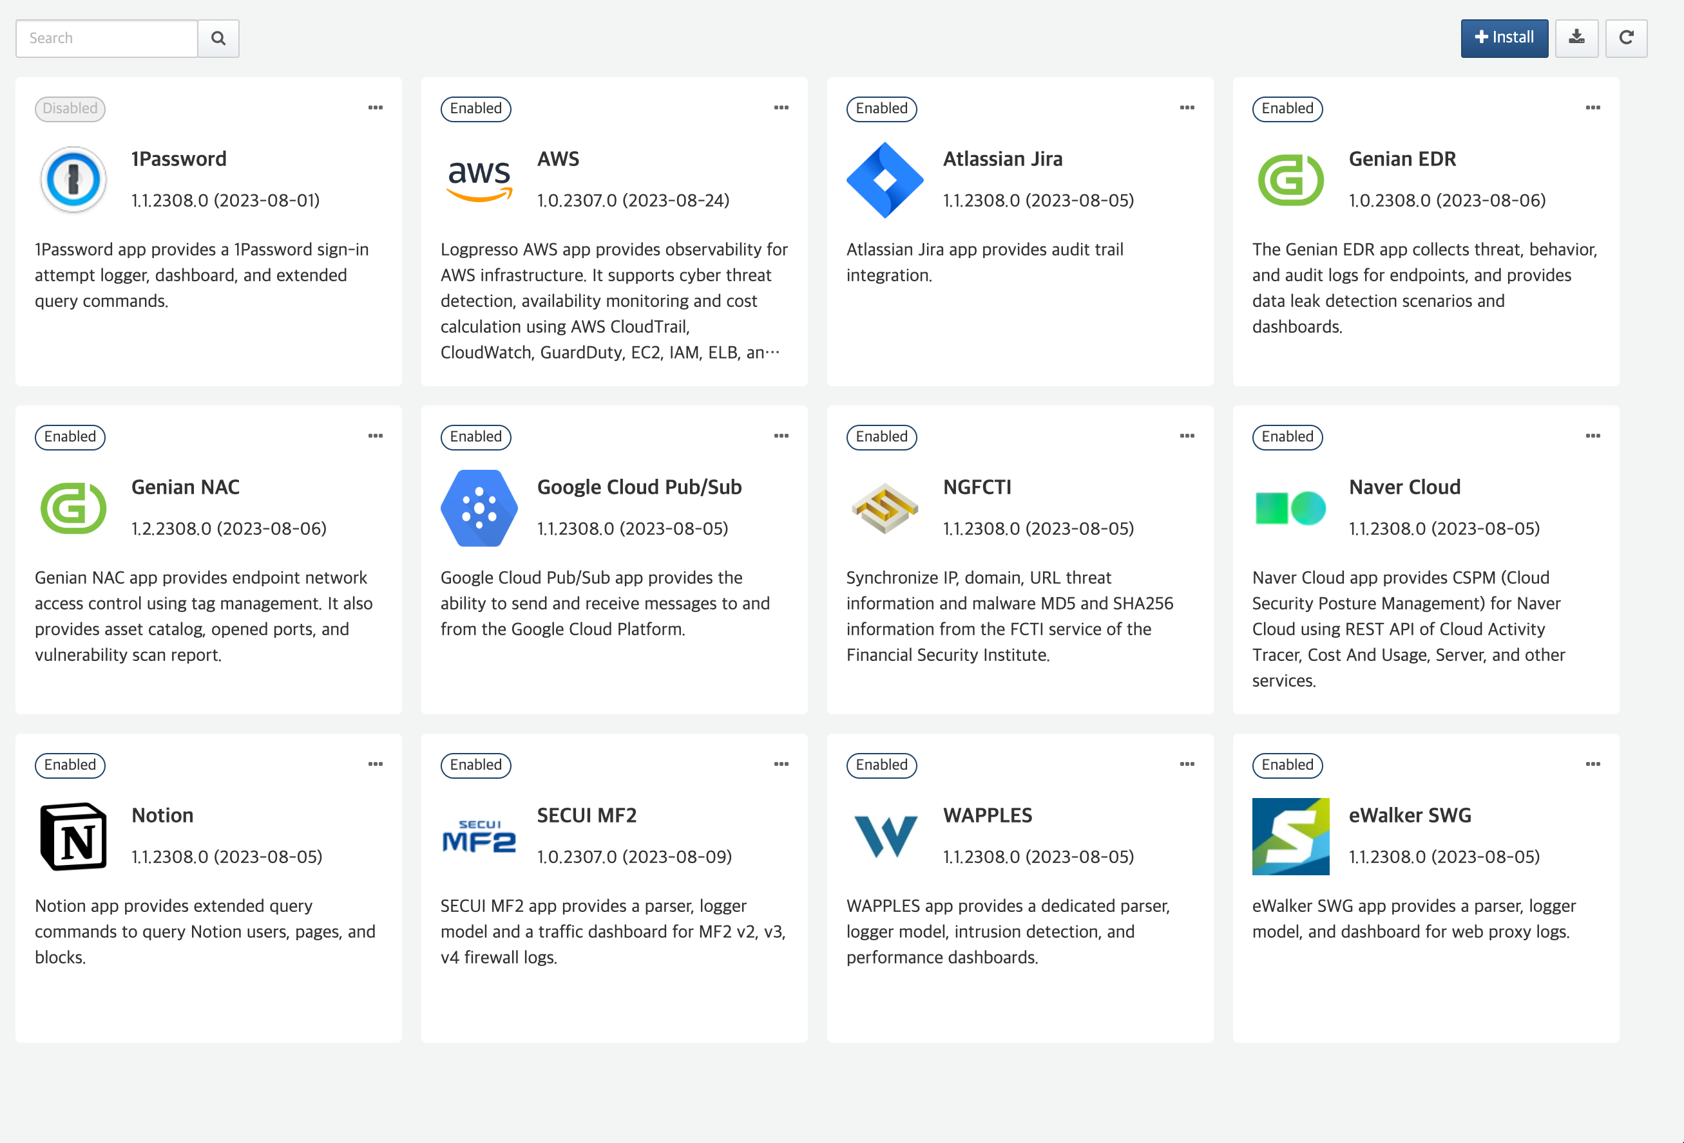

Install apps only from trusted sources.

#### Enable/Disable Apps

To use an app, you need to enable it first. Enable or disable an app as follows:

Click **...** in the top right corner of an app card marked **Enabled**.

Click **Disable** or **Enable**. Note that this is a toggle option.

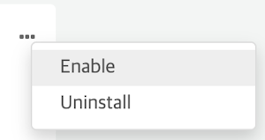 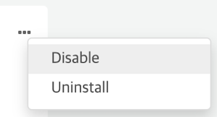

#### Uninstall Apps

To uninstall an app you no longer use:

Click **...** in the top right corner of an app card.

Click **Uninstall** from the menu.

When the **Uninstall App** message appears, check if you correctly choose the app to uninstall.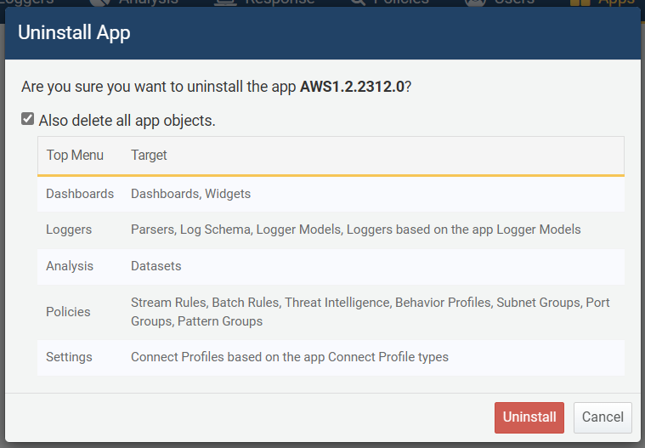

* To delete all app objects together with the app, Tick the option **Also delete all app objects**.
* To uninstall the app, click **Uninstall**. To cancel the Uninstallation, click **Cancel**.