Behavior Profile Data Source

Pivot operations are executed based on the previously created behavior profile data. This can be utilized for correlation analysis using long-term accumulated behavior profile data.

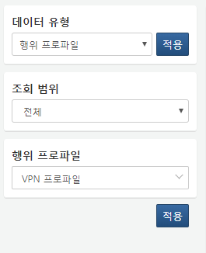

**Query Range**

Set the time range for the data to be queried. Selecting **Range** retrieves data within a fixed time range. Choosing **Period** retrieves data collected within a specific period from the current point in time. Selecting **All** retrieves data from all periods.

**Behavior Profile**

Select the behavior profile to be used from the list.