## Home

Upon accessing Logpresso Sonar, the home screen, which consists of the security status, is displayed by default as shown below. This screen contains only publicly available information received from the ISAC service, allowing users to view the same screen without logging in.

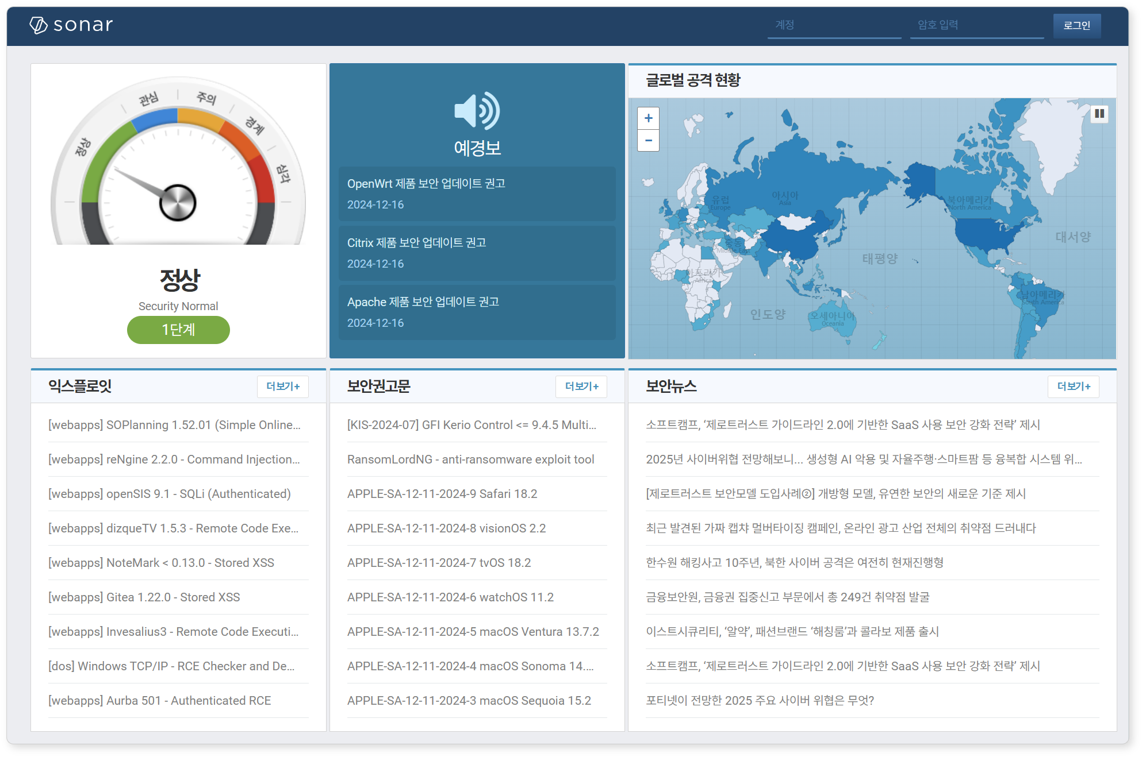

The home menu will be activated once the ISAC key is registered. Please configure your network security policy to allow the Logpresso Sonar server to connect to the ISAC service.

The components of the screen are as follows:

**Alert Level**

Displays the cyber threat alert level provided by the Korea Internet & Security Agency. The alert level changes based on the emergence of high-risk worms, malware, vulnerabilities, or political and military crises both domestically and internationally.

**Advisories**

Displays a list of security advisories distributed by the Korea Internet & Security Agency. This primarily includes recommendations regarding significant vulnerability updates and guidance on response measures in the event of large-scale attacks. Clicking on each title opens a new window displaying detailed security advisories from the [KRCERT site](https://www.krcert.or.kr/kr/bbs/list.do?menuNo=205020&bbsId=B0000133).

**Global Attack Status**

Collects attacker IPs attempting widespread attacks globally and displays statistics on threat countries. The statistics are based on threat information collected by the ISAC service. Hovering the mouse cursor over the map displays the statistical figures for the respective country, and using the mouse wheel allows for zooming in and out of the map.

**Exploits**

Provides information on recently registered exploits. The list is based on the exploit feeds collected by the ISAC service. Clicking on the title opens a new window that directs to the [Exploit Database](https://www.exploit-db.com/) for detailed information.

**Security Advisories**

Provides information on recently registered vulnerabilities. The list is based on the vulnerability feeds collected by the ISAC service. Clicking on the title opens a new window that directs to the [SecLists.Org](https://seclists.org/) for detailed information.

**Security News**

Provides the latest registered security news. The list is based on news feeds collected by the ISAC service. Clicking on the title opens a new window that directs to the [Security News](https://www.boannews.com/) site for detailed information.