## Intelligence

The Intelligence menu provides a list of security news, exploits, security advisories, and CVE information that can be browsed or searched. The information displayed on this screen consists solely of publicly available data received from the ISAC service, allowing you to view the same screen without logging in.

The Intelligence menu is activated only after registering the ISAC key. Please configure your network security policy to allow the Logpresso Sonar server to connect to the ISAC service.

### News

Displays the complete list of security news. Clicking on each title will open a new window directing you to the news site, where the article's content will be displayed. You can enter keywords in the search bar at the top to view search results related to article titles.

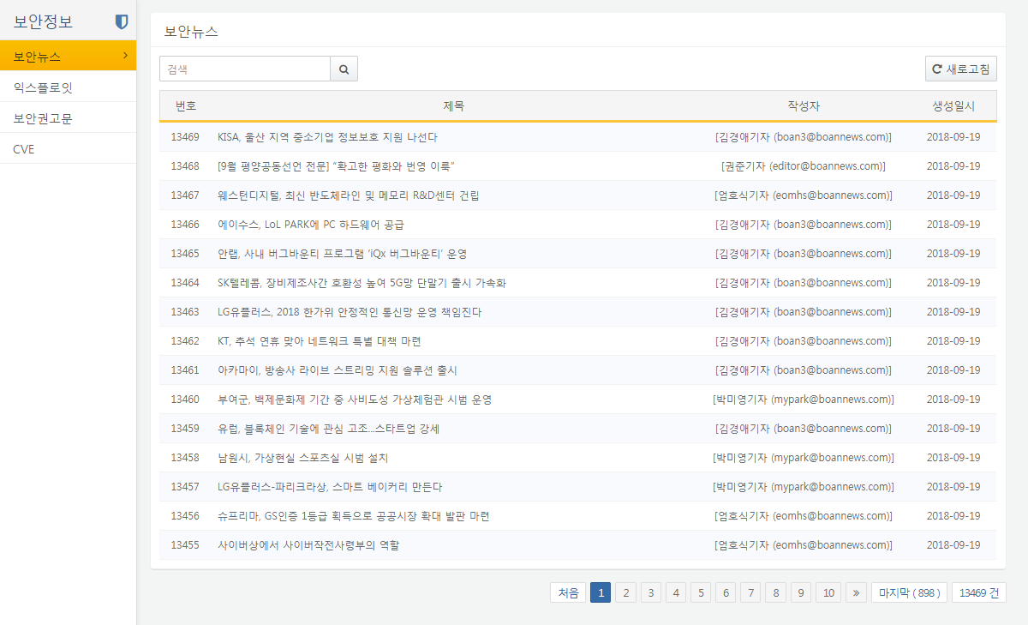

### Exploits

Displays the complete list of exploits. Clicking on each title will open a new window directing you to the ExploitDB site, where the content will be displayed. You can enter keywords in the search bar at the top to view search results related to titles.

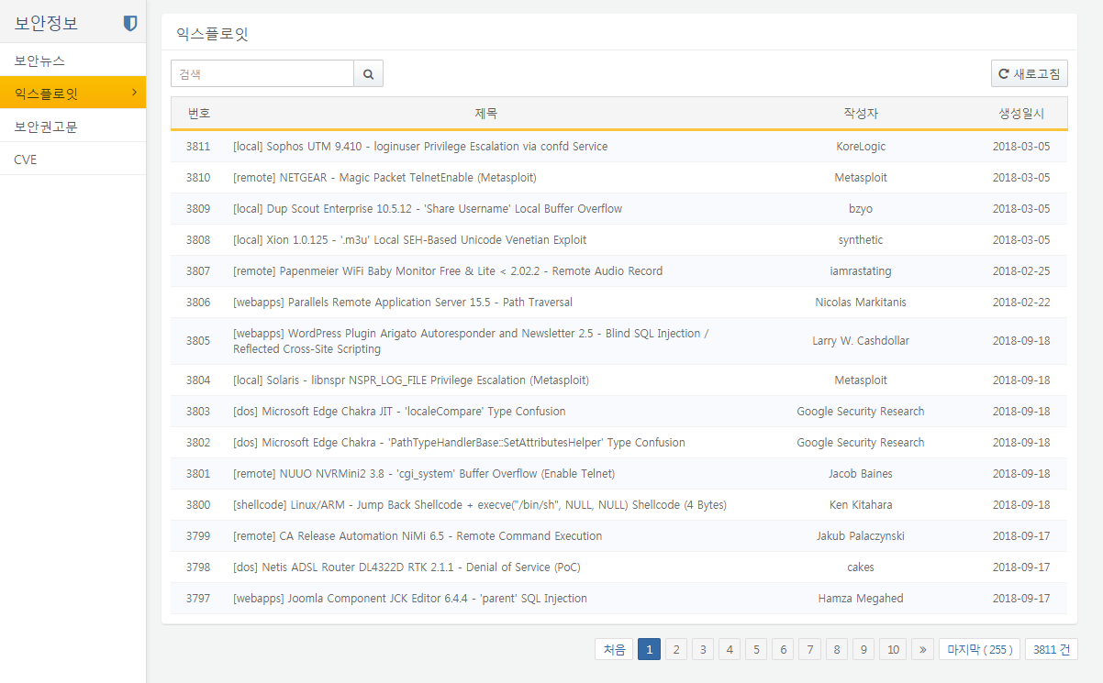

### Advisories

Displays the complete list of security advisories. Clicking on each title will open a new window directing you to the security advisory site, where the content will be displayed. You can enter keywords in the search bar at the top to view search results related to titles.

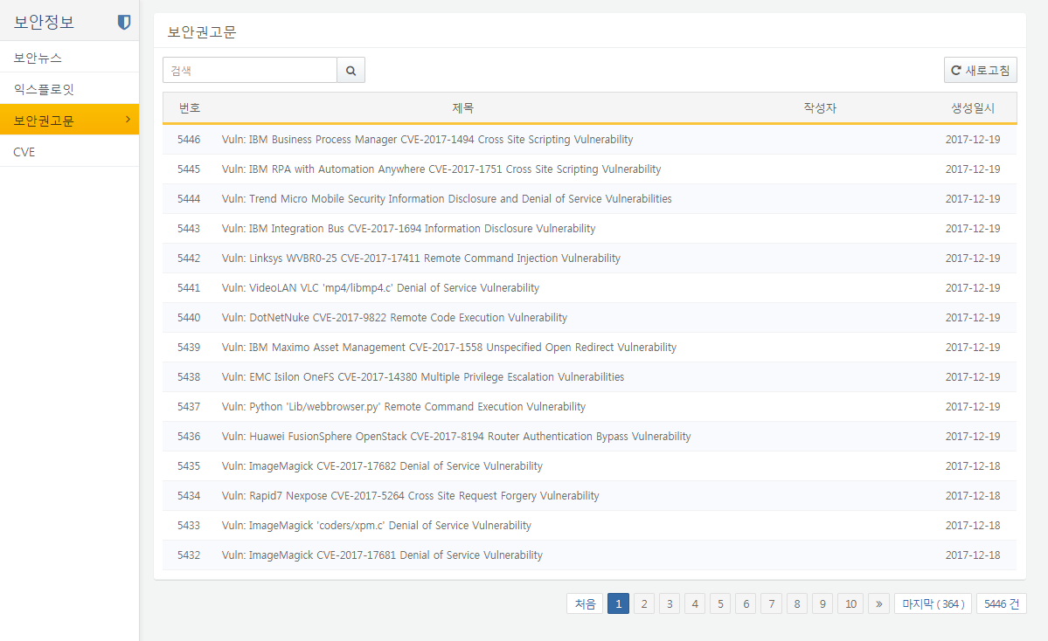

### CVEs

Displays the complete list of the CVE database. The list consists of CVE IDs and their descriptions, and clicking on a CVE ID will allow you to view detailed information about the vulnerability. The CVE ID refers to a standardized vulnerability identifier. You can enter keywords in the search bar at the top to view search results for all CVE entries.

