Column Filter

Clicking the button on the right side of the header in the data results window will display the column title context menu.

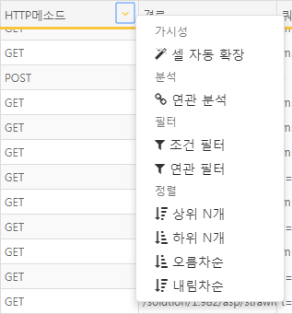

**Cell Auto Expansion**

Automatically expands or shrinks the width of the field cell to fit the content of the field.

**Correlation Analysis**

Conducts correlation analysis using the field as the key value. For more details, please refer to the relevant section.

**Conditional Filter**

Applies a conditional filter to the values of the field. The list of applicable filters varies depending on the field type and is applied to input filters.

**Correlation Filter**

Applies a correlation filter to the values of the field. To use this feature, data for correlation filtering must exist in another pivot tab. Filters can be applied to include or exclude field values present in the correlation analysis tab. For more details, please refer to the correlation filter section.

**Time Unit Truncation (Displayed only for time-type fields)**

Truncates the time value to the specified unit. For example, if the time value is 2018-10-10 12:34:56 and truncated to 10-minute intervals, it will convert to 2018-10-10 12:30:00. This is useful for time series analysis.

**Time Difference Calculation (Displayed only for time-type fields)**

Outputs the calculated time difference between the current time and the field value time.

**String Conversion (Displayed only for time-type fields)**

Converts time-type values to string type.

**IP Blacklist Filter (Displayed only for IP-type fields)**

Applies a filter based on whether the field value is included in the IP blacklist or not. This is applied to input filters.

**Subnet Group Filter (Displayed only for IP-type fields)**

Applies a filter based on whether the field value is included in the subnet group or not.

**Top N**

Displays records corresponding to N entries sorted in descending order based on the field values.

**Bottom N**

Displays records corresponding to N entries sorted in ascending order based on the field values.

**Ascending**

Displays the results sorted in ascending order based on the field values.

**Descending**

Displays the results sorted in descending order based on the field values.