Logger Data Types

Execute pivot operations on the data collected from Loggers created in the collection menu. The data is stored in the table specified during the Logger creation, allowing you to query data from the table mapped to the selected Logger during the pivot query.

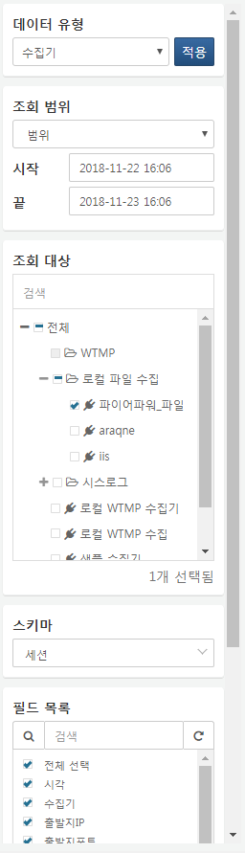

**Query Range**

Set the time range for the data to be queried. When selecting a fixed time range, data within that range will be retrieved. When selecting a period, data collected within a specific duration from the current point in time will be queried. Selecting "All" retrieves data from all periods.

**Query Target**

Select the Logger to be queried from the tree.

**Schema**

Choose the schema to be applied to the queried data. If an extraction model is defined for the Logger's collection model, you can select the schema of that extraction model. When selecting a schema other than the original schema, the field names will change according to the selected schema, and only the fields used in that schema will be queried.

**Field List**

Select the list of fields to be queried.