#### Adding a Dataset

Clicking the Add New Dataset button will transition you to the dataset definition screen.

Query Type Dataset

For query type datasets, users can manually input queries to create the dataset.

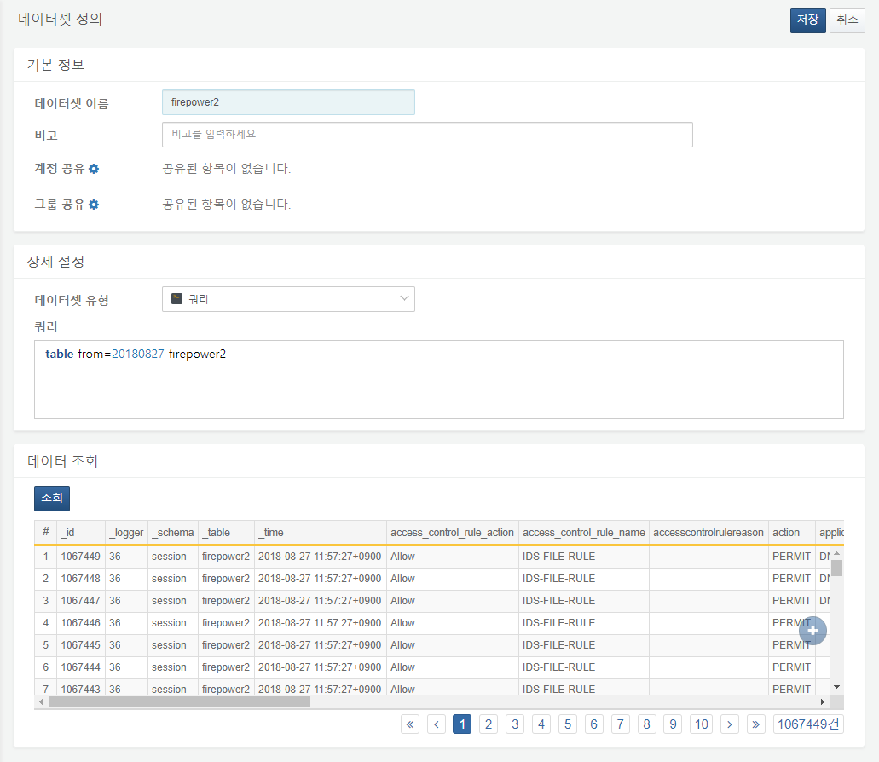

Association Analysis Type Dataset

For association analysis type datasets, additional datasets can be created using existing datasets. You can create datasets simply by dragging and dropping or clicking.

