Creating an External Site Widget

Click the Add New Widget button from the list and select Create External Site Widget to open a popup window for creating an external site widget.

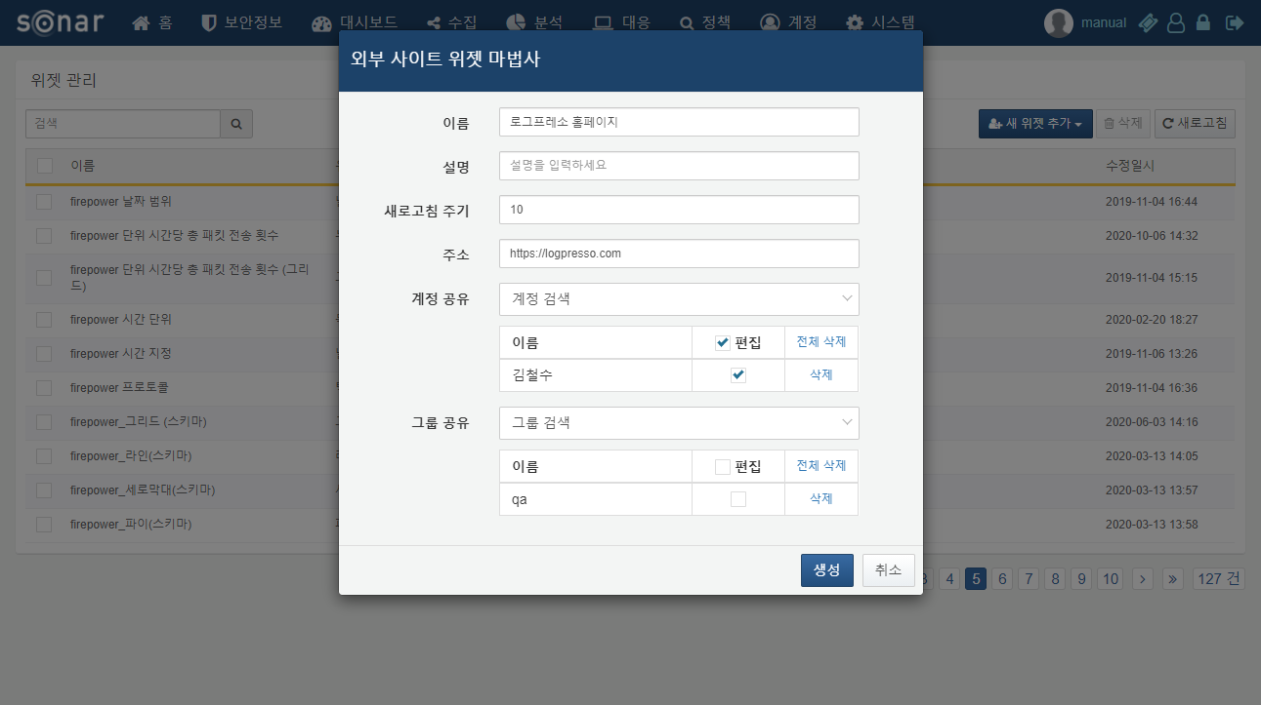

When creating an external site widget, the following fields must be filled out:

**Name**

Enter the name of the widget to be created.

**Description**

Enter a description for the widget.

**Refresh Interval**

Set the refresh interval. Entering '0' will disable the refresh.

**Address**

Enter the address of the external site to connect. Note that some sites may not display properly depending on the URL (e.g., Naver, Facebook, etc.).

**Account Sharing**

Select the accounts with which to share the widget. If edit permissions are granted to the account, users who receive the shared widget will be able to edit or delete it.

**Group Sharing**

Select the groups with which to share the widget. If edit permissions are granted to the group, users within the shared group will be able to edit or delete the widget.

