Creating Input Control Widgets

To create an input control widget, click the Add New Widget button from the list and select Create Input Control. A popup window will appear for creating the input control widget.

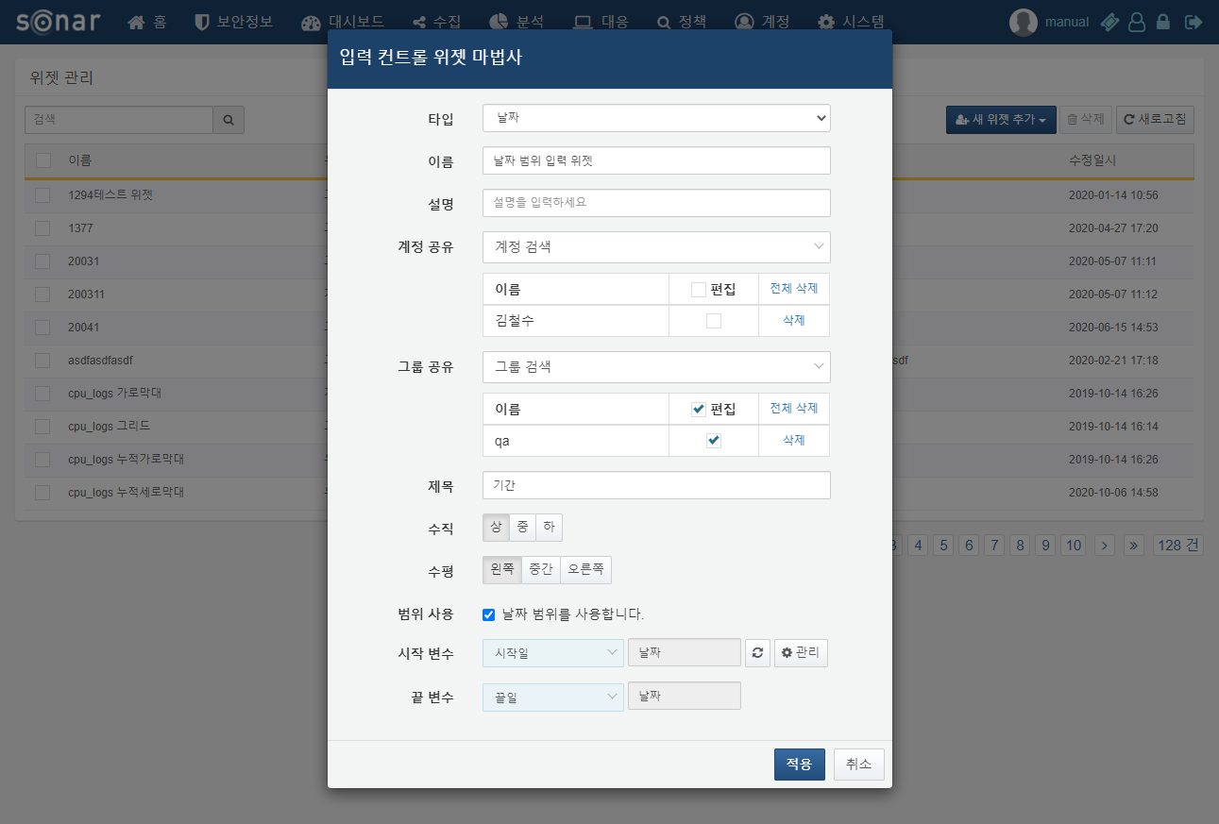

When creating an input control widget, the following items need to be filled out:

**Type**

Specify the type of the input control widget. You can choose from date, list, or text types.

**Name**

Enter the name of the input control widget.

**Description**

Enter a description for the input control widget.

**Account Sharing**

Select the accounts with which to share the widget. If edit permissions are granted to the accounts, users who receive the shared widget will be able to edit or delete it.

**Group Sharing**

Select the groups with which to share the widget. If edit permissions are granted to the group, users within the shared group will be able to edit or delete the widget.

**Title**

Enter the title of the input control widget as it will appear on the dashboard.

**Vertical/Horizontal**

Specify the vertical or horizontal position of the input field within the widget.

**Use Range**

This option is only set when creating a date type input control widget. Check this box if you want to use the date range as an input field.

**Start Variable/End Variable/Query Parameter**

The start variable and end variable are specified when creating a date type input control widget, while the query parameter is used when creating list or text type input control widgets. If there are no custom variables you wish to use, you can create them by clicking the management button.

**Selection Target List**

This item is only set when creating a list type input control widget. Enter the items to be displayed in the list.

