Query Widget Creation

Click the Add New Widget button from the list and select Create Query Widget to navigate to the Query Widget Wizard screen. There are two types of query widgets: grid widgets and chart widgets.

Grid Widget Creation

**Step 1**

Data Retrieval

When data is retrieved on the widget creation screen, a preview of the grid widget is generated based on the selected data source. Press Setting 1 to configure the appearance of the grid, column details, events, and more.

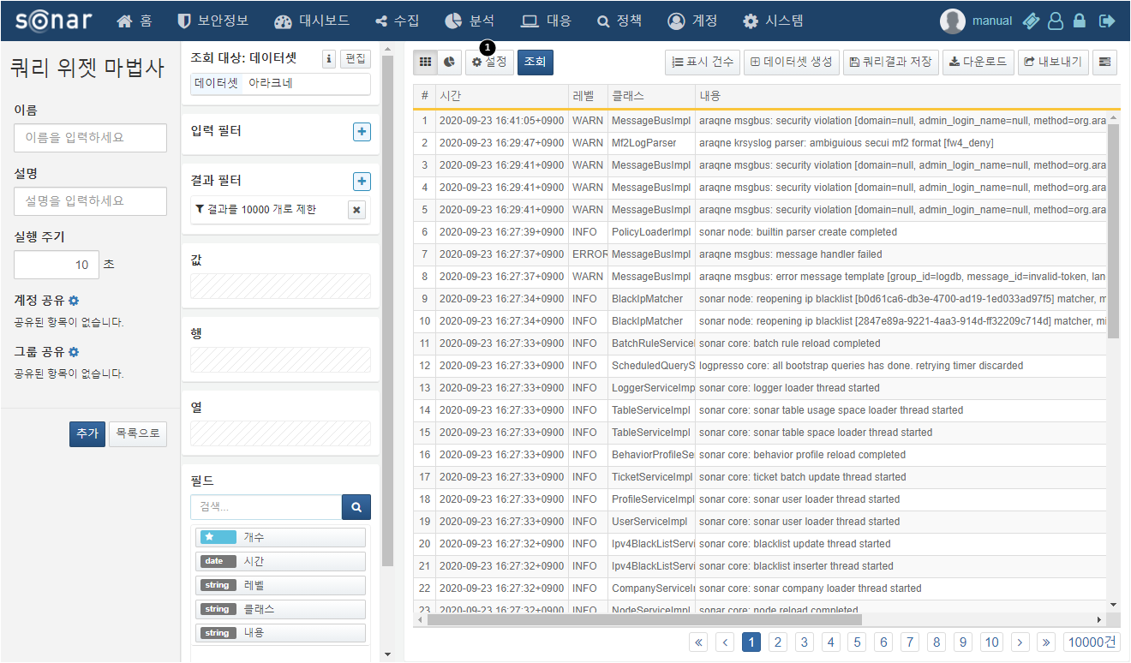

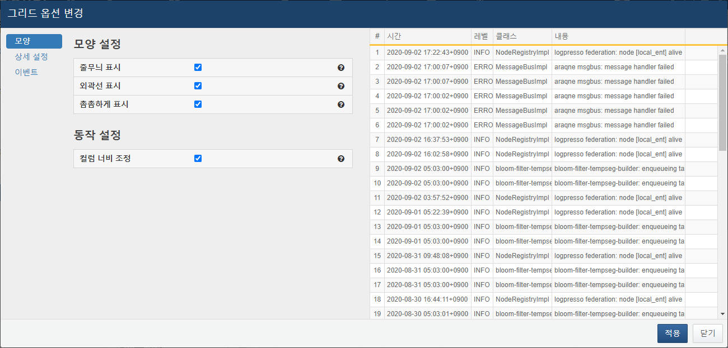

**Step 2**

Grid Appearance Settings

Once the grid settings are entered, changes can be immediately viewed in the preview on the right.



In the Appearance tab, you can configure the overall look of the grid.

Descriptions of each item are as follows:

* **Striped Display**: Applies a striped effect to the table rows.
* **Border Display**: Displays borders around all cells.
* **Tight Display**: Adjusts the spacing between cells to be tighter.
* **Column Width Adjustment**: Sets whether column width can be adjusted.

**Step 3**

Grid Detailed Settings

In the Detailed Settings tab, options for each grid column can be configured.

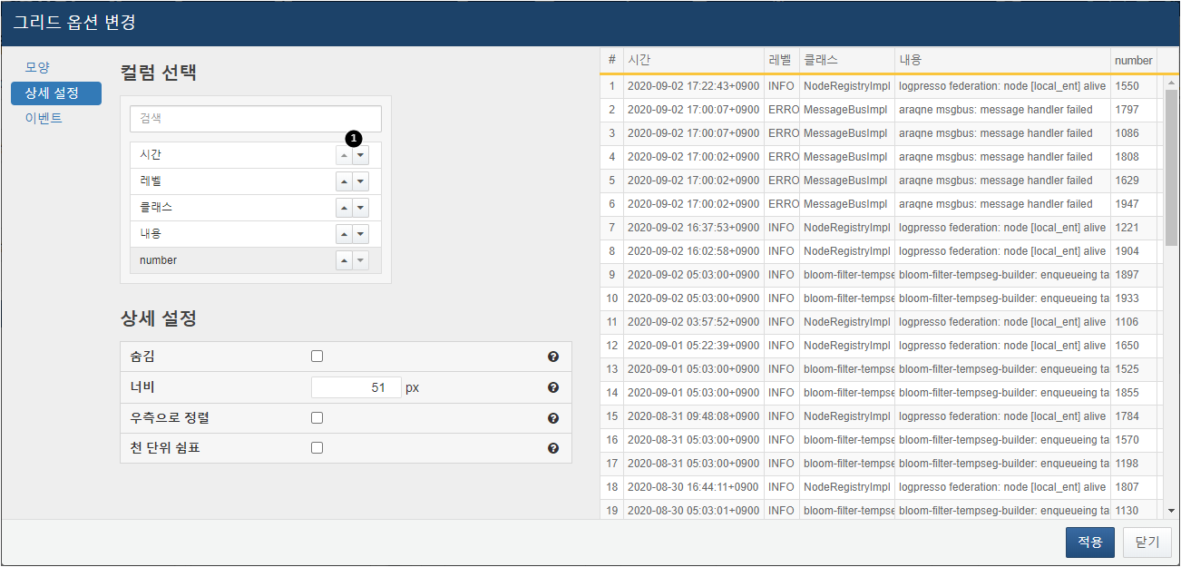

Descriptions of each item are as follows:

* **Column Order**: Click the arrow 1 next to the column name to set the order of the columns. Use Alt + ▲/▼ to move the column to the top/bottom.
* **Hidden**: Sets whether the column is displayed. If checked, the column will not be displayed.
* **Width**: Sets the width of the cell.
* **Right Align**: Aligns the cell values to the right.
* **Thousands Separator**: Displays a thousands separator in the cell values. This is only applicable when the column type is numeric.

**Step 4**

Grid Event Settings

In the Events tab, events for each grid column can be configured. For descriptions of events, refer to Widget Events.

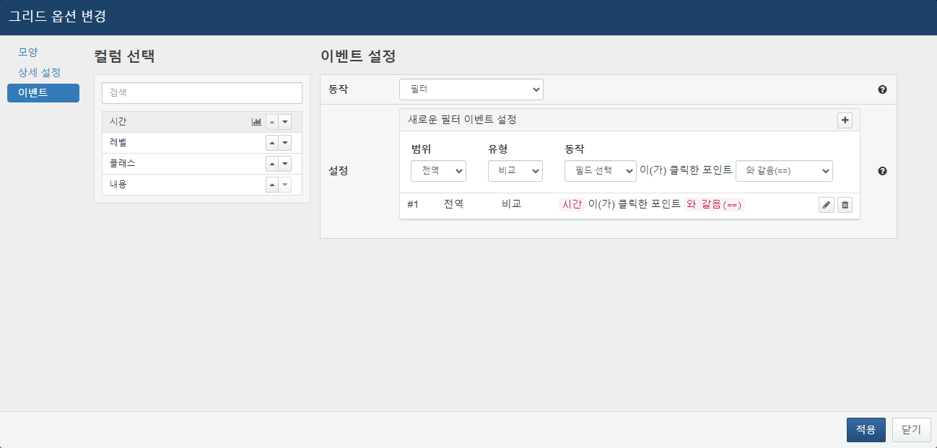

**Step 5**

Basic Grid Item Input

Press the Apply button to specify the grid settings and enter the name, description, and execution cycle. If you wish to share the widget with other accounts and groups, add accounts or groups in the sharing section. For details on widget sharing, refer to Query Widget Sharing.

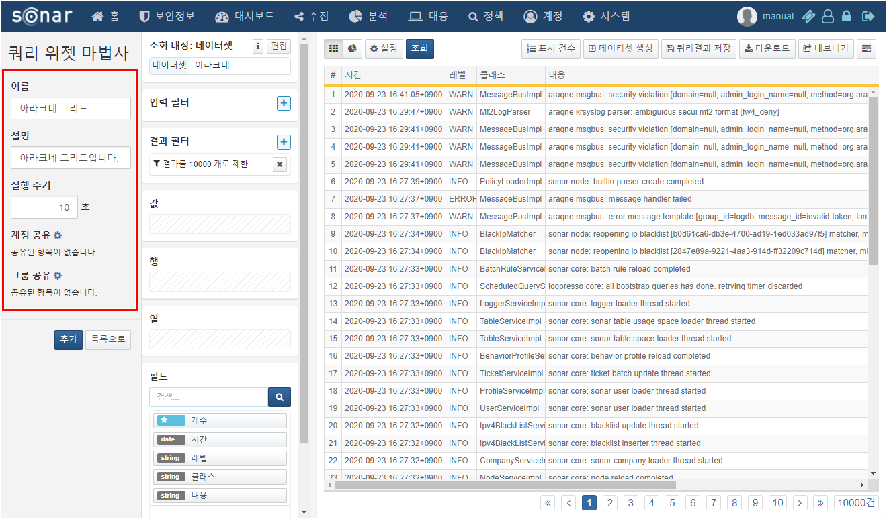

**Step 6**

Grid Widget Creation

Once the grid widget settings and basic item inputs are complete, press the Add button to create the widget. If accounts/groups were shared, the system will check the sharing status of the data source used in the widget and allow for bulk sharing of the data source as well.

Chart Widget Creation

**Step 1**

Data Retrieval

When data is retrieved on the widget creation screen, a preview of the grid widget is generated based on the selected data source. Use filters or pivot functions to process the data. Then, click the chart icon 1 and press Setting 2 to enter the chart detailed settings.

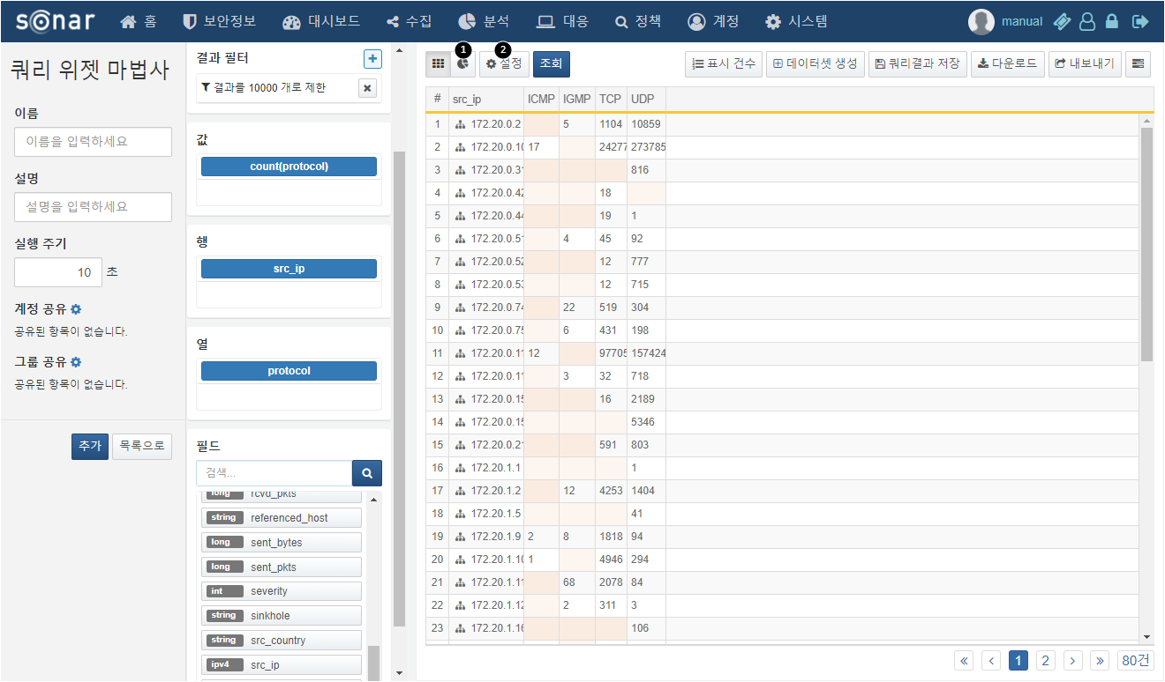

**Step 2**

Required Chart Settings

Enter the required chart settings, including chart type, independent variable, and dependent variable. The independent variable determines which field will serve as the basis for the chart, while the dependent variable indicates what values will be displayed for each independent variable. Even with just the required settings, a functional chart widget can be created.

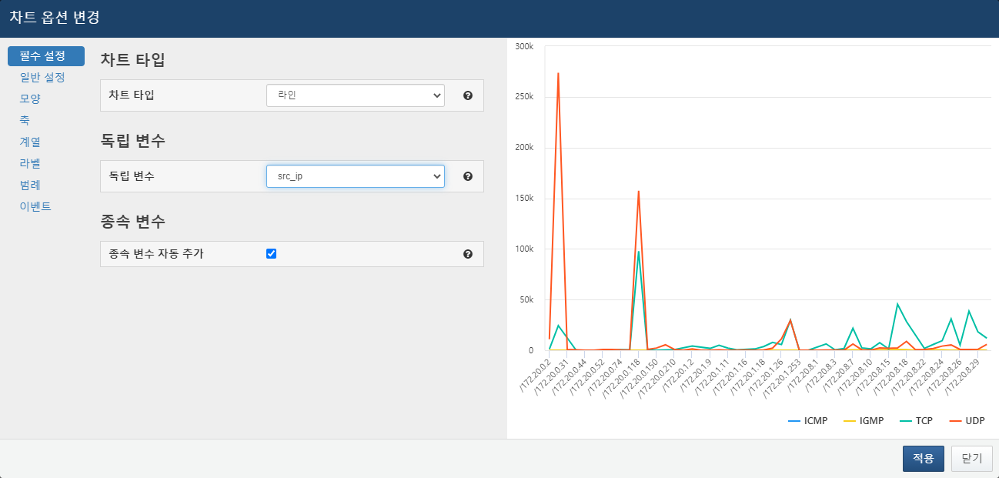

Available chart types include:

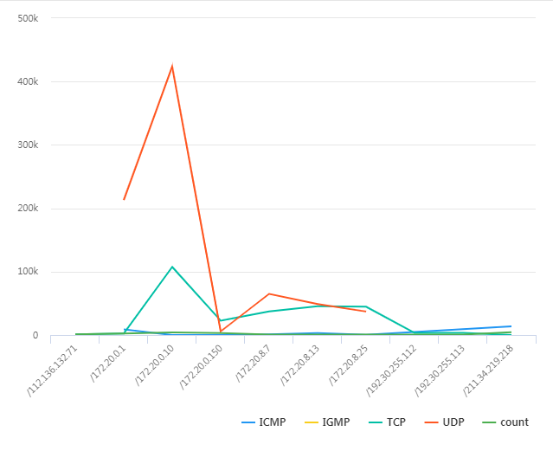

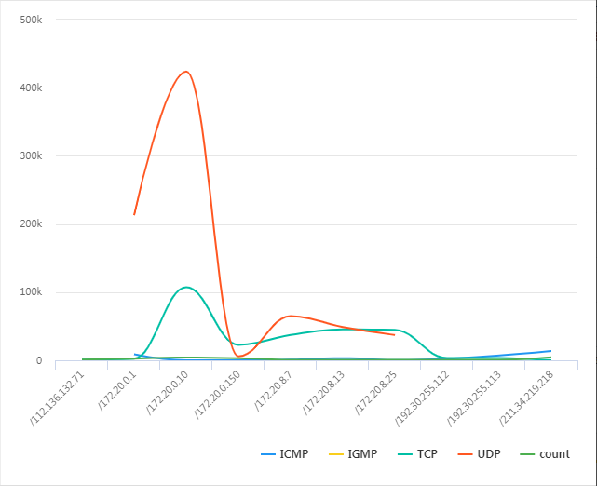

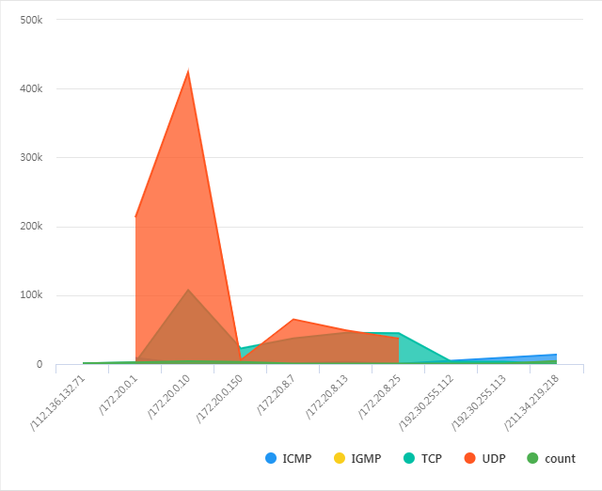

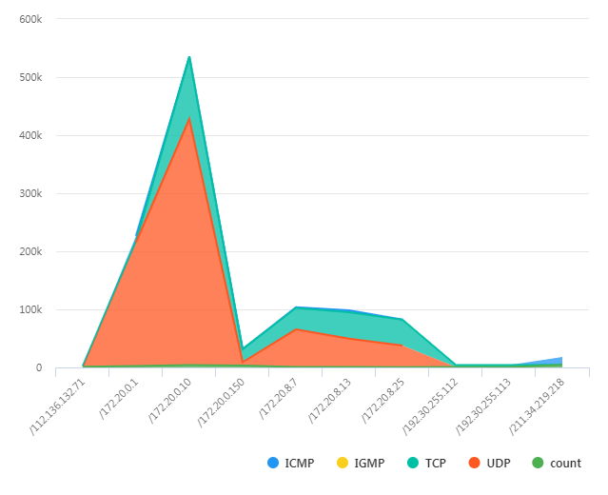

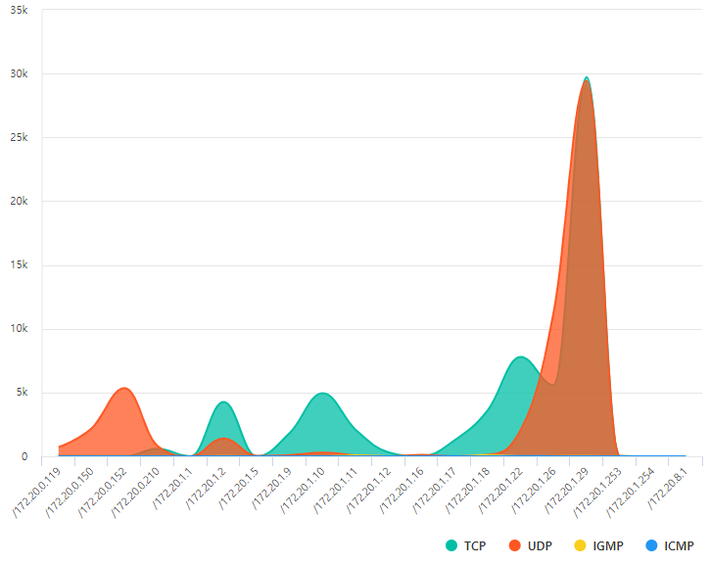

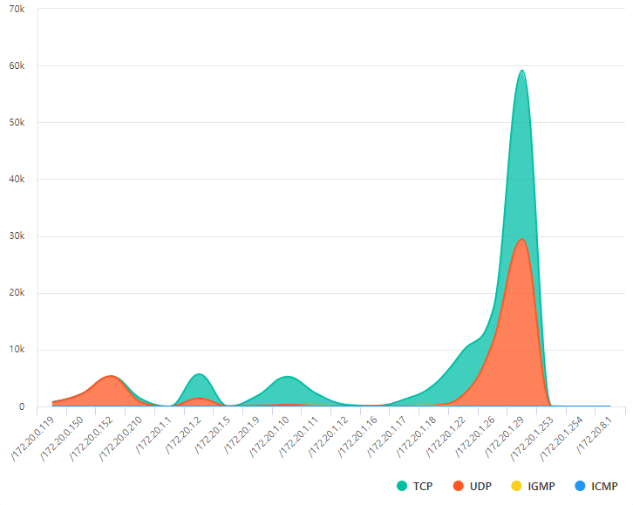

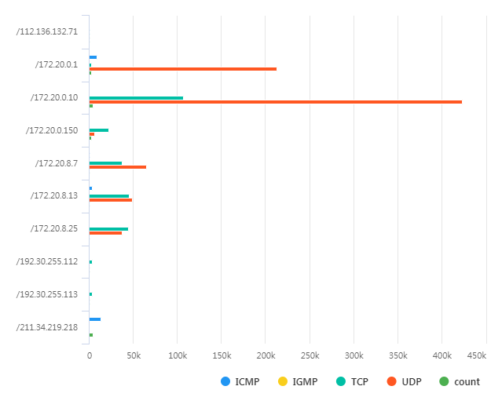

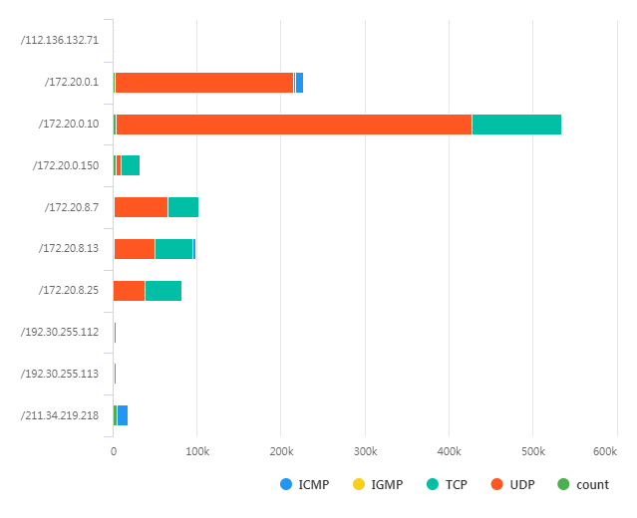

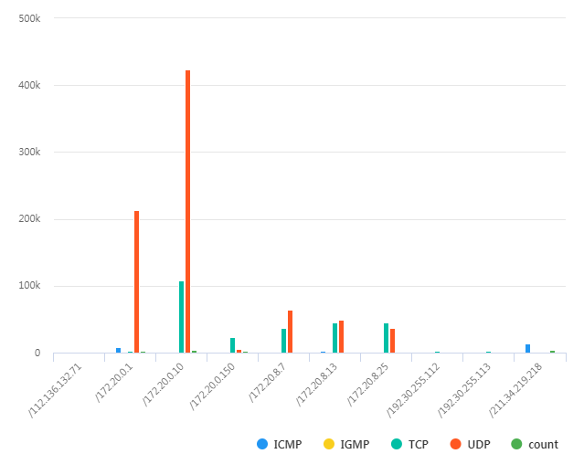

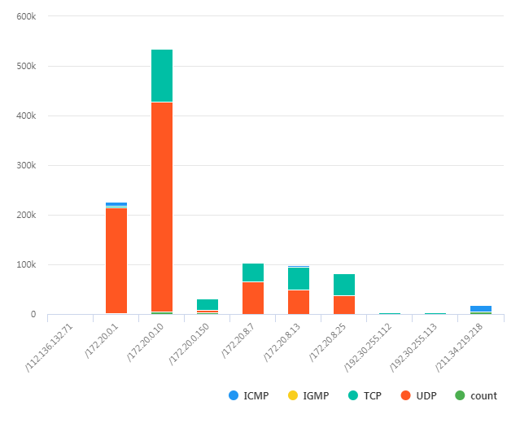

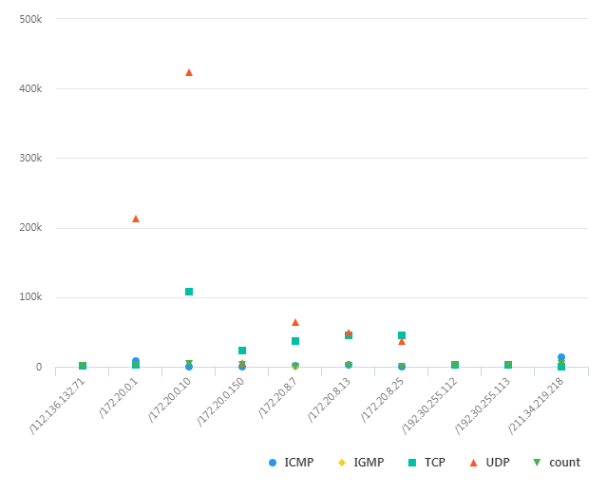

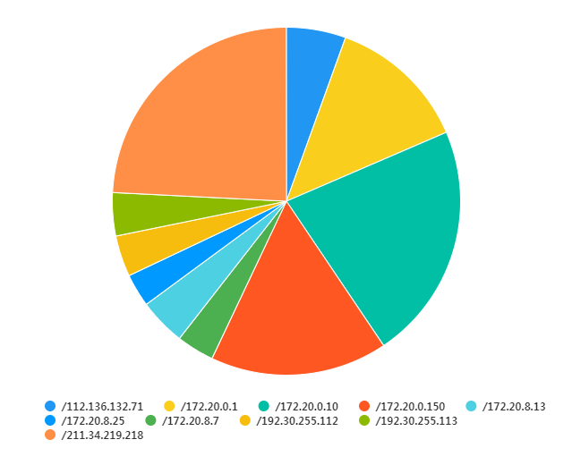

**Step 3**

General Chart Settings

Enter the general settings.

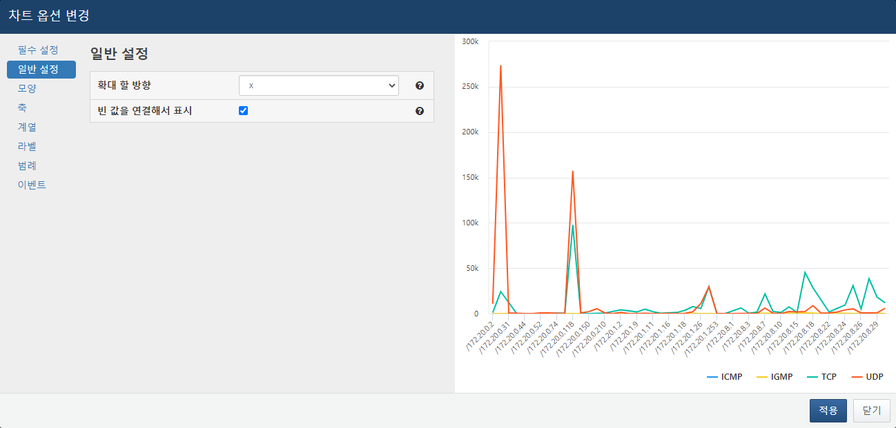

* **Zoom Direction**: Choose the zoom direction from x, y, or xy.
* **Display Empty Values Connected**: Set whether to display the chart as continuous or broken when there are no values for a specific independent variable.

In the example below, there are no UDP values for the specified source IP, but UDP data exists for the preceding and following values, so those values are displayed continuously.

**Step 4**

Chart Appearance Settings

Enter the chart title and border-related settings.

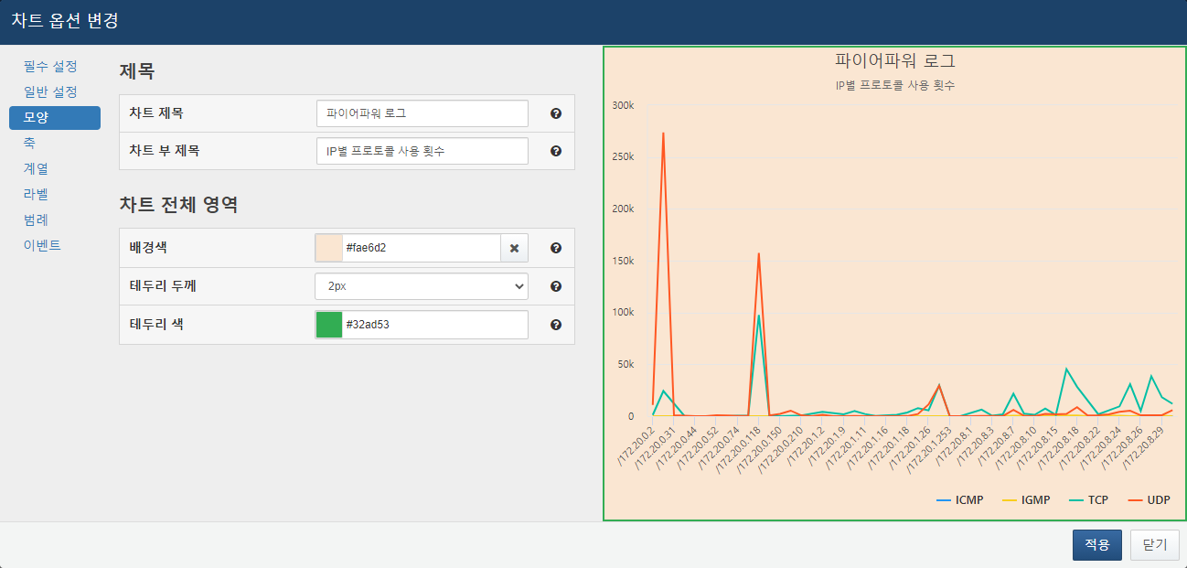

* **Chart Title**: Set the title of the chart.
* **Chart Subtitle**: Set the subtitle of the chart.
* **Background Color of Entire Chart Area**: Set the background color for the entire chart.
* **Border Thickness of Entire Chart Area**: Set the thickness of the border for the entire chart area.
* **Border Color of Entire Chart Area**: Set the color of the border for the entire chart area.

**Step 5**

Chart Axis Settings

Enter settings related to the chart axes.

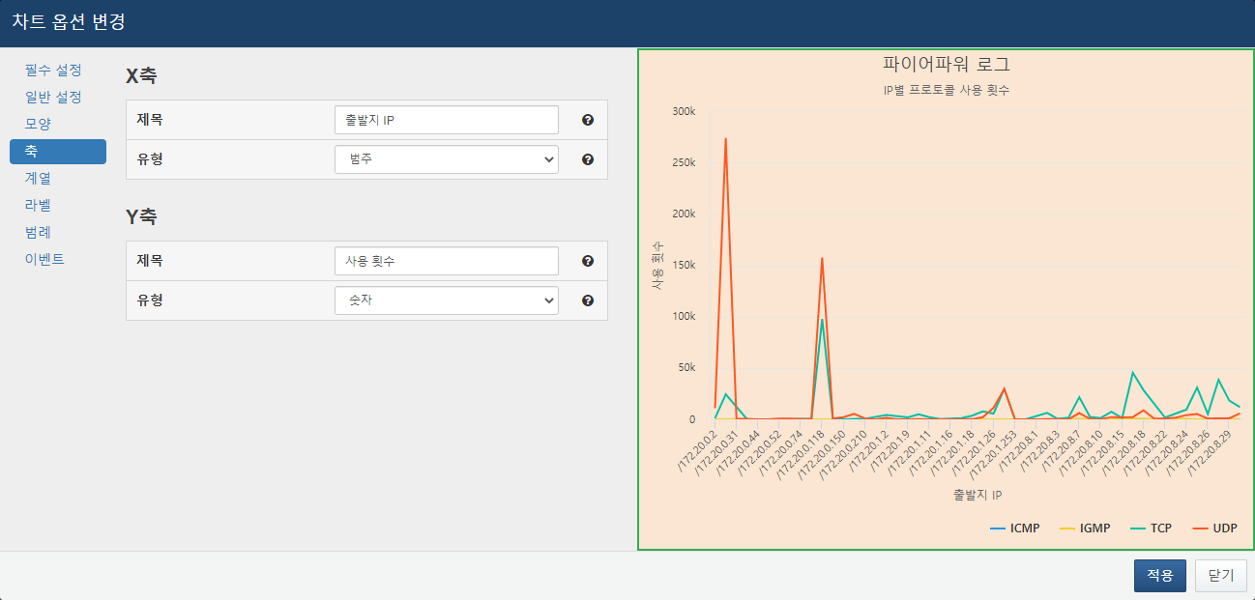

* **X-Axis Title**: Enter the title for the X-axis.
* **X-Axis Type**: Select the type for the X-axis. The default is automatically set based on the independent variable type. For numeric types, choose number; for logarithmic, choose log; for date types, choose date; and for IP or string types, choose category.
* **Y-Axis Title**: Enter the title for the Y-axis.
* **Y-Axis Type**: Select the type for the Y-axis. The default is automatically set based on the independent variable type. For numeric types, choose number; for logarithmic, choose log; for date types, choose date; and for IP or string types, choose category.

**Step 6**

Chart Series Settings

Enter settings for each series of the chart. Different types can be set for each series to create a combined effect of multiple charts.

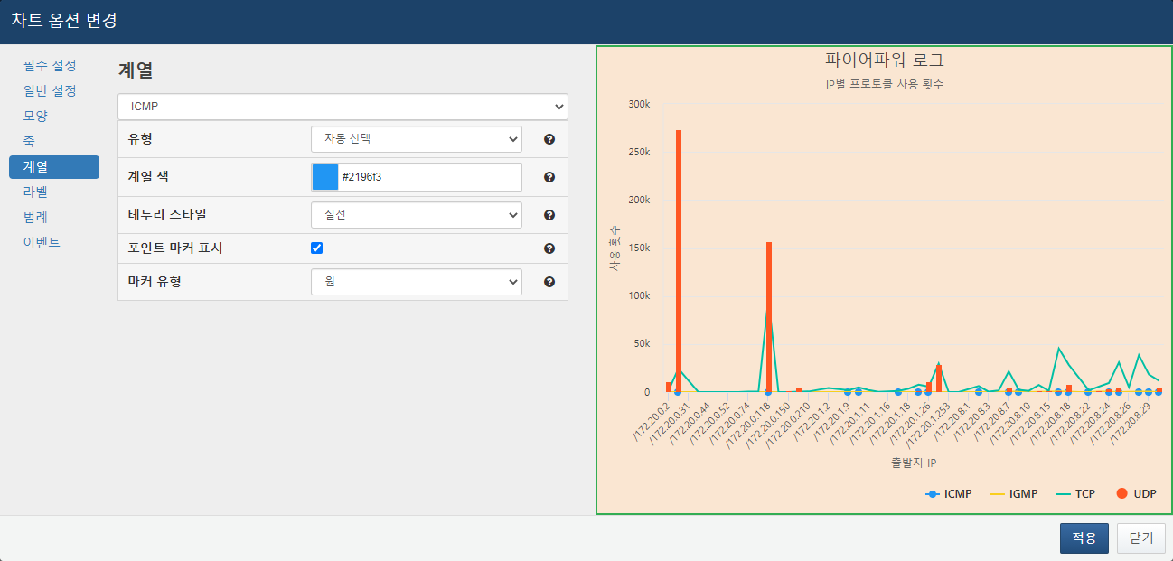

* **Type**: Select different chart types for each series. If set to auto-select, it will follow the chart type set in the required options.
* **Series Color**: Set the color to be applied to the series.
* **Border Style**: Choose the border style for the series. For line and spline types, the line shape changes, while for bar charts, the bar border shape changes.
* **Display Point Marker**: Set whether to display markers for the series. This does not affect bar chart types.
* **Marker Type**: Choose the type of marker to use. Options include circle, square, diamond, triangle, and inverted triangle. If set to auto-select, the marker type will be automatically set to avoid duplication with other series using point markers.

**Step 7**

Chart Label Settings

Enter settings for chart labels.

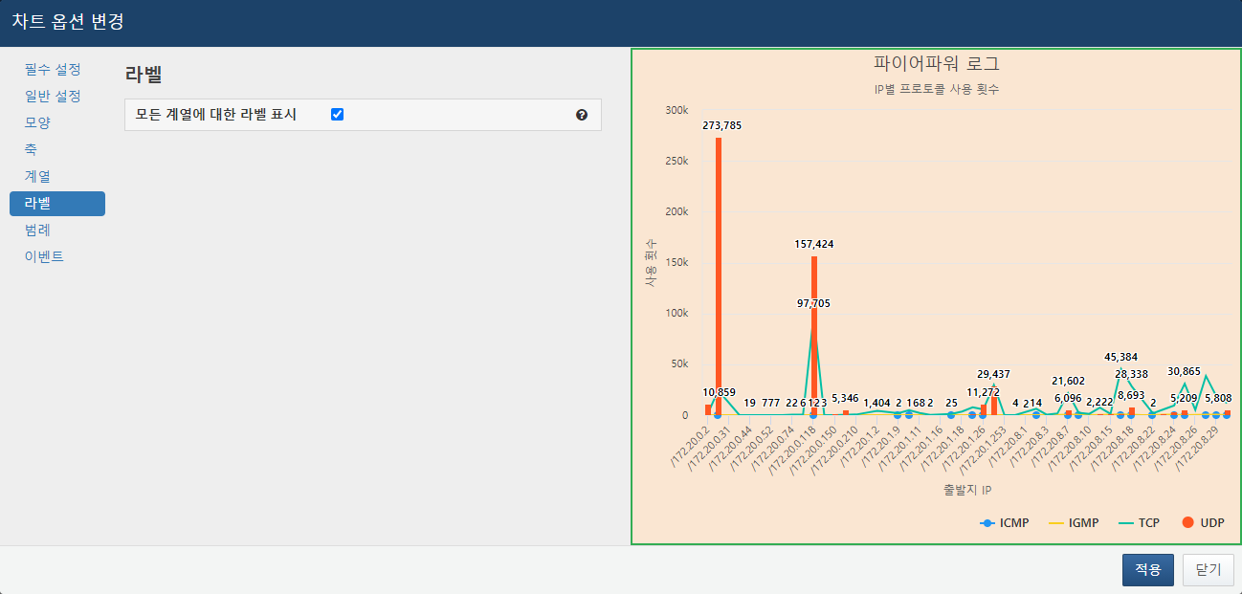

* **Display Labels for All Series**: Set whether to display labels for all chart items.

**Step 8**

Chart Legend Settings

Set the legend items that display the dependent variables.

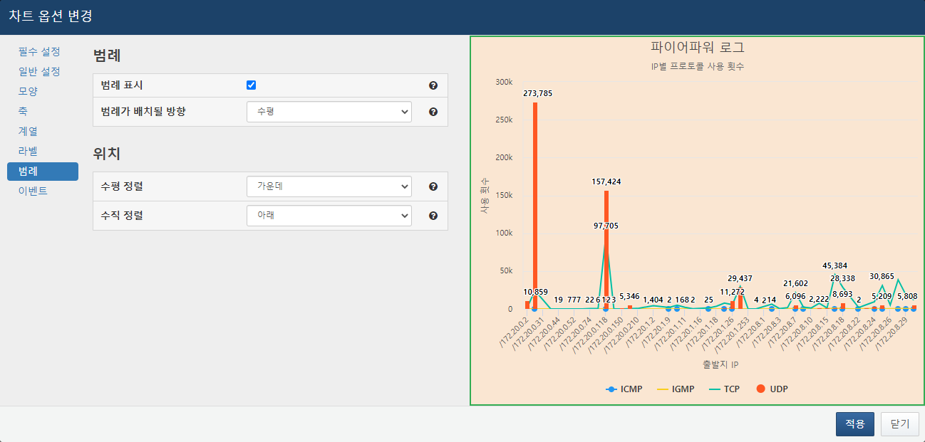

* **Display Legend**: Set whether to display the legend.
* **Legend Placement Direction**: Set whether to display the legend horizontally or vertically.
* **Horizontal Alignment**: Set whether to display the legend on the left, center, or right of the widget.
* **Vertical Alignment**: Set whether to display the legend at the top, middle, or bottom of the widget.

**Step 9**

Chart Event Settings

In the Events tab, events for the chart can be configured. If the independent variable is a time-type variable, drag events can be set. For descriptions of events, refer to Widget Events.

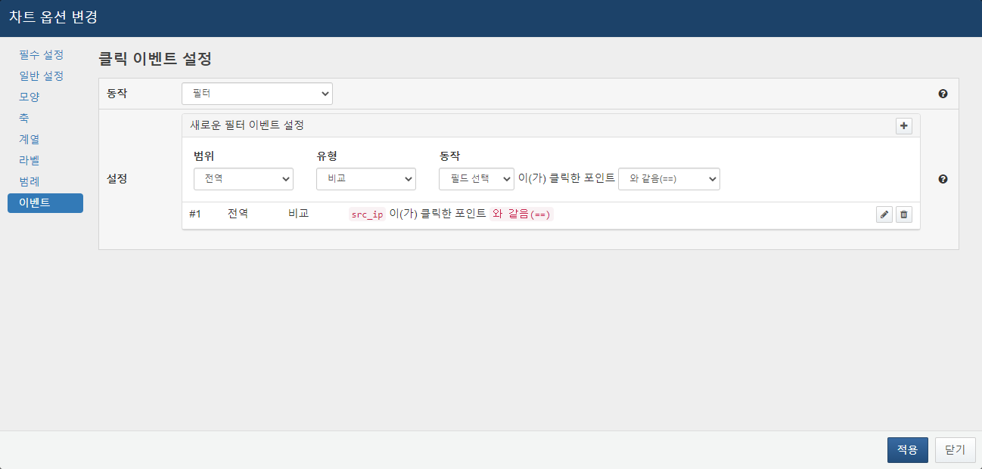

**Step 10**

Basic Chart Item Input

Press the Apply button to specify the chart settings and enter the name, description, and execution cycle. If you wish to share the widget with other accounts and groups, add accounts or groups in the sharing section. For details on widget sharing, refer to Query Widget Sharing.

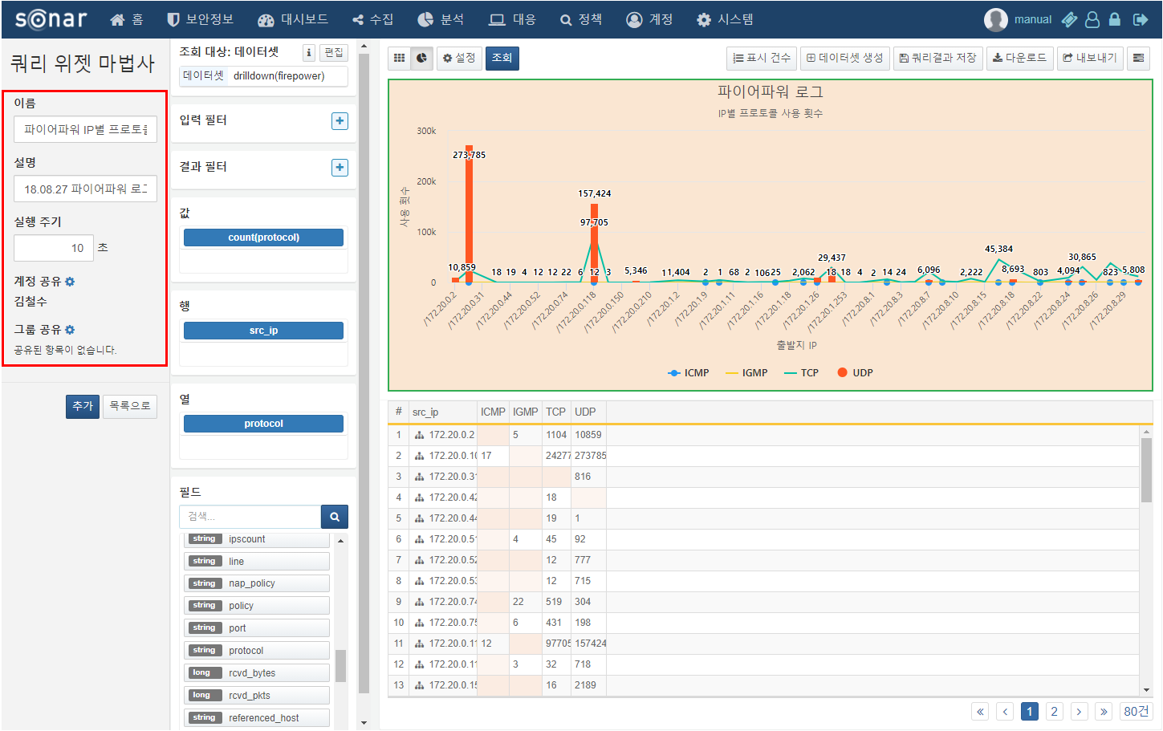

**Step 11**

Chart Widget Creation

Once the chart widget settings and basic item inputs are complete, press the Add button to create the widget. If accounts/groups were shared, the system will check the sharing status of the data source used in the widget and allow for bulk sharing of the data source as well.

Query Widget Sharing

You can select accounts and groups to share the widget with all accounts within the selected group. If you grant edit permissions to shared accounts, they will be able to edit or delete the shared widget. After specifying the shared accounts, when saving the widget, the system will check the sharing status of the data source being used. If the shared accounts do not have permissions for the data source, a modal will appear to allow for bulk sharing of the data source.

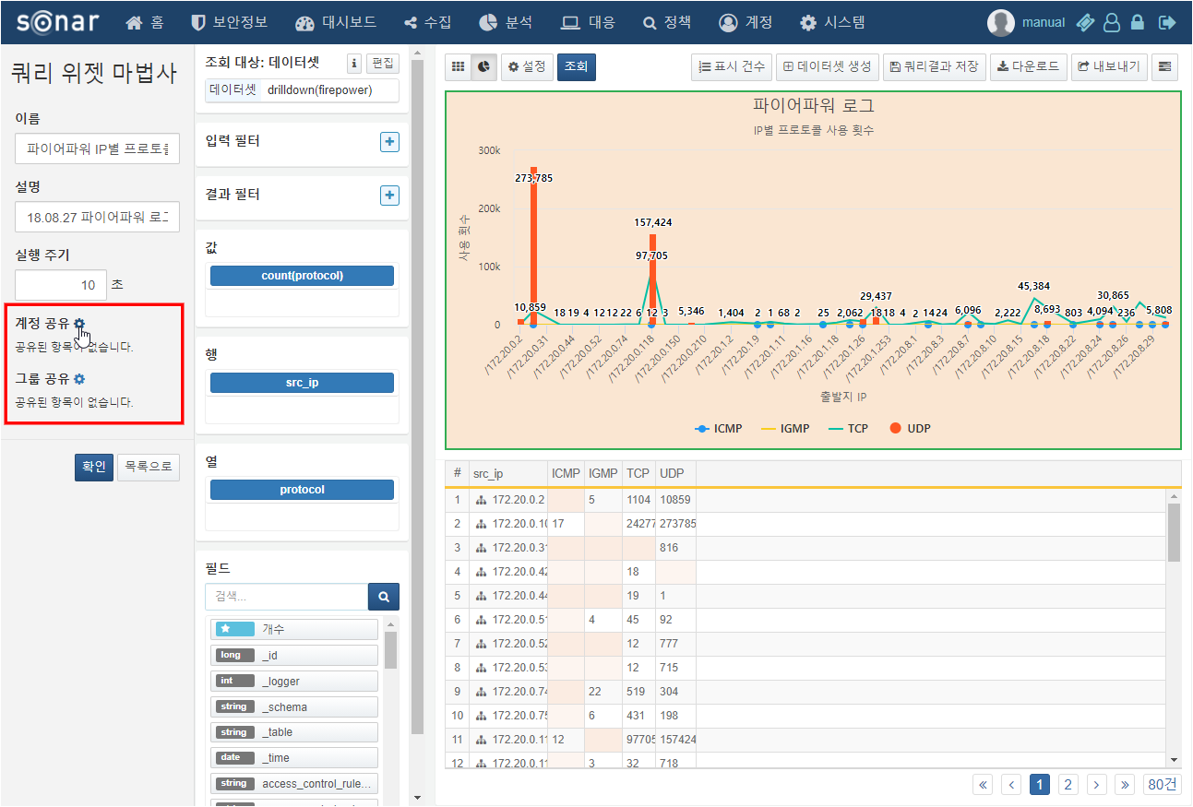

The method for sharing accounts is as follows. The method for sharing groups is the same as that for accounts and is therefore omitted.

**Step 1**

Select Shared Accounts

Click the gear icon next to account sharing to open the sharing modal and select the accounts you wish to share with.

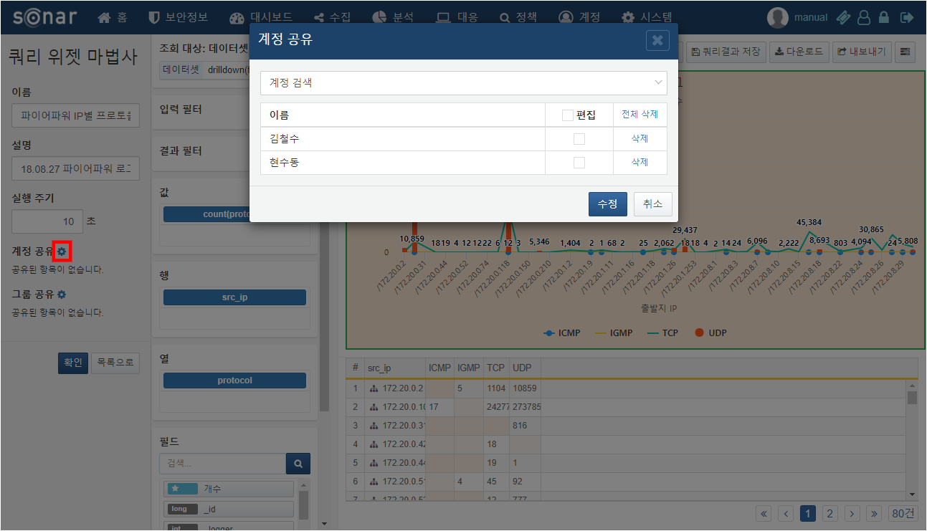

**Step 2**

Grant Edit Permissions to Shared Accounts

Check the checkbox next to the account you wish to grant edit permissions to. Users with edit permissions can edit or delete the widget, so this should be done with caution.

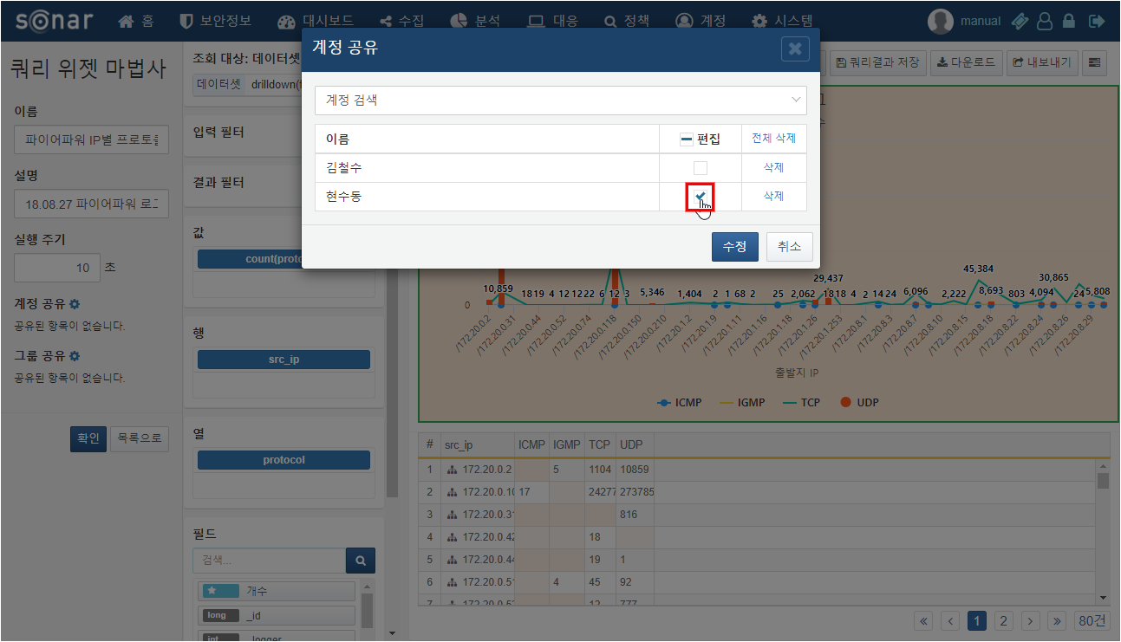

**Step 3**

Complete Account Sharing and Save Widget

After specifying the shared accounts and saving the widget, the system will check the sharing status of the data source being used in the widget. If the shared accounts only have access to the widget but not to the data source, the widget will not be displayed. Therefore, if the shared accounts do not have permissions for the data source, a modal will appear to allow for sharing of the data source as well.

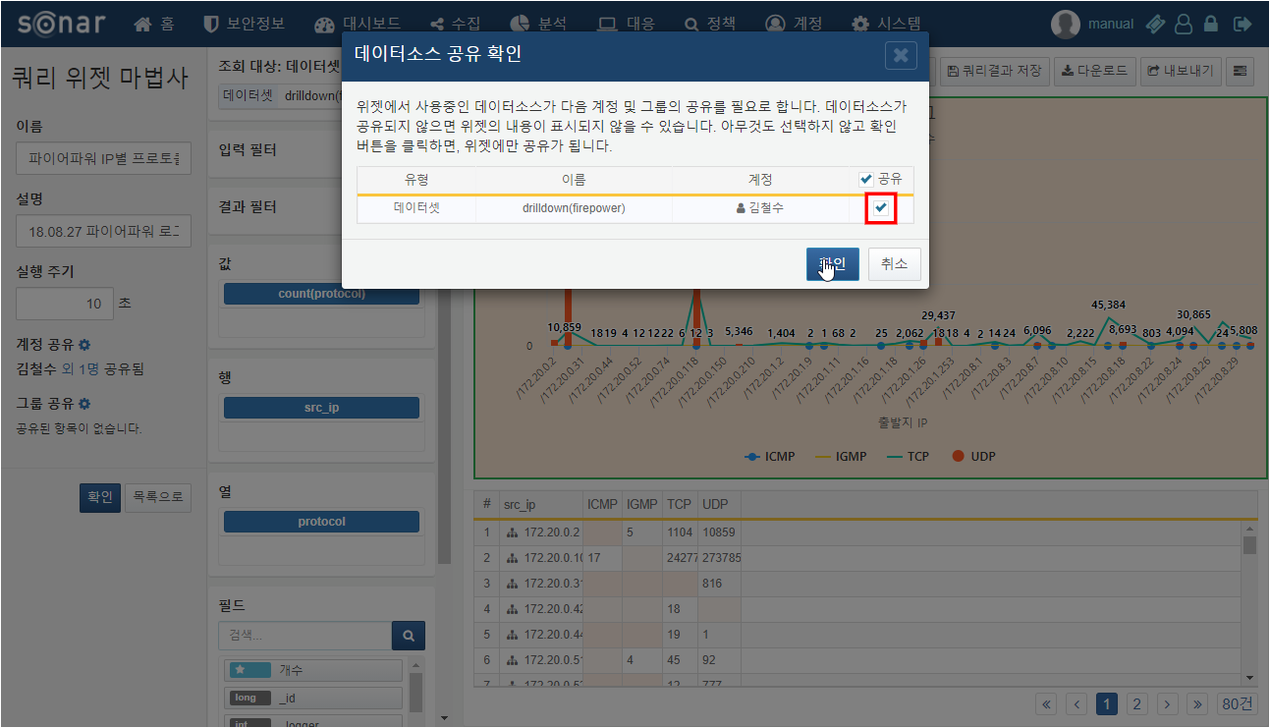

In step 2, the widget was shared with Hyunsoo and Cheolsu, but Cheolsu does not have access to the dataset drilldown (firepower), resulting in the data source sharing modal appearing.