#### Report Template Creation

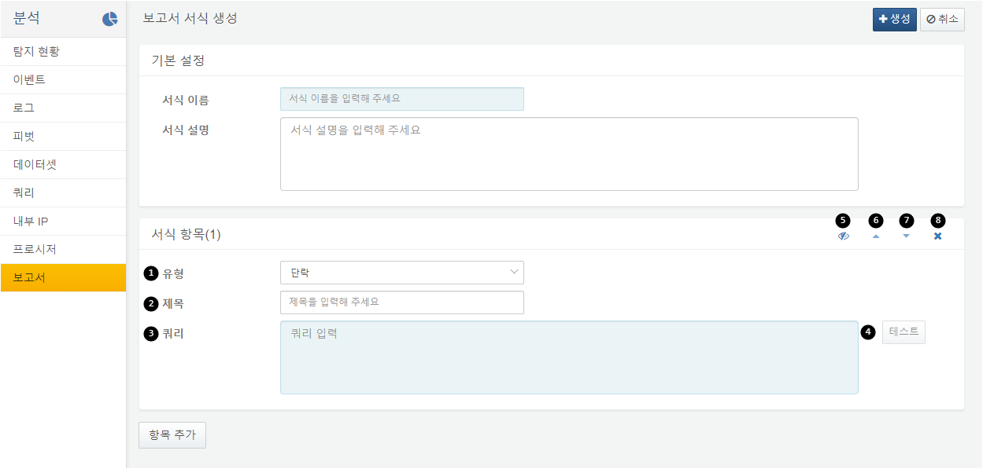

When creating a report template, specify the name of the template, add the necessary items, and set their order.

The types of items that make up the report template are paragraph, table, and note.

Enter the title for the template item. The title is optional.

Write the query to display the data for the template item. You can use the $("from") and $("to") parameters to create a report for a specific time range. If the item type is a paragraph or note, only the results from the line field will be displayed.

Click the test button to view the results of the written query in a new window. If the query cannot be executed, the test button will be disabled.

You can choose whether to display or hide the template item in the report. By holding the ALT key and clicking, you can toggle the visibility of all items in the template.

You can move the template item up. By holding the ALT key and clicking, you can send it to the very top.

You can move the template item down. By holding the ALT key and clicking, you can send it to the very bottom.

You can delete the template item. By holding the ALT key and clicking, you can delete all items in the template.

Report Template Item Types

**Paragraph**

Outputs the line field values from the query results as paragraph text. If there are multiple records, paragraphs will be output consecutively.

**Table**

Outputs the query results in a table format. The columns will be displayed in the same order as they appear in the query results window. That is, if the order is specified using fields or order commands, the columns will be output in that order.

**Note**

Outputs the line field values from the query results as note text within a bordered box area. If there are multiple records, notes will be output consecutively.

Example of Report Template Creation

This example demonstrates how to create a template that displays the query execution status for a specified time in a table format by user and source.

Step 1

Navigate to the Create New Template screen.

Click the Create New Template button from the report list to go to the report template creation screen.

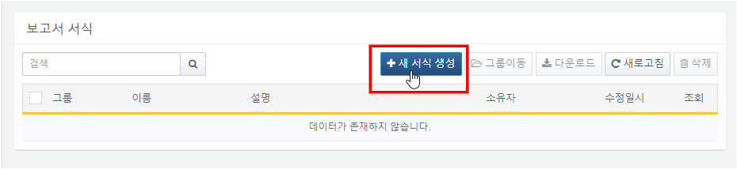

Step 2

Set the template name and items.

Using the example queries below, create five report template items.

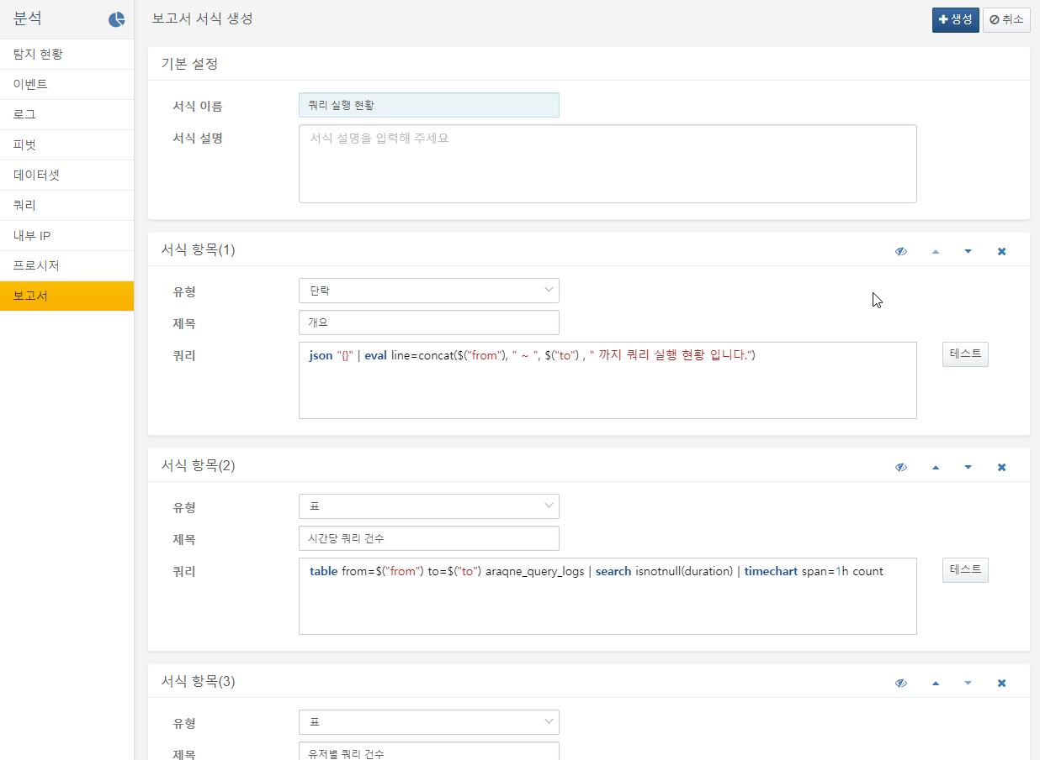

**Item 1. Type: Paragraph, Title: Overview**

json "{}" | eval line=concat($("from"), " ~ ", $("to"), " 까지 쿼리 실행 현황 입니다.")

**Item 2. Type: Table, Title: Query Count per Hour**

table from=$("from") to=$("to") araqne_query_logs | search isnotnull(duration) | timechart span=1h count

**Item 3. Type: Table, Title: Query Count by User**

table from=$("from") to=$("to") araqne_query_logs | search isnotnull(duration) | timechart span=1h count by login_name

**Item 4. Type: Table, Title: Query Count by Source**

table from=$("from") to=$("to") araqne_query_logs | search isnotnull(duration) | timechart span=1h count by source

**Item 5. Type: Table, Title: Query Count per Hour by User and Source**

table from=$("from") to=$("to") araqne_query_logs | search isnotnull(duration) | eval t=datetrunc(_time,"1h") | stats count by t, source, login_name

Step 3

Save the template.

Click the Create button to save the template.