#### Adding a New Ticket Repository

On the Ticket Repositories page, click the New Repository button to enter the new repository menu.

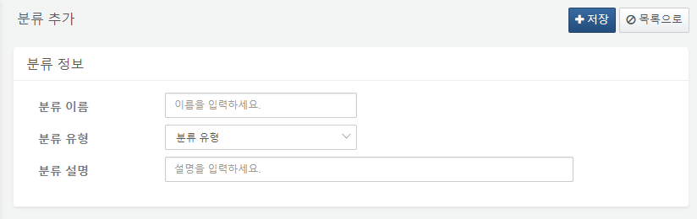

Each item of the repository information is as follows:

**Repository Name**

Enter the name of the ticket repository.

**Repository Type**

Specify the type of the ticket repository. The types of ticket repositories are divided into Event and Bulletin.

**Repository Description**

Enter a description for the ticket repository.