Register New Ticket
To register a new ticket, click the Add button on the Tickets page.
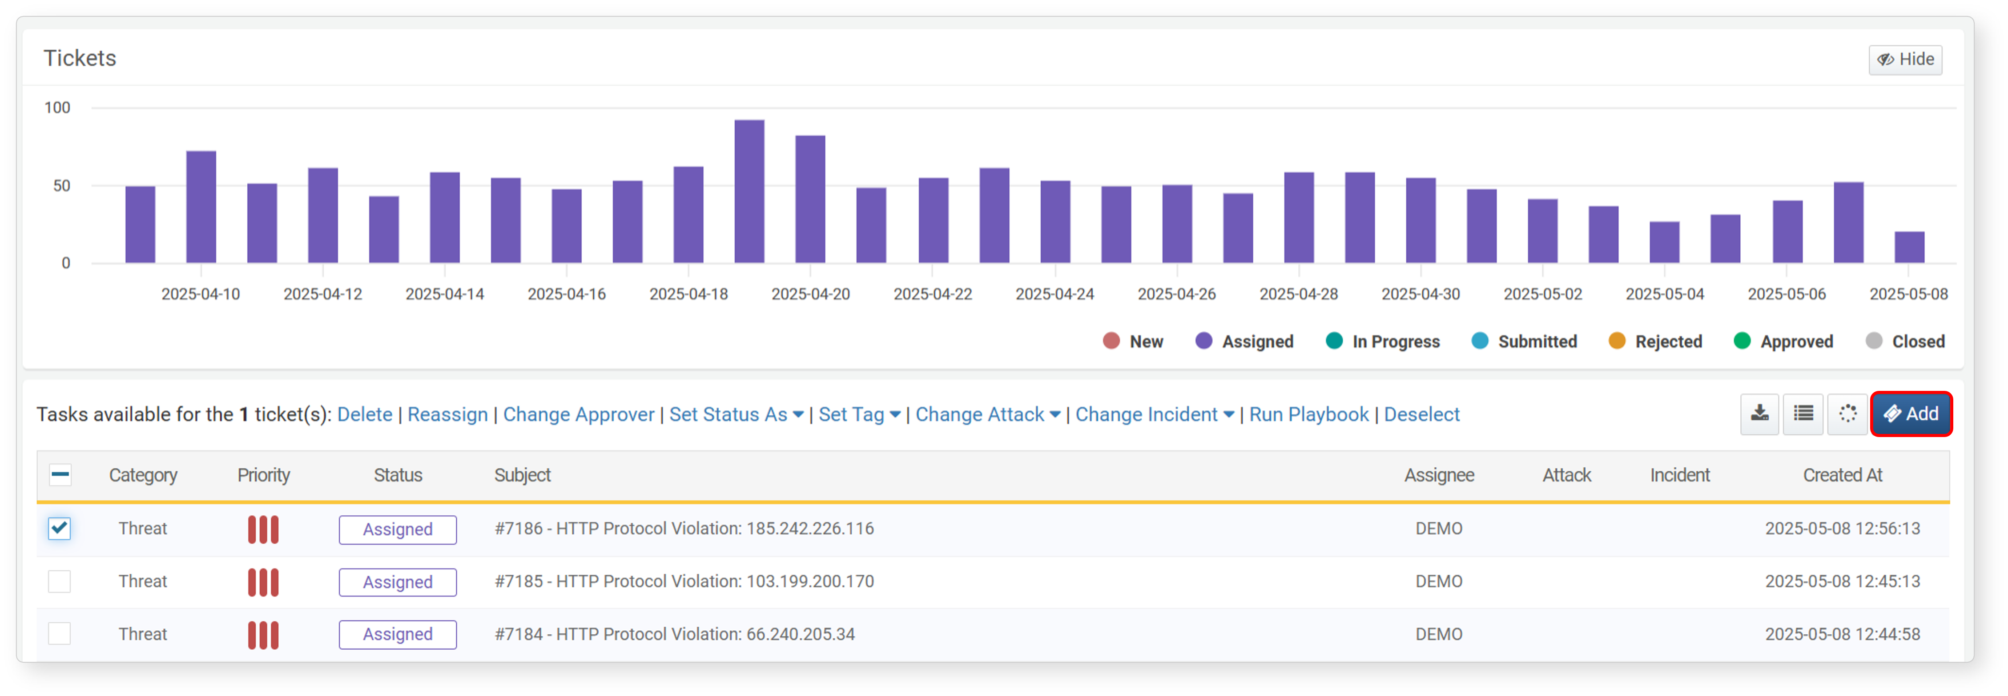
On the Add Ticket page, draft the ticket content. Markdown syntax is supported, and you can attach image files to insert into the body. The preview tab shows how the drafted content will appear.
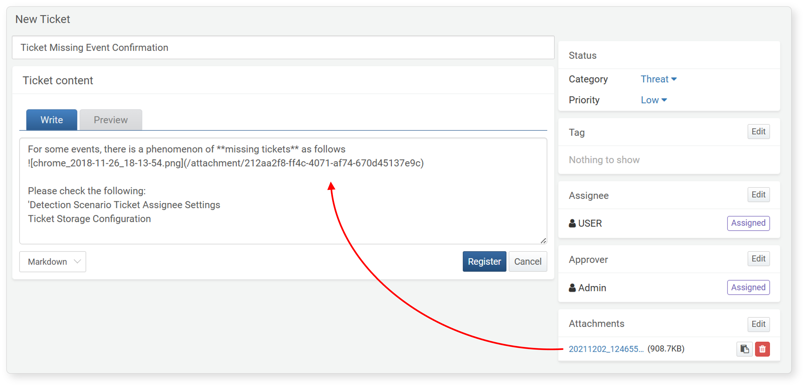
Title: Enter the ticket title to display in the ticket list.
Content: Provide detailed information for the ticket. You can use Markdown syntax or plain text.
Content Syntax: Select Markdown or plain text format for the ticket content.
Preview: View the ticket content with Markdown formatting applied.
Category: Select the ticket category.
Priority: Choose the ticket priority (High, Medium, or Low).
Assignee: Assign the Sonar account responsible for the ticket.
Approver: Select the Sonar account that will review and approve or reject the ticket.
Attachments: Upload files to attach to the ticket. Insert attachments into the content body using the clipboard button. Attachments can be downloaded when viewing the ticket. Use the Delete button to remove an attachment.
When finished, click the Register button to add the ticket.

