### Dashboard Configuration

A single dashboard is composed of multiple tabs and widgets, and it offers a docking layout feature that allows widgets to be placed at desired locations with arbitrary sizes. Once a widget is created, it can be reused multiple times, and any changes made to the widget properties will be uniformly applied across all dashboards.

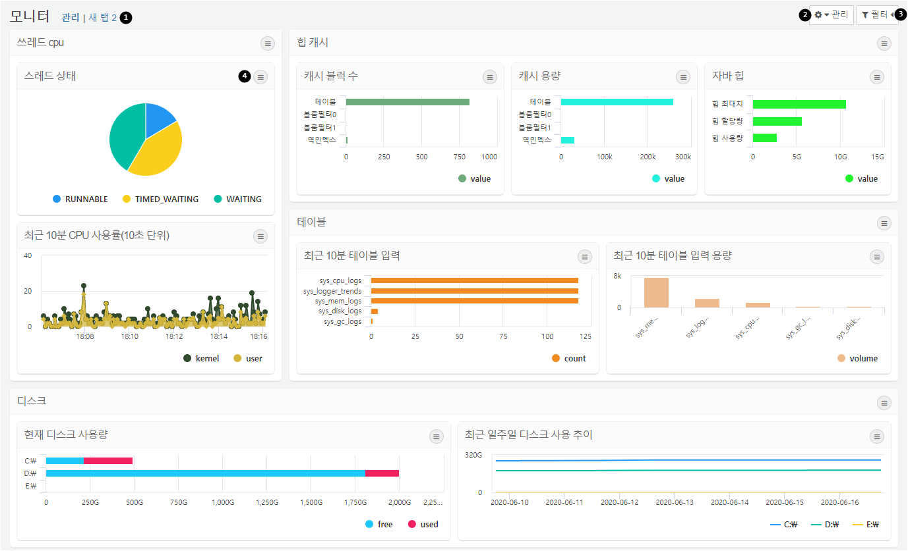

**Tab Switching**: Click on the tab title to switch to the corresponding tab.

**Dashboard Management**: Clicking the button will display options for managing the dashboard. You can select edit mode to change the layout of the dashboard, manage widgets, manage tabs, change themes, enter fullscreen mode, and adjust widget display options. For detailed explanations, refer to [Dashboard Management](https://docs.logpresso.comnull).

**Filters**: Clicking the button will open a panel where you can specify filters for the global dashboard or for widgets using the same dataset. For detailed explanations, refer to [Filter Management](https://docs.logpresso.comnull).

**Widget Settings**: Clicking the button will display options for widget information, refreshing, pausing, viewing query results, and enlarging the widget.