#### Dashboard Filters

Dashboard filters consist of **time filters** and **global filters** that specify conditions for all widgets on the dashboard, as well as **dataset filters** that apply conditions only to widgets created with related datasets. By clicking on Filters in the upper right corner of the dashboard, a panel appears where users can configure filter addition, deletion, and application status. Dashboard filters can be applied either through widget events or by directly adding filters in the filter management panel.

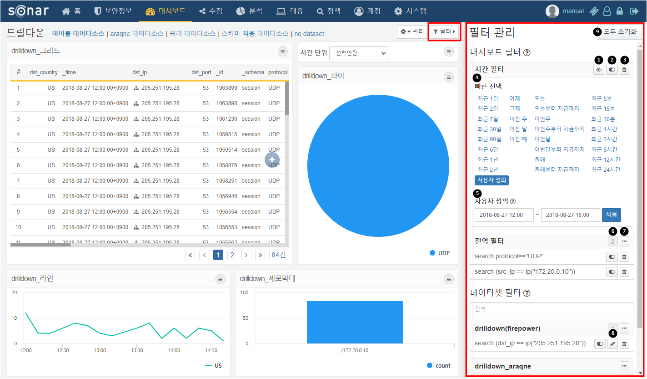

The following describes the items within the filter management panel:

**Hide Time Filter**: Minimizes the time filter.

**Filter Enable/Disable Button**: Activates or deactivates the filter.

**Delete Filter**: Removes the added filter.

**Quick Select Time Filter**: Allows for quick application of frequently used time range filters.

**Custom Time Filter**: Users can input a custom time range to apply. This option is available by selecting "Custom" from the quick select.

**Number of Filters**: Displays the number of filters added to the global or dashboard filters.

**Global Filter Menu**: Displays a menu for hiding the filter list, adding filters, bulk deleting filters, and bulk enabling/disabling filters.

**Edit Filter**: Edits the filter conditions. Editing is only possible for filters added directly by the user; filters added through widget events cannot be edited.

**Reset All**: Deletes all added filters.

Method 1 for Applying Filters - Widget Event Actions

When an event such as a click or drag occurs on a widget with filter options, the specified conditions are applied as filters. For more information on widget event filters, please refer to the widget event filter documentation.

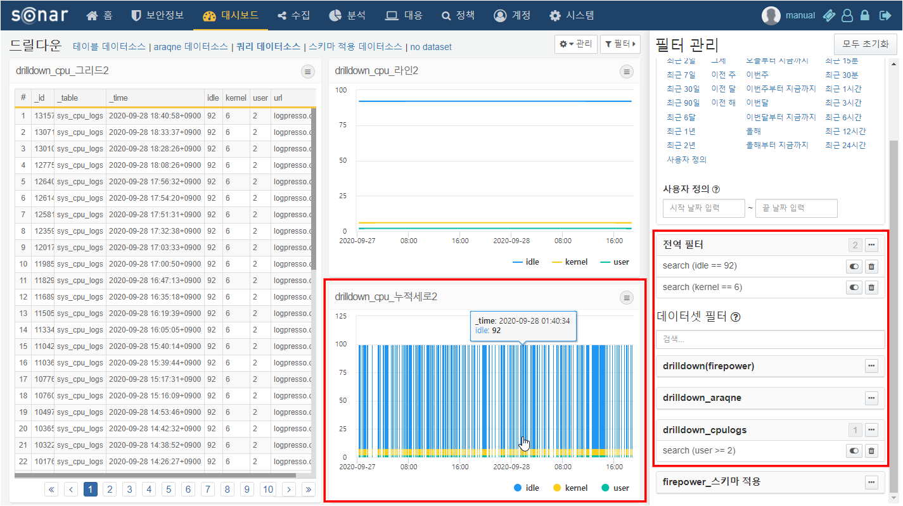

Method 2 for Applying Filters - Direct Addition

Users can directly add filters to the dashboard and datasets through the filter management panel. Click on ··· to open the filter menu and select **Add Filter Item** to add a filter.

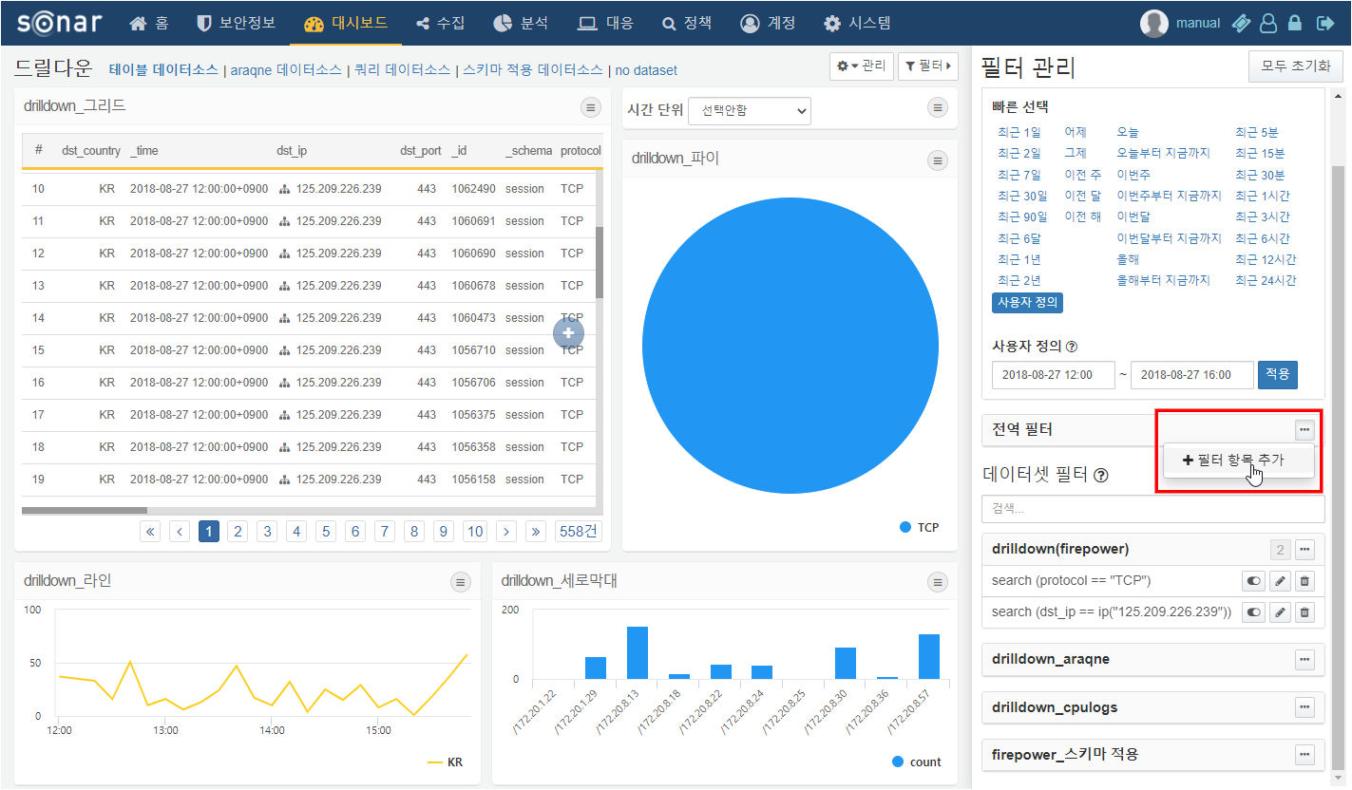

The types of filters that can be added are as follows:

* **Comparison Filter**: Creates a filter condition using the operations and values entered for a specific field.
* **Range Filter**: Creates a filter condition based on a range of values entered for a specific field.
* **Query Filter**: Applies a filter using a user-defined Logpresso query statement.

