#### Dashboard Management

Click the Manage button in the upper right corner to display the context menu. By clicking each menu item, you can add or remove widgets or containers in the current tab, as well as add or manage new tabs. Additionally, you can change the theme of the dashboard and the display options for the widgets.

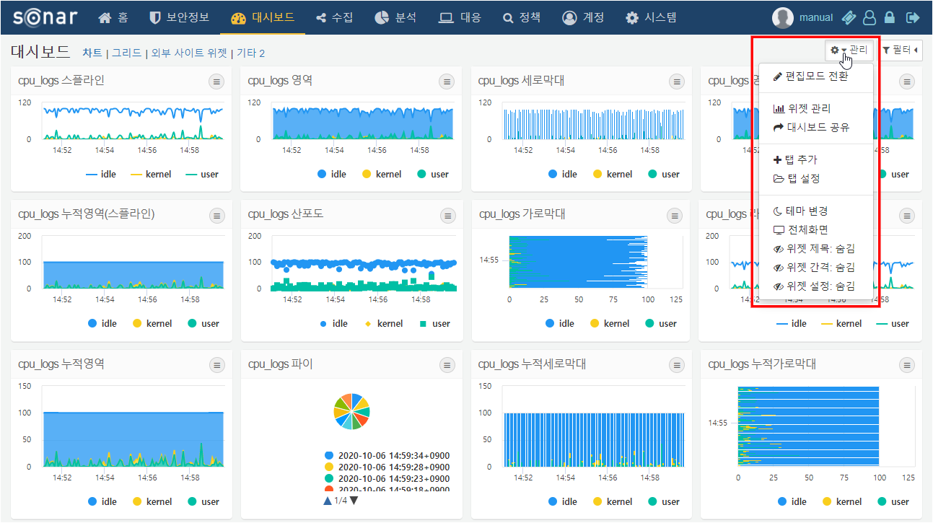

Switching to Edit Mode

Switch to a mode where you can add or remove widgets on the dashboard, as well as change the size and position of the widgets. For more details, please refer to Dashboard Editing.

Widget Management

Navigate to the management screen where you can create, edit, and delete widgets. For more information, please refer to Widget Management.

Dashboard Sharing

Select accounts and groups to share the dashboard with all accounts within the selected group. If you grant edit permissions to shared accounts, they will be able to edit or delete the shared dashboard.

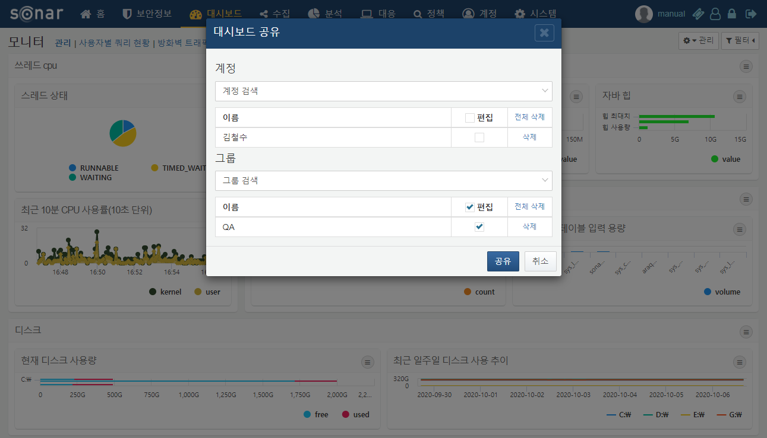

After selecting shared accounts and saving, the system checks the sharing status of the widgets and data sources used in the dashboard. If an account has access to the dashboard but lacks permissions for the widgets or data sources, those widgets will not display correctly. A list of items for which the shared accounts do not have permissions for the widgets and data sources will be provided.

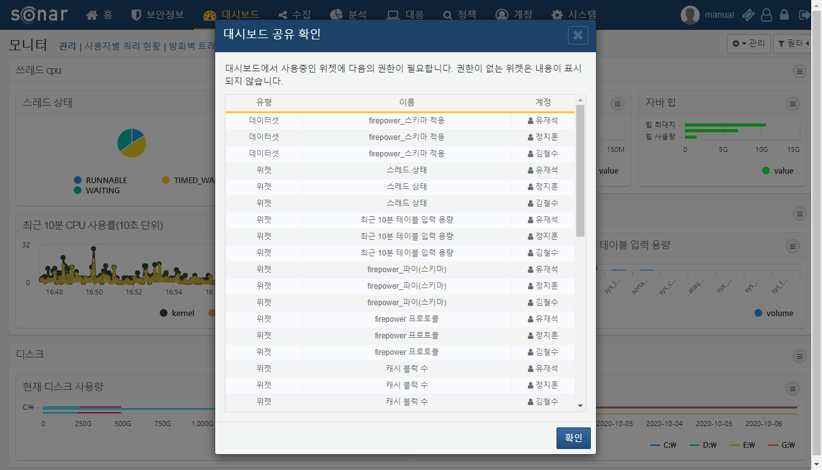

Adding Tabs

Add a tab to the dashboard. When you click "Add Tab," a popup window will appear where you can specify the name of the tab.

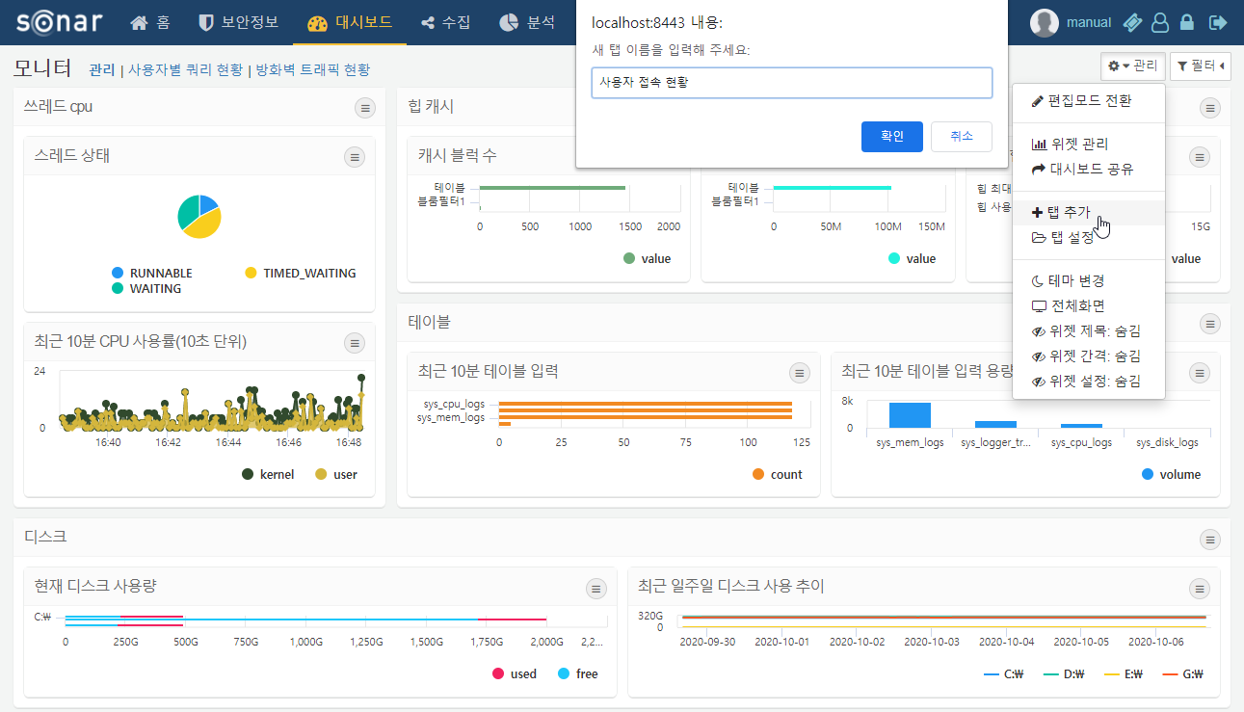

Tab Settings

Change the names and order of the dashboard tabs or delete tabs. After making modifications, click the confirm button to save the changes.

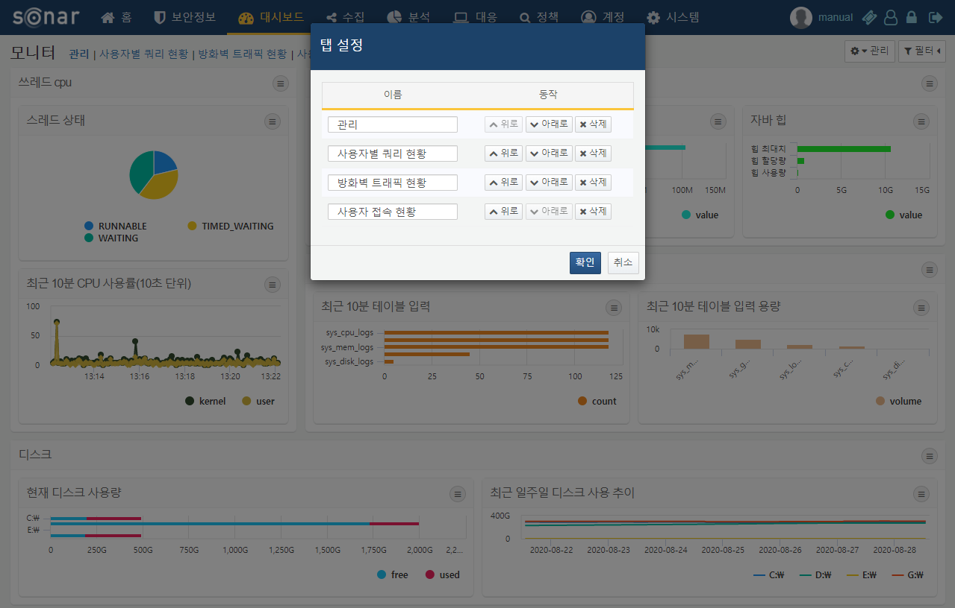

Changing Themes

Change the theme of the dashboard. There are options for a default theme and a dark theme. In the dark theme, the spacing between widgets does not appear regardless of the options selected.

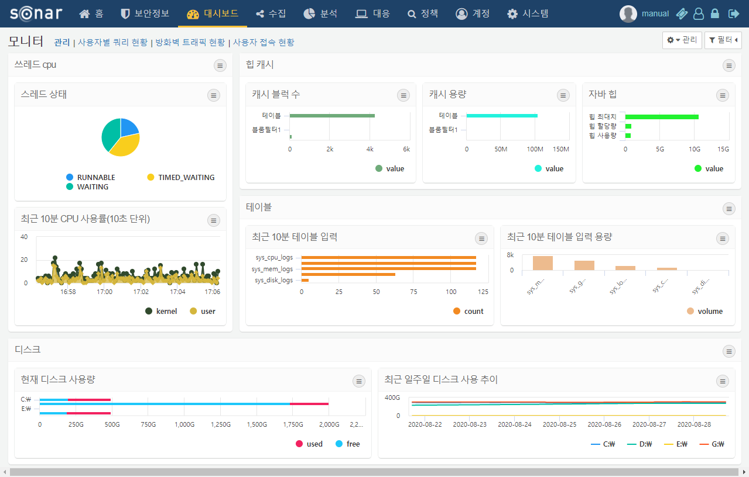

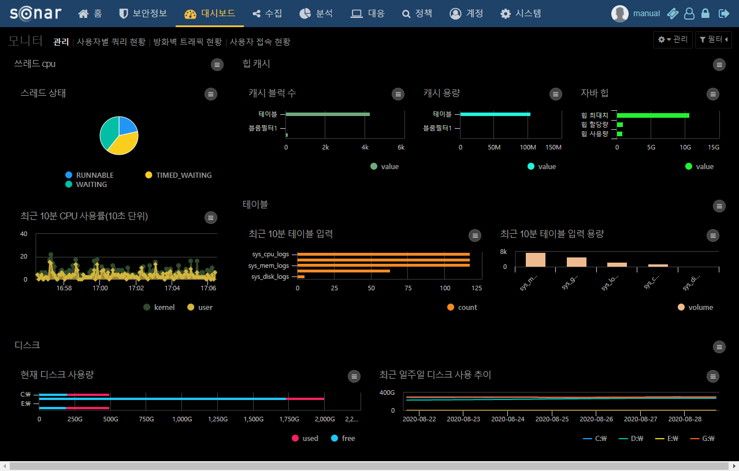

Full Screen

Remove the top menu of Sonar to display the dashboard in full screen within the browser.

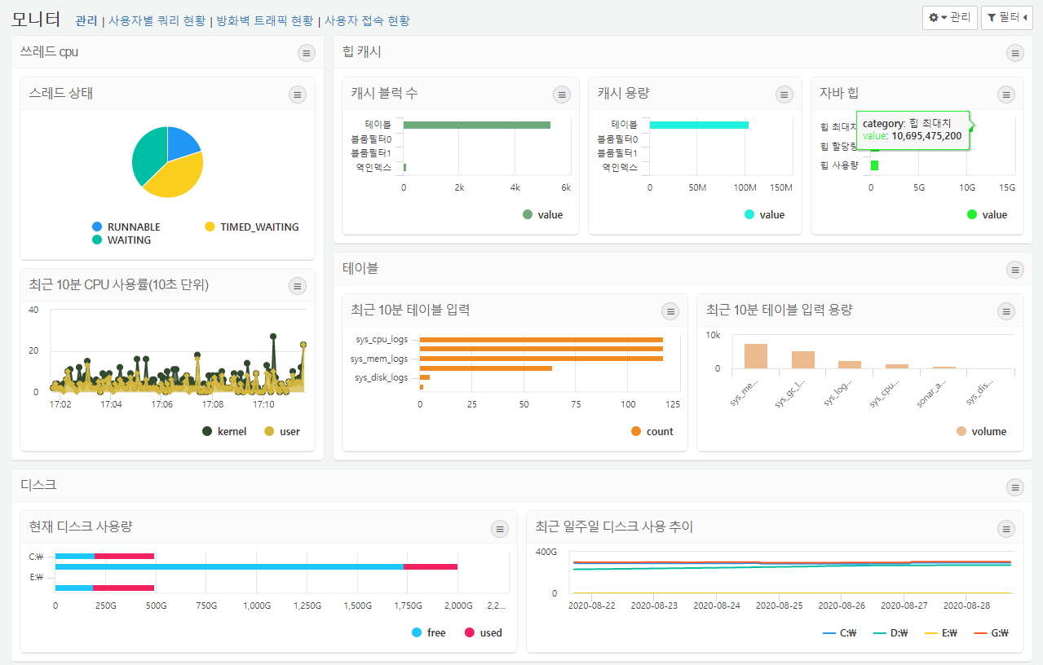

Widget Display Options

Widget Title

Set whether to display the title of the widget. For widget containers, the title is always displayed regardless of the option selected.

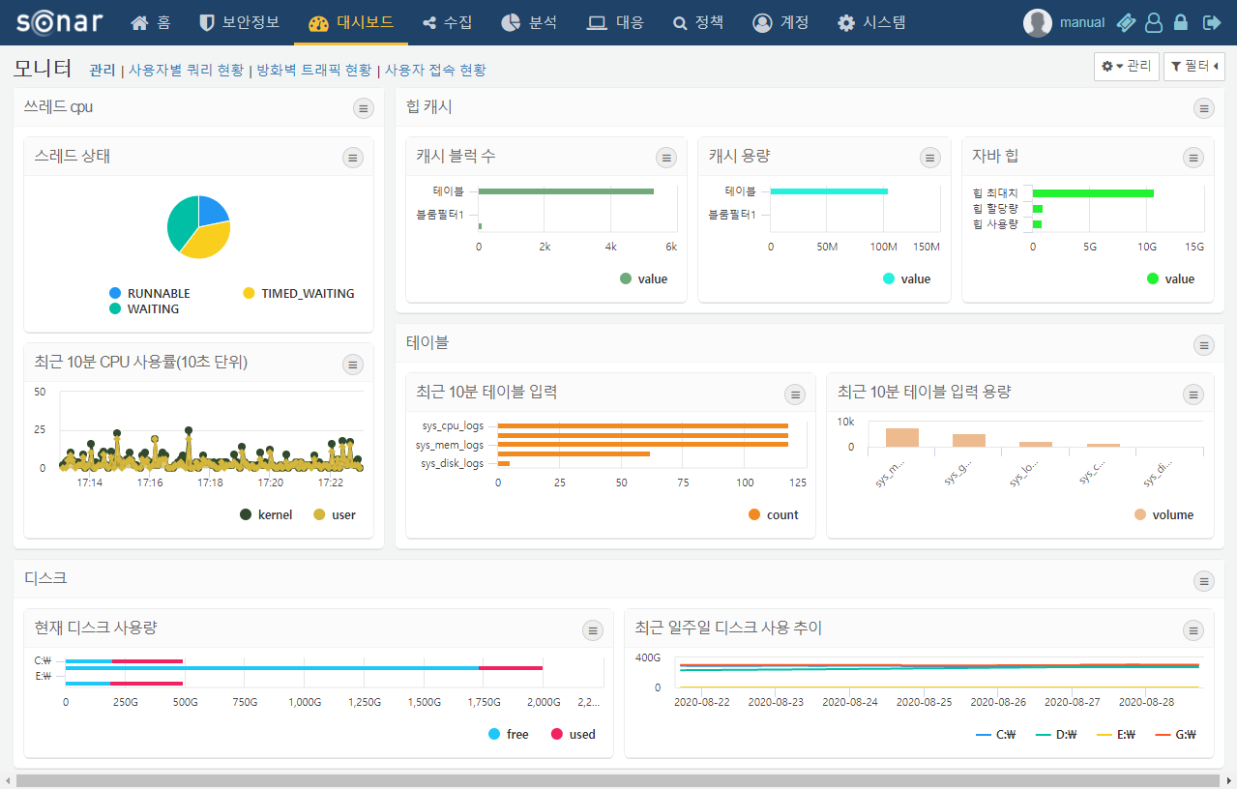

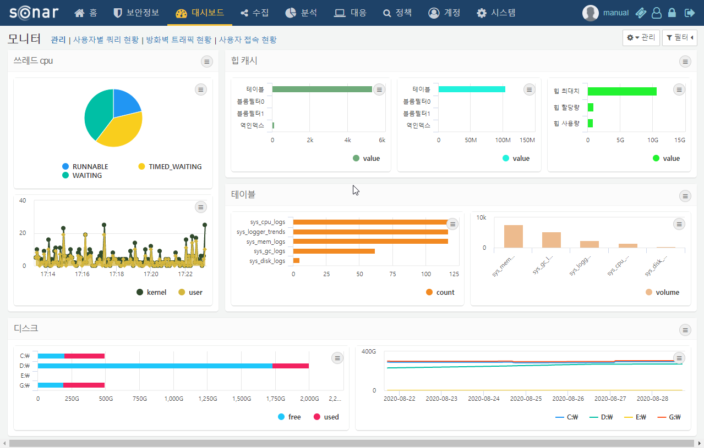

Widget Spacing

Set whether to display the spacing between widgets. For widget containers, the spacing is always displayed regardless of the option selected.

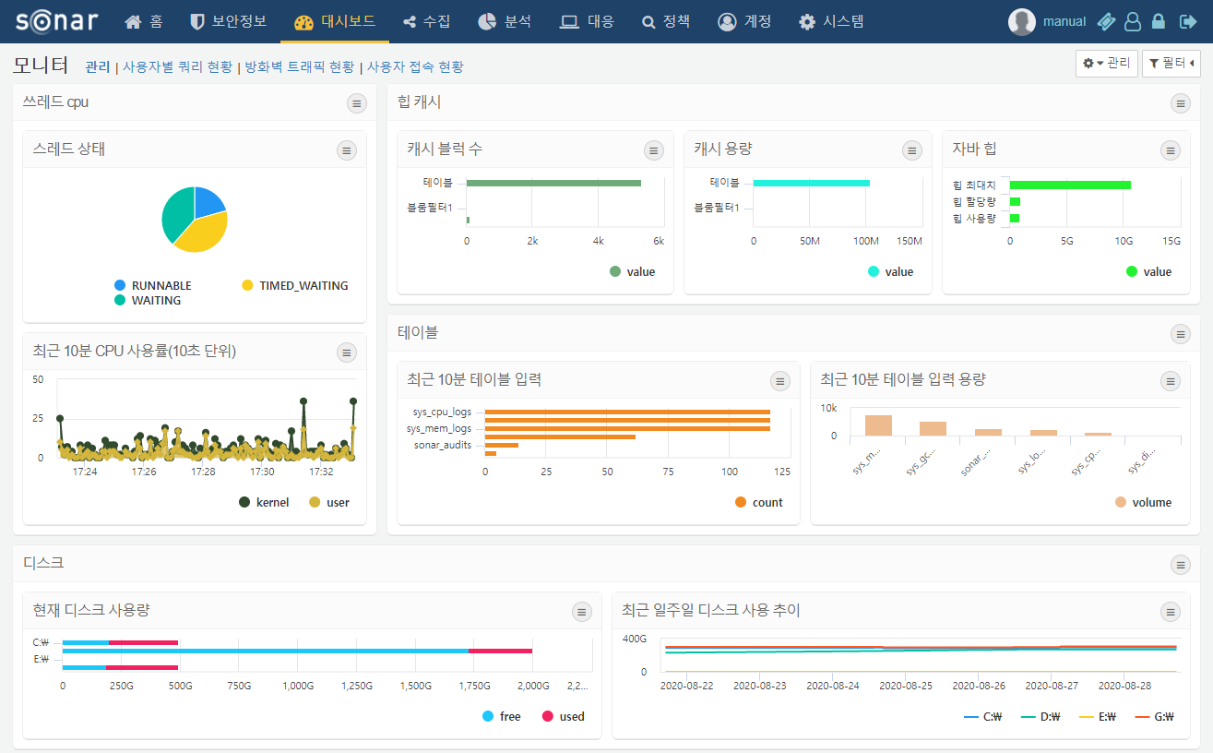

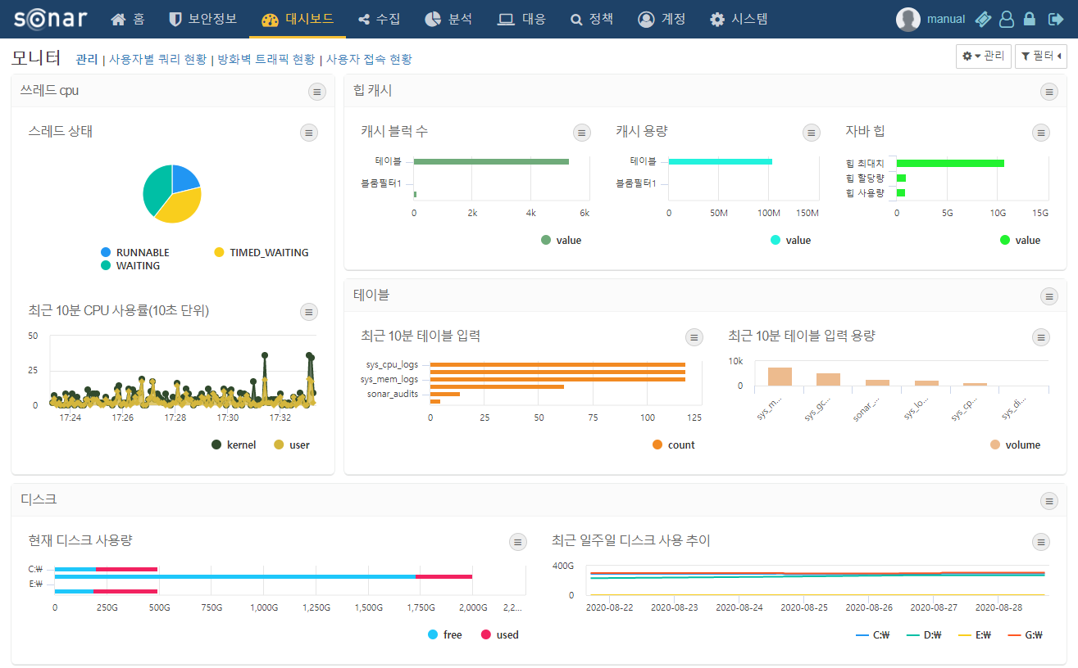

Widget Settings

Set whether to display the widget settings button. For widget containers, the settings button is always displayed regardless of the option selected.

