Dataset Data Types

Pivot operations can be executed on the data of existing datasets. Datasets can be created from the dataset menu, or the results of pivot analysis can be saved as datasets.

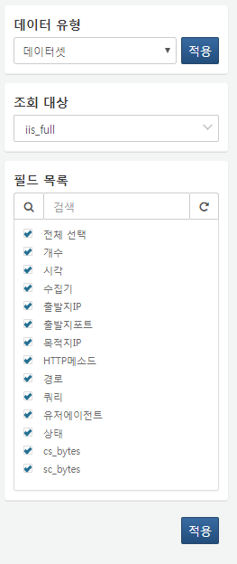

**Target for Query**

Select the dataset to be queried from the list.

**Field List**

Select the list of fields to be queried.