#### Report Download

Users can input dates and times to retrieve reports, which can then be downloaded in either DOCX or HTML format. When downloading, the file name is designated as the title of the report.

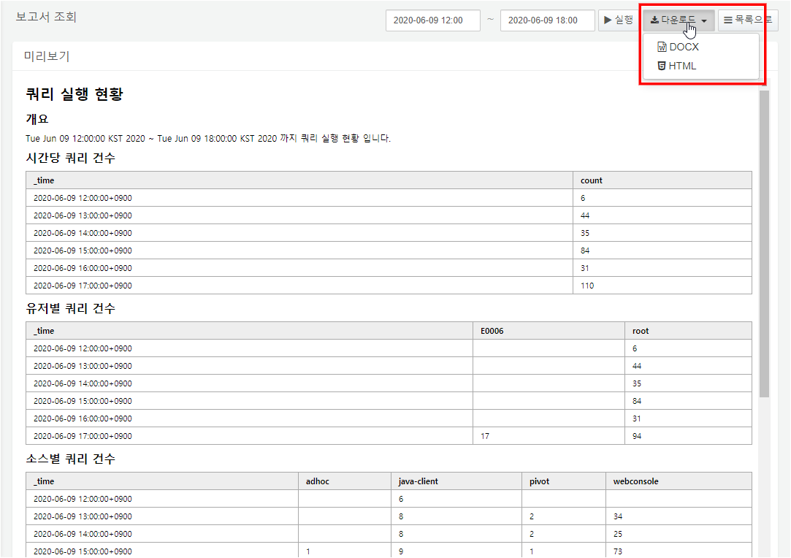

Example of Downloaded Files

