#### Dynamic Filters

When creating or editing a widget, add a dynamic filter in the input filter and apply the filter by assigning values to custom variables through the input control widget.

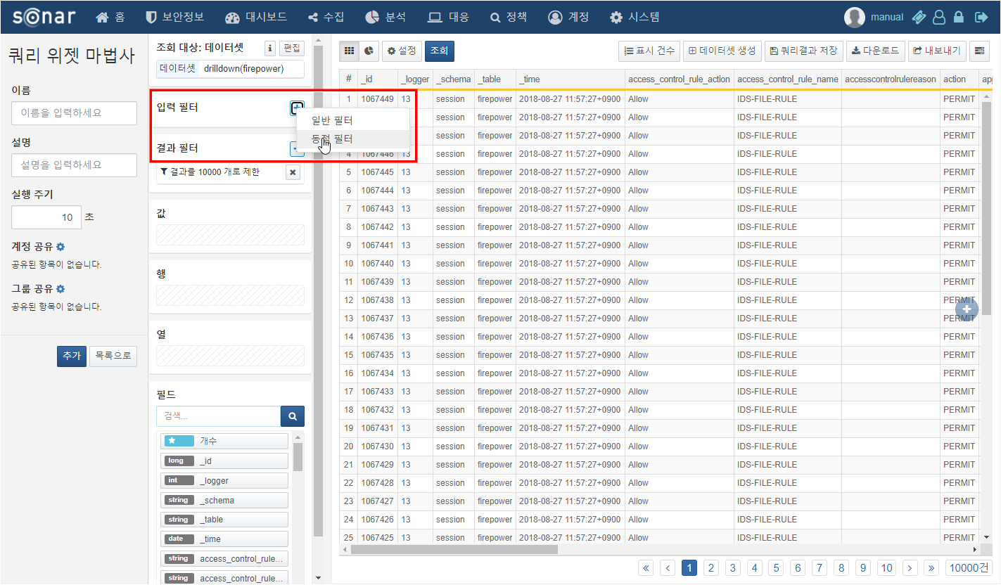

Custom Variables

These are the variables used to assign filter values for dynamic filters. Custom variables are assigned based on the values entered in the input control widget, which then applies the dynamic filter.

Custom variables can be managed through the Manage Custom Variables option on the dashboard home screen or by clicking the Manage button in the variable section when creating or editing an input control widget, which opens the custom variable popup window.

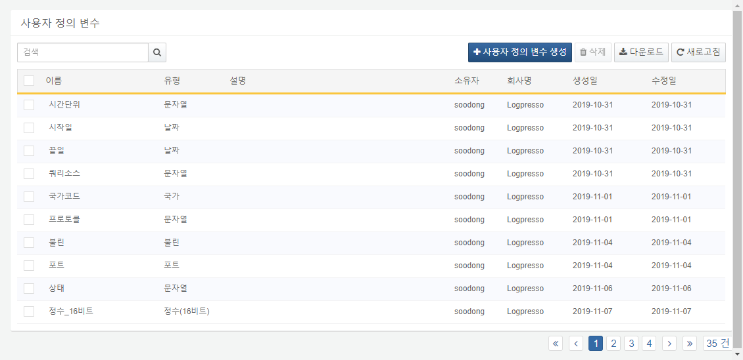

How to Apply Filters

Step 1

Create Custom Variables

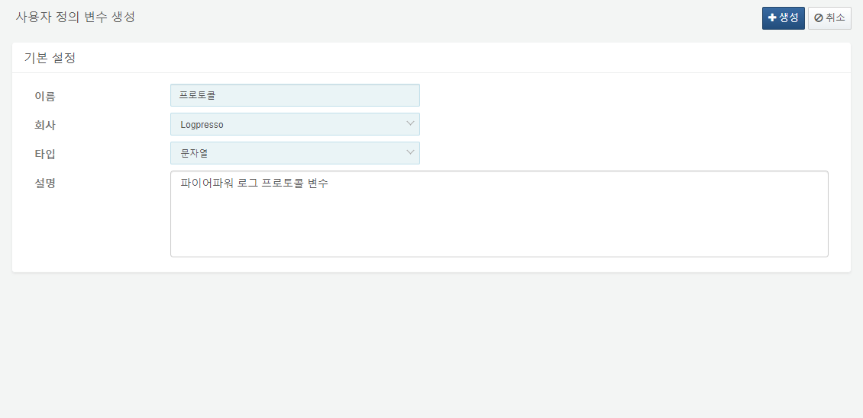

Step 2

Add Dynamic Filter When Creating Widget

Specify the created custom variable as the value variable to add the dynamic filter.

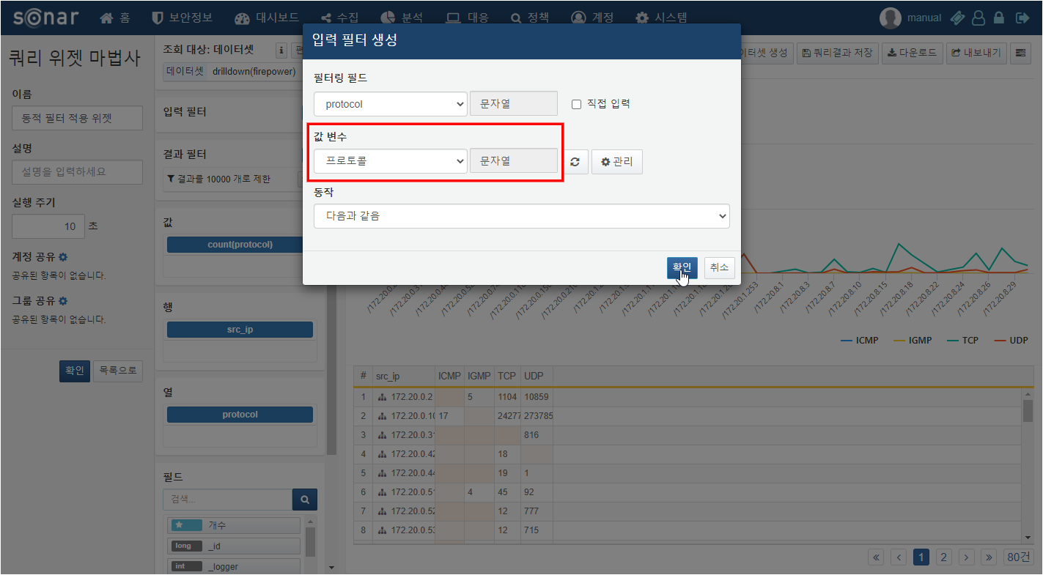

Step 3

Create Input Control Widget

Create the input control widget by designating the value variable entered when adding the dynamic filter as a query parameter.

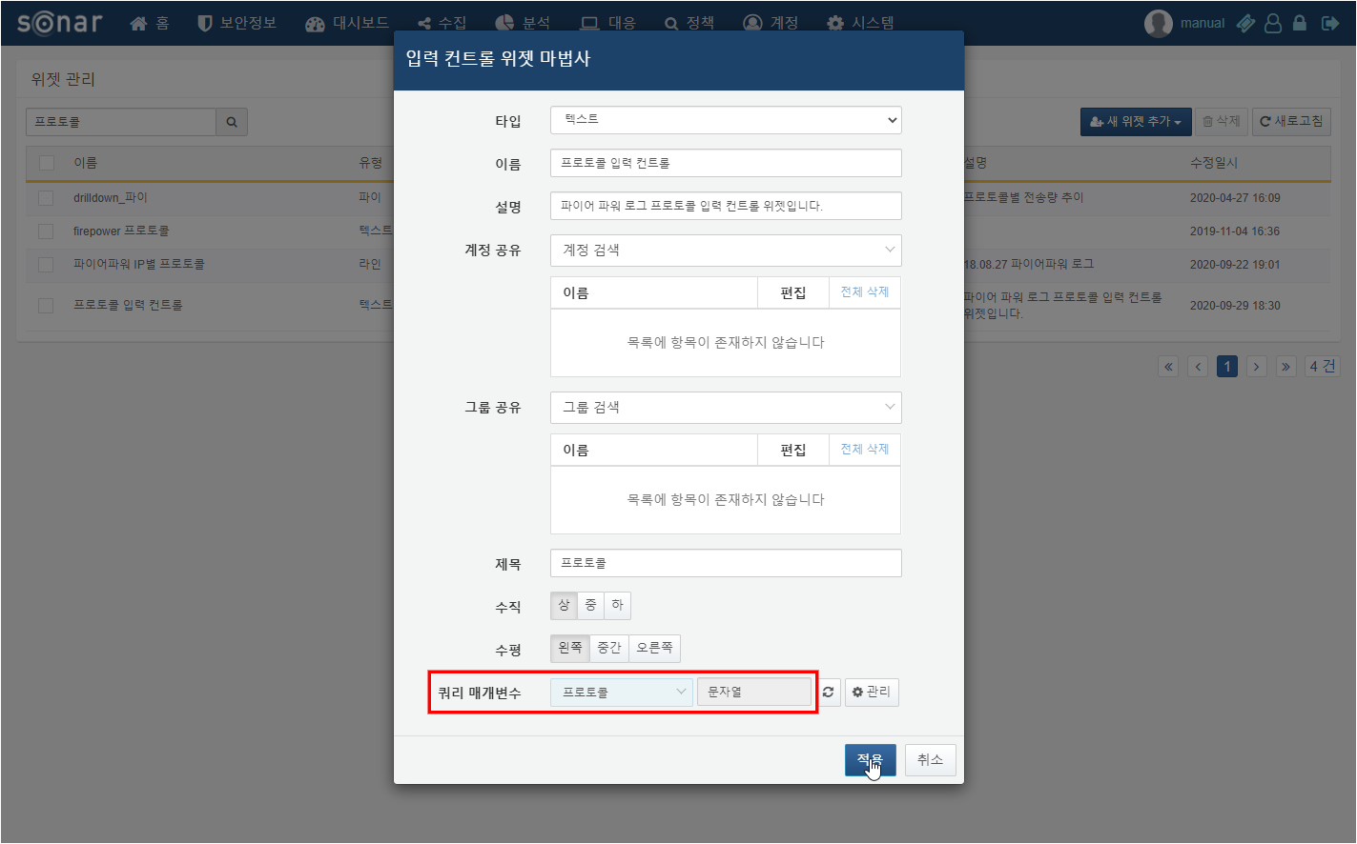

Step 4

Add Widget to Dashboard

Add the widget with the applied dynamic filter and the input control widget to the dashboard.

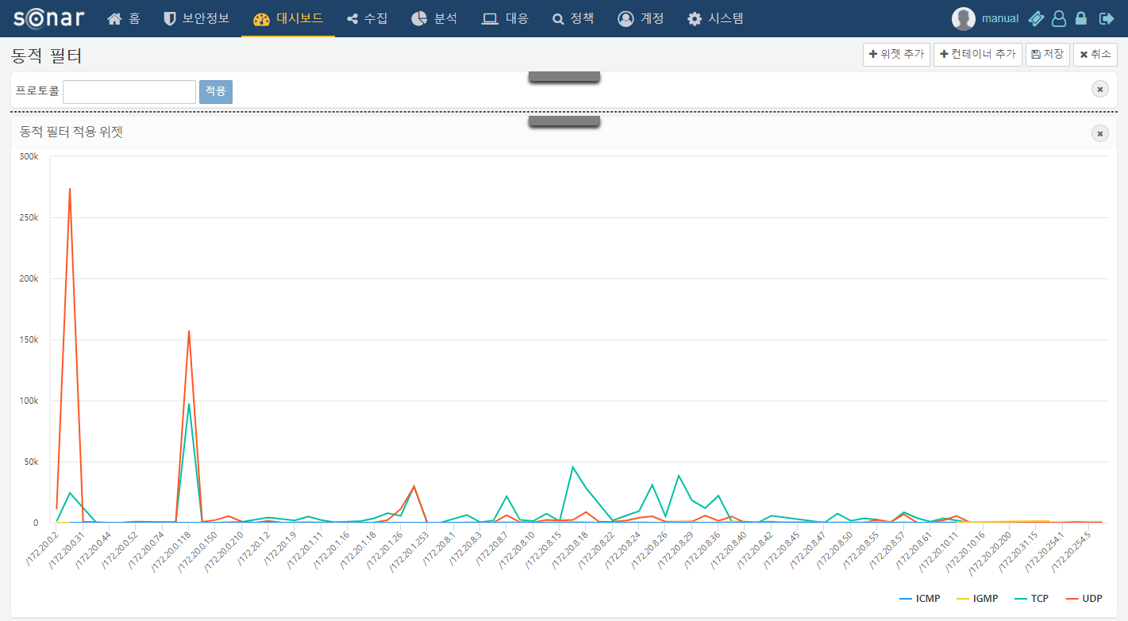

Step 5

Assign Variable Values with Input Control Widget

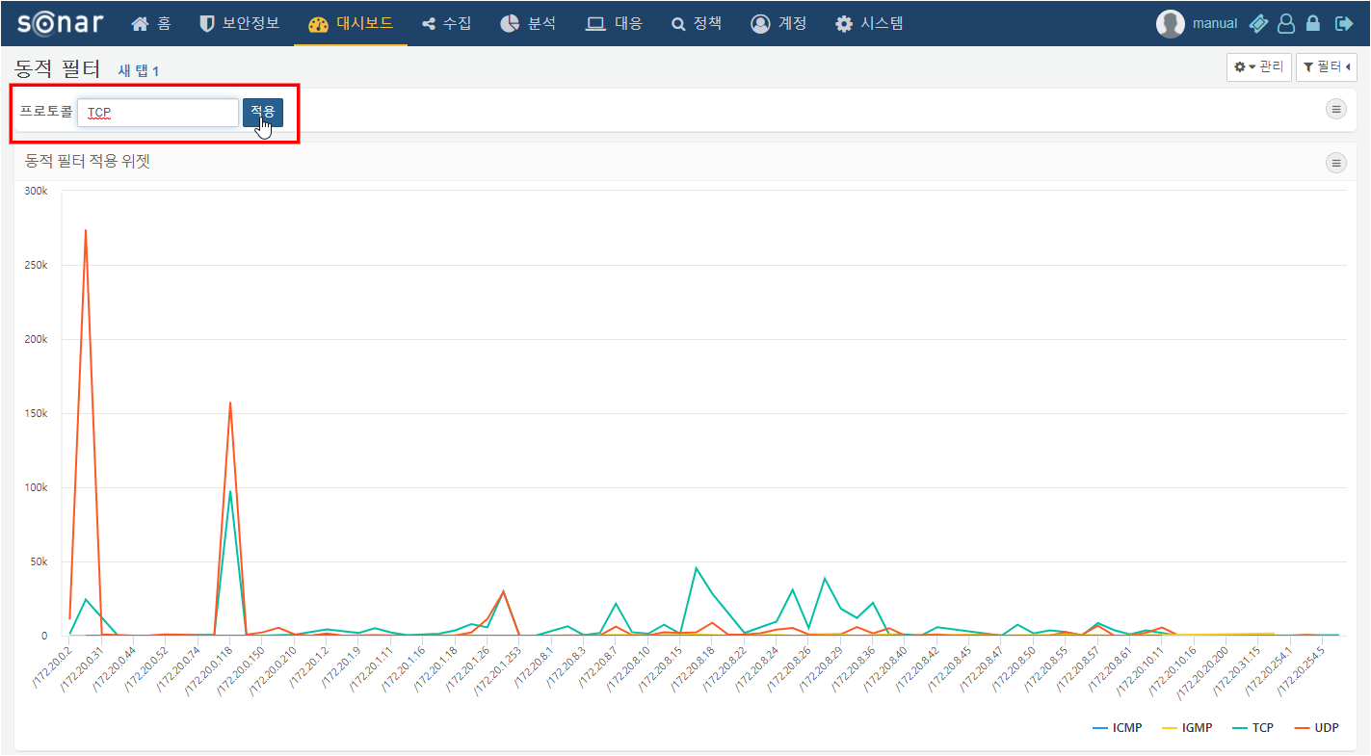

Step 6

Apply Dynamic Filter

