### Dashboard Edit

By clicking on the Edit Mode in the management section, you will enter a state where you can add or delete widgets and containers, as well as change the size and position of widgets on the dashboard.

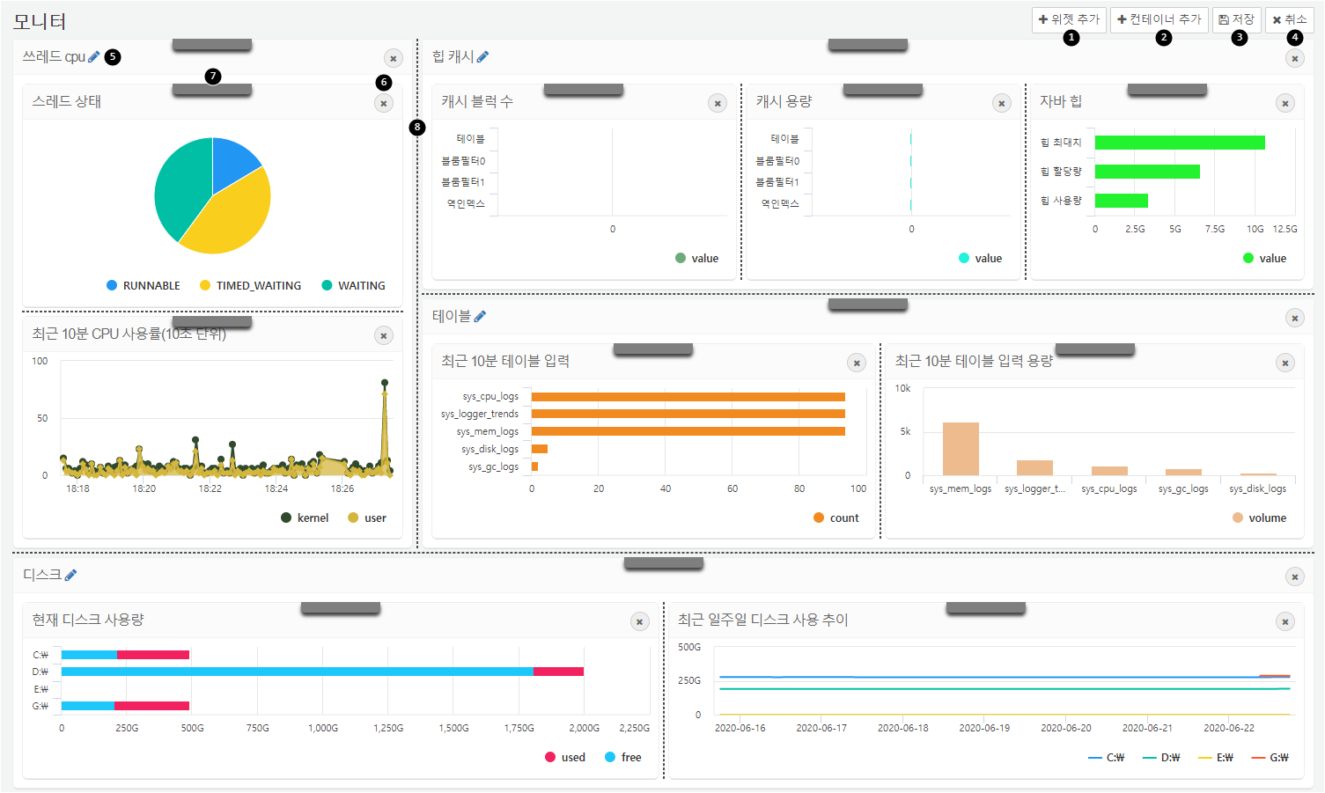

**Add Widget**: Add a widget to the dashboard.

**Add Container**: Add a widget container that allows you to group different widgets together to function as a single widget.

**Save**: Complete your edits and click the save button to save your changes.

**Cancel**: If you do not wish to save your edits, click the cancel button to discard your changes.

**Edit Widget Container Name**: Edit the name of the widget container. If you wish to edit the name of a widget, navigate to the widget management screen to make changes.

**Delete Widget/Container**: Click the x button to delete a widget or widget container.

**Rearrange Widget**: Drag and drop the gray handle to move the widget or its position within the dashboard, either vertically or horizontally, or within the container.

**Adjust Splitter**: Drag the dotted line to resize the widget.