#### Ticket Repository Edit

If you need to edit a ticket repository, click on the name of the ticket repository you wish to modify to navigate to the Ticket Repository Edit page.

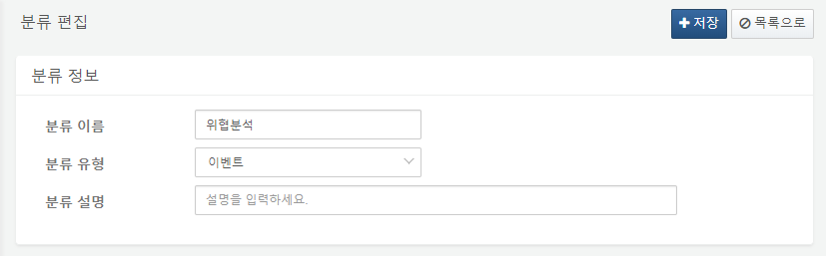

The items for classification information are as follows:

**Classification Name**

Enter the name of the ticket repository.

**Classification Type**

Specify the type of the ticket repository. The types of ticket repositories are divided into Event and Bulletin Board.

**Classification Description**

Enter a description for the ticket repository.