#### Ticket Modification

Tickets that you have created can be edited by clicking the pencil icon located in the upper right corner of the ticket content. Tickets generated by detection policies cannot be modified.

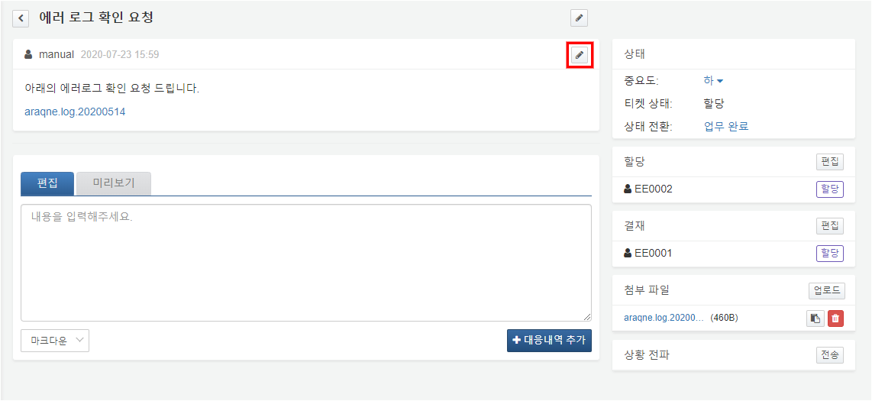

Once you have completed editing the ticket content, press the Done button to save your changes.

