Event Data Types

Execute pivot operations on the list of detected events from real-time/batch detection scenarios.

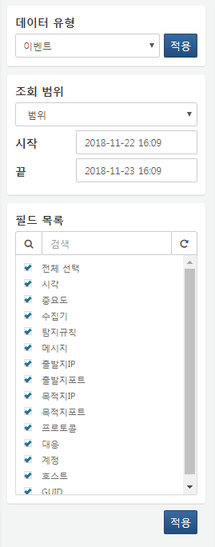

**Query Range**

Set the time range for the data to be queried. Selecting **Range** retrieves data within a fixed time range. Choosing **Period** retrieves data collected within a specific period from the current point in time. Selecting **All** retrieves data from all periods.

**Field List**

Select the list of fields to be queried.