#### Explanation Classification Management

To access the Explanation Classification Management page, click the Explanation Classification Management button on the explanation list screen. The classifications available here can be used when creating explanations.

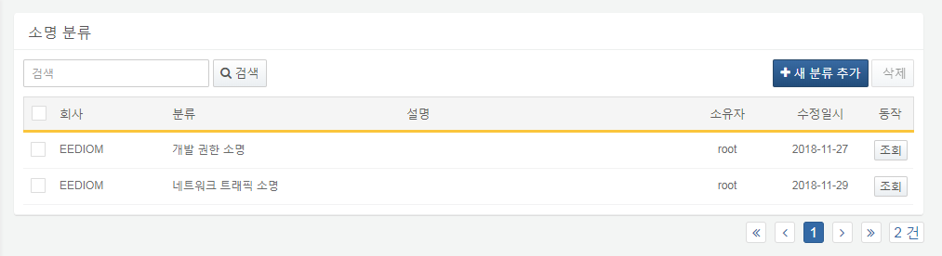

Use the Add New Classification button to create a new explanation classification.

Clicking the View button allows you to view and modify the selected classification.

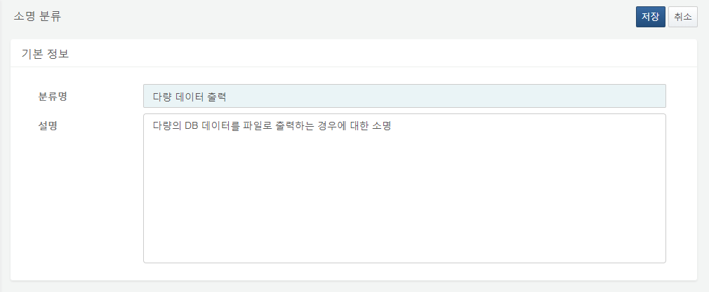

After checking the classification you wish to delete, click the Delete button to remove it. Note that if there are existing explanations associated with that classification, deletion will not be possible.

