#### Explanations List

The list of explanation request histories is displayed. Explanation requests may arise from tickets, or users can create new requests using the add button.

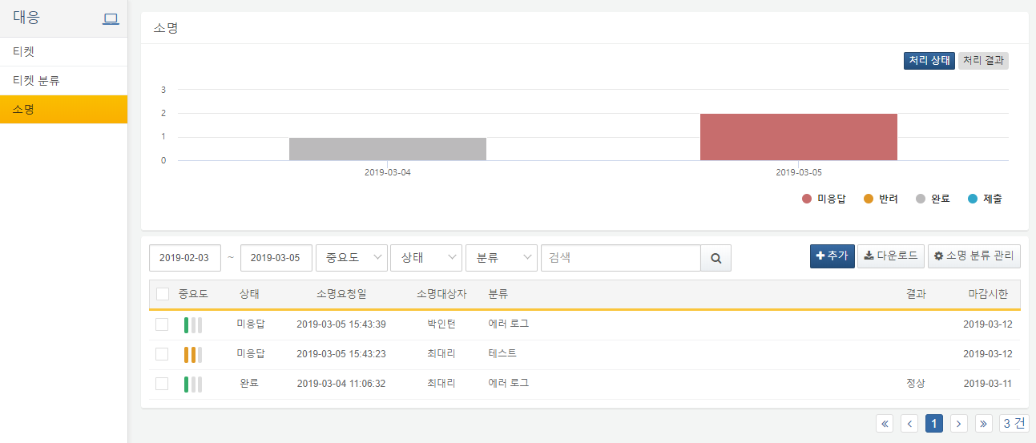

In the upper right corner, users can choose whether to view the processing status or the processing results.

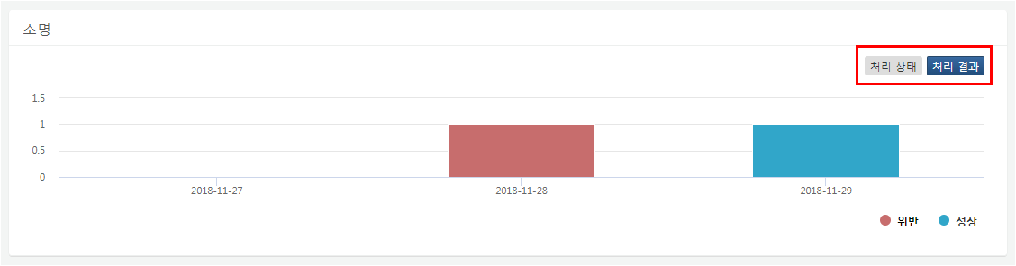

In the lower right corner of the chart, users can select the status/results to be displayed in the chart.

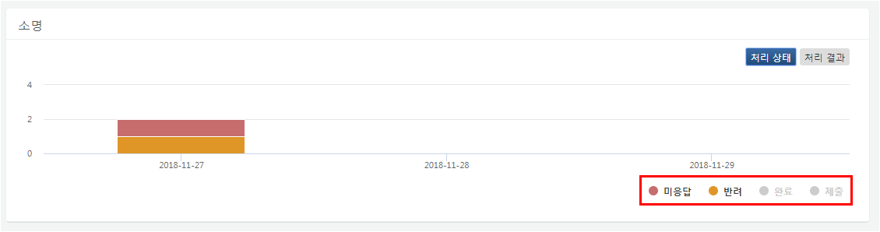

Users can click the download button to download the explanation list as a file.

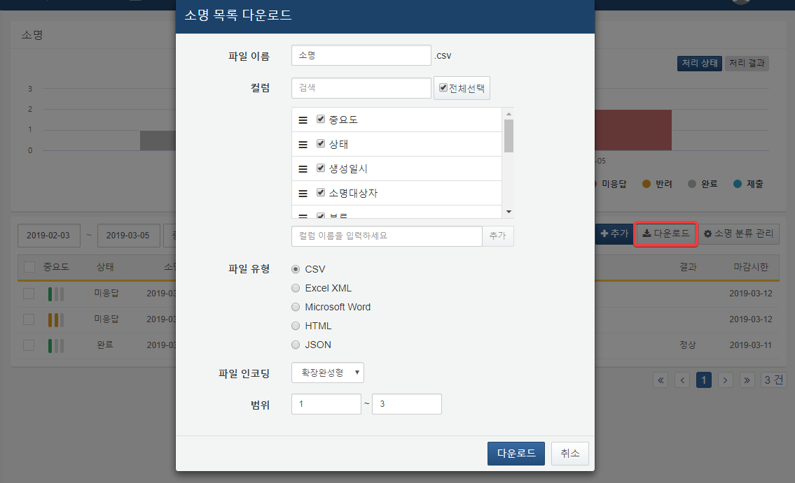

**File Name**

Enter the name for the file to be saved.

**Column Search**

Search for the desired column name in the list of columns to be saved.

**Column List**

Select the columns to be saved in the file.

**File Type**

Choose the file format type.

**File Encoding**

Select the file encoding.

**Range**

Select the range of explanations to be saved. The first explanation on the first page is considered as number one.

Using the checkboxes on the left side of the list, users can bulk delete or change the status of selected explanations.

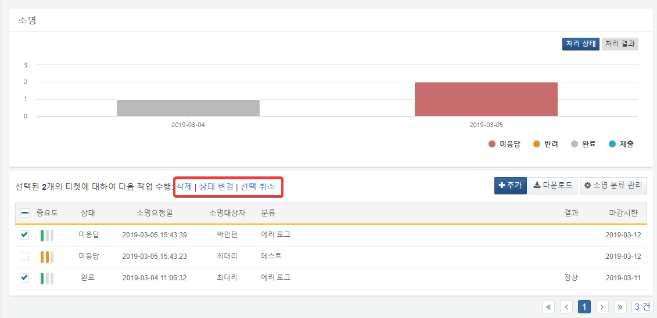

**Delete**

Deletes the selected explanations.

**Change Status**

Clicking on Change Status will open a popup window for status modification. In the popup, users can bulk change the status of selected explanations. The statuses can be changed to Approved (Normal), Approved (Violation), or Rejected. A reason for the status change is required. When changed to Rejected, the ticket's status will change to Unanswered, and when changed to Approved (Normal) or Approved (Violation), the ticket's status will change to Review Approved, with the results recorded as Normal or Violation.

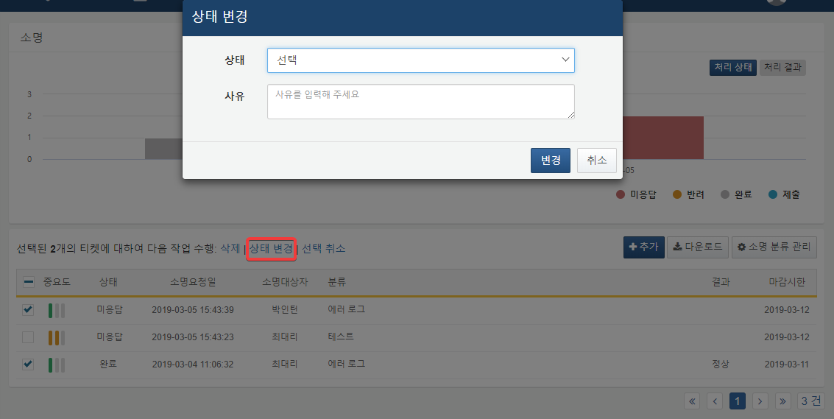

**Deselect**

Deselects the selected tickets.