Association Filter

The association filter is a feature that includes or excludes only the records present in specific data results. It is similar to the concepts of intersection and complement in set theory. To apply an association filter, a pivot tab containing the data to be filtered is required.

Like other filters, the association filter is used to narrow down data to display only the necessary information. While the condition filter compares predefined values for matches, non-matches, and inequalities, the association filter can compare multiple values based on the current situation, allowing for more sophisticated filtering.

The concept of the association filter can be briefly understood through the image below. There are two datasets, which can be compared through key fields. In the example, a record with key B exists in both datasets. In the association filter settings, you can choose to extract only the records where the key values are the same (left below) or, conversely, only the records where the key values are different (right below).

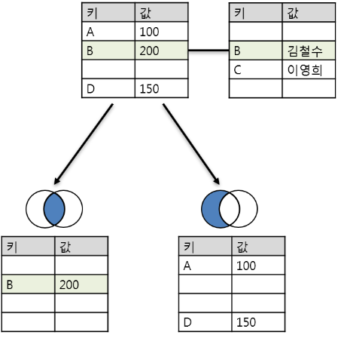

To use the association filter, prepare data for analysis in at least two tabs, then click on the column header that will serve as the key value in the pivot tab and select the association filter.

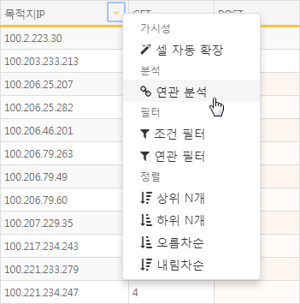

In the association filter menu, enter the relevant settings for the association filter.

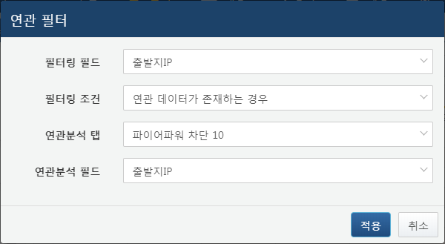

**Filtering Field**

Select the field in the current tab to which the filtering will be applied. This will determine whether to display the record based on whether the field value exists in the association analysis tab.

**Filtering Condition**

Choose the filtering condition. To extract only when the filtering field matches, select **When associated data exists**; to extract only when it does not match, select **When associated data does not exist**.

**Association Analysis Tab**

Select the tab where the data that will serve as the filtering condition is loaded.

**Association Analysis Field**

Select the field among the association analysis fields that will be used for filtering. This will be compared with the field selected in the filtering field.

When the association filter is applied, the pivot result screen changes to the association analysis screen. As with the previous pivot screen, filtering, sorting, and additional association analysis can be performed.

Clicking the Back button in the upper left will return you to the screen before the association filter was applied.

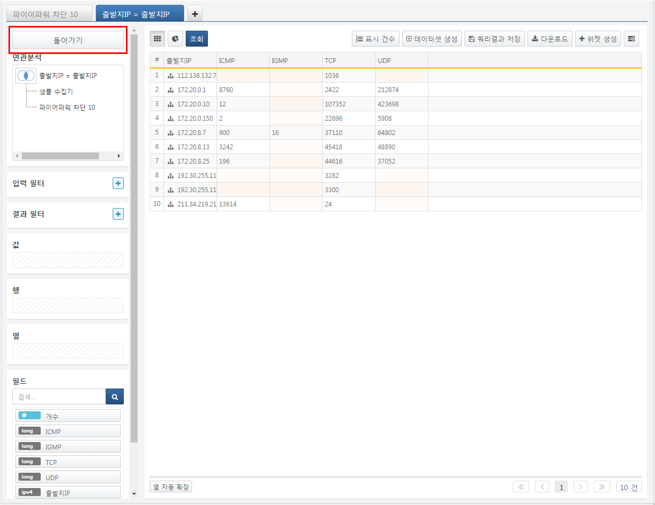

In the association analysis screen at the top left, you can edit the association analysis settings. Clicking the Venn diagram icon allows you to change the type of association analysis. When clicking on the association analysis or data, a context menu will appear. Selecting delete from this menu will remove the corresponding data or association analysis from the entire association analysis. Clicking edit allows you to modify the corresponding data or association analysis. Selecting rename allows you to change the name displayed in the association analysis menu. Clicking add association enables you to add a new association analysis.

