#### Report Query

Users can query data for the desired time period in a report format using the query entered in the report template section.

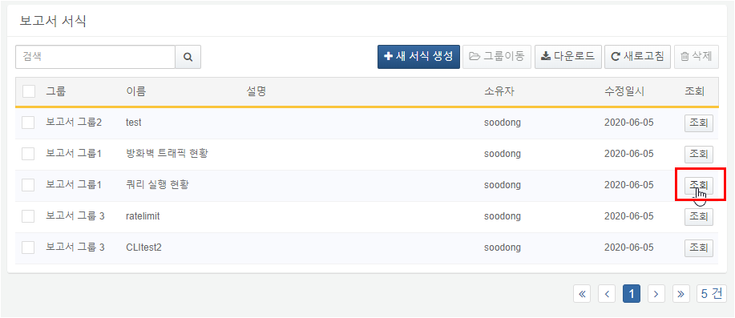

Report Query Example

This example demonstrates how to query the execution status between 12:00 PM and 6:00 PM on June 9, 2020, using the template created in the report template creation example.

Step 1

Click the Query button of the report template to proceed to the report query screen.



Step 2

Set the range for the query and click the Execute button.

Enter the desired date and time (2020-06-09 12:00 to 2020-06-09 18:00) and click the Execute button.

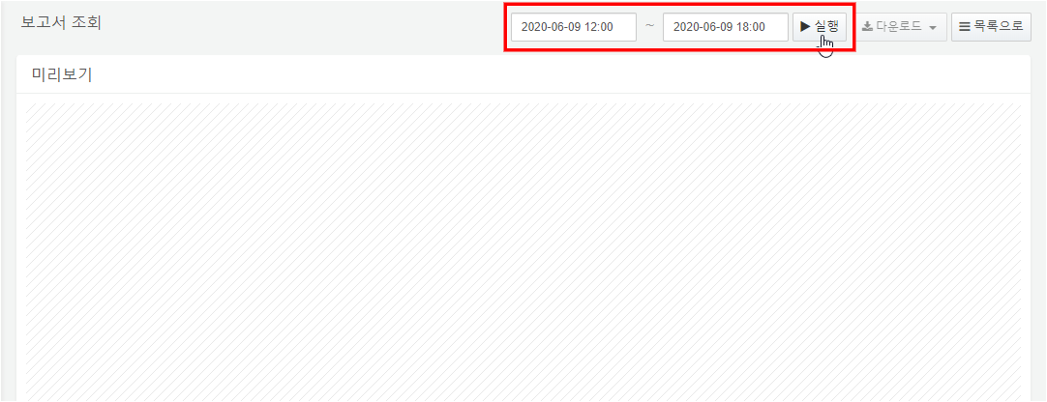

Step 3

The report will be displayed according to the entered date and time.

