#### Ticket Situation Propagation

When you want to quickly relay ticket information to other users, you can use the situation propagation feature. By clicking the Send button on the ticket screen, the situation propagation window will appear. After selecting the recipient users and the method of delivery (SMS or messenger), click the Send button to send messages to the selected users.

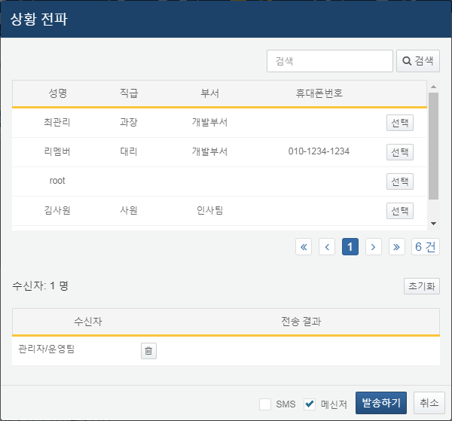

Upon clicking the Send button, messages will be sent to the selected users, and the results will be displayed. After reviewing the content, click the Close button to close the situation propagation window.

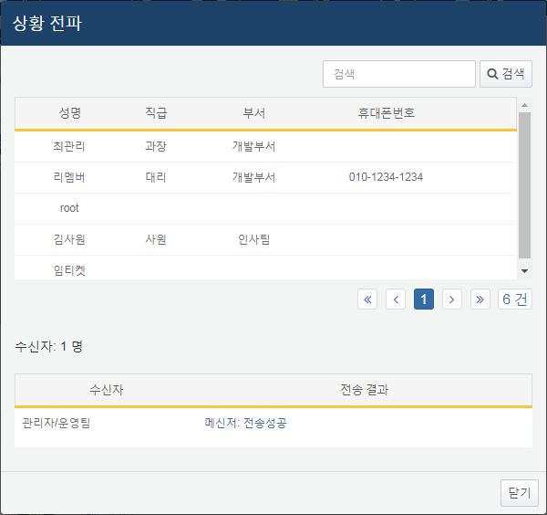

The situation propagation feature does not autonomously send SMS or messenger messages within Logpresso Sonar. To utilize the situation propagation feature, you need to build a system that sends messages appropriately using the sonar_push_messenger and sonar_push_sms stream queries. For example, you can store the content to be sent via messenger in the DBMS using the dboutput query command from the sonar_push_messenger stream query, then read the data from the database and send the message through the internal messenger API. After that, you can create a batch program that executes an UPDATE SQL statement in the database to check the messages that have been sent.