Query Data Source

Retrieve the desired data using Logpresso queries and proceed with pivot operations. This method provides the highest level of flexibility; however, all configurations, such as data retrieval periods and field lists, must be written directly in the query.

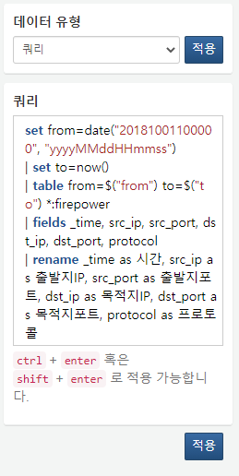

**Query**

Enter the query to be used for data retrieval.