Query Widget

The Query Widget processes data collected by Logpresso Sonar and visualizes it in the form of charts such as bars and lines, or in grid format. For details on creating a Query Widget, please refer to the section on creating Query Widgets.

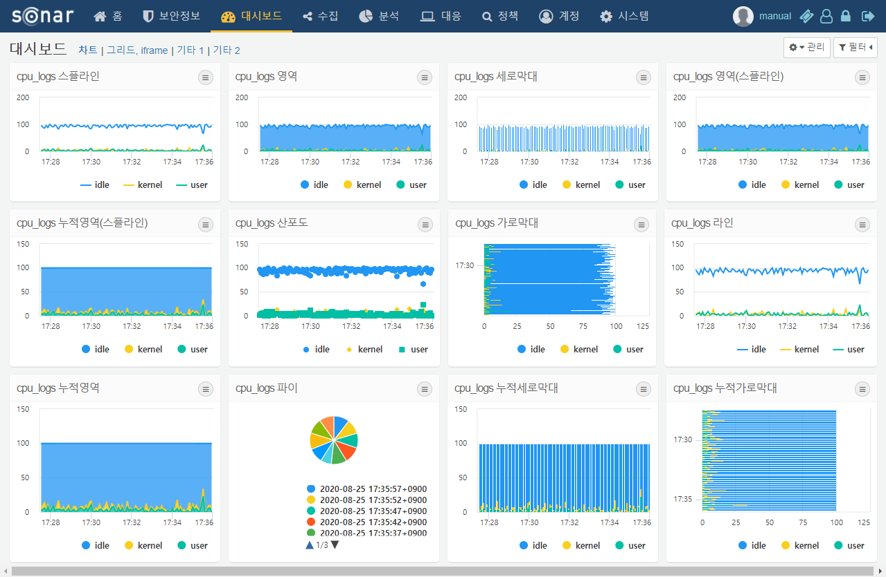

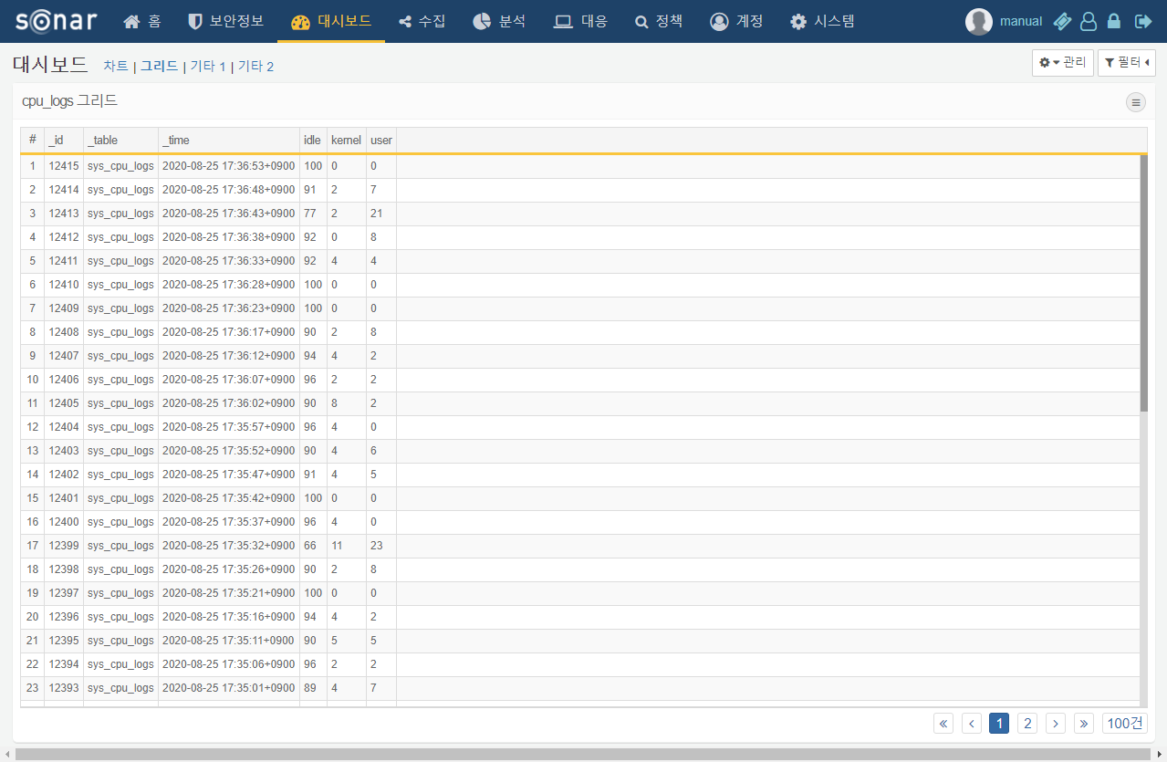

Widget Events

The Query Widget can execute actions such as applying filters, executing queries, and opening browsers when clicked or dragged. These actions can be configured in the event section added to the widget creation/editing screen.

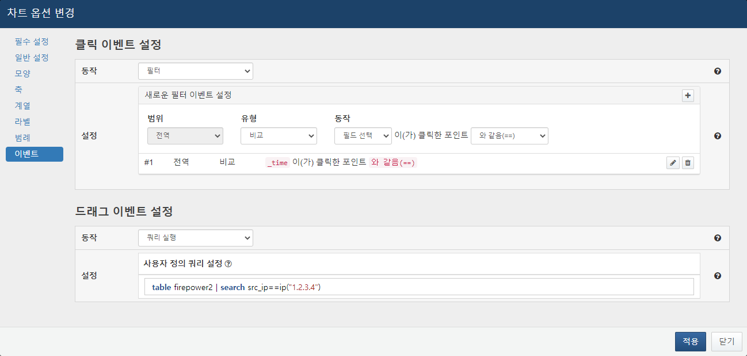

**Event Types**

**Click Event**

An event that performs an action when the widget is clicked.

**Drag Event**

An event that performs an action when the widget is dragged. The drag event is applicable only when the independent variable of the chart widget is of time type.

**Action Types**

**Filter**

When a click or drag event occurs, the specified filter by the user is applied. When configuring filter actions, select the filter range, type, and action, and press + to add the filter. Filters of the same action cannot be added multiple times, but multiple filters can be added to a single event.

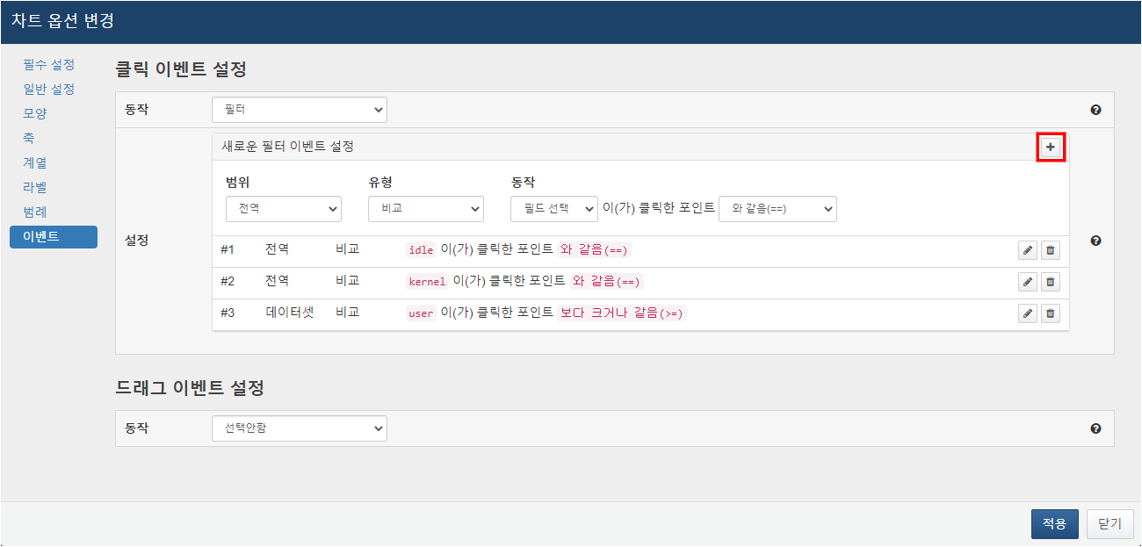

* Range: Global filters apply to all widgets within the dashboard, while dataset filters apply to widgets using the same dataset as the current widget.
* Type: The comparison type allows the selection of filter conditions, while the query type enables the user to directly input comparison conditions as Logpresso query statements. Reserved words can be used when entering queries. For details on reserved words, please refer to the section on executing queries. The range type can be selected when configuring drag events, filtering cases that match the dragged time range.
* Action: When filtering, specify the fields and comparison operations to be used. Only filters for click events can have conditional expressions set, while filters for drag events can only be added when the independent variable is of time type, automatically designating conditions that match the range of the time field.

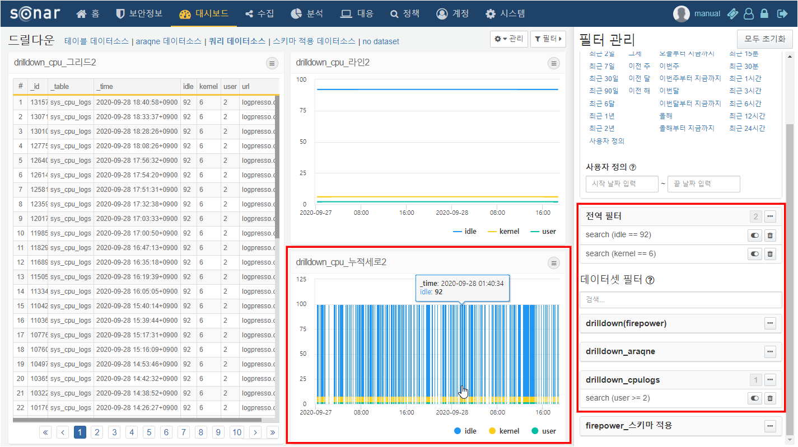

**Query Execution**

When a click or drag event occurs, a new window opens in the web browser to execute the user-specified query. The following reserved words can be used in the query statement:

Reserved Words for Click Events

* $series$: The name of the field
* $fieldname$: The value displayed in the field specified by the name

Reserved Words for Drag Events

* $xfield$: The name of the time field
* $from$: The starting time value of the drag
* $to$: The ending time value of the drag

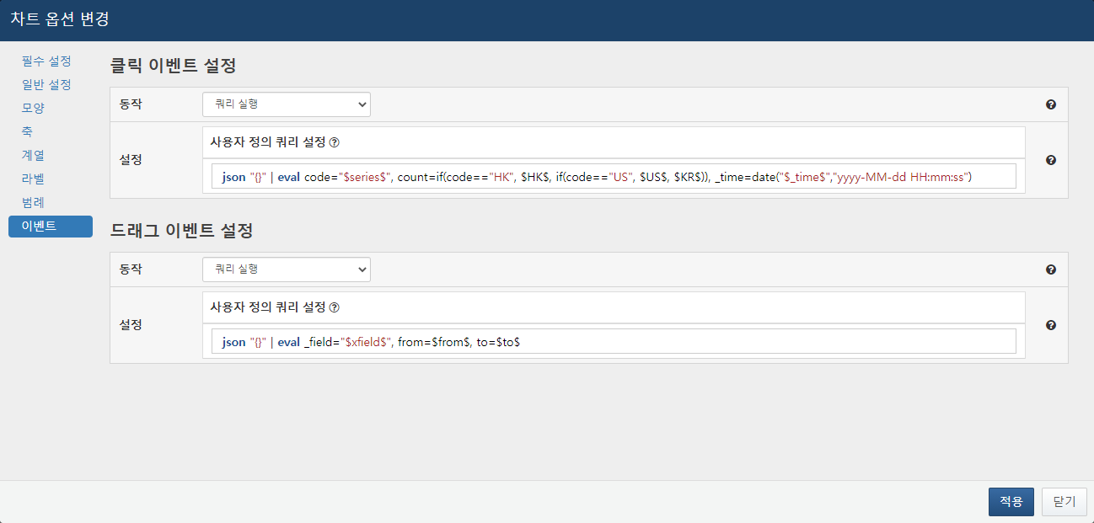

When the query execution action is specified, the designated query will be executed in a new window upon the occurrence of the event.

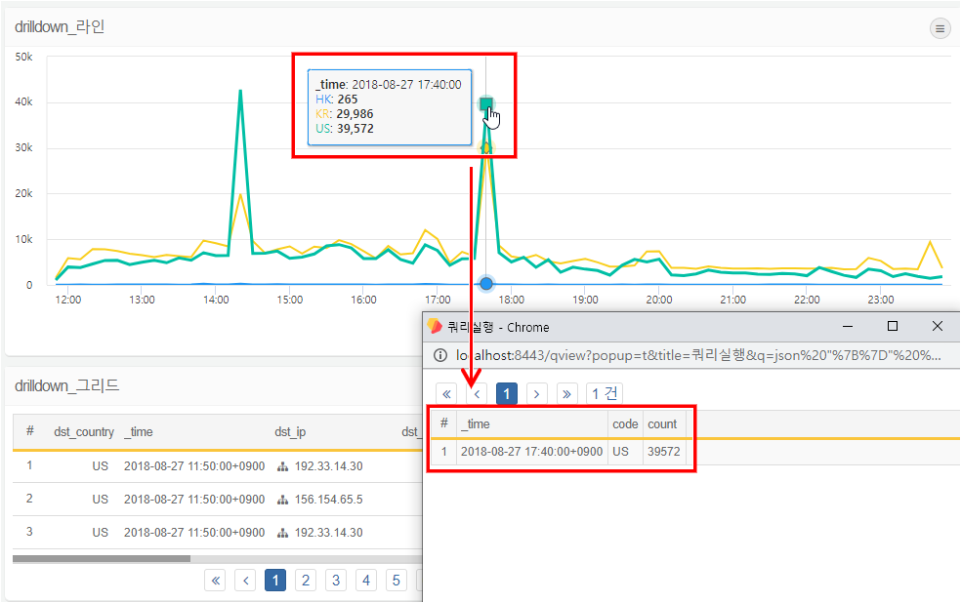

**Browser Execution**

When a click or drag event occurs, a new window opens in the web browser to access the URL specified in the user-defined field.

