#### Ticket Explanation Request

When an explanation from the violator is required regarding the ticket content, click the explanation request button to set the target, reviewer, importance, classification, and other parameters to initiate the request. An explanation request can only be made if there is supporting documentation in the ticket.

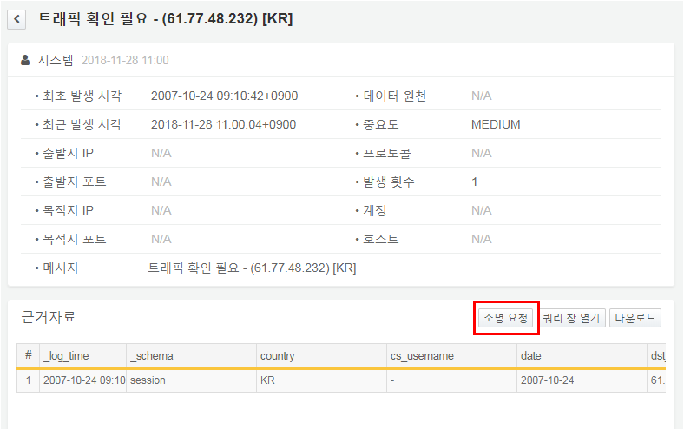

For detailed instructions on how to add an explanation request, please refer to the section on adding explanations.

