#### Adding Explanations

Explanations can be set to be automatically generated in real-time or batch detection, and can also be requested from the ticket screen or manually added by pressing the Add button on the explanation screen. Here, we will explore how to add explanation requests from both the ticket screen and the explanation screen.

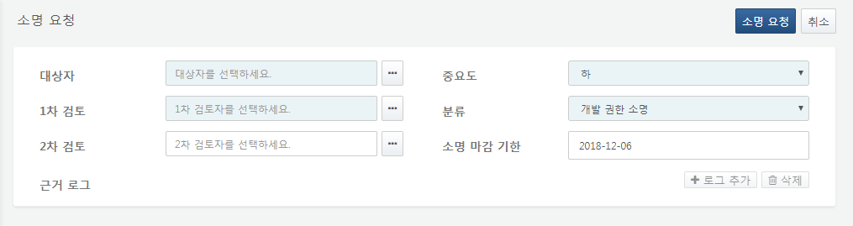

Step 1

Assigning the Target Person

First, assign the target person. When a target person is designated, the primary reviewer is automatically assigned as the department head of the target person's department. The secondary reviewer can be assigned if necessary. You can enter the target person/reviewer name directly in the input box or select the target person/reviewer from the organizational chart by clicking the ... button.

Automatic Assignment of Primary Reviewer

* The department head of the target person's department is designated as the primary reviewer.
* If there is no department head in the target person's department, the department head of the higher-level department is designated as the primary reviewer.
* If there is still no department head up to the top-level department, an employee with administrative privileges is designated as the primary reviewer.

Automatic Assignment of Primary Reviewer When the Target Person is the Department Head

* If the target person (department head) has a department head in the higher-level department, the department head of the higher-level department is designated as the primary reviewer.
* If there is no higher-level department or if there is no department head even at the top-level department, an employee with administrative privileges is designated as the primary reviewer.

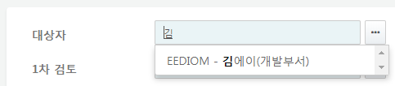

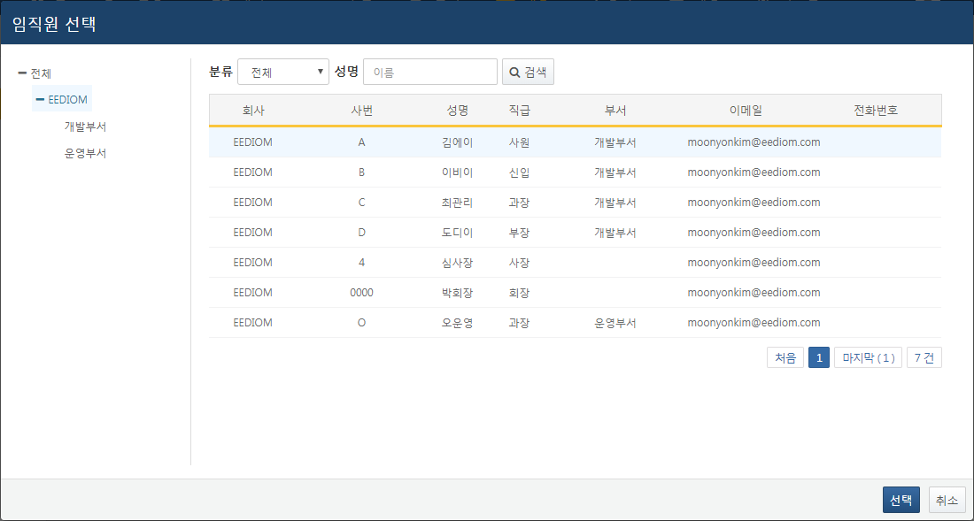

In the target person selection screen, searching for classifications as "Expected to Leave" will display only employees with a confirmed departure date.

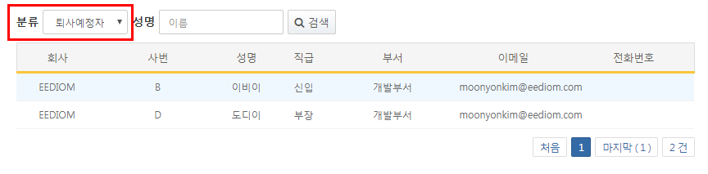

Step 2

Setting Explanation Classification

Set the explanation classification and importance. You can add, delete, or edit explanation classifications on the explanation classification management page.

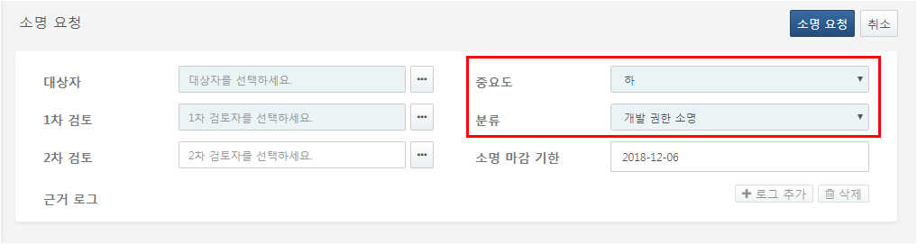

Step 3

Adding Supporting Logs

Search for supporting log data. Retrieve evidence that the target person has engaged in suspected security violations from the data collected by the Logpresso Sonar logger and add it to the explanation request.

When querying supporting logs, only records related to the target person are displayed. This is implemented so that during the search, only records where the emp_key field in the queried table matches the target person's employee number are output. Therefore, when creating the logger, it is necessary to map the employee number to the collected data and store it in the table to use the collected data as evidence during the explanation request. For example, you can utilize a method to map the IP address or account name in the collected data to the employee number through a mapping table or lookup and store them together.

**Query Target**

Select the table from which the supporting data has been collected.

**Data Type**

Choose the schema of the logger that collected the supporting data. The queried table will search for data stored under that schema, and the query results will also be displayed under that schema.

**Query Period**

Enter the period for the query. Data collected within that period will be output.

**Search Keywords**

Enter keywords to search within the data content. Using the AND condition will output results only if all keywords exist, while the OR condition will output results if at least one keyword exists. If you select the query expression condition, you can directly input a full-text search boolean expression query to be used for data searching.

**Maximum Count**

Specify the maximum number of data entries to retrieve.

**Display Unit**

Specify the maximum number of data entries to display on one screen.

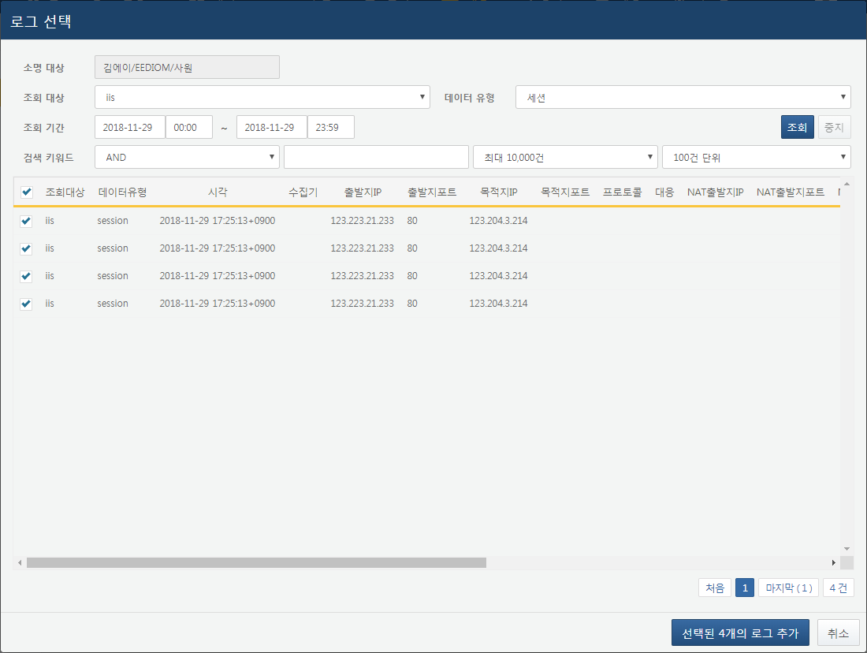

By clicking the Add Selected Logs button, the selected log list and session type will be added to the explanation request.

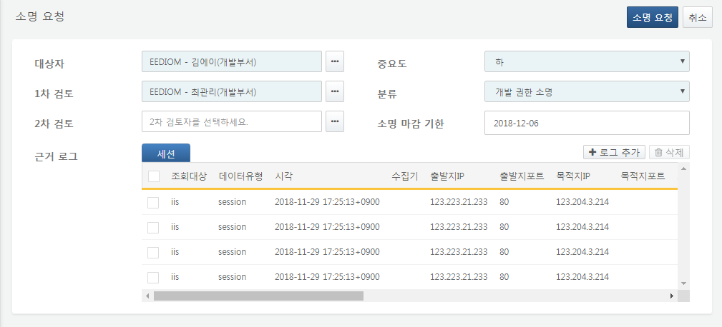

When requesting an explanation from the ticket screen, the supporting data for that ticket is automatically added as the supporting logs for the explanation.

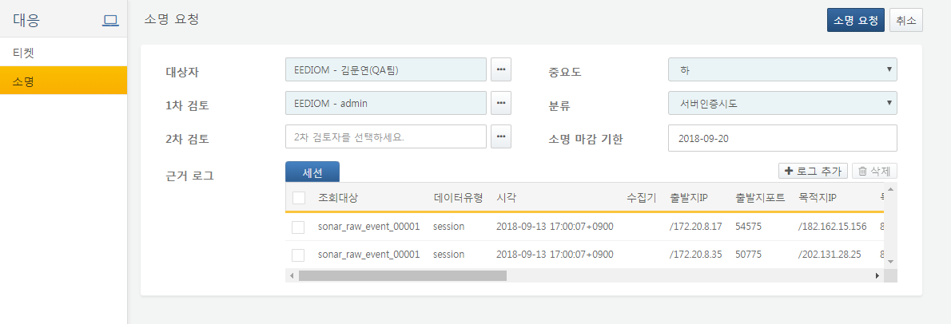

Step 4

Submitting the Explanation Request

Once all necessary information for the explanation has been completed, click the Explanation Request button in the upper right corner of the screen to create the explanation request.