#### Explanation Review

When the individual under review submits their justification, a review email is sent to the reviewer. The reviewer clicks the link in the email to access the details of the explanation review request and proceeds with the review process based on this information.

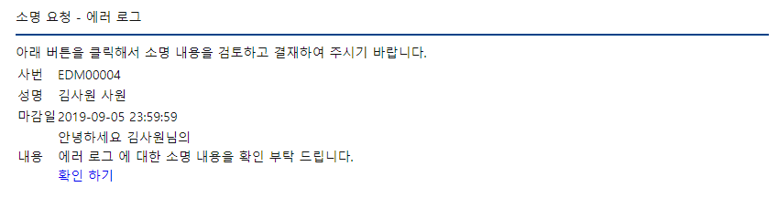

The reviewer examines the justification information and detailed records, leaves comments, and clicks the Reject button to reject the justification, the Approve (Normal) button if the justification is valid, or the Approve (Violation) button if there is a violation.

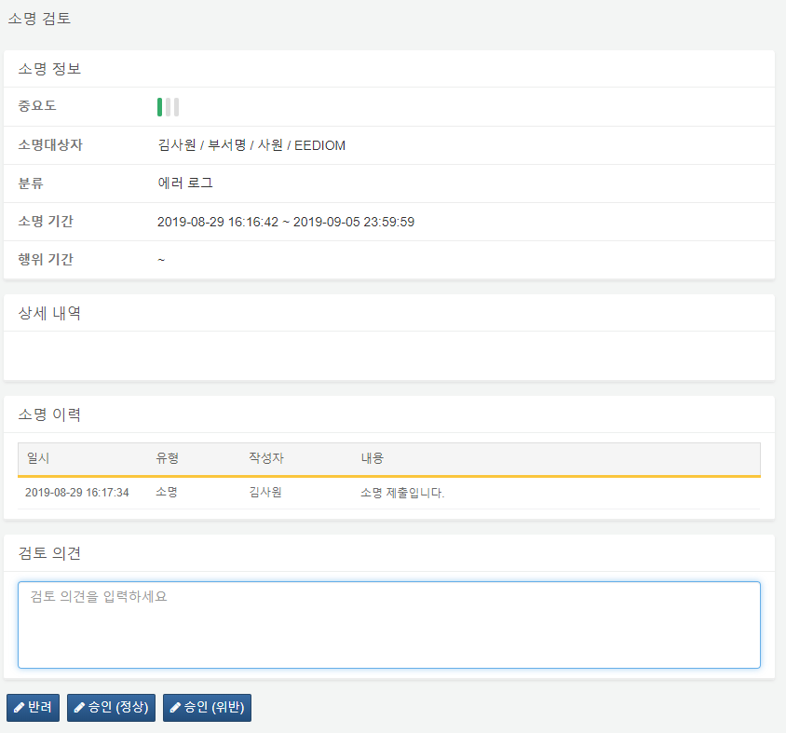

The explanation review can only be conducted by employees of the respective company. If a non-employee account attempts to access the justification, the following permission violation message will be displayed.

