#### Executing Procedures

There are two methods to execute a procedure. You can either directly call the procedure using the PROC command in a query or execute it by clicking the Execute button for the desired procedure in the procedure menu.

Step 1

Click the Execute button for the desired procedure from the list.

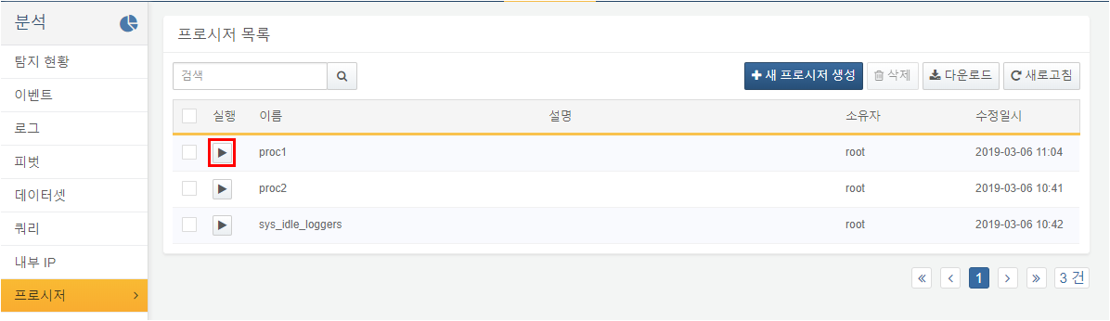

Step 2

Enter the desired parameter values and click the Execute button.

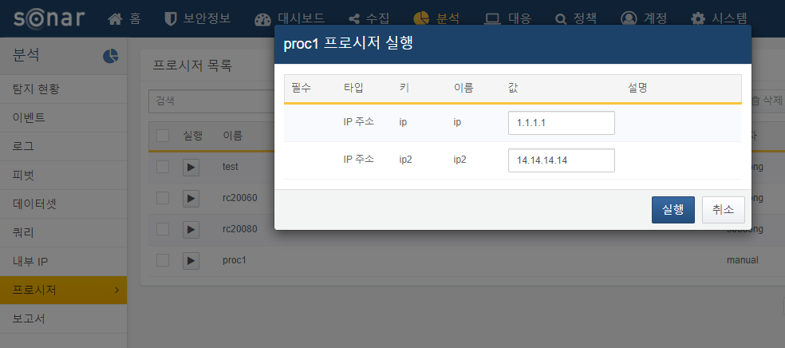

Step 3

Check the results of the procedure execution in the query window. A procedure call statement will be generated and executed according to the parameters you entered.

You can also directly call the procedure by entering in the format `proc procedure_name(parameter1,parameter2,...)` in the query window.

