Address Group

Overview
The Address Group feature allows for the grouping and management of IP addresses based on specific purposes. Address groups can be used to register and manage the IP addresses of network hosts exhibiting malicious behavior or anomalies for a certain period in real-time and batch detection scenarios, or to handle specific IP addresses as exceptions in detection scenarios. Additionally, through the Response Targets feature, they can be utilized as a list of IP addresses to be blocked by network access control systems such as firewalls or IPS.

Viewing/Search Address Group List
You can view or search the address group list under Policy > Address Group.
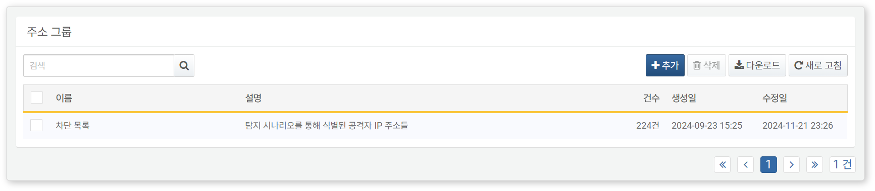
- Name: The unique name of the address group
- Description: A description of the address group
- Count: The number of IP addresses included in the address group
- Creation Date: The date the address group was created
- Modification Date: The date the address group was last modified
To find a specific address group in the list, use the search tool in the toolbar. The search tool will display address groups that contain the entered term in the Name or Description fields. The search tool is case-insensitive.
Download List
To download the address group list as a file to your local PC, click Download in the toolbar.
Refresh
To refresh the address group list with the latest information, click Refresh in the toolbar.

Adding an Address Group
To add an address group:
Click Add in the toolbar under Policy > Address Group.
In the Add Address Group dialog, enter the required values and click OK.
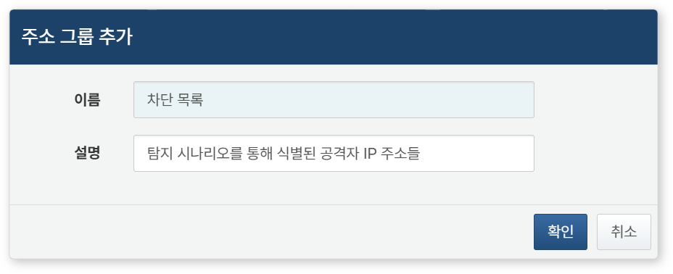
- Name: The name of the address group (up to 50 characters)
- Description: A description of the address group (up to 2,000 characters)

Modifying an Address Group
To modify an address group:
Click the name of the address group you wish to modify in the Address Group List.
In the Modify Address Group screen, update the information and click Save.
Viewing/Search IP Address List
To view or search the IP addresses registered in an address group:
Click the name of the address group in the Address Group List.
In the Modify Address Group screen, you can view or search the IP address list.
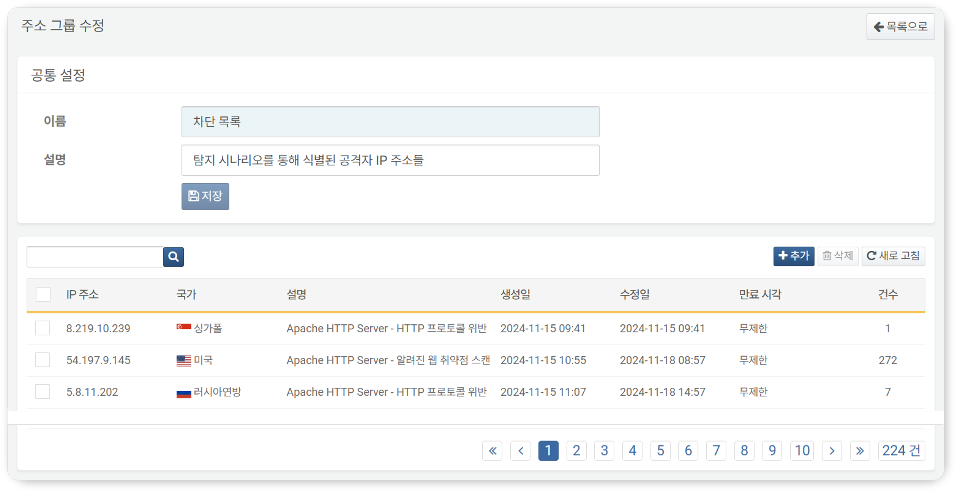
- IP Address: The IP address registered in the address group
- Country: The country information of the IP address confirmed through the built-in geoip lookup
- Description: A description of the IP address. For IP addresses registered in the address group that are considered malicious or exhibiting anomalies based on real-time/batch detection scenarios, the name of the detection scenario will be noted here.
- Creation Date: The date and time the IP address was first registered
- Modification Date: The most recent date and time the IP address was registered. If an IP address is re-registered in the address group, the modification date will be updated.
- Expiration Time: The time when the IP address will be removed from the address group due to the expiration of its retention period
- Count: The number of times the IP address has been re-registered
To find a specific IP address in the list, use the search tool in the toolbar. The search tool will display items that contain the entered term in the IP Address or Description fields and is case-insensitive.
Adding an IP Address
To add an IP address to an address group:
Click the name of the address group in the Address Group List.
In the Modify Address Group screen, click Add in the toolbar.
In the Add IP Address dialog, enter the IP address information and click OK.
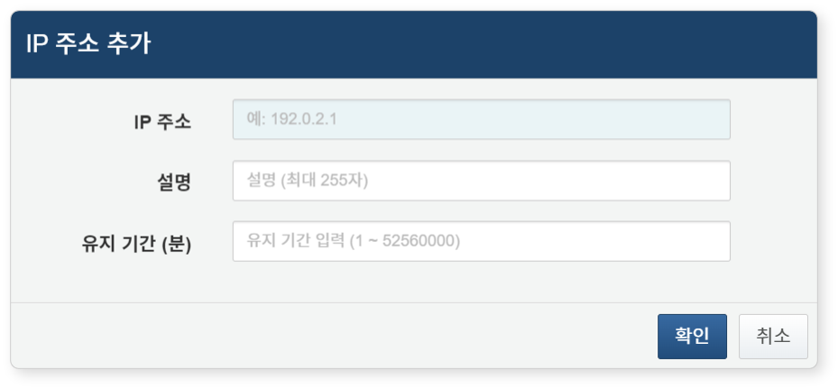
- IP Address: IPv4 address
- Description: A description of the IP address (up to 255 characters)
- Retention Period (minutes): The duration for which the IP address will be retained in the address group (unit: minutes). IP addresses whose retention period has expired will be removed from the address group. If unspecified, they will be retained permanently. (Range: 1–52560000, with a maximum value corresponding to approximately 100 years)
If an already added IP address is added again, the count of the IP address will increase by 1, and the description and retention period will be updated with the last entered information.
When an IP address is added to an address group referenced by the Response Targets feature, a synchronization request for the IP address block list will be immediately sent to the connected devices.
Deleting an IP Address
To delete an IP address from an address group:
Click the checkbox next to the IP address you wish to delete in the IP Address List.
Click Delete in the toolbar.
In the Delete IP Address window, confirm the IP address information to be deleted and click Delete. Click Cancel if you do not wish to delete.
When an IP address is deleted from an address group referenced by the Response Targets feature, a synchronization request for the IP address block list will be immediately sent to the connected devices. The same synchronization request will be made if the IP address is deleted due to the expiration of its retention period.

Utilizing Address Groups
The added address groups can be utilized for the following purposes:
Threat Detection and Management
Real-time detection or batch detection scenarios provide functionality to add malicious IP addresses suspected during event detection to the address group or to compare them against IP addresses already in the address group.
Adding Malicious IP Addresses to Address Group:
In real-time detection scenarios, you can configure the address group item of the real-time detection scenario to register IP addresses suspected of being threats during event detection.
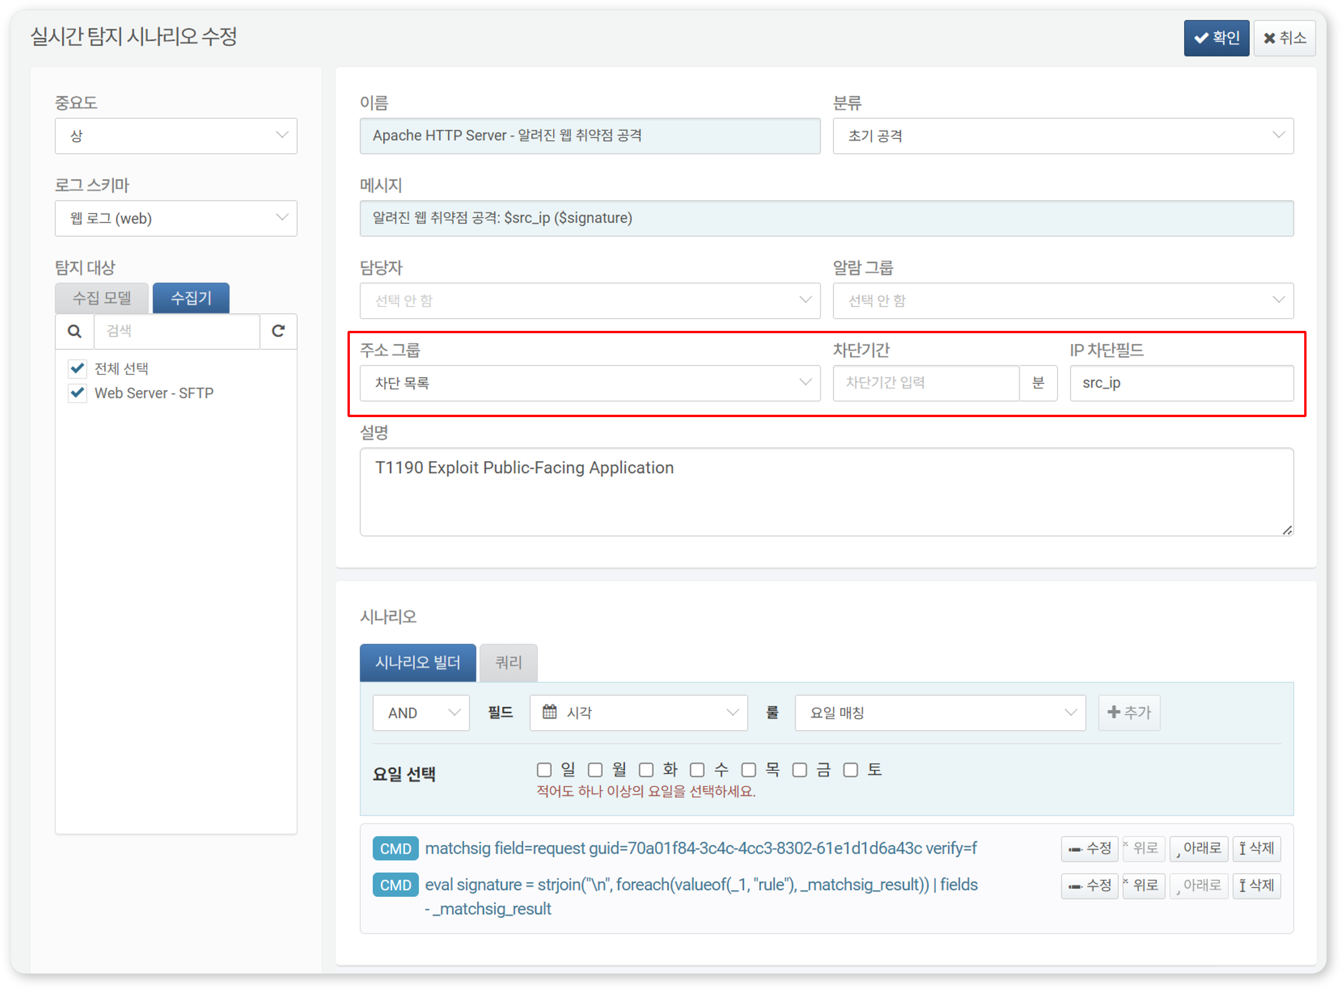
The same functionality applies in batch detection scenarios.
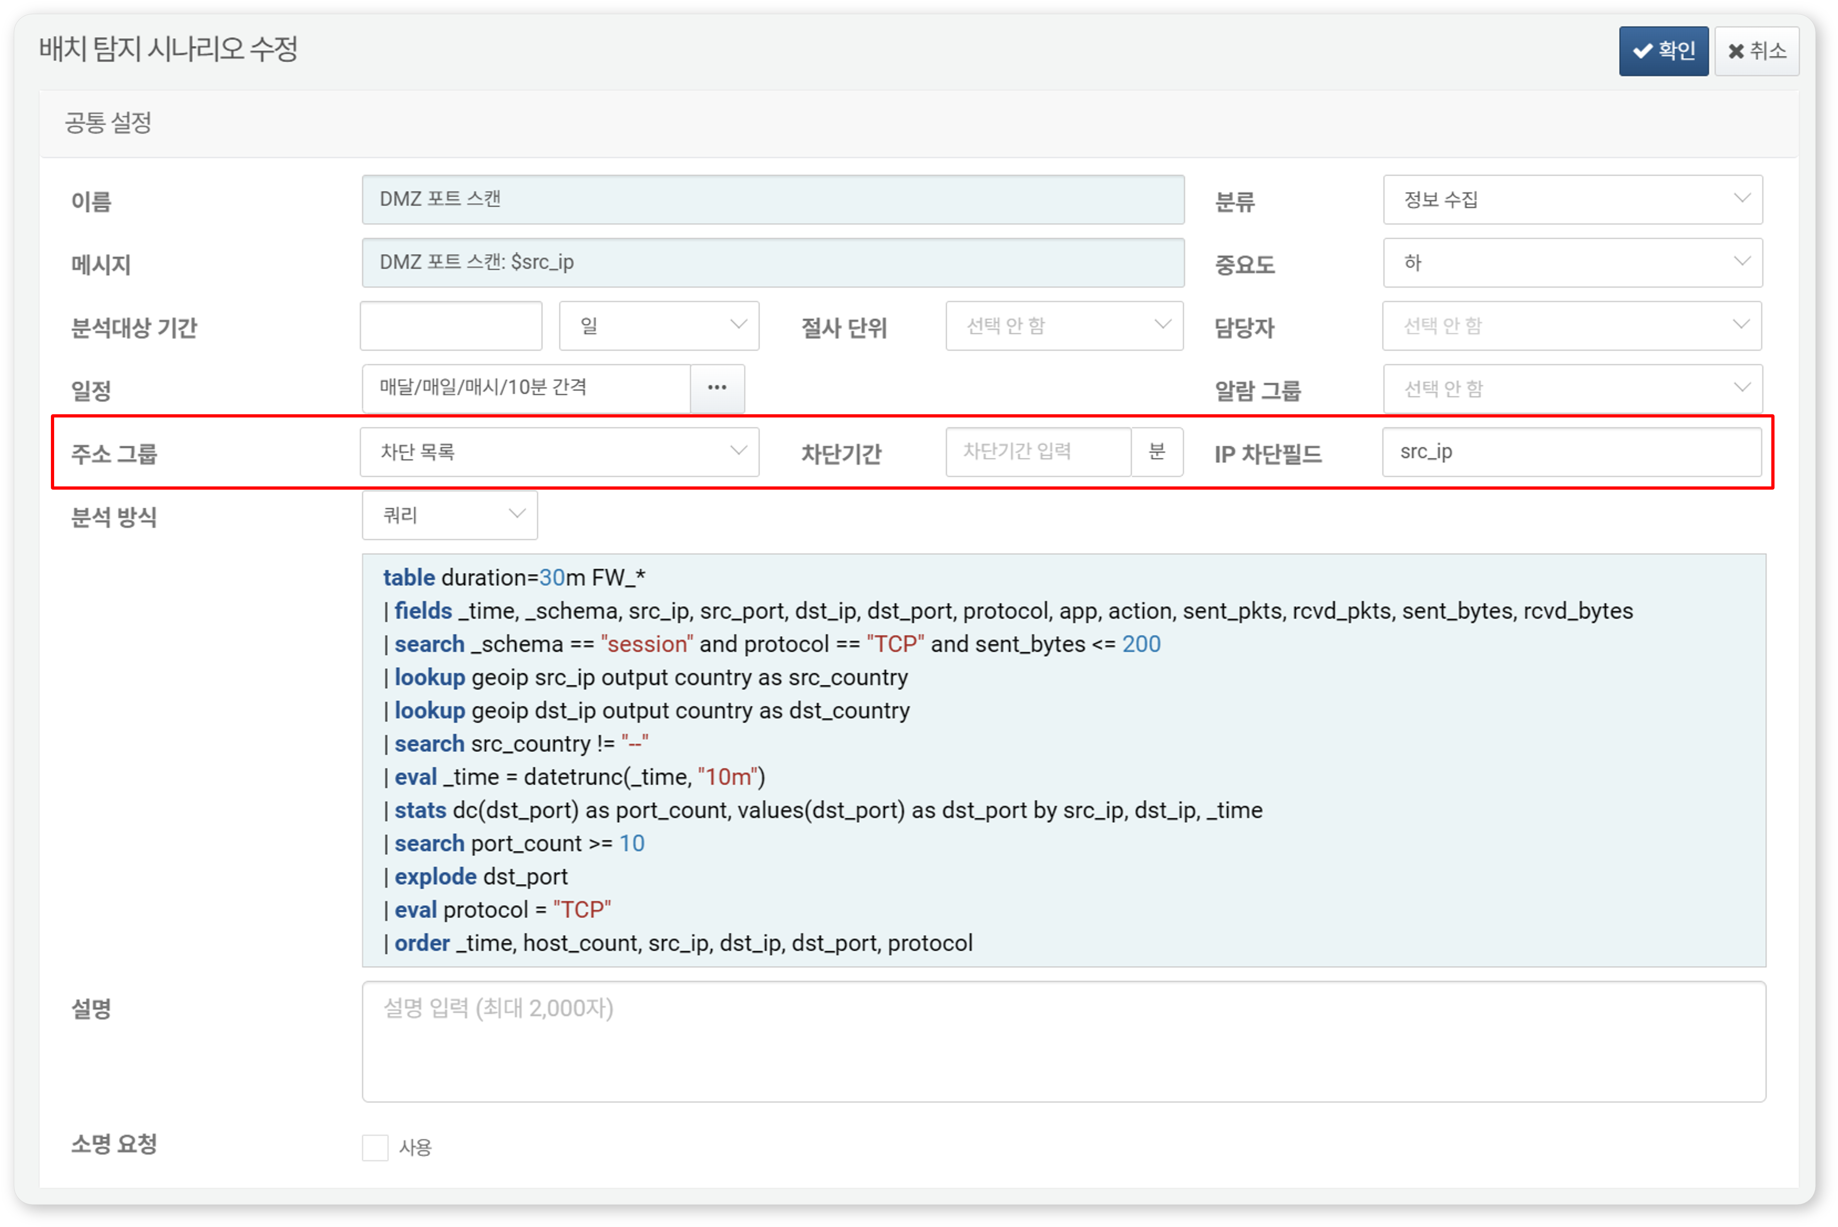
Comparing Registered IP Addresses in Address Group (Scenario Builder):
You can configure scenarios using the Scenario Builder to check whether an IP address suspected of being a threat is already registered in the address group.
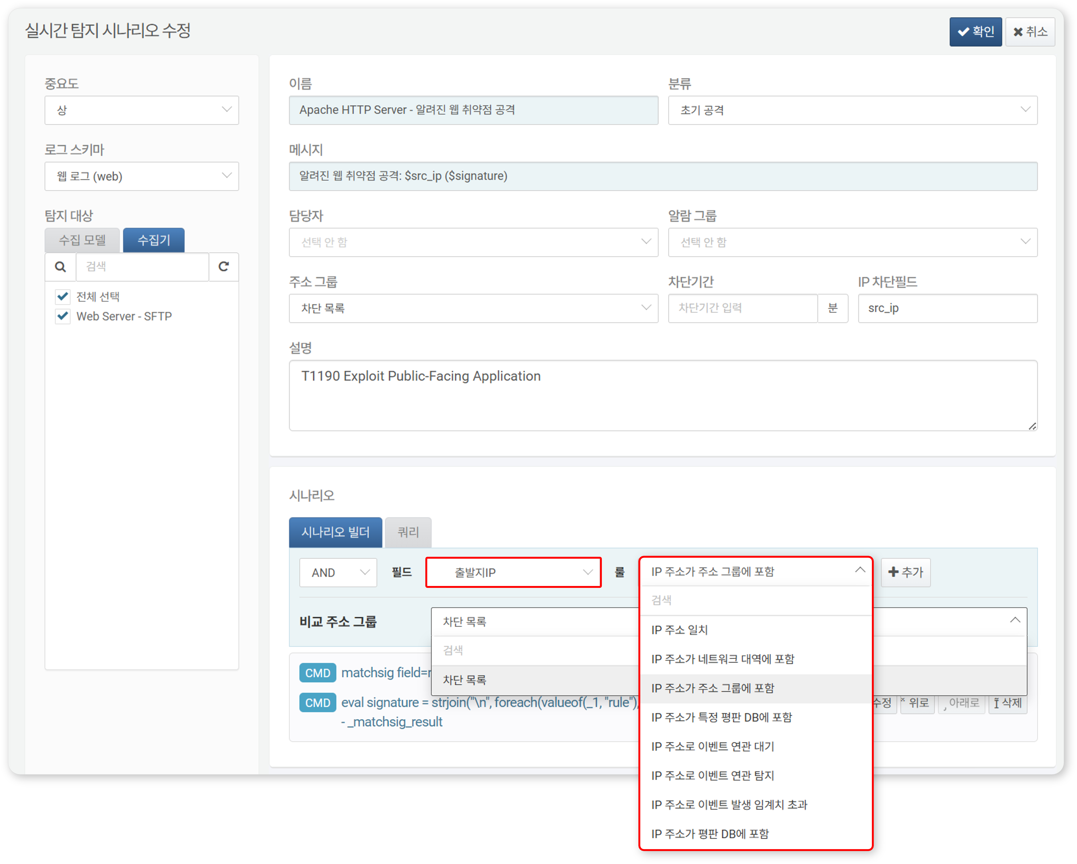
Below is a summary of the address group-related content that can be used when the input field type is IP in the Scenario Builder. For more details, refer to Field Type Rules and Parameters.
Rule | Parameter | Input Range | Description
IP Address is in Address Group | Compare Address Group | Select Address Group | Filters field values included in the address group
Comparing Registered IP Addresses in Address Group (Query):
You can use the matchblackip command or the matchblackip() function to check whether an IP address suspected of being a threat is already registered in the address group.
Automated Response
When managed as a threat IP address group by the Applied in Real-time Detection Policy 2 item, you can set up blocking integration with information security systems (FW, IPS) to automatically relay information to block the IP addresses in the address group.
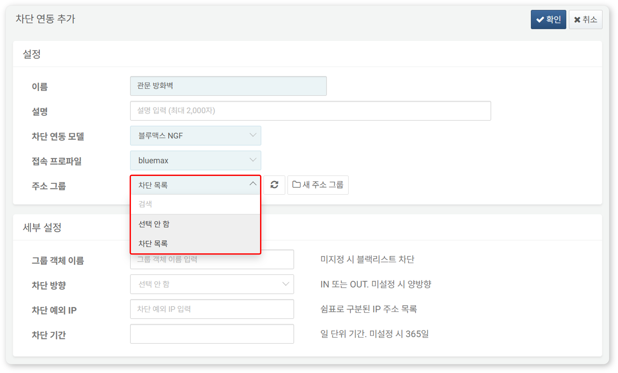

Deleting an Address Group
To delete an address group:
Click the checkbox next to the address group you wish to delete in the Address Group List.
Click Delete in the toolbar.
In the Delete Address Group window, confirm the address group information to be deleted and click Delete.
Be cautious when deleting an address group referenced in real-time detection or batch detection scenarios, as it may cause the detection scenarios to not function as originally intended.

