AI Assistant

Overview
The AI Assistant, known as LoRo (Logpresso Robot), assists users in leveraging Logpresso Sonar more effectively. When users ask conversational questions such as "Show me the recent ticket list," it responds in natural language or executes the requested action by calling Logpresso query commands or REST APIs.
Capabilities
Users can perform the following tasks through conversations with the AI Assistant:
- Responding to User Questions: The AI Assistant provides necessary information when users inquire about the usage of Logpresso query commands or functions, the password expiration period for accounts, or how to present and normalize log samples.
- Executing Logpresso Queries: After analyzing the user's request, the AI Assistant combines Logpresso query commands and functions to execute tasks such as retrieving firewall logs, viewing tickets assigned to users, and checking IP reputations through app integrations (AbuseIP, Criminal IP, Logpresso CTI). If the app provides AI prompts, it can recognize and execute the app's extended commands.
- Calling Logpresso REST APIs: The AI Assistant executes tasks by calling the Logpresso REST API. For example, it can retrieve ticket lists or add loggers or parsers.
- Multi-Step Queries or REST API Calls: If the user's request involves complex tasks that require multiple steps, the AI Assistant analyzes the request and breaks it down into sequential query executions or REST API calls, executing them in order.
The AI Assistant executes Logpresso queries or performs actions through the Logpresso Sonar REST API according to the methods defined in AI Prompts. AI prompts provided with Apps are immediately applied upon app installation, extending the AI Assistant's functionality to suit the app.
Limitations
There are certain tasks that the AI Assistant is not suitable for:
- Extracting Information from Images: The AI Assistant does not provide functionality for recognizing information from image files.
- Requests for Non-Existent Features on the Logpresso Platform: The AI Assistant cannot execute requests for features that are not provided by Logpresso.
- Questions and Requests Unrelated to the Logpresso Platform: The AI Assistant can only handle questions or requests related to the functionalities provided by Logpresso Sonar.
- Control of Execution Order, Such as Scheduling or Waiting: For example, it cannot process requests like "Notify me by email when User A logs in" or "Update all threat intelligence tomorrow at noon," which require specific conditions or timing for Logpresso Sonar to perform tasks.
- Result Correction through Reinforcement Learning: Typically, large language models (LLMs) undergo reinforcement learning processes to correct results through iterative feedback and learning. However, training the AI Assistant with reinforcement learning does not guarantee that it will continuously remember learned content or provide improved responses.
Confidentiality and Security
The AI Assistant is subject to the OpenAI Business Terms. Provisions regarding confidentiality, security, and privacy are presented in sections 4. Confidentiality, 5. Security, and 6. Privacy. According to these terms, the confidentiality of information provided through the AI Assistant is maintained. However, if there are concerns about the potential leakage of confidential or personal information while using the AI Assistant, please refrain from using this feature.
Preparation for Use
To use the AI Assistant, you need to:
Obtain an AI Assistant license.
Ensure access to the Logpresso AI service (https://ai.logpresso.com) from the Logpresso Sonar analysis node.
Create a Logpresso AI Assistant Connect Profile after obtaining an API key from Logpresso. Go to System > Connect Profiles to create the Logpresso AI Assistant connect profile.
Refresh the web browser or log out and log back in to access the AI Assistant screen.
The AI Assistant screen can only be used after creating a connect profile.

Screen Layout
The AI Assistant can be accessed under Analysis > AI Assistant. The AI Assistant screen is divided into a conversation list and a conversation window.
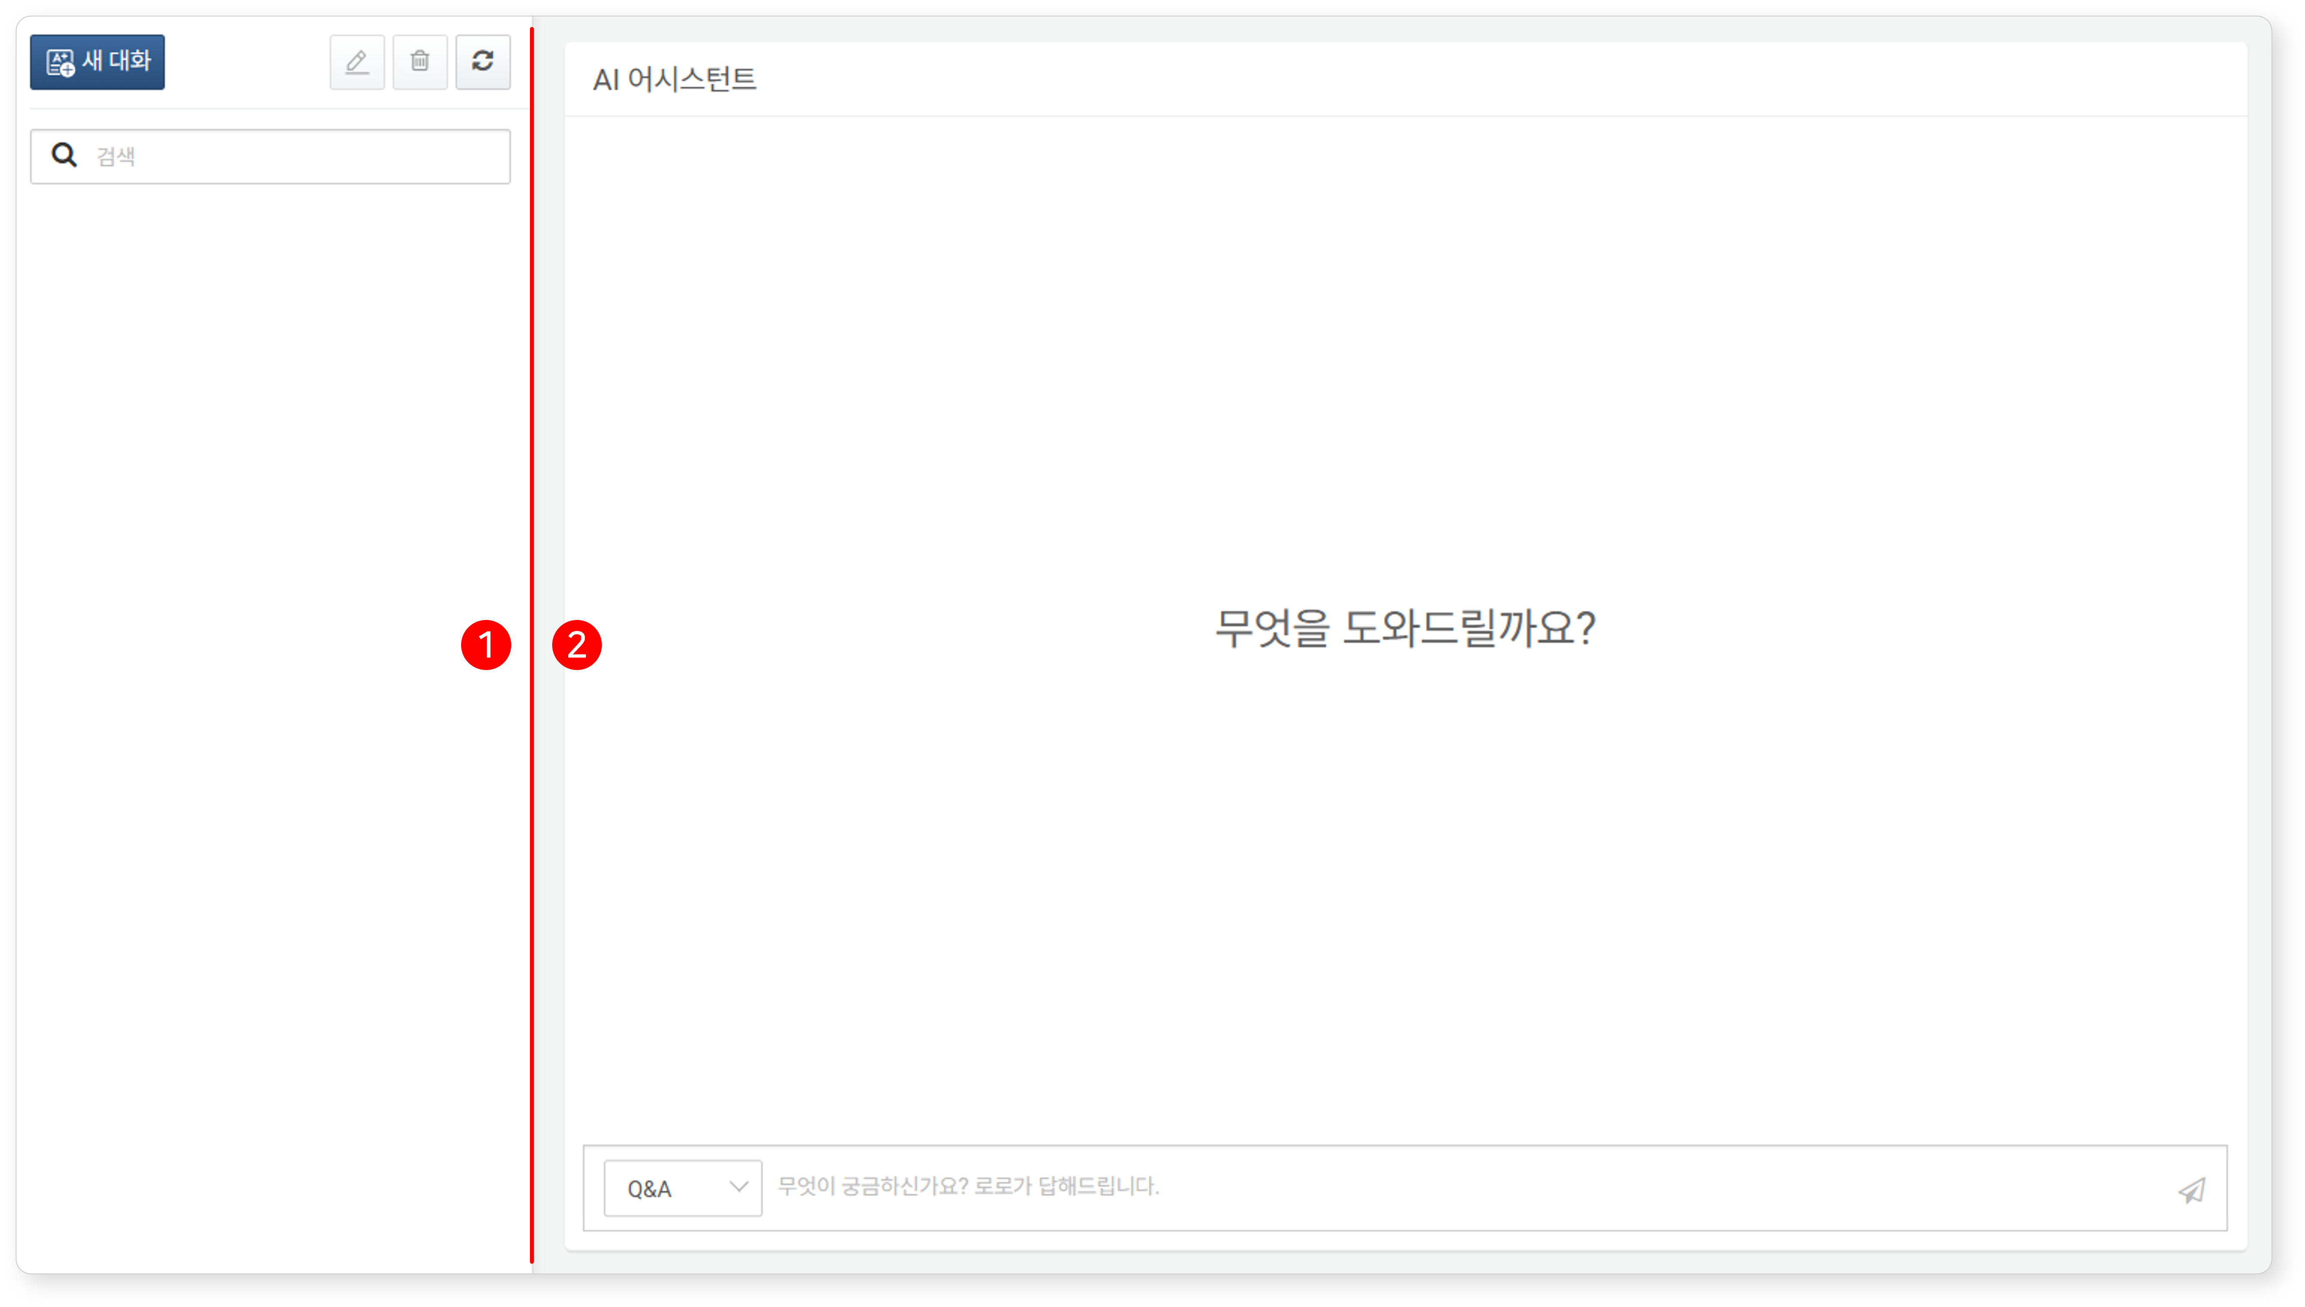
(1) Conversation List
The left side of the screen displays the conversation list. Each conversation session listed consists of a series of questions and responses exchanged between the user and the AI Assistant on a specific topic. Clicking on a conversation title allows you to view the content or continue the conversation. Open conversations are indicated by a gray background for the title.
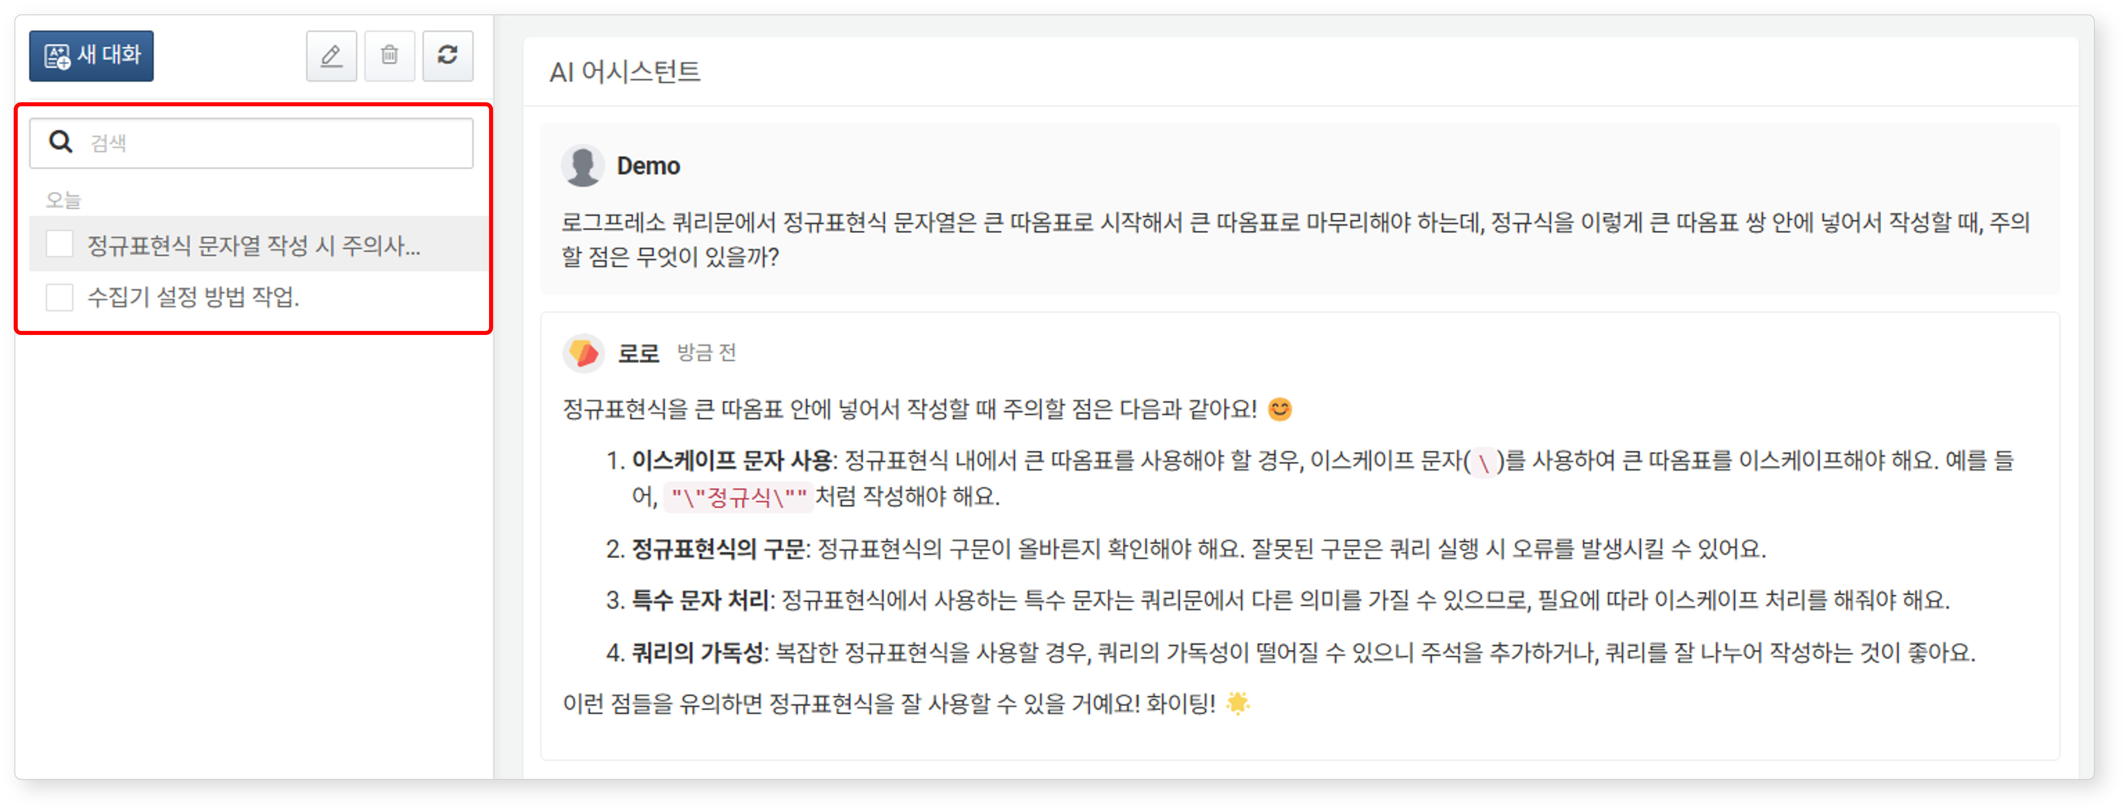
- The titles displayed in the conversation list are automatically assigned based on the first question.
- To change a conversation title, select the conversation you wish to rename and click on .
- To delete a conversation, select the conversation you wish to delete and click on .
- Enter a word or phrase in the search tool and press the Enter key to filter the conversation list to show only those conversations that include the entered string in their titles.
(2) Conversation Window
You can converse with the AI Assistant as if you were talking to a person. The conversation window consists of a dropdown box for selecting the type of conversation, an input box for entering your questions, and a conversation area where you can view responses from both the user and the AI Assistant.
The dropdown box in the conversation input area offers three options: Q&A, Action, and Plan (default: Q&A). Depending on the selected type, the AI Assistant performs different actions.
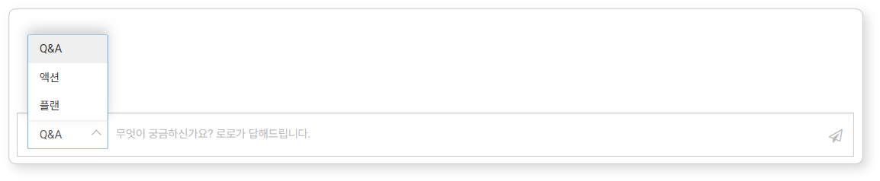
- Q&A: Provides answers to general questions.
- Action: Analyzes the user's request and executes the requested task by performing Logpresso queries or processing requests via REST APIs, displaying the processed results.
- Plan: Analyzes the user's request and executes sequential Logpresso queries or REST API calls to handle complex tasks.

Conversing with the AI Assistant
Getting Started
To start a conversation with the AI Assistant:
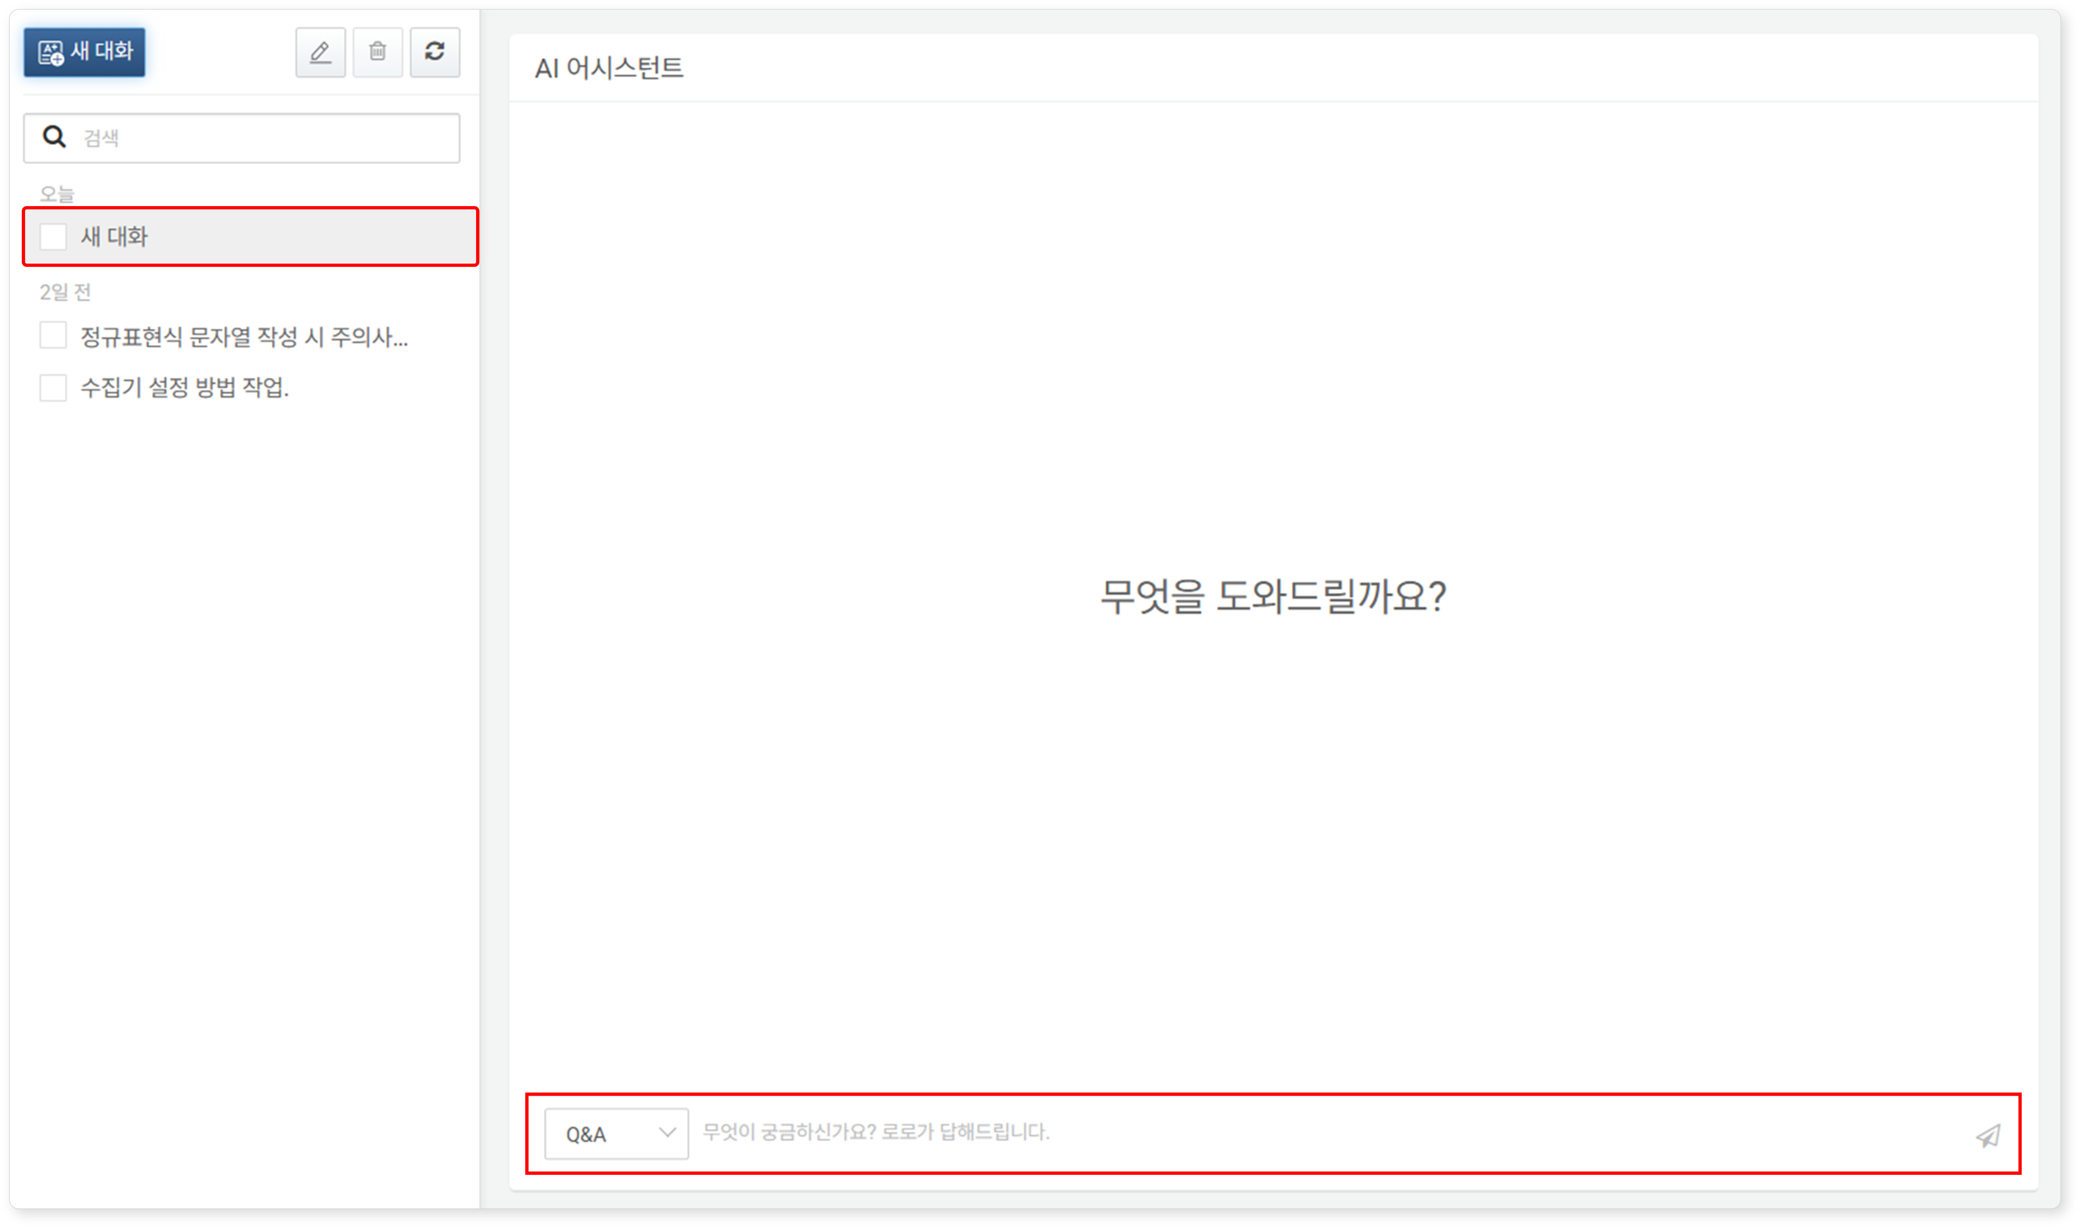
Click on in the conversation list under Analysis > AI Assistant to initiate a new conversation.
- The new conversation screen is the default screen for the AI Assistant, so you can proceed without clicking New Conversation.
- To start a new conversation while exiting an ongoing session, click New Conversation.
Once a New Conversation appears in the conversation list, select the conversation format (Q&A, Action, Plan) in the conversation window, enter your question, and click or press the Enter key. The default conversation format is Q&A.
- To insert a line break while entering a question, press Shift + Enter.
- The AI Assistant's response format may vary depending on the conversation type:
- Q&A Type: Answers related to the Logpresso platform.
- Action: Execution of Logpresso queries or REST APIs and their results.
- Plan: Step-by-step execution of prompts for both Q&A and Action types.
- You can change the conversation format each time you ask a question within a single conversation session.
Tips for Effective Questioning
To engage in effective conversations with the AI Assistant, please adhere to the following principles:
Focus on a single topic during the conversation. Start a new conversation for questions on different topics.
Ask questions using precise and concise sentences. Descriptive and factual expressions, as well as explicit wording, are preferred.
It is advisable to include ambiguous or polysemous words in English, such as "logger."
Clearly distinguish between questions and commands according to the conversation format (Q&A, Action, Plan).
Describe the content of your questions or the tasks that Logpresso Sonar needs to execute in detail. Instead of asking, "What is the address 192.0.2.4?", phrase it as "Check if there is any threat intelligence information related to 192.0.2.4."
When execution is required, list the names and values of the input parameters needed for execution (e.g., Name "Firewall Logger," Type "Syslog").
Examples by Conversation Format
The AI Assistant recognizes the context of the conversation and utilizes it in subsequent exchanges, similar to how a person recalls previous discussions. However, as the conversation progresses, accuracy may gradually decrease. It is advisable to limit a single conversation session to a specific topic. Start a new conversation for questions on different topics.
Q&A
In a Q&A conversation, the AI Assistant can refine its answers through dialogue with the user.
For example, you might ask, "Tell me how to use the stats query," and then request an example by saying, "Also, provide an example of the stats query." If the AI Assistant provides incorrect information in its response, you can point it out by saying, "It seems the usage of YY in the XXX query is incorrect," and the AI Assistant will provide a corrected response.
Here is an example response when asking, "How do I create a logger?"
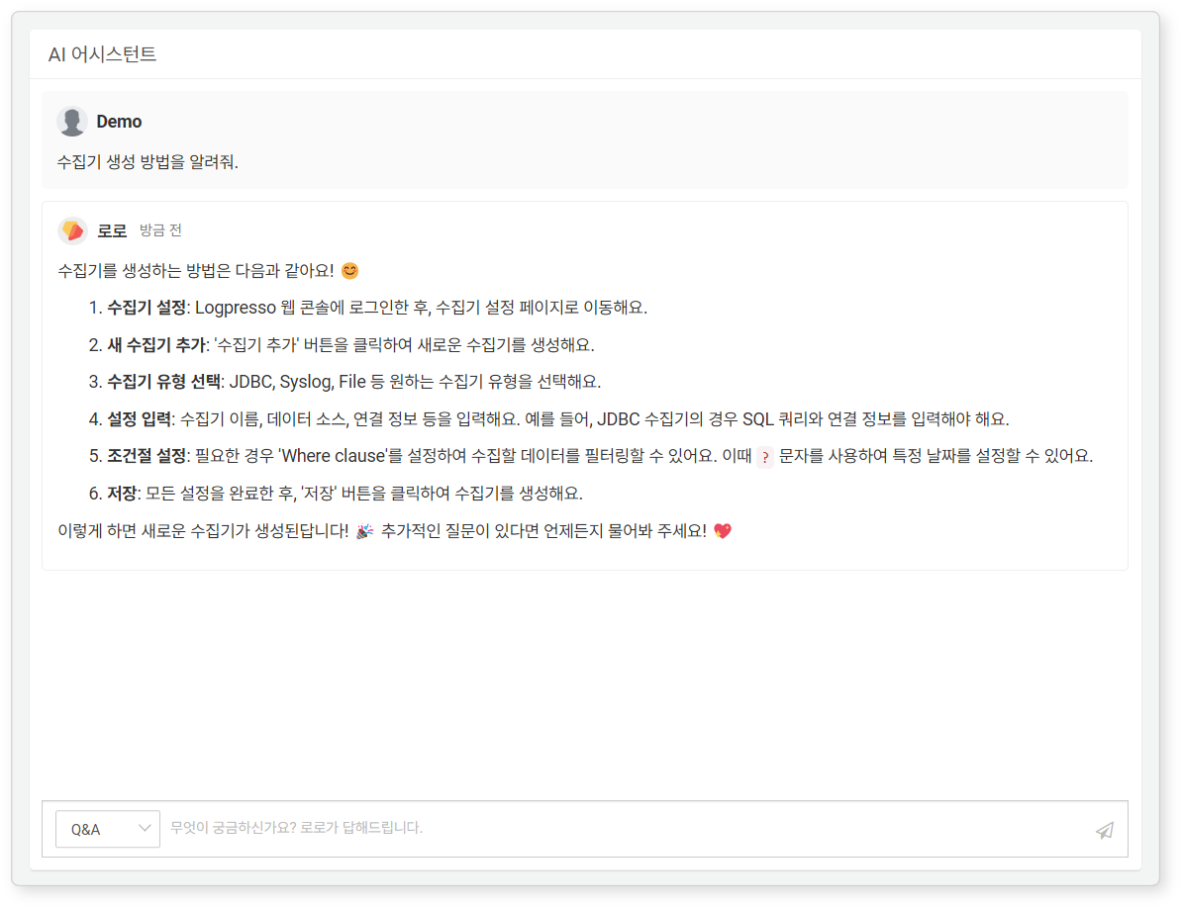
Here is another example response when asking, "Tell me how to use the stats command. An example would be great."
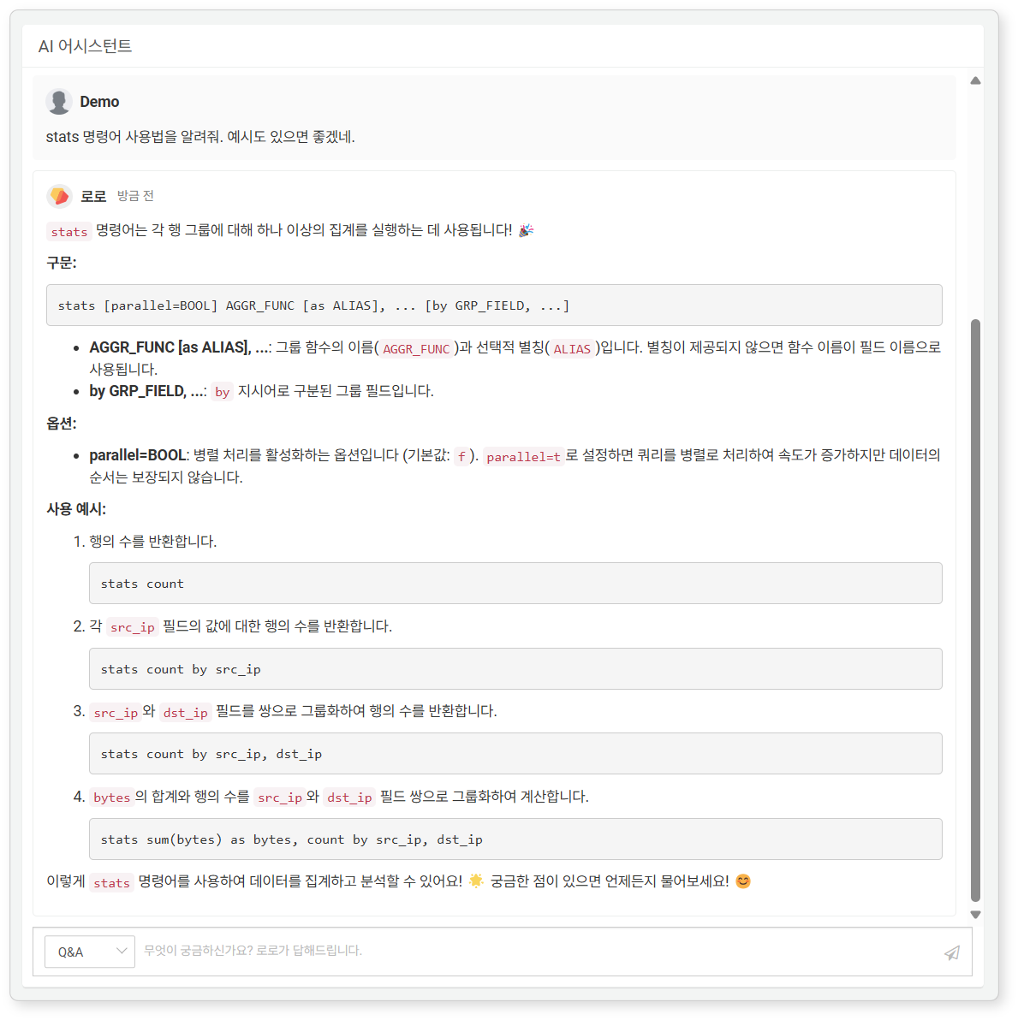
Action
When the conversation format is Action, the AI Assistant performs specific tasks based on the user's requests. Tasks can be executed using the Logpresso Sonar REST API or by running Logpresso queries. The method of operation is determined by the AI prompts.
The AI Assistant displays up to 10 results for executed queries and REST API calls. To view all query results, refer to the query provided in the AI Assistant's response and execute it directly in the "Analysis > Query" screen. For REST API calls, remove the limit parameter from the API request in the response and execute the API call.
Query-Based Action
Query-based actions leverage the extensibility of Logpresso queries, allowing for a wide range of query executions from simple table lookups to complex join statements. Below is an example of the AI Assistant responding by executing a Logpresso query.
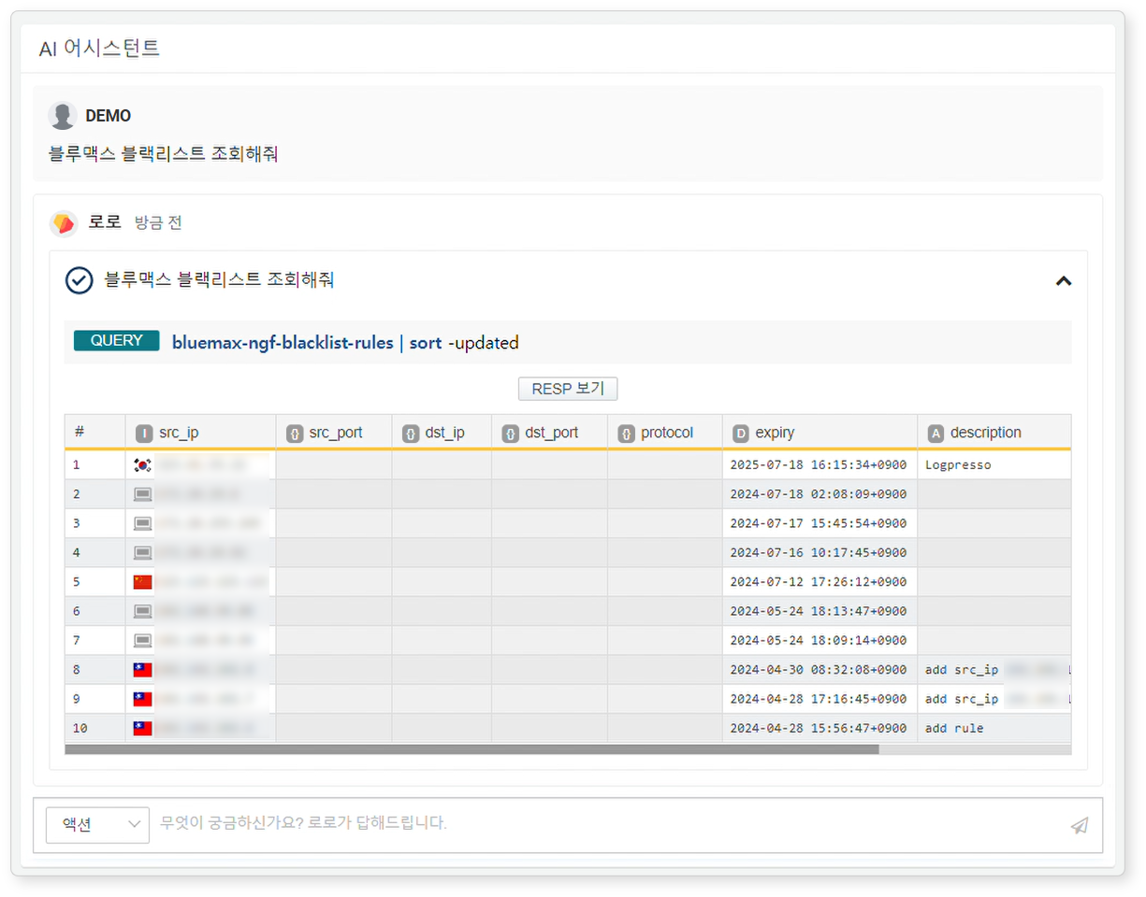
You can request additional analysis on the results retrieved through query-based actions. This is useful when you need a summary of the query execution or further interpretation.
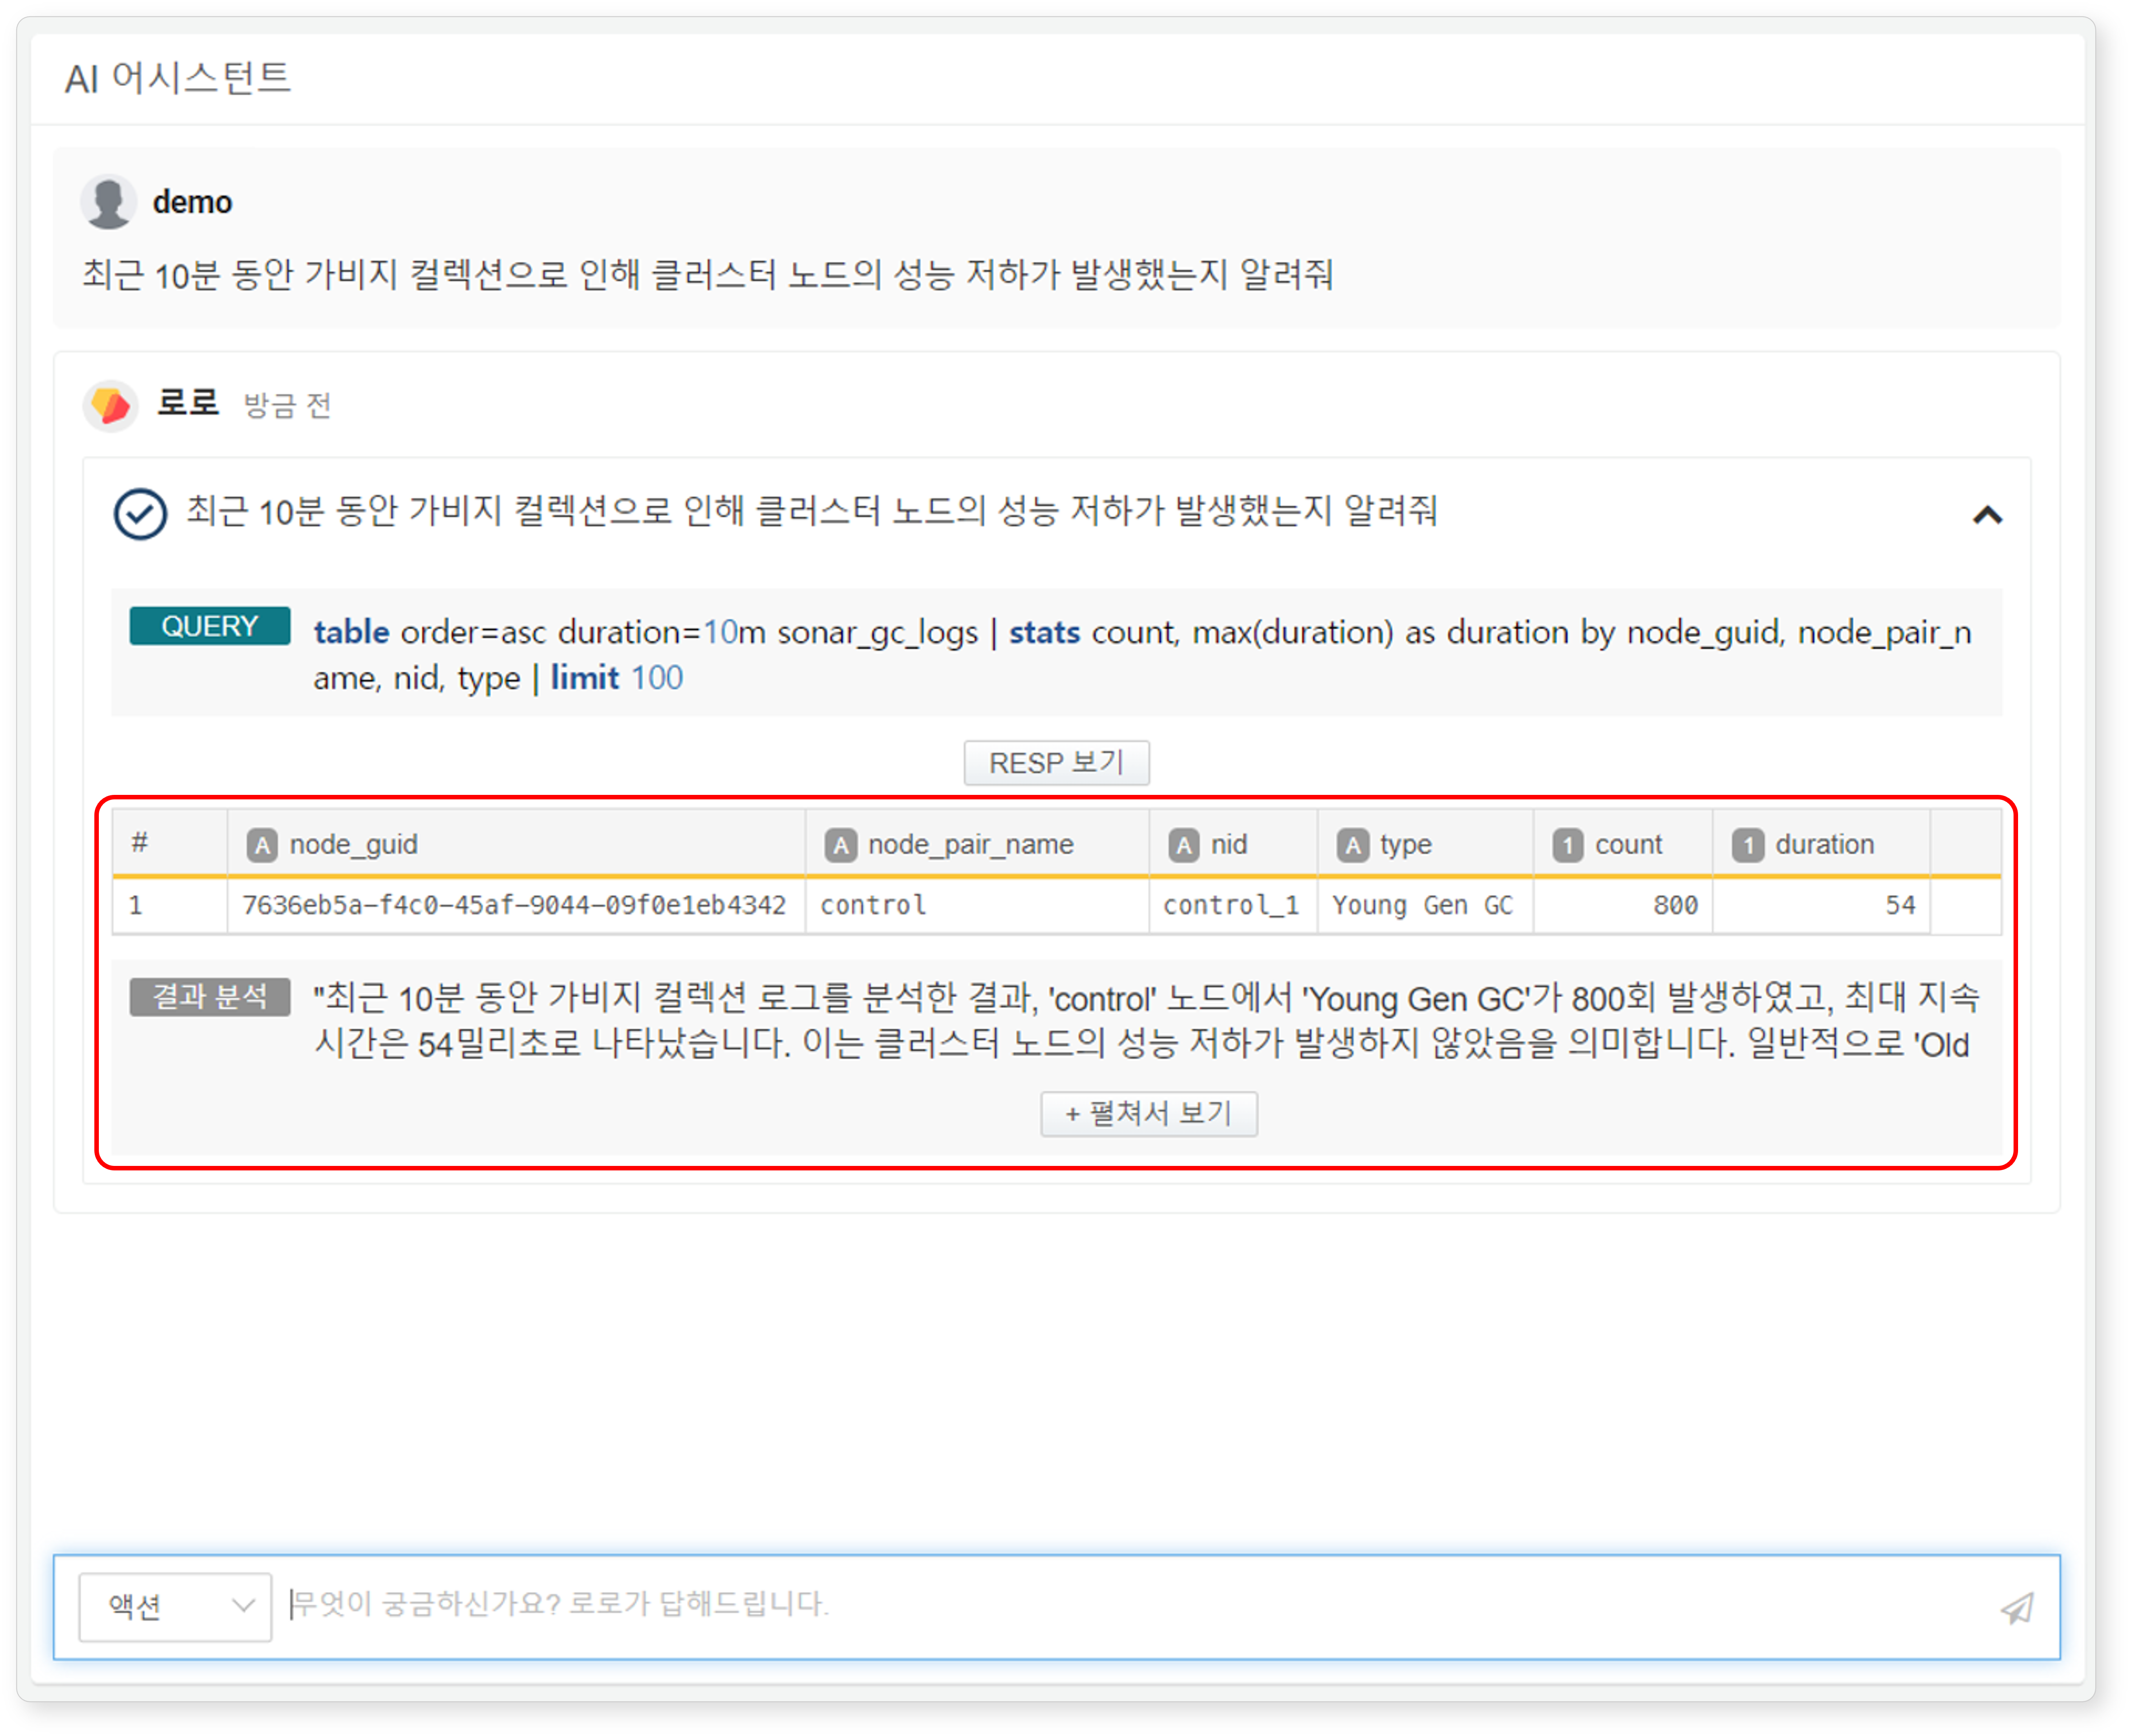
Clicking View RESP allows you to see the query results and the analysis of those results. If the analysis is lengthy, only the beginning of the response will be shown. To view the entire response, click Expand to View.
REST API-Based Action
Most functionalities of Logpresso Sonar are provided through REST APIs. The following illustration shows an example of the AI Assistant responding by retrieving data using the REST API.
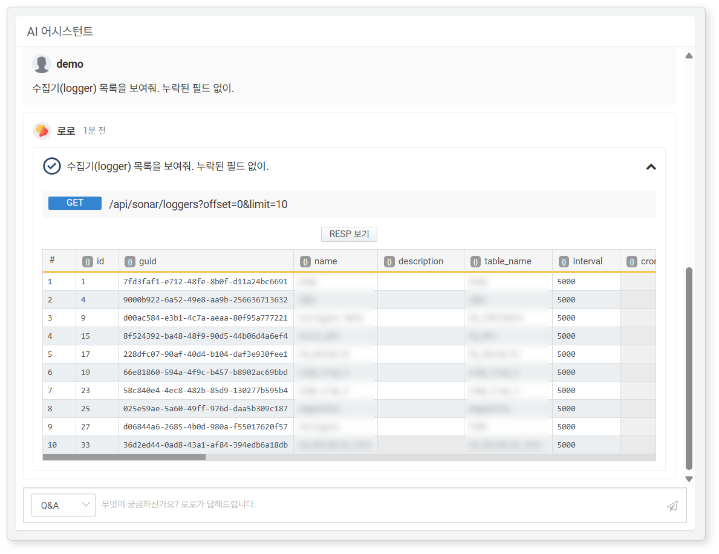
Clicking View RESP allows you to see the actual response content. If the response is lengthy, only the beginning will be displayed, as shown in the next illustration. To view the entire response, click Expand to View.
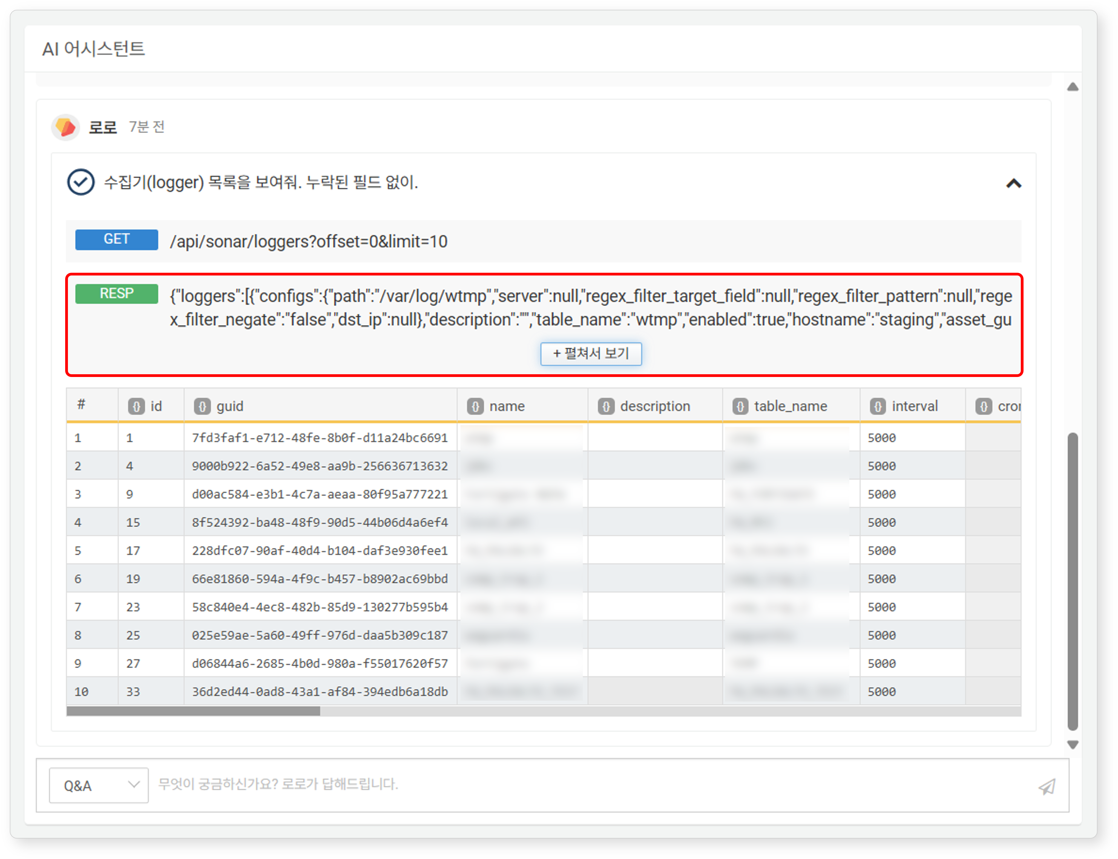
When a task requires user-provided data, the AI Assistant presents a list of input parameters and requests approval before making the API call, as shown in the following illustration.
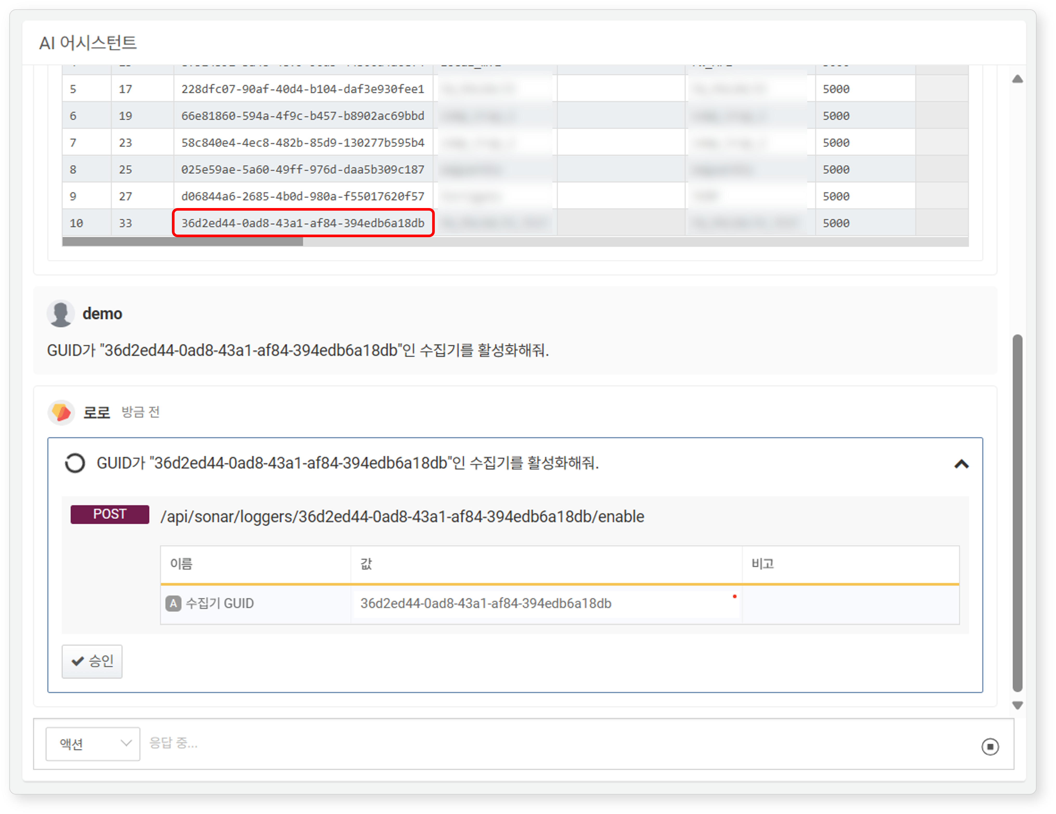
- If the user's request includes input parameters, the AI Assistant will reflect that content and display the list of input parameters needed for the REST API call.
- Users can also enter input parameters directly. Parameters with a red dot in the upper right corner of the input box are mandatory fields.
- When the user clicks Approve, the AI Assistant requests data changes (or deletions) from Logpresso Sonar via the API.
- The AI Assistant uses methods such as GET, POST, PUT, and DELETE to make API calls.
Once the AI Assistant receives a response to the API request, it displays it as follows:
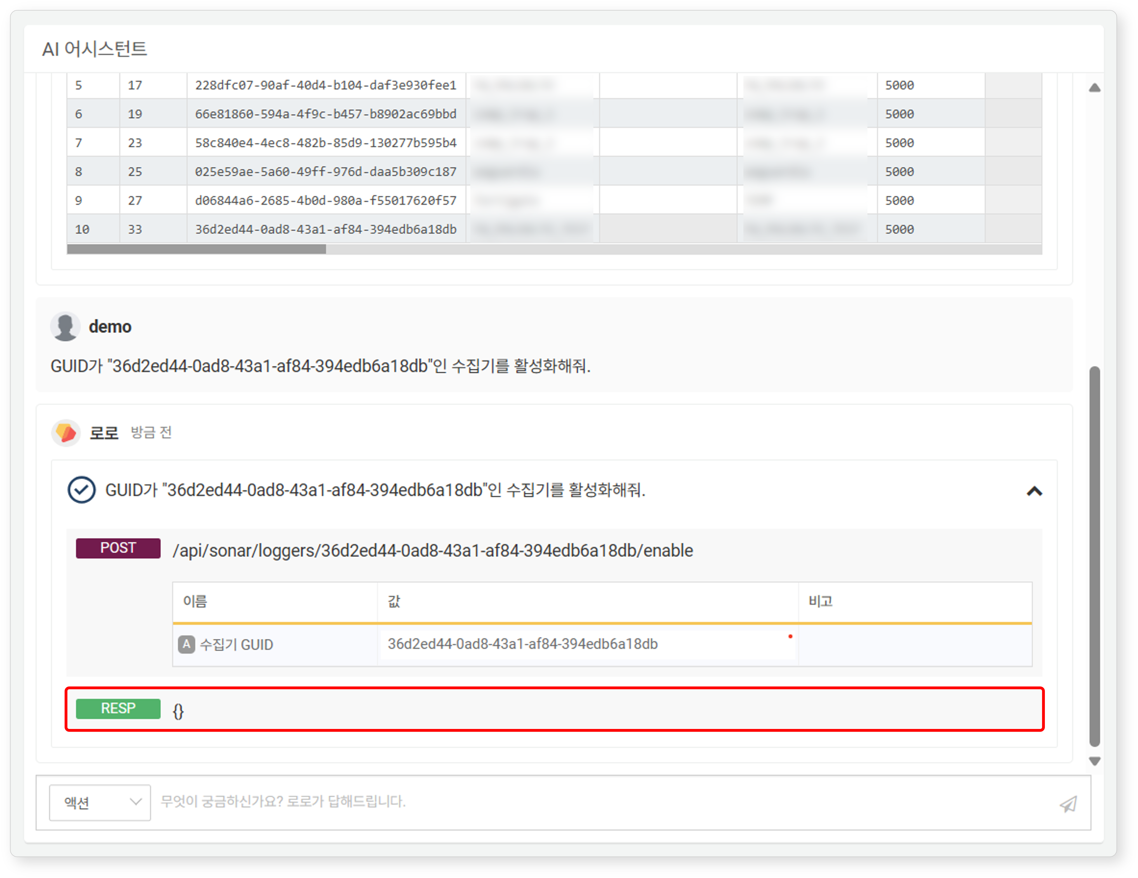
Plan
The Plan conversation format can be used when a user's request requires multiple steps of query executions or REST API calls. You can input multiple action questions to perform a task in one question using the Plan format.
The following illustration shows a sequence of actions where the GUID of a blacklist (an IP address group object to manage blocked IP addresses) is retrieved, followed by adding an IP address.
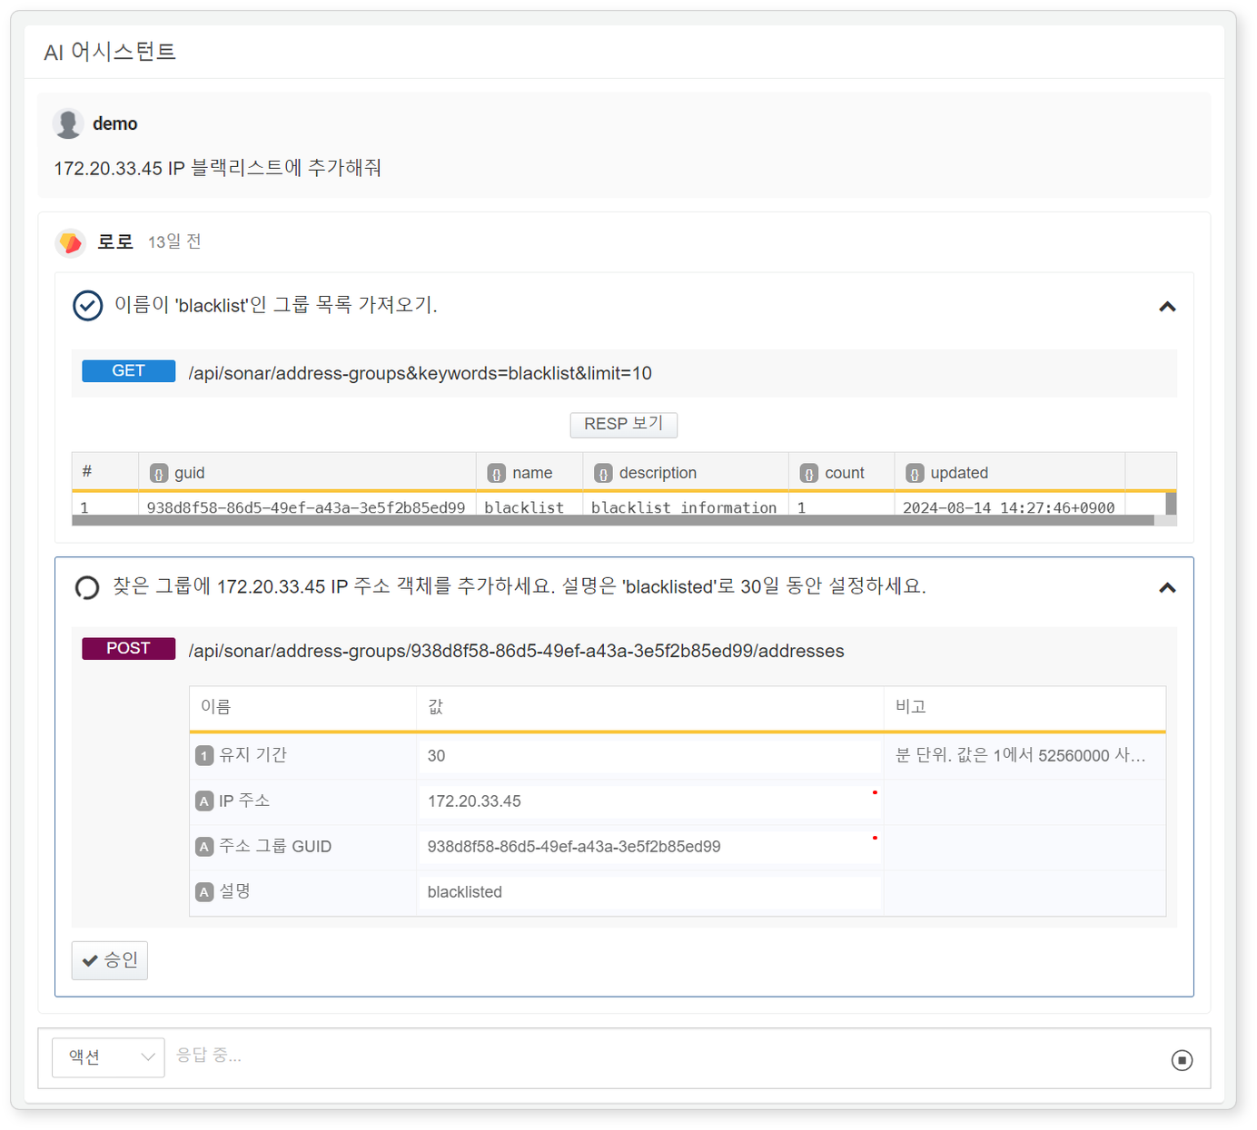
The executed tasks are as follows:
Retrieve the GUID of the address group named 'blacklist' from the address group list.
Add an IP address to the 'blacklist' address group.
Example Use Cases for the AI Assistant
Finding Apps that Match Log Formats
When you present a log sample to the AI Assistant, it normalizes the log and suggests applicable Logpresso apps. Install the recommended apps and utilize the logs for security monitoring tasks.
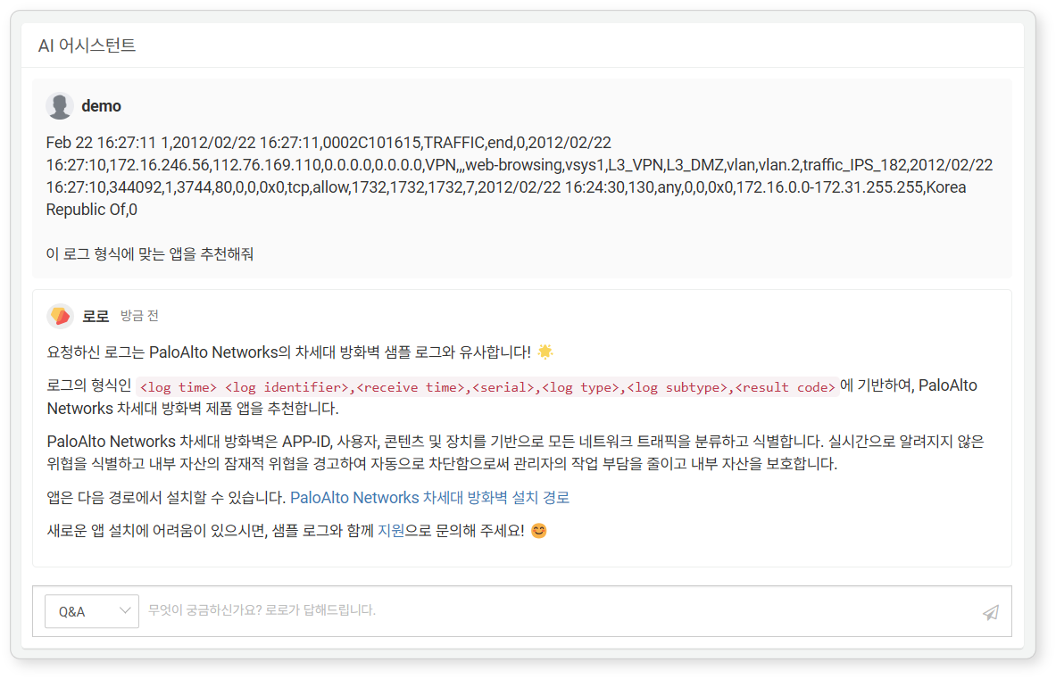
Generating Log Normalization Query
When adding a query-based parser, you may find it challenging to write the query. In such cases, consider using the AI Assistant. The following illustration shows an example of requesting a query to normalize a log sample.
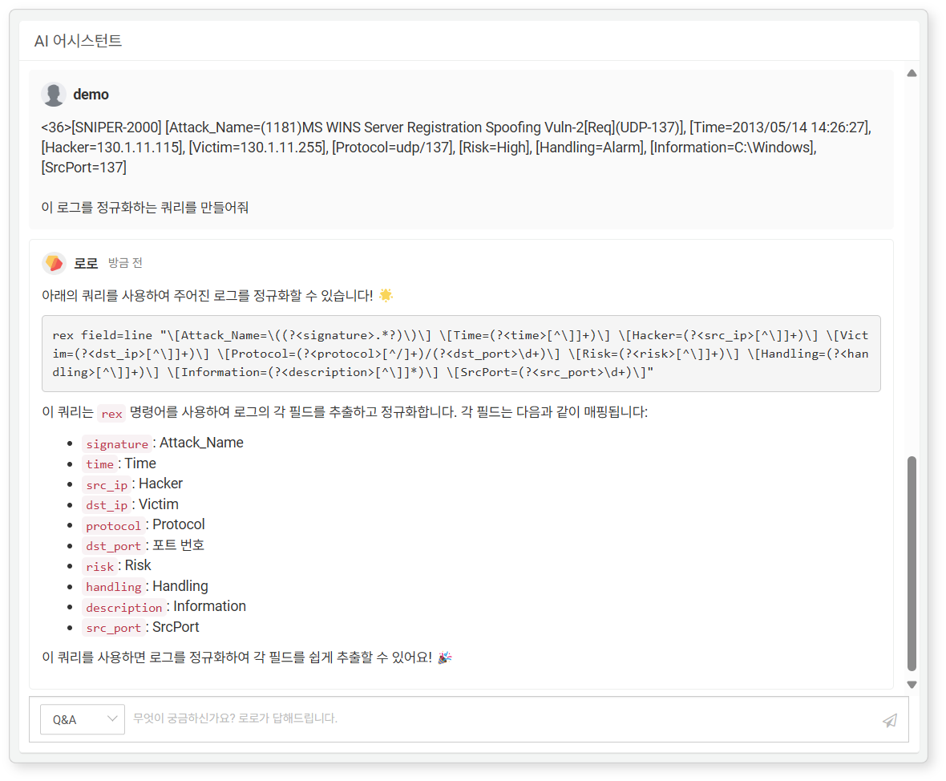
The log sample used in the example is as follows:
<36>[SNIPER-2000] [Attack_Name=(1181)MS WINS Server Registration Spoofing Vuln-2[Req](UDP-137)], [Time=2013/05/14 14:26:27], [Hacker=130.1.11.115], [Victim=130.1.11.255], [Protocol=udp/137], [Risk=High], [Handling=Alarm], [Information=C:\Windows], [SrcPort=137]
Creating a Parser
Building on the log normalization query generation, you can also use the AI Assistant to add a parser.
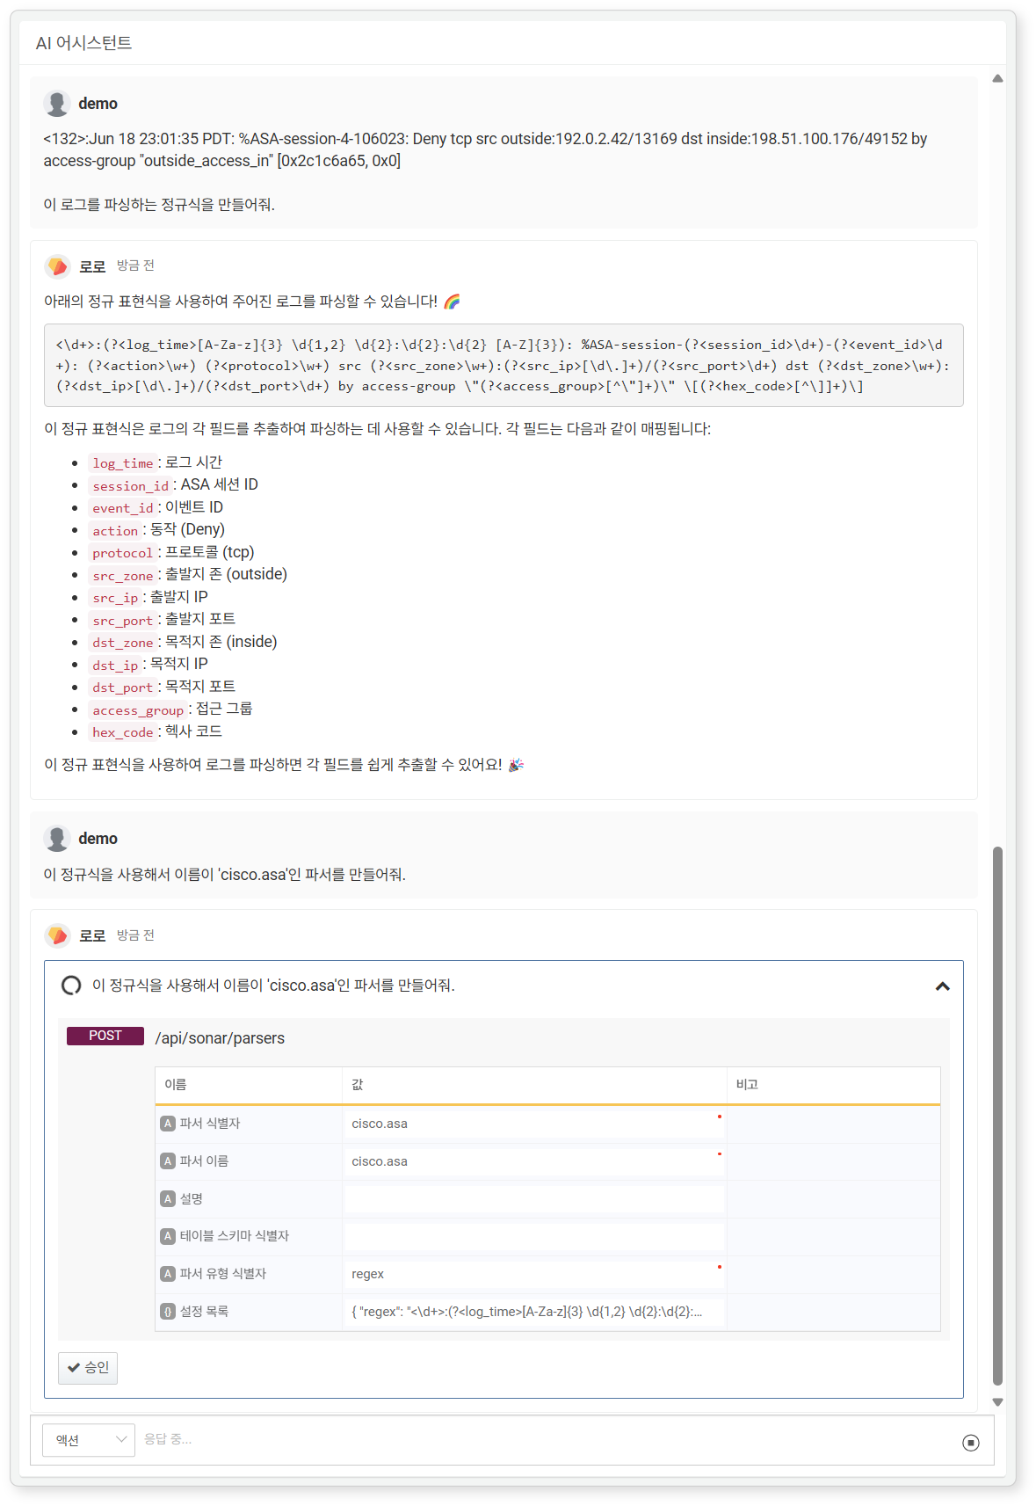
The illustration shows an example of creating a parser with the following questions:
Generate a normalization query using Q&A format.
Create a parser using the regular expression generated in the previous question in Action format.
The log sample used in the example is as follows:
<132>:Jun 18 23:01:35 PDT: %ASA-session-4-106023: Deny tcp src outside:192.0.2.42/13169 dst inside:198.51.100.176/49152 by access-group "outside_access_in" [0x2c1c6a65, 0x0]
Stopping Responses
To stop the AI Assistant's response during a conversation, click on in the conversation window.
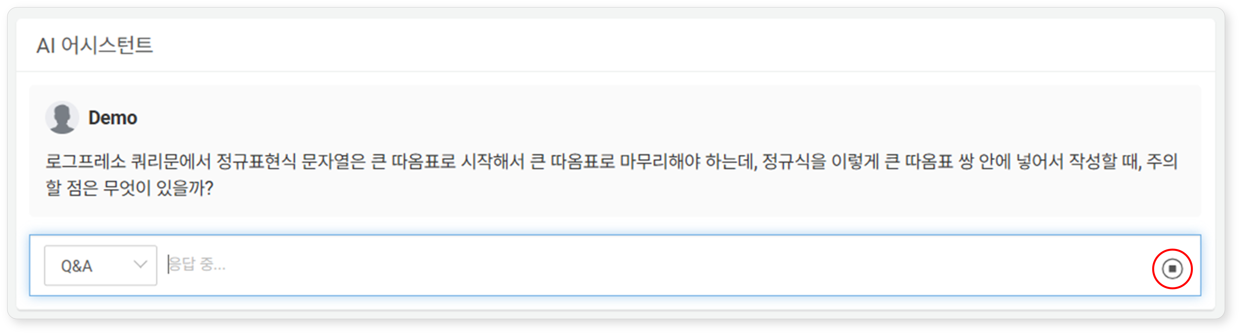
- The and buttons are toggle buttons.
- The Send button is activated when the user can input questions in the conversation window.
- The Stop button is activated when the AI Assistant is responding.
- While the AI Assistant is responding, users cannot input further dialogue.

Changing Conversation Title
When a conversation starts, a title is automatically assigned. To change the conversation title:
Select the conversation you wish to rename from the conversation list and click on .
Click on the title string to select it. The checkbox is used for deleting conversations.
In the Change Conversation Title dialog, enter a new title and click OK (maximum 50 characters). Click Cancel if you do not wish to change the title.
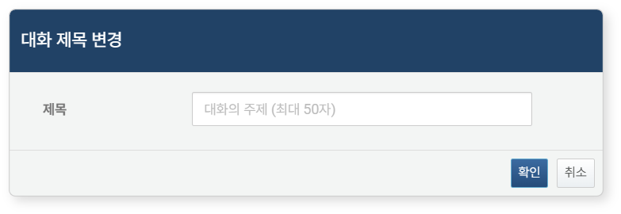

Deleting a Conversation
To delete a conversation session:
Select the checkbox for the conversation title you wish to delete from the conversation list and click on .
In the Delete Conversation Session dialog, click Delete. Click Cancel if you do not wish to delete it.
