### AI Prompt

#### Overview

The AI Prompt feature manages the prompt documents that define how the AI Assistant responds to user inquiries within the Logpresso platform. Logpresso Sonar provides basic AI prompts, allowing users to utilize the AI Assistant without needing to add prompts themselves.

Types of Prompts

Prompts are divided into system prompts, app prompts, and user prompts.

* **System Prompt**: The system prompt defines the content that the AI Assistant will respond with or the procedures it will execute when a user asks questions about the features of Logpresso Sonar or requests specific tasks. This prompt controls the detailed operations of the AI Assistant, and users cannot view or modify system prompts from the AI Prompt screen.
* **App Prompt**: The app prompt enables the execution of extension commands for [apps](https://docs.logpresso.comnull) or allows tasks to be performed through the API of integrated systems. App prompts can be viewed on the AI Prompt screen, but users cannot modify them.
* **User Prompt**: The user prompt is created directly by the user. Through user prompts, users can define the tasks that the Logpresso platform will perform according to their work characteristics or environment.

Prompt Format and Language

Prompts have document formats corresponding to three types of conversation: Q&A, Action, and Plan. All documents must be written in [YAML format](https://yaml.org/spec/1.2.2/).

* Q&A and Plan prompts consist of **question**, **cot** (Chain of Thought), and **answer**.
* Action prompts consist of **question**, **cot**, and **spec**.
* Templates for each conversation type are provided for user reference on the prompt creation screen.

Prompts can be written in any user language. However, it is **recommended to write in a single language** for accuracy, effective token usage, and to avoid ambiguities when comparing LLM prompt embeddings. Note that both system prompts and app prompts are written in English.

Preparation for Use

To use AI prompts, you need to:

Obtain an AI Assistant license.

Ensure that Logpresso Sonar nodes can access https://ai.logpresso.com.

Create a [Logpresso AI Assistant Connect Profile](https://docs.logpresso.comnull) after obtaining an API key from Logpresso. Navigate to **System > Connect Profiles** to create the Logpresso AI Assistant Connect Profile.

Refresh your web browser or log out and log back in to access the AI Prompt screen.

The AI Prompt screen can only be accessed after creating a connect profile.

#### Viewing/Search AI Prompt List

You can view or search the AI prompt list under **System > AI Prompt**. This screen only displays user prompts, so the initial state shows an empty list. The following image illustrates an example with four registered user prompts.

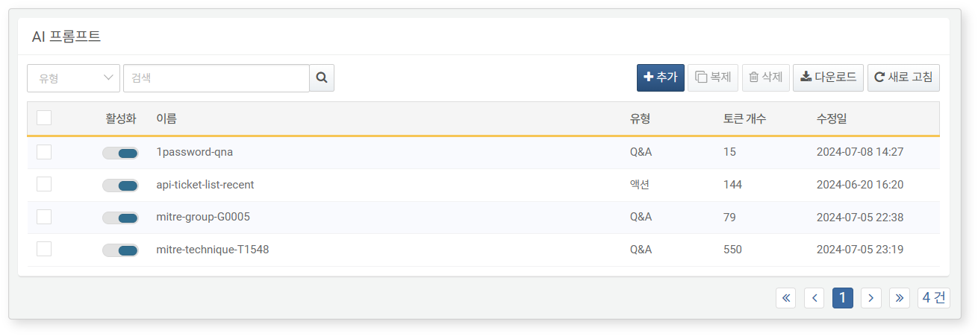

The items used in the above menu are as follows:

* **Activation**: Toggle button for activating registered prompts.
* **Name**: The name used for identifying the prompt. It does not affect the operation of the AI Assistant.
* **Type**: The type of prompt (one of Q&A, Plan, Action). The AI Assistant behaves differently based on each type.
* **Token Count**: The number of tokens converted through OpenAI's embedding model. The maximum number of usable tokens may vary by the LLM model used.
* **Modification Date**: The date the prompt was created or last modified.

To find a specific prompt in the AI prompt list, use the search tool in the toolbar. The search tool will display AI prompts that contain the words entered in either **Name** or **Description** (one of the properties of AI prompts). The search tool is case-insensitive.

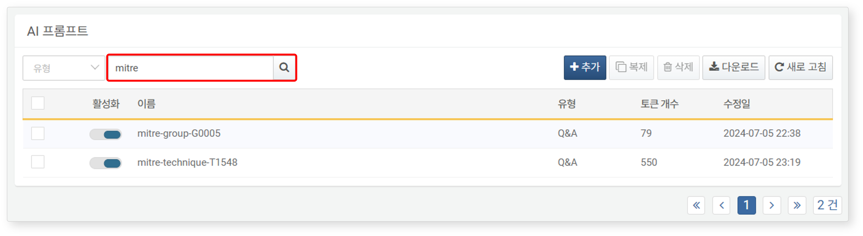

#### Downloading AI Prompt List

To download the prompt list:

Click **Download** in the AI Prompt list toolbar.

In the **Download AI Prompt List** dialog, specify the properties of the file to be downloaded and click **OK**.

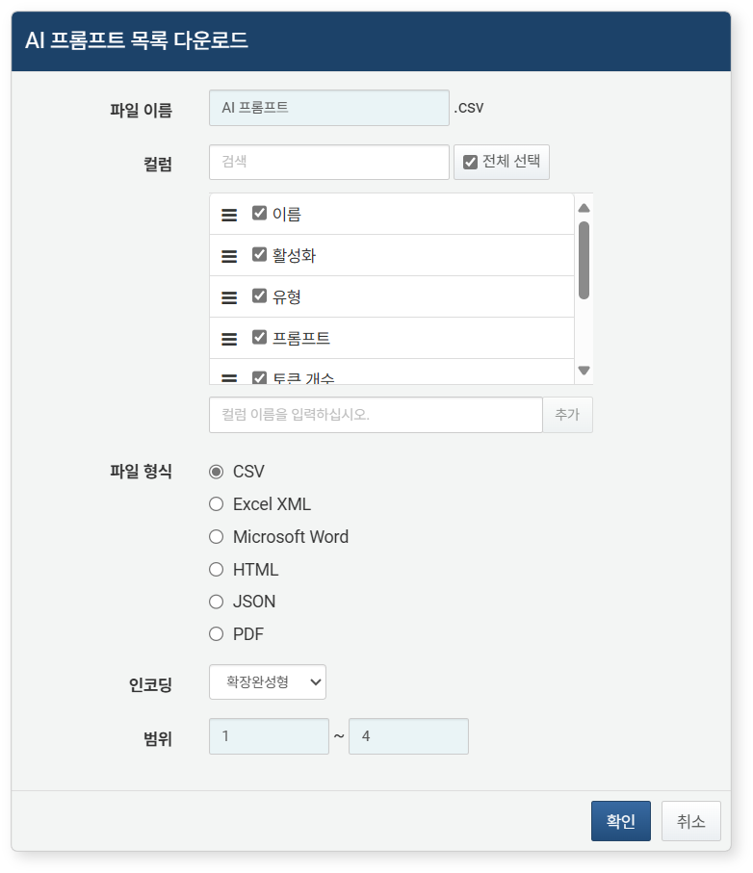

* **File Name**: The name of the file to be downloaded (default: AI Prompt).
* **Columns**: The fields to be recorded in the download list (default: Select All).
* **File Format**: Choose from **CSV**, **Excel XML**, **Microsoft Word**, **HTML**, **JSON** (default: CSV).
* **Encoding**: Select the string encoding format for the file from **Extended Completion**, **UTF-8**, **UTF-16 BE** (default: Extended Completion).
* **Range**: Select the range of AI prompts to be recorded in the list. The default includes all AI prompts, starting from the topmost prompt on the first page of the AI prompt list.

Once the server sends the file to your web browser, save the file and check the downloaded AI prompt list file.

#### Adding AI Prompt

To add a prompt:

Click **Add** in the toolbar under **System > AI Prompt**.

In the **Add Prompt** screen, enter **Type**, **Name**, **Description**, and **Prompt**, then click **OK**. After selecting the **Type**, clicking the **Template** below the **Prompt** input field will fill the prompt input field with a template based on the conversation type.

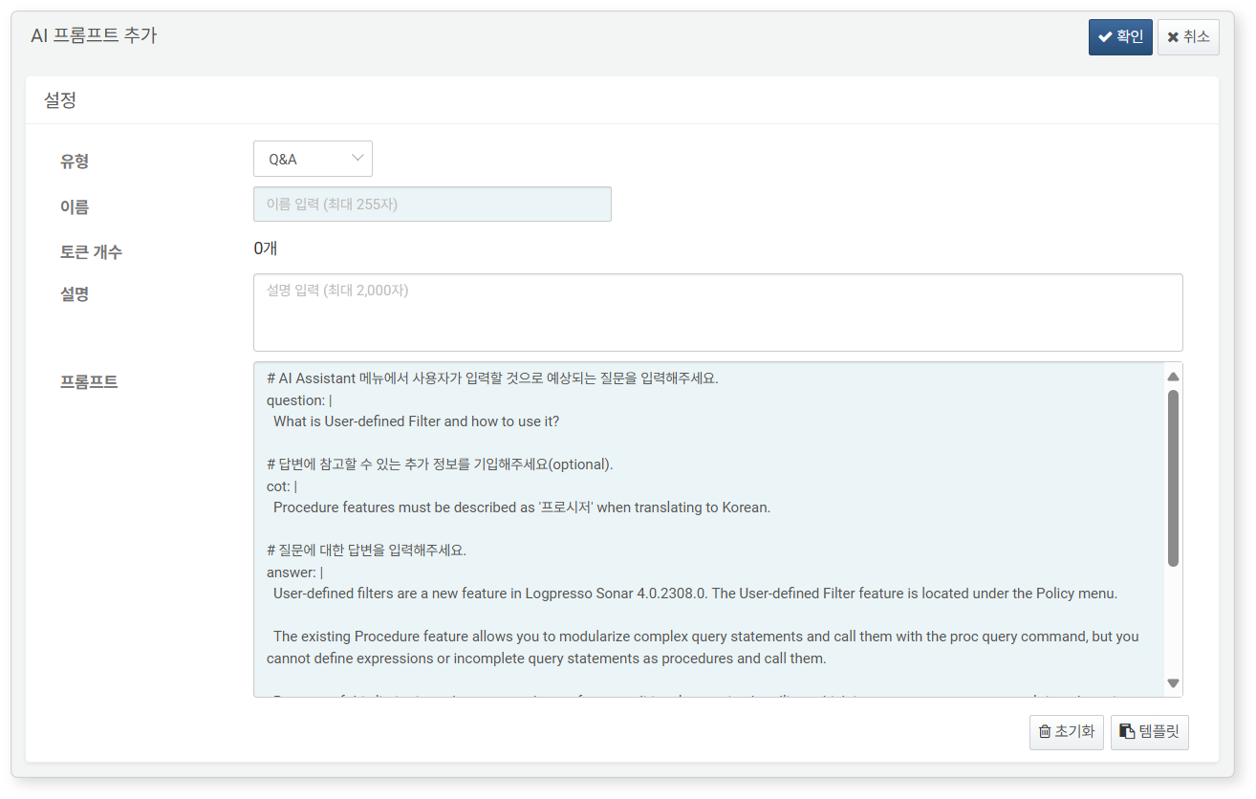

* **Type**: Select the conversation type for the AI Assistant from **Q&A**, **Action**, **Plan** (default: Q&A). The AI Assistant behaves differently based on each type.
* **Name**: The name used for identifying the prompt. Spaces are not allowed; use dashes (-) instead (e.g., qna-description-of-ai-assistant).
* **Description**: Can be entered without restriction, up to 2,000 characters.
* **Prompt**: Write **question** and **answer** in YAML format.
* **cot** can be omitted, but it is recommended for generating more accurate and logical responses from the AI Assistant.
* **spec** defines the query or REST API call method required for executing the action prompt.

When the **Type** is **Action**, select the action to be executed as either **Query** or **REST API** before clicking **Template**. Queries and REST APIs use different templates.

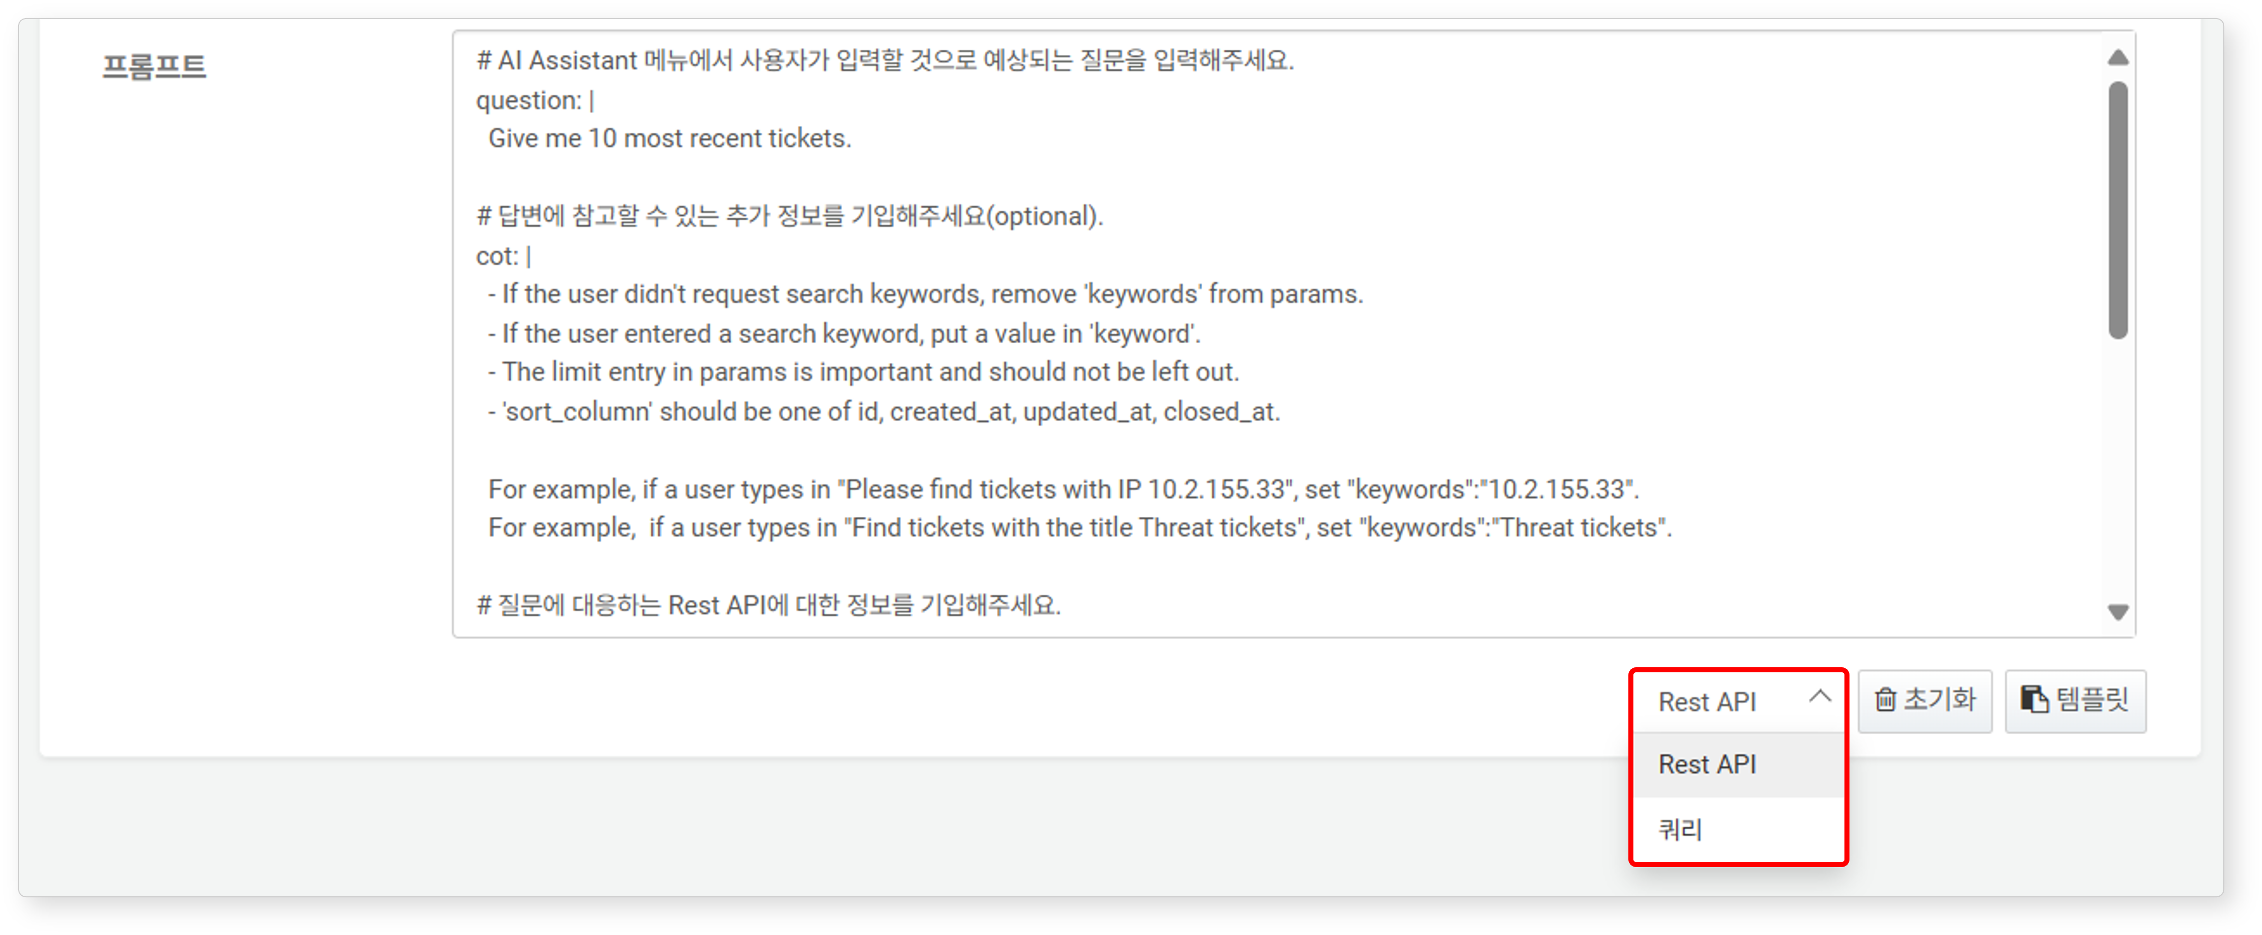

#### Activating/Deactivating AI Prompt

When an AI prompt is added to Logpresso Sonar, it is immediately activated and applied to the AI instance.

* To deactivate an AI prompt, click the  in the activation column of the AI prompt you wish to deactivate, changing it to .
* To activate a deactivated AI prompt, click  to change it back to .

#### Modifying AI Prompt

To modify a prompt:

Click the name of the prompt you wish to modify in the AI prompt list.

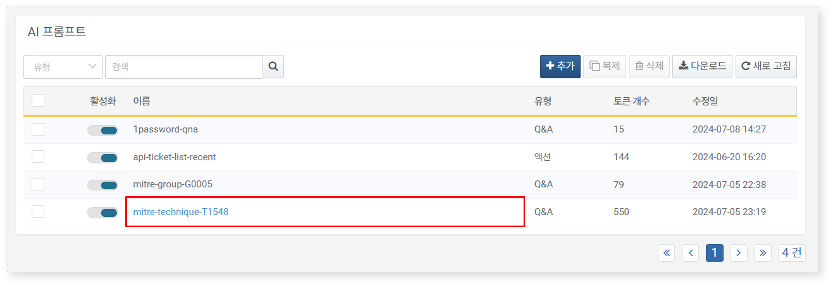

In the **Modify AI Prompt** screen, make your changes and click **OK**.

* For descriptions of the properties to modify, refer to [Adding AI Prompt](https://docs.logpresso.comnull).

#### Duplicating AI Prompt

To duplicate a prompt and then modify it to create a new prompt:

Select the prompt to duplicate from the AI prompt list, then click **Duplicate** in the toolbar.

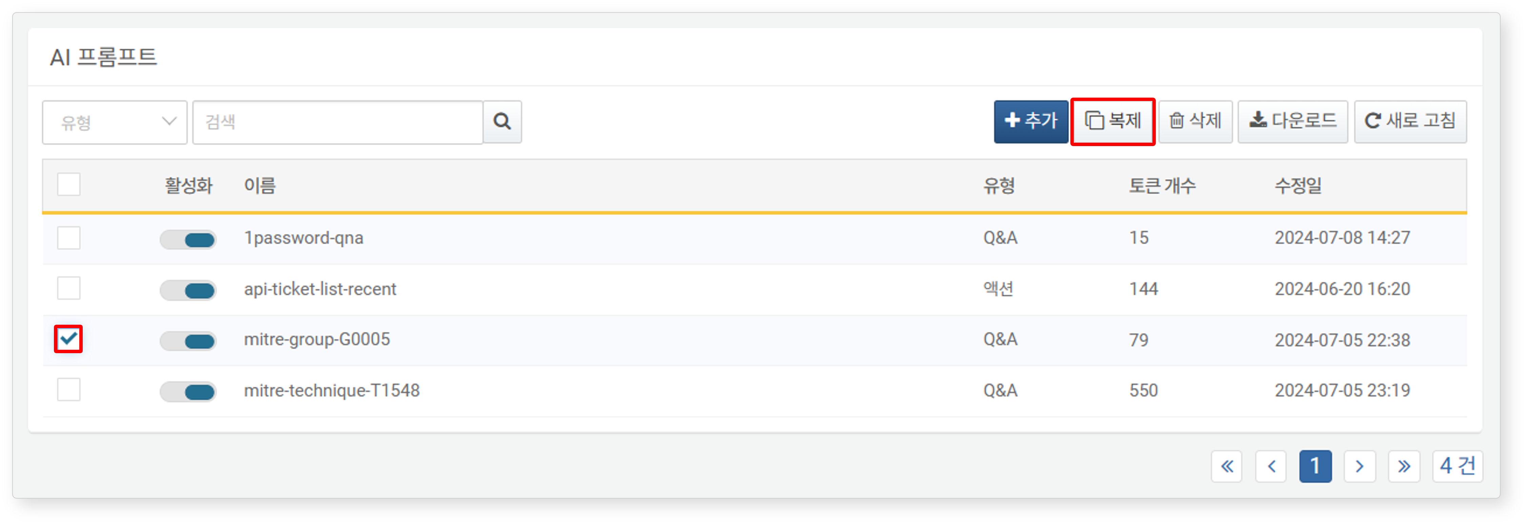

In the **Duplicate AI Prompt** dialog, confirm the name of the prompt to be duplicated and click **Duplicate**.

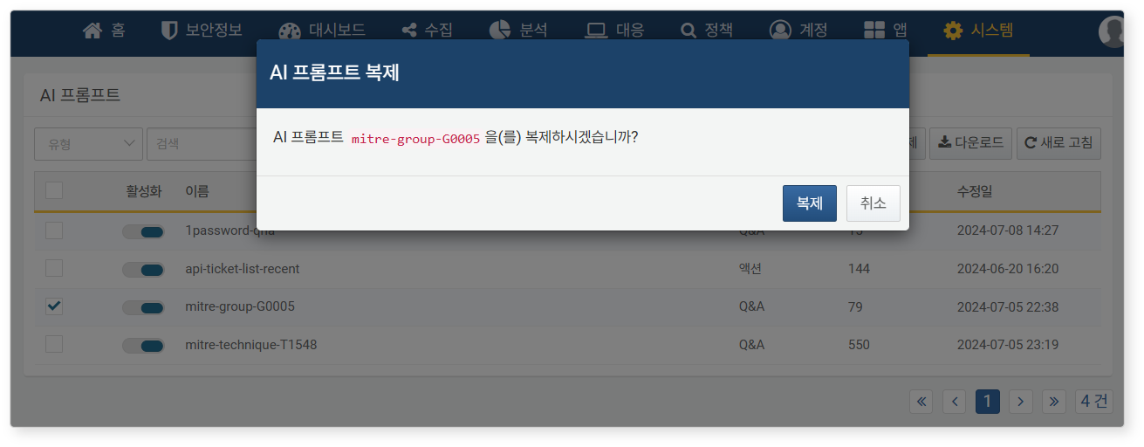

Refer to [Modifying AI Prompt](https://docs.logpresso.comnull) to create a new prompt from the duplicated prompt.

#### Deleting AI Prompt

To delete a prompt:

Click the checkbox in the row containing the information of the prompt you wish to delete in the AI prompt list.

Click **Delete** in the toolbar.

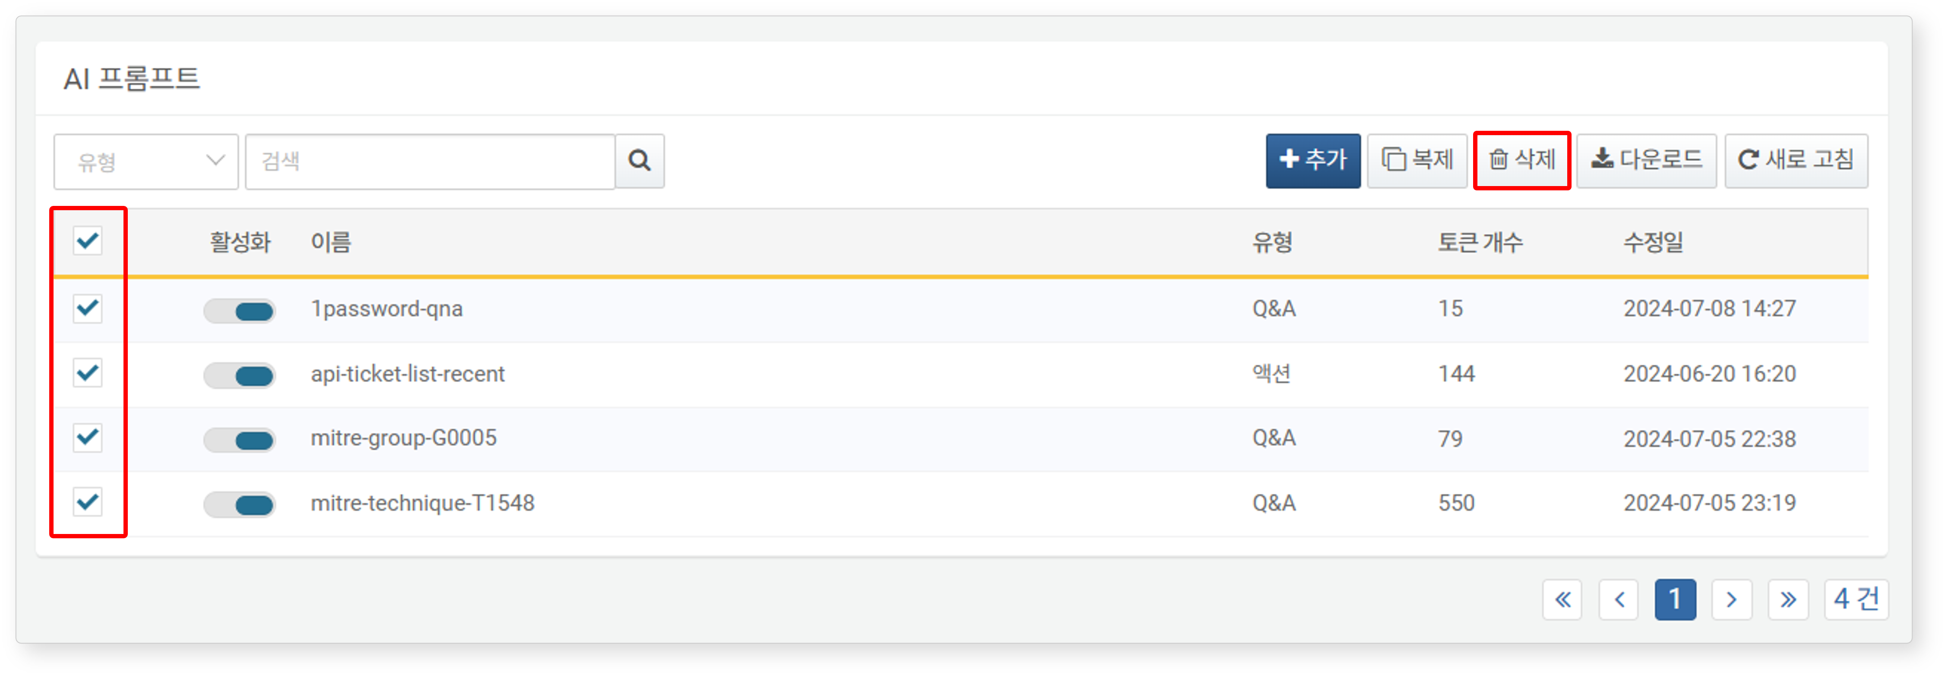

In the **Delete AI Prompt** dialog, review the list of prompts to be deleted and click **Delete**. Click **Cancel** if you do not wish to delete.

