### Alarm Group

#### Overview

You can set up Alarm Groups for event detection based on real-time detection scenarios and batch detection scenarios, allowing alarms (SMS, email, messenger) to be sent to the accounts and account groups specified in the Alarm Group.

#### Viewing/Search Alarm Group List

You can view or search the list of Alarm Groups in **Policies > Alarm Groups**.

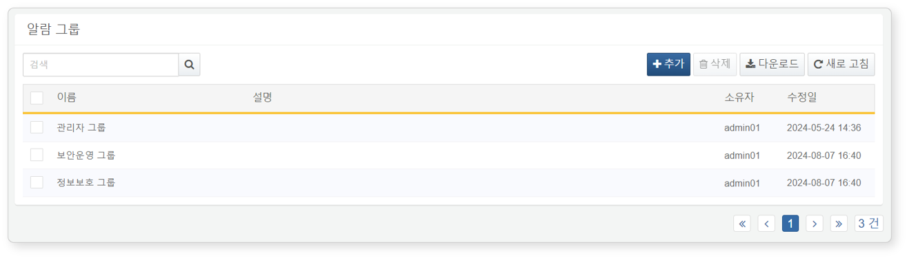

* **Name**: The unique name of the Alarm Group
* **Description**: A description of the Alarm Group
* **Owner**: The user account that added the Alarm Group
* **Modified Date**: The date the Alarm Group was created or last modified

To find a specific Alarm Group in the list, use the search tool in the toolbar. The search tool will display Alarm Groups that contain the entered word in the **Name** or **Description** fields. The search tool is case-insensitive.

Downloading the List

To download the Alarm Group list as a file to your local PC, click **Download** in the toolbar.

Refreshing the List

To refresh the Alarm Group list with the latest information, click **Refresh** in the toolbar.

#### Adding an Alarm Group

To add an Alarm Group:

Click **Add** in the toolbar under **Policies > Alarm Groups**.

In the **Add Alarm Group** screen, enter the following items and click **OK**.

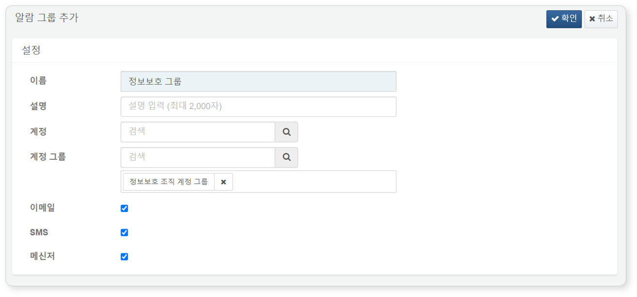

* **Name**: The name of the Alarm Group (up to 50 characters)
* **Description**: A description of the Alarm Group (up to 2,000 characters)
* **Accounts**: A list of [accounts](https://docs.logpresso.comnull) that will receive alarms. You can search for accounts by name or login name to add them. The search box is case-sensitive.
* **Account Groups**: A list of account groups that will receive alarms. You can search for account groups by group name to add them. The search box is case-sensitive.
* **Email/SMS/Messenger**: The medium through which alarms will be sent. Select one or more methods for sending alarms.

1. Alarms will be sent to the email addresses and mobile phone numbers of the accounts registered in the Alarm Group.2. An SMTP server must be registered in "System > Mail Server" to send emails.

#### Modifying an Alarm Group

To modify an Alarm Group:

Click the name of the Alarm Group you wish to modify in the [Alarm Group List](https://docs.logpresso.comnull).

In the **Modify Alarm Group** screen, update the information and click **Save**.

#### Utilizing Alarm Groups

Alarm Groups can be set up and used in the following ways:

* Setting Alarm Groups in **Policies > Real-Time Detection**
* 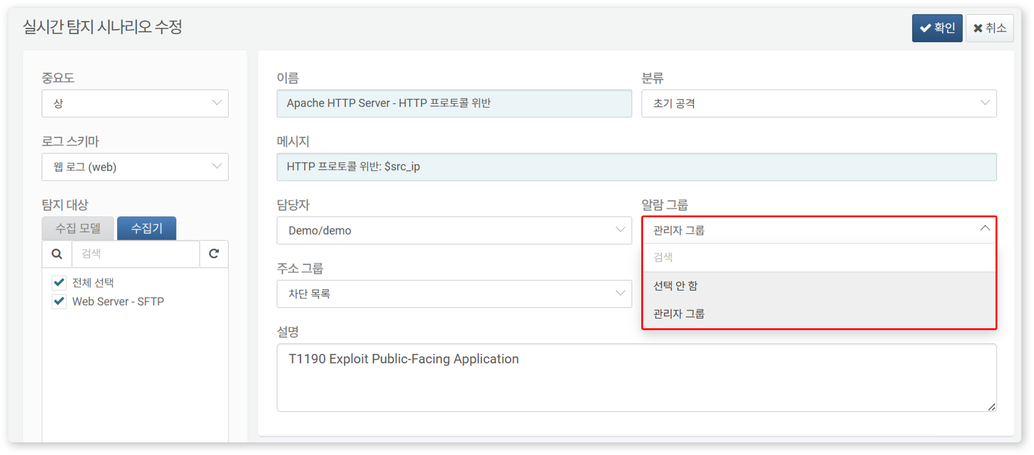
* Setting Alarm Groups in **Policies > Batch Detection**
* 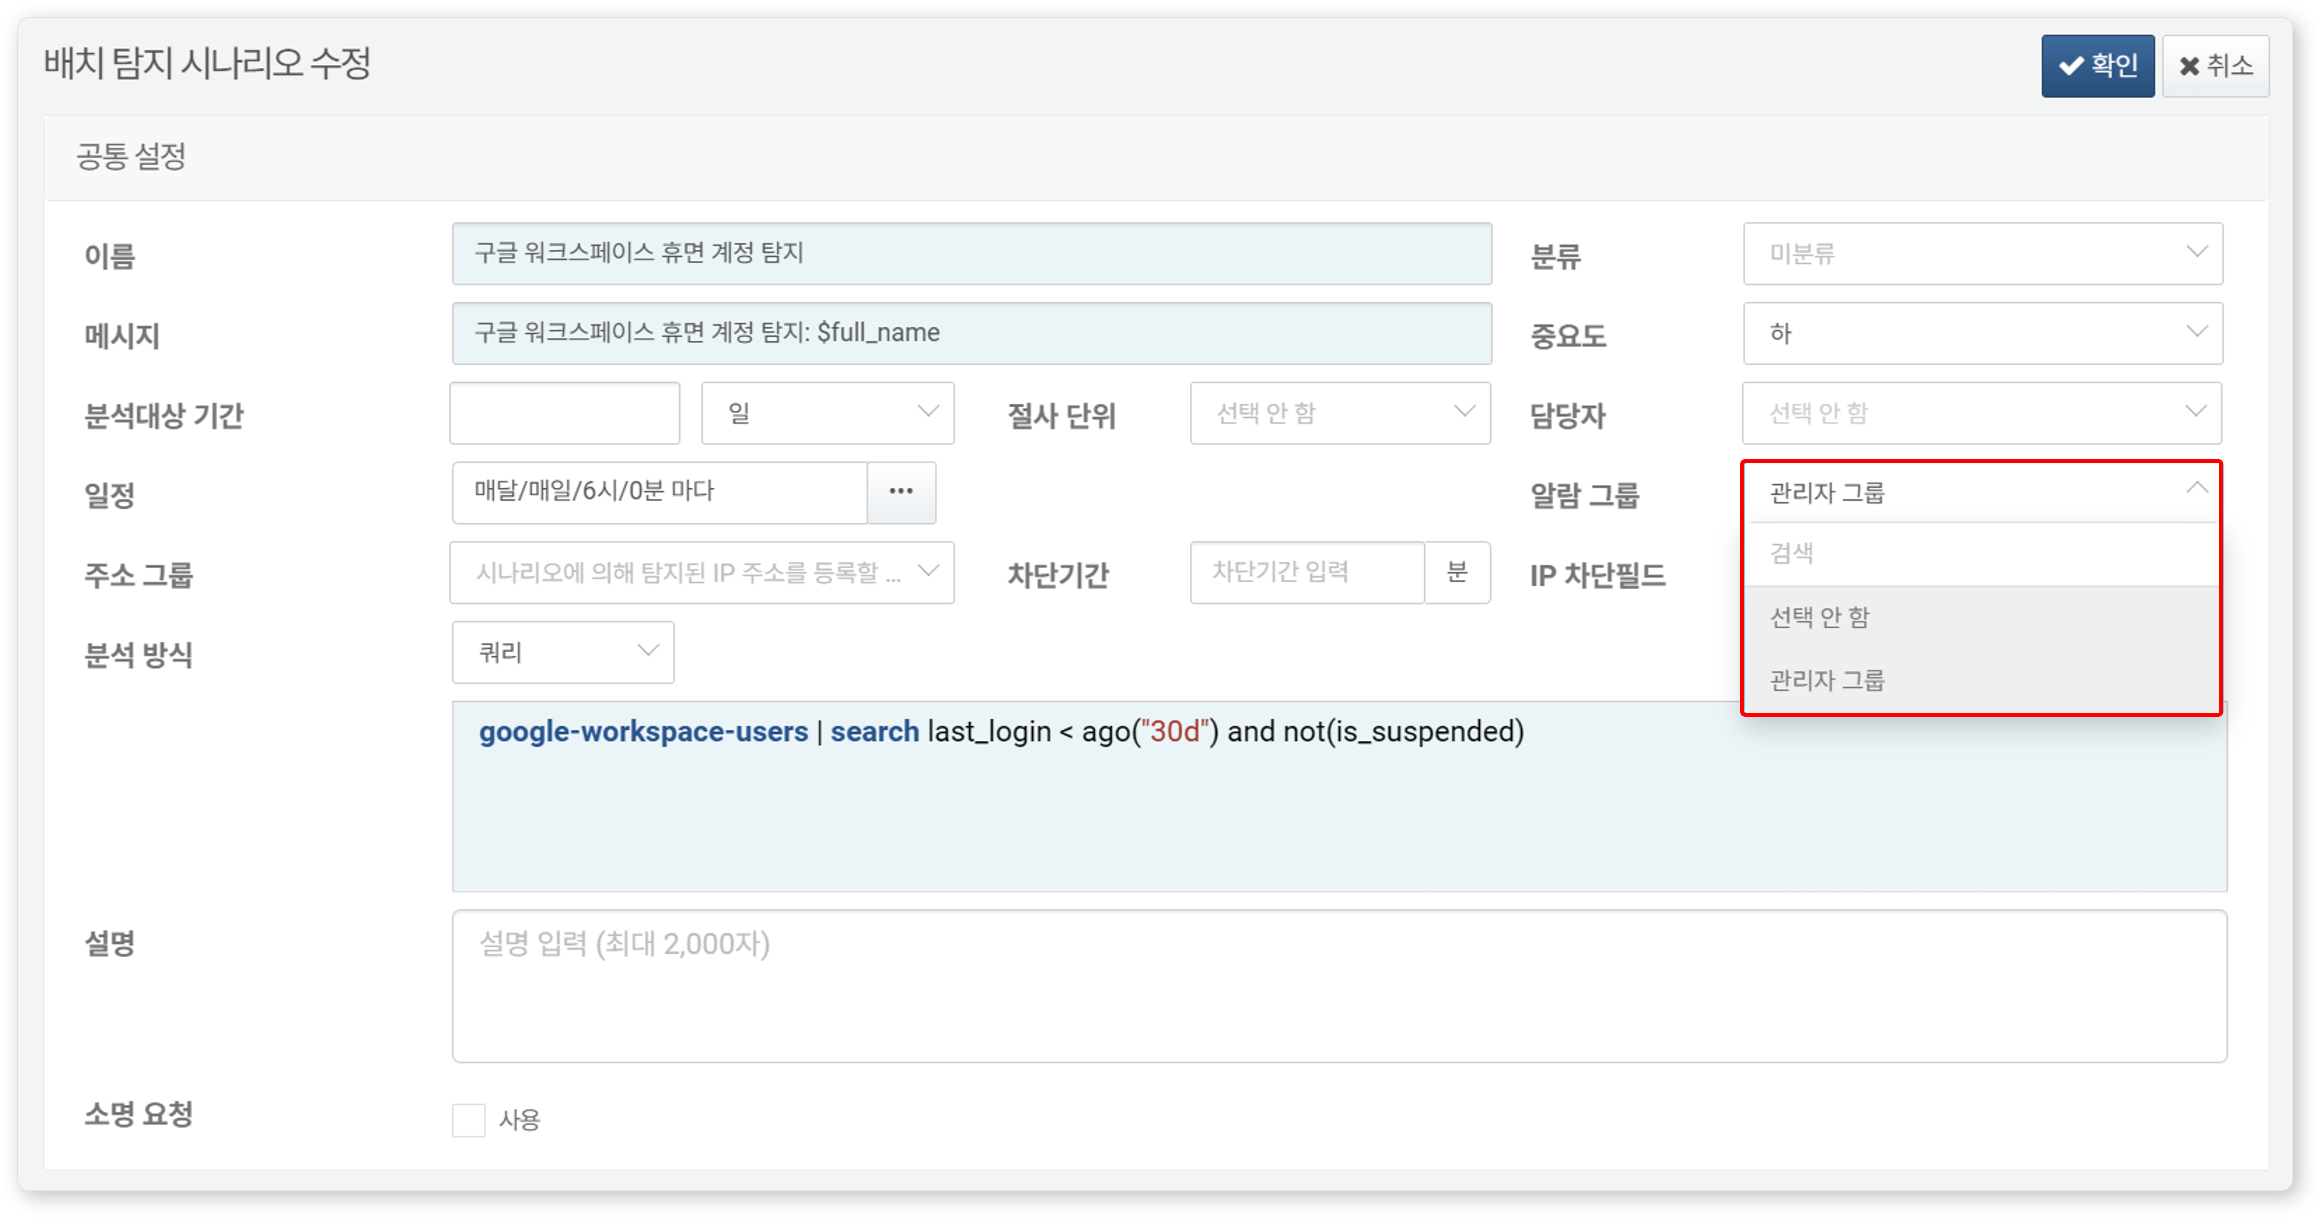

#### Deleting an Alarm Group

To delete an Alarm Group:

Select the checkbox for the row of the Alarm Group you wish to delete in the [Alarm Group List](https://docs.logpresso.comnull).

Click **Delete** in the toolbar.

In the **Delete Alarm Group** dialog, review the list of Alarm Groups to be deleted and click **Delete**. Click **Cancel** if you do not wish to delete.

Be cautious when deleting an Alarm Group that is in use in real-time detection or batch detection, as it may not function as intended.