### Event Summary

The Event Summary menu displays the status of events generated by real-time detection and batch detection policies.

At the top of the screen, the Event Summary chart is displayed, showing the number of detected scenario events by time zone. By clicking on the scenario name in the legend, users can toggle the visibility of the corresponding scenario event count.

At the bottom of the screen, the scenario list is displayed. Users can set the search period, classification, keywords, etc., at the top of the list to modify the occurrence status and search for event statuses. By clicking the download button, users can save the event status results as a file. Clicking on a scenario name in the list opens a new browser window displaying the event query screen. Additionally, clicking the Test button in the list takes users to the editing screen for that scenario.

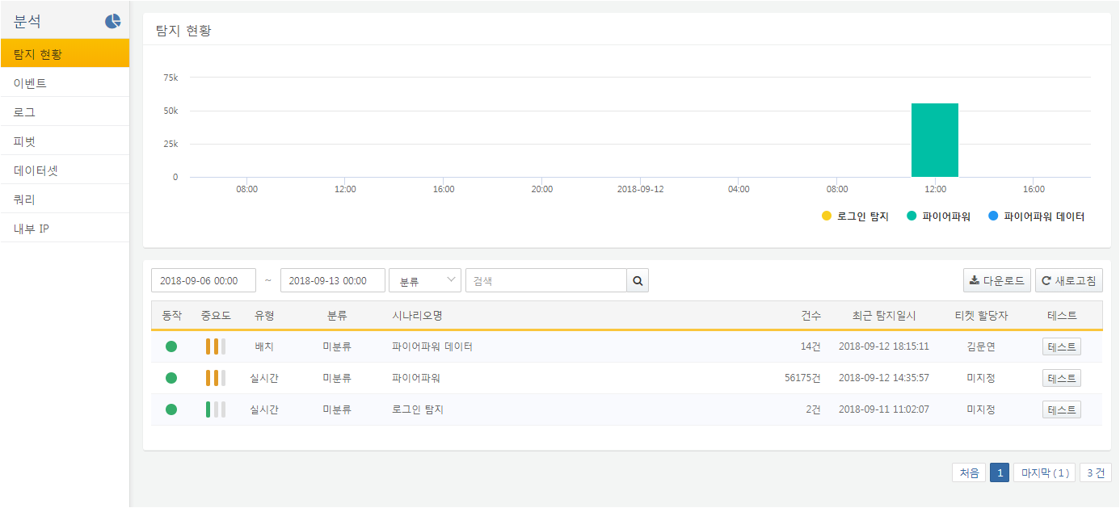

When the Download button is clicked, the Event Summary download menu appears, allowing users to set the following items before clicking the Download button to save the event summary list as a file:

**File Name**

Enter the name for the file to be saved.

**Columns**

Select the list of columns to be saved in the file. If there are many columns, users can search for the desired column name in the column search box to select/deselect it. If the desired column is not in the list, users can enter the column name in the column input box and click the add button to include the desired column.

**File Type**

Select the file type.

**File Encoding**

Select the file encoding.

**Range**

If you want to save only the results from a specific page, enter the page range.

