### Approval Log

The Approval Log displays a list of processed approval requests from the [Approval Requests](https://docs.logpresso.comnull) section.

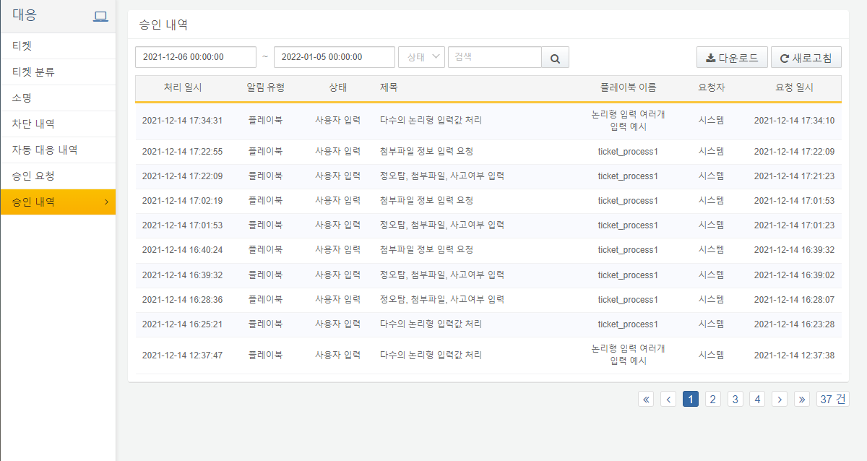

**Approval Log Search**

Users can execute searches for approval request details by entering date, status, and keyword filter criteria. The example below shows the results of searching for requests with the status User Input between 2021-12-13 and 2021-12-14.

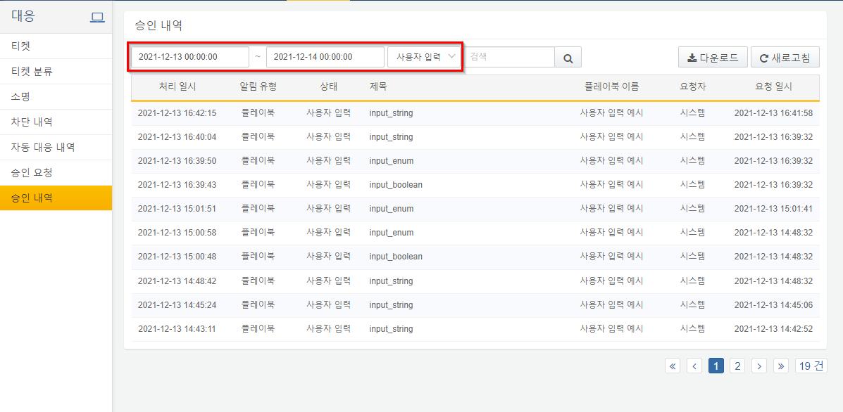

**List Download**

By clicking the download button, users can download the approval log list in file formats such as CSV, Excel XML, MS Word, HTML, and JSON.

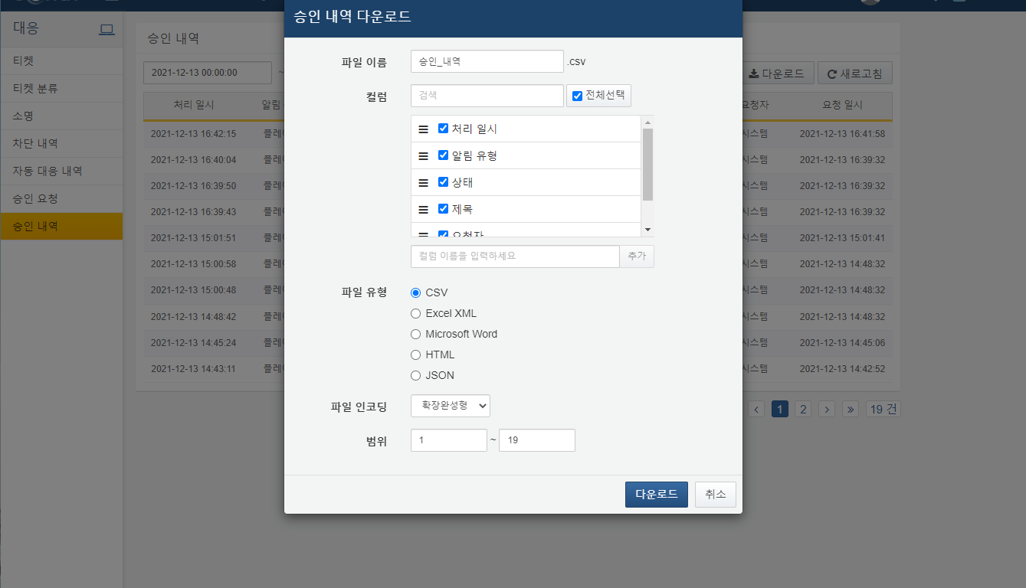

1. **File Name**: The name of the file to be saved.
2. **Column List**: The list of columns to be recorded in the file. Users can search for columns by their desired names in the column list.
3. **File Type**: The format of the file to be saved. One of CSV, Excel XML, MS Word, HTML, or JSON.
4. **File Encoding**: The encoding method for the file. One of UTF-8, UTF-16 BE, or Extended Completion Form.
5. **Range**: The range of approval log items to be saved. The first page's top title designation is considered as number 1.

**Approval Log Details**

By clicking on the title of a specific approval log in the list, users can view detailed information about that approval log in a new window titled with the approval log.

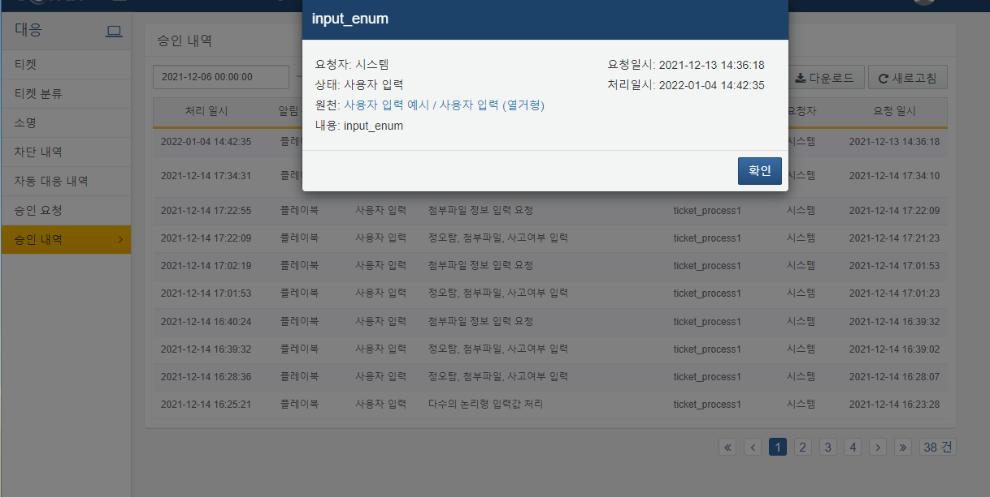

**Requester**: The individual who made the approval request.

**Status**: The form received.

**Source**: A hyperlink to the name of the playbook or task associated with the automated response item. Clicking the hyperlink will navigate to the task screen of the playbook that processed the input, as shown below in the [Playbook History](https://docs.logpresso.comnull).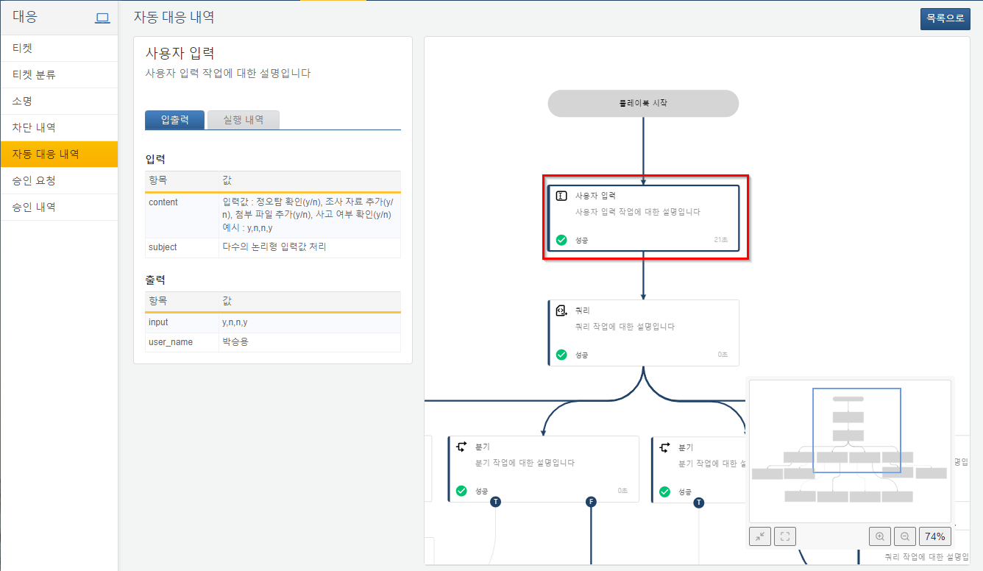

**Content**: The content received.

**Request Timestamp**: The time the request was made.

**Processing Timestamp**: The time the request was processed.