### Approval Request

The Approval Request feature displays a list of playbooks that are waiting for **user input** or **approval requests** when the corresponding actions are executed.

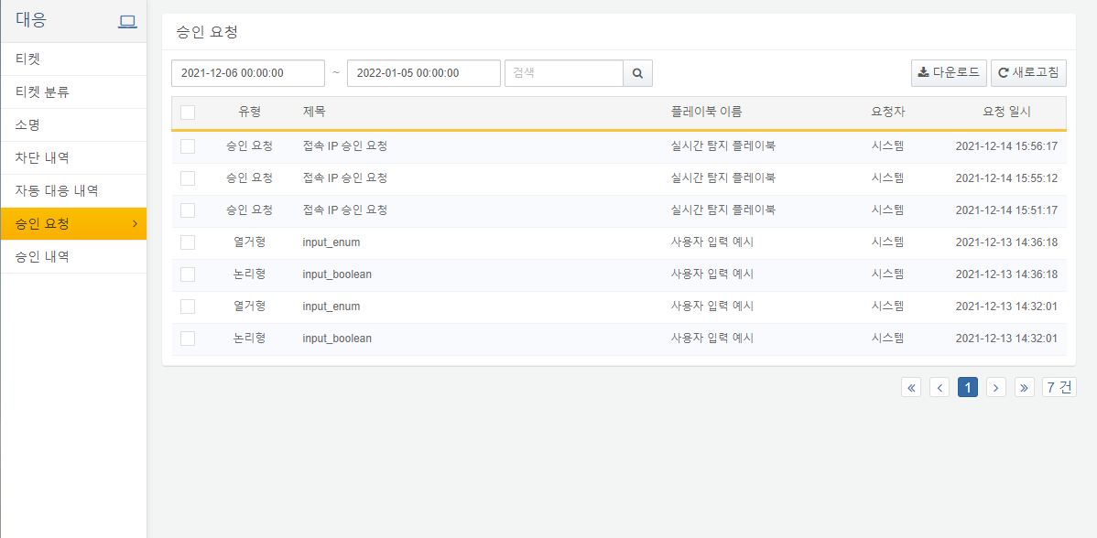

#### Searching Request History

Users can execute searches for approval request details by applying filters based on date, status, and keywords. The example below shows the results of a search for records only between **December 13, 2021, and December 14, 2021**.

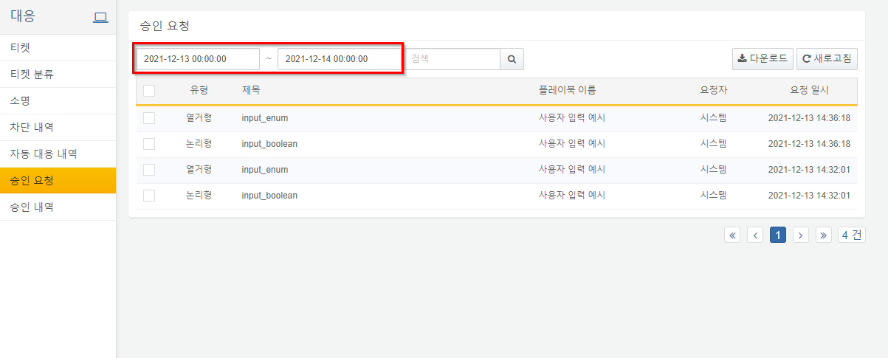

#### Downloading the List

By clicking the download button, users can download the approval request list in CSV, Excel XML, MS Word, HTML, or JSON format.

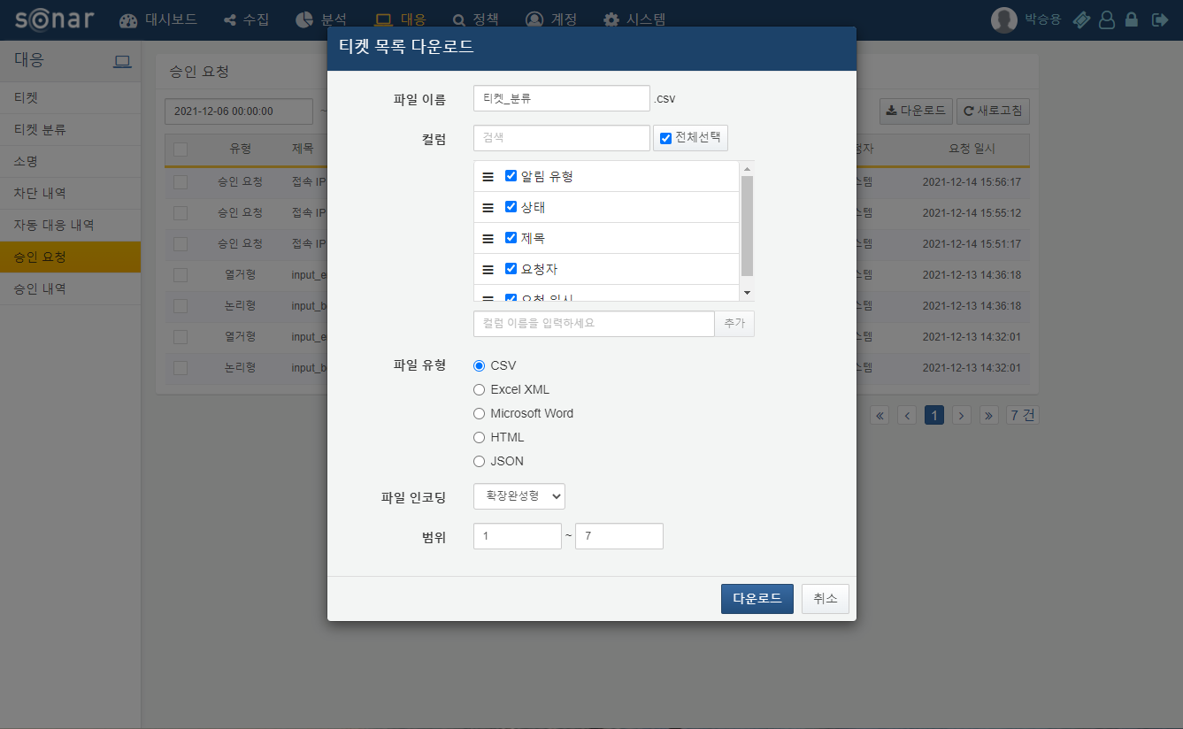

1. **File Name**: Enter the name for the file to be saved.
2. **Column Search**: A list of columns to be recorded in the file. Users can search for desired column names from the list.
3. **Column List**: Select the columns to be saved in the file.
4. **File Type**: The format of the file to be saved. Choose one from CSV, Excel XML, MS Word, HTML, or JSON.
5. **File Encoding**: The encoding method for the file. Choose one from UTF-8, UTF-16 BE, or Extended Completion Form.
6. **Range**: Select the range of automatic history to be saved. The first approval request name at the top of page 1 is considered as number 1.

#### Inputting Approval Requests

Clicking on a specific title in the approval request history list will display a popup requesting user input based on the approval type. The example below shows a popup for an enumerated type.

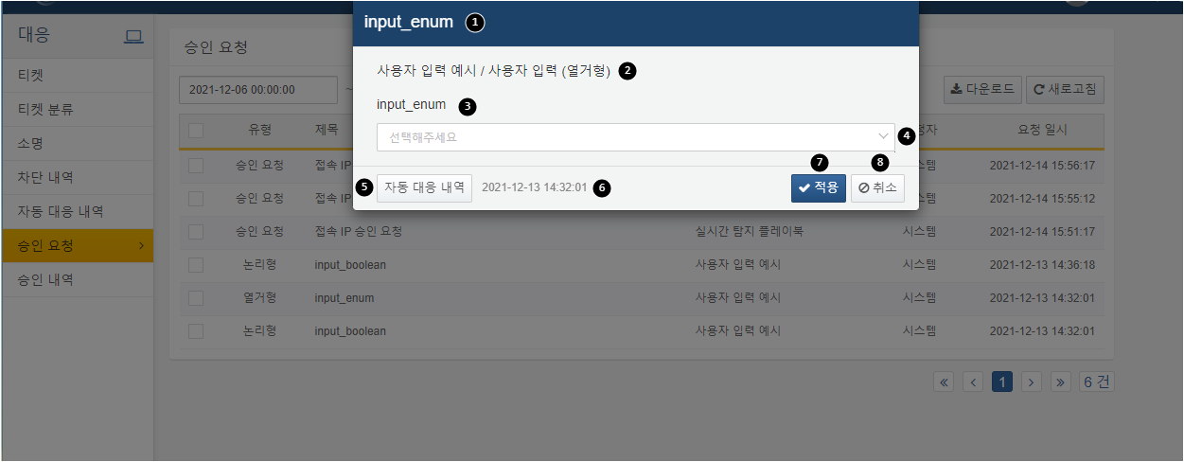

**Approval Request Title**: Displays the title of the clicked approval request item.

**Playbook Title**: Displays the name of the playbook / task associated with the clicked item.

**Variable**: Displays the variable names that the clicked item requires input for.

**Input**: The field for receiving user input values.

**Automatic Response History**: Navigates to the corresponding task in the automatic response history.

**Request Date and Time**: Displays the time when the request was made.

**Apply**: Applies the entered content to the task and continues the playbook process.

**Cancel**: Cancels the entered content.

By clicking on the automatic response history in the above popup, users will be directed to the tasks in the playbook that are waiting for input, as shown below.

