App Management

Overview
In the Apps menu, you can install apps downloaded from the Logpresso Store. In version 3.x, configuring a dashboard to collect logs required setting up widgets, dashboards, log schemas, parsers, logger models, stream and batch rules, datasets, subnet groups, port groups, and pattern groups individually. In version 4.0, most of these tasks are completed simply by installing an app.
All users, including administrators, can use apps within the scope of their granted permissions.
The app system was introduced in version 4.0.2308.0. The web console features necessary for app management are supported starting from version 4.0.2312.0.

App Installation
To install an app on the Logpresso server, administrative privileges are required. The app installation file (with a .app extension) can be downloaded from the Logpresso Store (registration required).
Click Install in the upper right corner of the Apps screen.
When the App Installation Wizard appears, upload the app file you wish to install. The installation will begin automatically once the file is uploaded.
- Click Select File to choose the app file, or drag and drop the app file into the App Installation Wizard.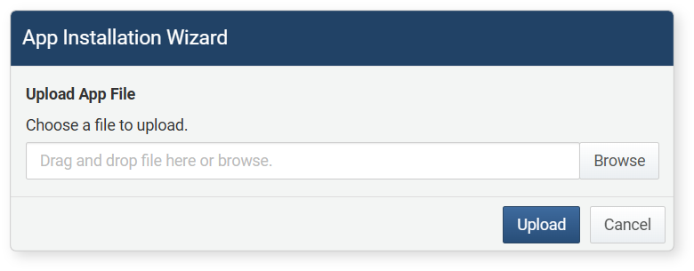
- Click Upload to upload the app file to the server.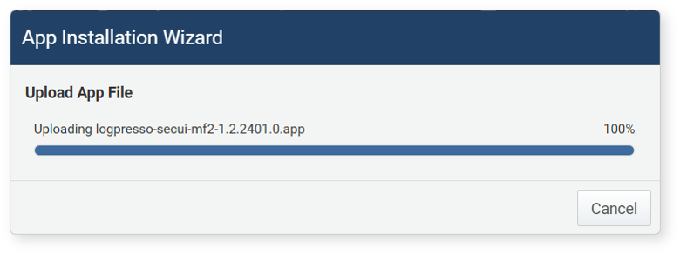
- If the app file is successfully uploaded, the installation will begin automatically.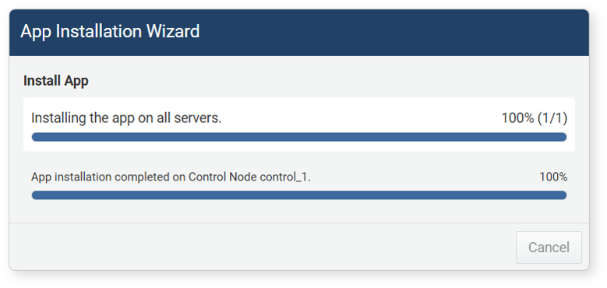
- When installing apps on multiple Logpresso servers, the app will be installed in the order of the forwarder node, data node, and control node.
- The installation status for each server is independent of the installation order.
- Once the app is installed on all servers, the App Installation Wizard will close.
The app will be activated automatically upon installation, and a card for the app will appear on the Apps screen. You can check the installation date next to the app's version information.
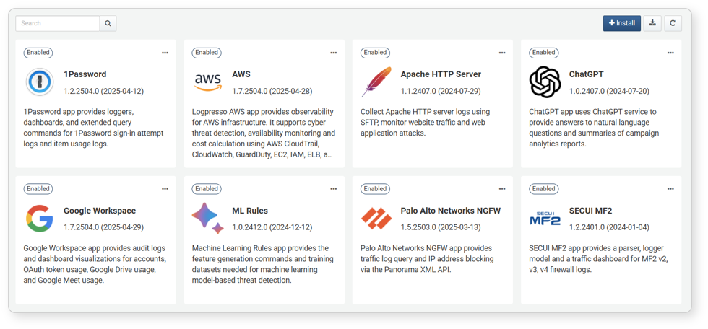
Please use only apps from trusted sources. Logpresso provides apps through the Logpresso Store (https://logpresso.store).

Enable and Disable App
For users to utilize an app, it must be enabled. The steps to enable or disable an app are as follows:
Click the "..." in the upper right corner of the app card marked as Enabled.
From the menu, click Disable or Enable (Enable/Disable is a toggle menu).
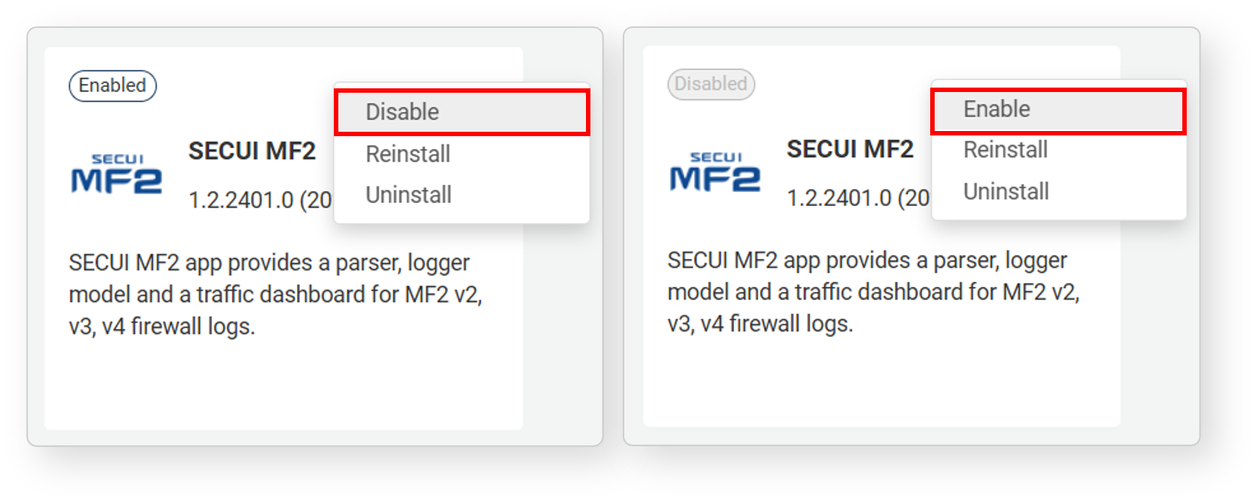

Reinstall App
If you have modified the node configurations, some nodes may not have the app installed. Reinstalling the app will ensure the app is installed on any nodes where it is missing.To reinstall an app:
Click the "..." in the upper right corner of the app card.
From the menu, click Reinstall.
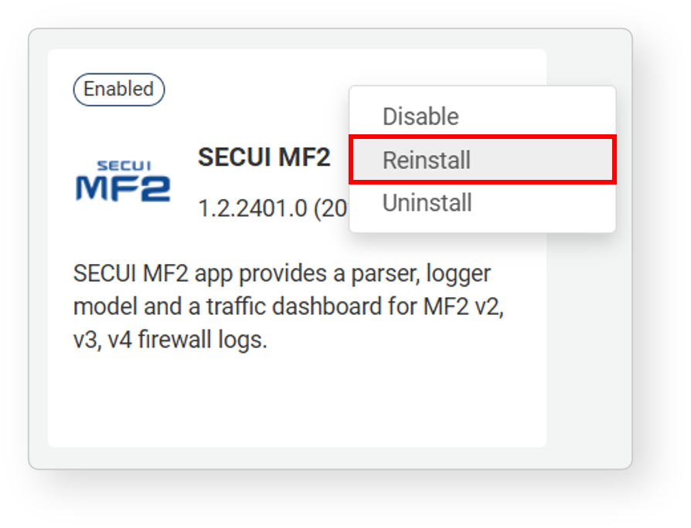
The subsequent process is the same as the app installation.

Uninstall App
To remove an app that is no longer in use:
Click the "..." in the upper right corner of the app card.
From the menu, click Uninstall.
In the Uninstall App dialog box, confirm that the app to be removed is correct.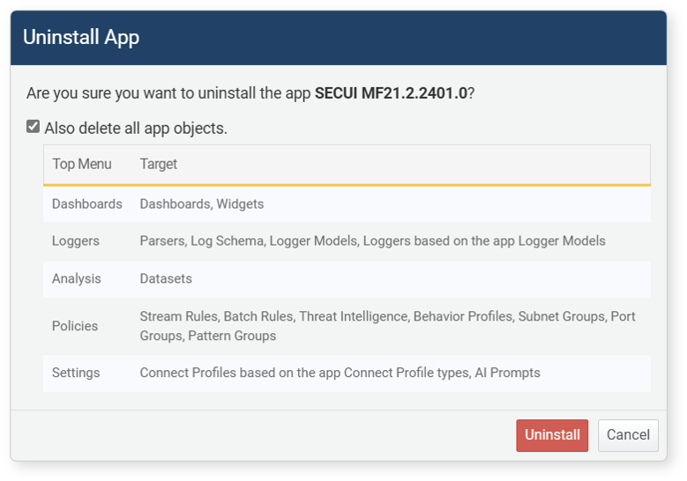
- To delete all objects installed with the app, select Also delete all app objects.
- Click Uninstall to proceed with the removal, or click Cancel if you do not wish to remove it.

