### Audit Logs

#### Overview

Logpresso Sonar records the configuration changes and security monitoring activities performed by users after logging into the web console. The logs recorded in this manner are referred to as audit logs.

#### Viewing/Search Audit Logs

You can view or search the audit logs under **System > Audit Logs**. The default search period is the last 30 days.

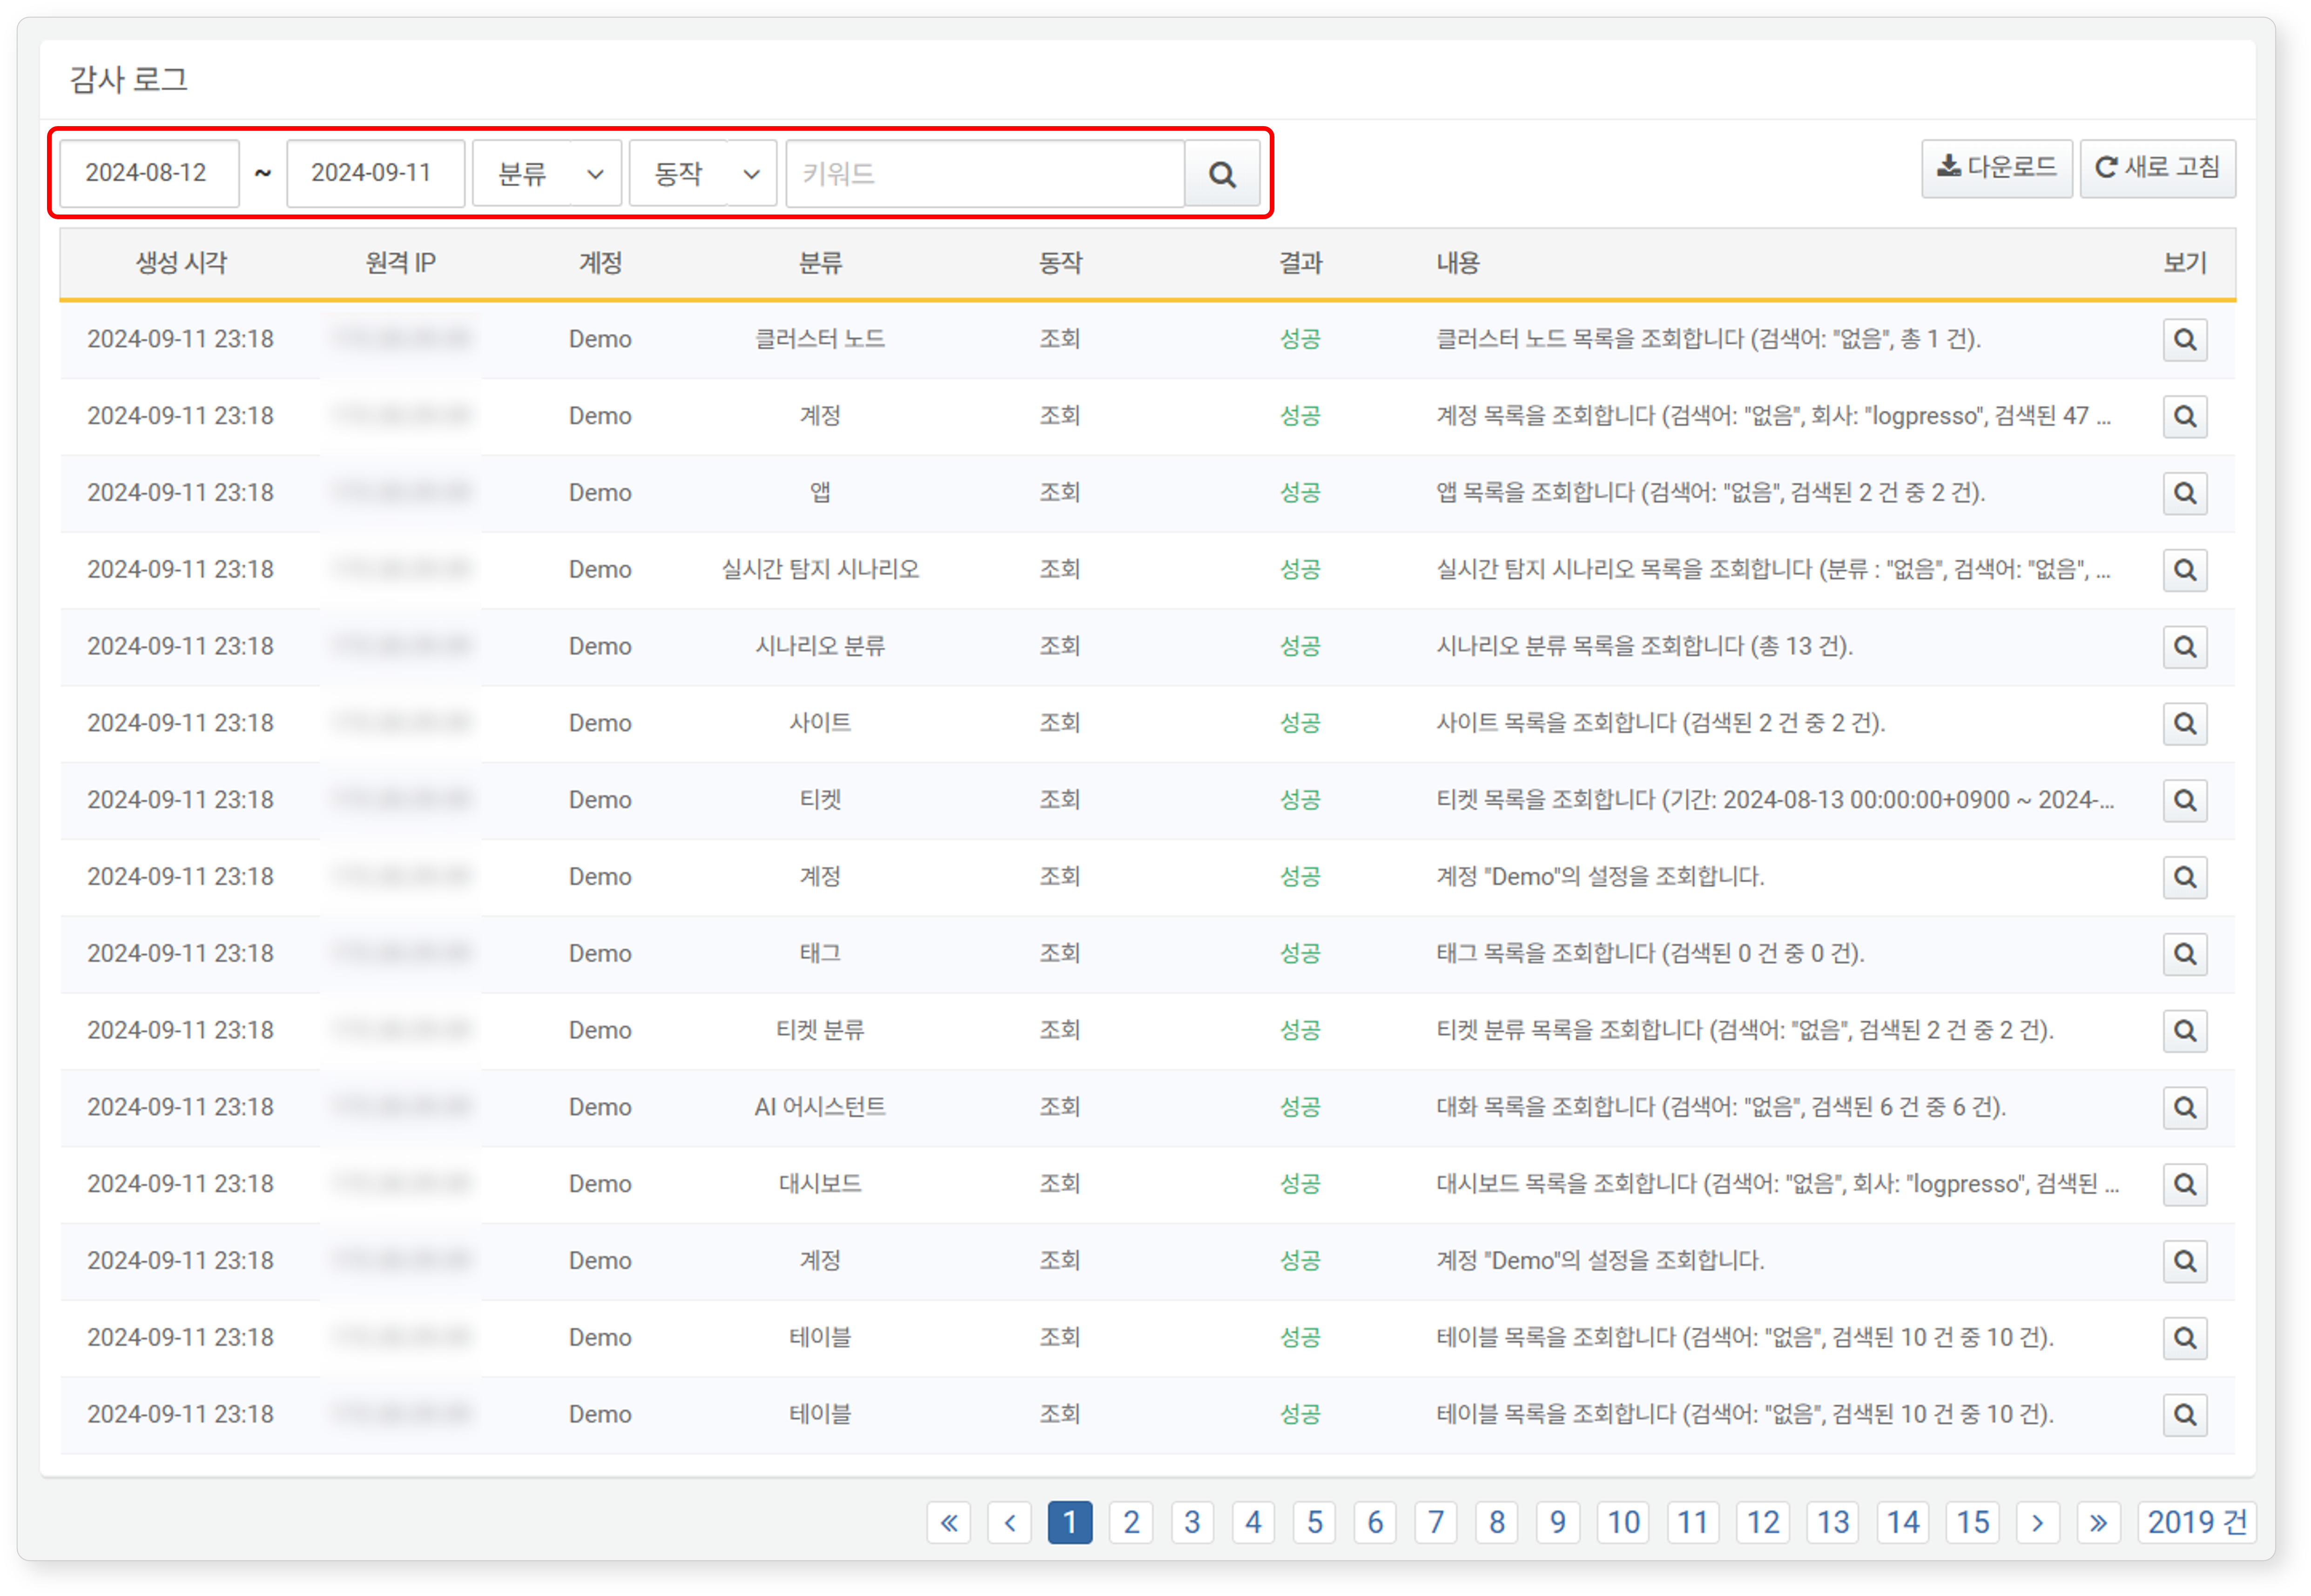

* In the toolbar, you can specify the period, category, and action to define the range of logs to be retrieved.
* By entering keywords, you can filter the logs to display only those that contain the specified keywords.

#### Detailed View of Audit Logs

Click the  icon on the right side of the audit log to view the detailed information of that audit log. If the result is a failure, the error details will also be displayed.

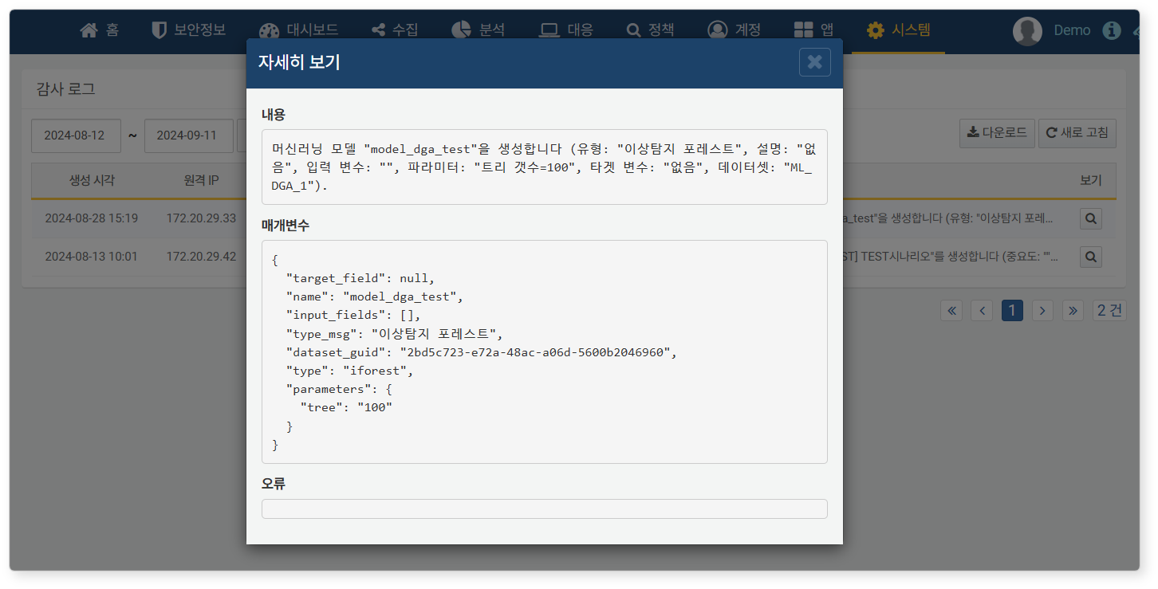

#### Downloading Audit Logs

To download the audit logs:

Click **Download** in the toolbar.

In the **Audit Log Download** dialog, specify the properties of the file to be downloaded and click **OK**.

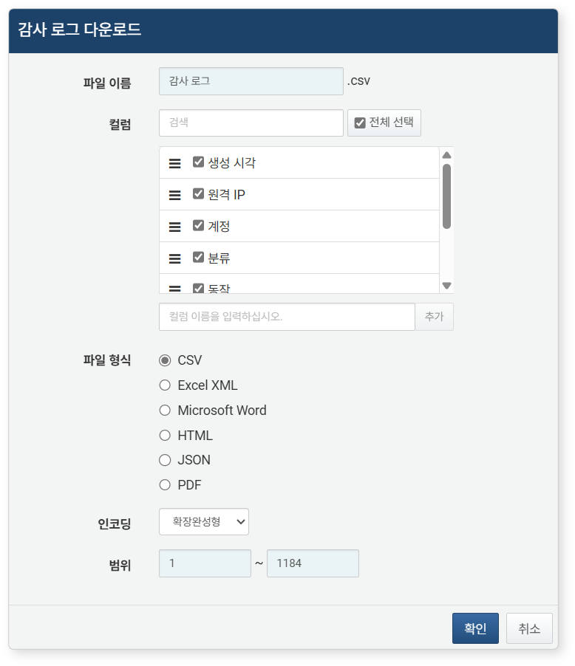

* **File Name**: The name of the file to be downloaded (default: Audit Log)
* **Columns**: The fields to be recorded in the download list (default: Select All)
* **File Format**: Choose from **CSV**, **Excel XML**, **Microsoft Word**, **HTML**, **JSON** (default: CSV)
* **Encoding**: Select the string encoding format of the file from **Extended Completion Type**, **UTF-8**, **UTF-16 BE** (default: Extended Completion Type)
* **Range**: Choose the range of audit logs to be recorded in the list. The default is set to include all audit logs, starting from 1 on the first page of the audit log list.

Once the server transmits the file to your web browser, save the file and check the downloaded audit log file.